# **GAYATRI VIDYA PARISHAD COLLEGE FOR DEGREE AND PG COURSES (AUTONOMOUS)**

# ABOUT :-

## Heading:ABOUT GVPCDPGC

## **Sub Heading:**About Gayatri Vidya Parishad

| **S.NO** | **PHOTO** | **Name & Qualification** | **Designation** |
| --- | --- | --- | --- |
| 1 |  | Prof. P. Srinivasa Rao  B.Tech. (Hons), M.Tech., Dr.Ing (Munich) | President |
| 2 |  | Sri. D. Dakshina Murthy  M.Sc | Vice-President |
| 3 |  | Prof. K P R Sastry | Vice-President |
| 4 |  | Prof. P. Soma Raju,  M.A., Ph.D. | Secretary |

Gayatri Vidya Parishad is an Educational Society established by a group of erudite academicians of Visakhapatnam City in the year 1988 and supported by a number of industrialists and philanthropists of the city.

Gayatri Vidya Parishad started its activities from 28-09-1988. The Society is managed by eminent educationists, philanthropists and technocrats. One of the major aims of the Trust is "To promote, establish, maintain and assist in maintaining educational and other institutions with a view to imparting education in all branches in general and advanced technology, management, education, human and science in particular, and thus to facilitate securing gainful employment to the youth of the country".

The founding sagas are a source of inspiration and strength to the institution and their wisdom is reflected in the content and quality of the curriculum for all the courses. All the other members of the Governing Body are eminent academicians, great educationists and social workers who laid strong foundations for the promotion of professional, ethical and human values for this great edifice of academic excellence and continue to guide it to scale new heights over the past three decades.

**The various institutions adorned the cap of GVP over the span of three decades are as follows:**

| **S.No.** | **Institutions in the GVP group** | **Year of Establishment** |
| --- | --- | --- |
| **1** | **Gayatri Vidya Parishad** | **1988** |
| **2** | **Gayatri Vidya Parishad Degree College** | **1989** |
| **3** | **Gayatri Vidya Parishad College for Degree and PG Courses(A)** | **1994** |
| **4** | **Gayatri Vidya Parishad College of Engineering(A)** | **1996** |
| **5** | **GVP College of Engineering for Women** | **2008** |
| **6** | **Lakshmikantham Institute of Advanced Sciences** | **2009** |
| **7** | **Kasturba Centre for Women Studies** | **2010** |
| **8** | **GVP Scientific and Industrial Research Center** | **2011** |
| **9** | **Bio Science Research laboratory** | **2011** |
| **10** | **Nano Science Research Laboratory** | **2011** |
| **11** | **GVP MLBT School** | **2014** |
| **12** | **Centre for Promotion of Human Values and Ethics** | **2014** |
| **13** | **Gayatri Vidya Parishad-Institute of Health Care and Medical Technology** | **2016** |
| **14** | **Centre for Integrated Tribal Research & Development** | **2022** |

**FOOTER-ABOUT:**

**Address: Gayatri Vidya Parishad College for Degree and P.G Courses(A),**

**Rushikonda, Visakhapatnam-530045, Andhra Pradesh.**

**Get In Touch:**

**mail principalgvpcdpgca@gmail.com**

**phone 0891-2955084**

**Working Hours:**

**Mon-Sat 10:00 AM-5:00 PM**

**phone 0891-2783722 (UG)**

**phone 0891-2955084 (PG)**

**phone 0891-2953719 (E&T)**

**College route map: photo**

**Follow Us: logo ( facebook, twitter, instagram,youtube)**

## **Sub Heading:** **Institute Distinctiveness**

GAYATRI VIDYA PARISHAD was established in the year 1988 by a group of distinguished academicians under the visionary leadership of Late Prof. B.Sarveswara Rao garu, former Professor of Economics, Andhra University, Member - Planning Commission of India and a Cambridge mind with an objective of promoting value rich and quality focused higher education in distinct area of academics in the city of Destiny – Visakhapatnam.

The Mission of the institution places emphasis on three aspects (thrust areas) essentially: Academic excellence through value-based education, strong research base and sustainable development thereby leading to exponent for development of a holistic personality of a student intern resulting in the realization of institution’s vision - “CREATING HUMAN EXCELLENCE FOR A BETTER SOCIETY”. Development of a holistic personality resulting in the realization of the vision:(Sustainable Development) Participation of the students in co-curricular and extra-curricular activities helps to enhance total development of personality of students to face the turbulent times with a fortitude attitude. Experience gained through these activities turns very helpful to the students during internships and placement. In addition to Departments, IIPC and EDC units also organize expert lectures, invited talks, industrial visits which attribute to effective implementation of the curriculum. Skill Development programs are organized regularly to students to upgrade their skills. Career guidance, personal counseling, training well-structured and integrated into various academic programs through a mentoring system and central placement cell activity. Student participation in professional bodies and associations is encouraged. Many of our illustrious alumni are holding positions of responsibility in the corporate world as well as in public services and politics. Quite a few of them have established their own business and progressing in their chosen career paths. Alumni have a strong attachment to their alma mater and are prepared to connect among themselves as well as to the Institution. Re-union meetings are helping them to be aware of the progress of the Institution. Ardent efforts are made consistently to sync our ‘Mission’ and ‘vision’ for the holistic development of students so that they can replicate the success story of their predecessors. The most effective method of marching forward towards this objective is through academia-industry meet (by way of organizing seminars, conferences, symposia etc.) as well as fruitful interactions with successful alumni through alumni meet, guest lectures. All the above-mentioned efforts made by the institution leads to appreciable all round performance of the students by assuring academic excellence through value enriched education with strong research base finally paving way to sustainable development resulting in realizing the vision of the institution.

The Institute has a structured Examination committee consisting of Secretary and correspondent, Principal, Adviser, Professors, senior faculty members and Controller of Examinations which prepares the academic calendar well in advance before the commencement of the session/semester.

**FOOTER-ABOUT-Institute Distinctiveness :**

**Address: Gayatri Vidya Parishad College for Degree and P.G Courses(A),**

**Rushikonda, Visakhapatnam-530045, Andhra Pradesh.**

**Get In Touch:**

**mail principalgvpcdpgca@gmail.com**

**phone 0891-2955084**

**Working Hours:**

**Mon-Sat 10:00 AM-5:00 PM**

**phone 0891-2783722 (UG)**

**phone 0891-2955084 (PG)**

**phone 0891-2953719 (E&T)**

**College route map: photo**

**Follow Us: logo ( facebook, twitter, instagram,youtube)**

## **Sub Heading:** [**Genesis of GVPCDPGC**](https://gvpcdpgc.edu.in/about/about_genesis_of_gvp.php)

##### Our Institution [**College Buildings**](https://gvpcdpgc.edu.in/about/collegephotos.pdf)

## 

## **The Gayatri Vidya Parishad College for Degree and P.G. Courses since establishment has been progressing tremendously and today it is one of the premier institutions in the state of Andhra Pradesh contributing significantly to the human resource base that the economy needs and is run with self-generated funds.**

## **The College was accredited by NAAC with B++ Grade and was conferred the Autonomous Status by Andhra University after due approval by the UGC in April 2007 and in the second cycle in June 2014. NAAC accreditation and the autonomous status have increased the responsibility of the institution enhancing of the quality of teaching-learning, research, consultancy, skill development, and community development and for holistic development of the student.**

##### The Goals and Objectives of the College

## 

## **The goals & objectives of this illustrious institution in pursuit of excellence are to:**

## **Provide a strong foundation to students for developing sound theoretical and practical knowledge in their chosen areas of knowledge and specialization.**

## **Nurture research in thrust areas of knowledge relevant to national and global concerns.**

## **Build strong interface with the industry for the skill development and the promotion of ready employability of the students.**

## **Create an ambience for excellence and in pursuit of this objective an ethic of sharing and a spirit of collaboration.**

## **Focus on instilling in the student a sense of discipline and concern for society and prepare him for participation in national productivity enhancement.**

##### Courses Offered

## 

## **Gayatri Vidya Parishad College for Degree and P.G. Courses was established in 1989 offering B.A., B.Com., B.Sc. and B.B.A. with innovative and restructured combinations including Computer Science and Electronics, in addition to the traditional combinations. Biosciences were introduced from the academic year 2005-06. All these courses were brought into autonomous status from the academic year 2007-08. Post-Graduate courses were started from 1993-94 in various disciplines. These courses were conferred the autonomous status from 2009-10.Four engineering programs were added in 2011 and are autonomous since 2019-20**

##### U.G. Courses

## 

## **The College offers a number of U.G. and P.G. Courses in Autonomous stream in English medium. All the Courses offered are based on the needs of the society and industry. The courses offered are:**

## **Bachelor of Science**

## **Mathematics, Physics and Chemistry**

## **Mathematics, Physics and Computer Science**

## **Mathematics, Statistics and Computer Science**

## **Mathematics, Electronics and Computer Science**

## **Microbiology, Biotechnology and Biochemistry**

## **Commerce and Management Studies**

## **Bachelor of Commerce (B.Com)**

## **Bachelor of Business Administration (B.B.A)**

## **Bachelor of Computer Applications (BCA)**

## **P.G. Courses (Autonomous)**

## **Master of Business Administration (MBA)**

## **Master of Computer Applications (MCA)**

## **M.Sc. (Computer Science)**

## **Master of Human Resource Management (MHRM)**

## **M.Sc. (Organic Chemistry)**

## **Part-time Ph.D.**

## **Engineering and Technology Program (Autonomous)**

## **B.Tech Civil Engineering (CE)**

## **B.Tech Computer Science Engineering (CSE)**

## **B.Tech Electronics and Communication Engineering (ECE)**

## **B.Tech Mechanical Engineering (ME)**

##### Research Programme

## 

## **The Directorate for Research and Development of the college motivates the faculty to take up research and consultancy activities. Andhra University recognized P.G. College as a Research Centre to pursue Ph.D in Management Studies**

##### General Discipline Of The Campus

## 

## **Dress Code**

## **Dress Code is strictly implemented in the college. Every UG student must wear the prescribed uniform on all week days except Saturday. Further, the student is required to wear the uniform on all examination days and on special occasions. On Saturdays they can have formal wear. The PG Students are required to come in formal wear.**

## **Ban on Cell Phones**

## **Use of mobile phones or other telecommunication devices are not allowed on the campus. If any faculty observes a student using a mobile phone in the college, the same will be confiscated and handed over to the Principal.**

## **Undertaking Letters**

## **At the time of admission the students and their parents shall submit a declaration to the effect that the rules and regulations of the college will be scrupulously followed. Parents are also advised to be in touch with the concerned mentors regularly. They shall also give an undertaking to the effect that they will abide by the decisions taken by the Staff-council.**

## **Credit system**

## **The College adopted credit system as per the guidelines of Andhra University (vide Resolution No. 2 (AC-03/07-08) of the Third Meeting of the Academic Council held on 30-03-2008).**

## **As per the UGC guidelines the evaluation system and computation of the Cumulative Grade Point Average (CGPA) based on student's performance in examinations has been implemented from 2015-16 admitted batch onwards.**

## **Choice Based Credit System (CBCS)**

## **The CBCS provides an opportunity for the students to choose courses from those prescribed comprising core, elective/minor or skill based.**

## **Scholarships**

## **Scholarships will be facilitated to every deserving candidate if he / she achieves minimum requirement of marks and puts in the requisite minimum attendance.**

## **Attendance**

## **A candidate shall be required to attend not less than 75% of the theory classes and 90% of the practical classes in each subject during each semester. The Principal may grant condonation of shortage of attendance in exceptional cases for a valid reason of absence up to a maximum of 10%. Unauthorized absence of any student from the classes is not allowed since all the courses are full-time. If a student applies for leave on medical grounds he / she shall enclose a Medical Certificate to the leave letter.**

## **However, the Principal may grant an additional condonation for those candidates who represented the University/State in any inter-university or national camp(s), competition(s), games or sports or any national event during the relevant period of absence.**

##### Activities

## 

## **Voice 4 Girls**

## **An adolescent girl has the unique power to break harmful cycles of economic and social inequality. Through activity-based camps like “Voice 4 Girls” the college student trainers train the girls of rural and remote areas in and around the city of Visakhapatnam. The girls are given training in life skills, spoken English and critical information that helps them make changes in their own and others lives.**

## **Literary and Cultural Activities**

## **The College encourages students to participate in literary and cultural activities to bring out their latent talents. Competitions in essay writing, elocution, debate, quiz and histrionic activities are frequently conducted in the college. Selected students will be given guidance to represent the college at intercollegiate competitions, youth festivals etc.**

## **Youth Red Cross**

## **The Youth Red Cross in association with the Indian Red Cross Society organizes Blood Donation camps. In times of natural disaster the volunteers come forward to help the displaced and needy.**

## **Red Ribbon Club**

## **The College has a Red Ribbon Club which provides awareness about AIDS and its control.**

## **Legal Literacy Club**

## **The College has a legal literacy club which provides legal knowledge and awareness to the students and through them to the general public.**

## 

**FOOTER-ABOUT-**[**Genesis of GVPCDPGC**](https://gvpcdpgc.edu.in/about/about_genesis_of_gvp.php) **:**

**Address: Gayatri Vidya Parishad College for Degree and P.G Courses(A),**

**Rushikonda, Visakhapatnam-530045, Andhra Pradesh.**

**Get In Touch:**

**mail principalgvpcdpgca@gmail.com**

**phone 0891-2955084**

**Working Hours:**

**Mon-Sat 10:00 AM-5:00 PM**

**phone 0891-2783722 (UG)**

**phone 0891-2955084 (PG)**

**phone 0891-2953719 (E&T)**

**College route map: photo**

**Follow Us: logo ( facebook, twitter, instagram,youtube)**

## **Sub Heading:** [**Vision & Mission**](https://gvpcdpgc.edu.in/about/about_vision_mission.php)



Vision

Creating Human Excellence For A Better Society

Long term objectives

* To provide value based high quality technical education
* To inculcate professionalism in the faculty as well as students
* To establish Industry-Institute Interaction
* To attain the conversion of theory into practice
* To promote innovation and research
* To attain accreditations and autoxomy



Mission

Unfold Into A World-Class Organization With Strong Academic And Research Base, Producing Responsible Citizens To Cater To The Changing Needs Of The Society

Short term Goals

* To hone the skills of the students to international standards
* To develop the personality of the students
* To ensure student centric teaching methodology
* To provide state-of-the art laboratories and learning ambience
* To promote entrepreneurship among the student community
* To impart placement training for better employability

**FOOTER-ABOUT-**[**Vision & Mission**](https://gvpcdpgc.edu.in/about/about_vision_mission.php) **:**

**Address: Gayatri Vidya Parishad College for Degree and P.G Courses(A),**

**Rushikonda, Visakhapatnam-530045, Andhra Pradesh.**

**Get In Touch:**

**mail principalgvpcdpgca@gmail.com**

**phone 0891-2955084**

**Working Hours:**

**Mon-Sat 10:00 AM-5:00 PM**

**phone 0891-2783722 (UG)**

**phone 0891-2955084 (PG)**

**phone 0891-2953719 (E&T)**

**College route map: photo**

**Follow Us: logo ( facebook, twitter, instagram,youtube)**

## **Sub Heading:** [**Other Institutions**](https://gvpcdpgc.edu.in/about/other_institutions.php)

###### [Gayatri Vidya Parishad College of Engineering (A)](http://www.gvpce.ac.in/)

###### [Gayatri Vidya Parishad College of Engineering for Women](http://www.gvpcew.ac.in/)

###### [M.L.B.T. High School](https://gvpcdpgc.edu.in/about/other_institutions.php#)

###### [Gayatri Vidya Parishad Prof. V. Lakshmikantam Institute of Advance Studies](https://gvpcdpgc.edu.in/about/other_institutions.php#)

###### [Gayatri Vidya Parishad SIRC: A Scientific and Industrial Research Center](http://www.gvpsirc.in/)

###### [Institute of Health Care and Medical Technology](http://www.gvpmc.in/)

**FOOTER-ABOUT-**[**Other Institutions**](https://gvpcdpgc.edu.in/about/other_institutions.php)**:**

**Address: Gayatri Vidya Parishad College for Degree and P.G Courses(A),**

**Rushikonda, Visakhapatnam-530045, Andhra Pradesh.**

**Get In Touch:**

**mail principalgvpcdpgca@gmail.com**

**phone 0891-2955084**

**Working Hours:**

**Mon-Sat 10:00 AM-5:00 PM**

**phone 0891-2783722 (UG)**

**phone 0891-2955084 (PG)**

**phone 0891-2953719 (E&T)**

**College route map: photo**

**Follow Us: logo ( facebook, twitter, instagram,youtube)**

## **Sub Heading:** [**Governing Body Memebers**](https://gvpcdpgc.edu.in/about/about_governing_body.php)

#### Governing Body

| **S.No** | **Name** | **Designation** |
| --- | --- | --- |
| 1 | Prof. P. Srinivasa Rao  President  Gayatri Vidya Parishad | Chairman |
| 2 | Sri. D. Dakshina Murty  Vice President  Gayatri Vidya Parishad | Member |
| 3 | Prof. P. Somaraju  Secretary  Gayatri Vidya Parishad | Member |
| 4 | Sri. V. R. K. S. Siva Prasad  Treasurer  Gayatri Vidya Parishad | Member |
| 5 | Prof. V.S.R.Krishna Prasad  Member  Gayatri Vidya Parishad | Member |
| 6 | Dr. K.S. Bose  Professor  Department of Management Studies  Gayatri Vidya Parishad College for  Degree and PG Courses (Autonomous) | Principal Nominee |
| 7 | Dr. V. Radhika  Senior Assistant Professor  Department of Mathematics  Gayatri Vidya Parishad College for  Degree and PG Courses (Autonomous) | Principal Nominee |
| 8 | Prof. P.V.Sarma  Secretary and Correspondent Gayatri Vidya Parishad College for  Degree and PG Courses (Autonomous) and  Gayatri Vidya Parishad | Member |
| 9 | Prof. Rekha Acharya  Head, School of Social Sciences  Devi Ahilya Vishwavidyalaya  Indore-452001 | Member  UGC Nominee |
| 10 | Prof. U. Shameem  Department of Zoology  Andhra University | A.P.State Council  of Higher Education Nominee |
| 11 | Prof. P. Srinivas Kishore  Department of Mechanical Engineering , A.U | Andhra University  Vice Chancellors Nominee |
| 12 | Prof. S. Rajani  Principal  Gayatri Vidya Parishad College for Degree and PG Courses (Autonomous) | Member Secretary |
| 13 | Prof. K P R Sastry  Vice President  Gayatri Vidya Parishad | Special Invitee |
| 14 | Sri. A.S.N. Prasad  Gayatri Vidya Parishad | Special Invitee |
| 15 | Sri. D.V.S.Kameswara Rao  Joint Secretary  Gayatri Vidya Parishad | Special Invitee |
| 16 | Dr. B. Subba Rao  Member  Gayatri Vidya Parishad | Special Invitee |
| 17 | Prof. P. Rajaganapati  Joint Secretary  Gayatri Vidya Parishad | Special Invitee |
| 18 | Sri. K.G.K.V.S.B.S.R.Ch.K.Raju  Gayatri Vidya Parishad | Special Invitee |

**FOOTER-ABOUT-**[**Governing Body Memebers**](https://gvpcdpgc.edu.in/about/about_governing_body.php) **:**

**Address: Gayatri Vidya Parishad College for Degree and P.G Courses(A),**

**Rushikonda, Visakhapatnam-530045, Andhra Pradesh.**

**Get In Touch:**

**mail principalgvpcdpgca@gmail.com**

**phone 0891-2955084**

**Working Hours:**

**Mon-Sat 10:00 AM-5:00 PM**

**phone 0891-2783722 (UG)**

**phone 0891-2955084 (PG)**

**phone 0891-2953719 (E&T)**

**College route map: photo**

**Follow Us: logo ( facebook, twitter, instagram,youtube)**

**Sub-sub Heading:** [**Minutes**](https://gvpcdpgc.edu.in/about/about_governing_body_minutes.php)

1. **Governing Body**
2. * **Governing Body Members**  [**Click Here**](https://gvpcdpgc.edu.in/about/bos_data/GB_Members_list.pdf)
   * **Governing Body Meeting Minutes**
     + **20th GB 22-07-2021** [**Click Here**](https://gvpcdpgc.edu.in/about/bos_data/Minutes%2020th%20GB%20Meeting%20%20%2027-08-2021.pdf)
     + **19th GB 23-12-2020** [**Click Here**](https://gvpcdpgc.edu.in/about/bos_data/19th_GB_23-12-2020.pdf)
     + **18th GB 27-03-2019** [**Click Here**](https://gvpcdpgc.edu.in/about/bos_data/18th_GB_27-03-2019.pdf)
     + **17th GB 31-12-2018** [**Click Here**](https://gvpcdpgc.edu.in/about/bos_data/17th_GB_31-12-2018.pdf)
     + **16th GB 27-10-2017** [**Click Here**](https://gvpcdpgc.edu.in/about/bos_data/16th_GB_27-10-2017.PDF)
3. **Academic Council**
4. * **Academic Council Members** [**Click Here**](https://gvpcdpgc.edu.in/about/bos_data/Academic_Council_list.pdf)
   * **Academic Council Meeting Minutes**
     + **18th AC 18-06-2021** [**Click Here**](https://gvpcdpgc.edu.in/about/bos_data/Minutes%20of%2018th%20meeting%20of%20Academic%20Council.pdf)
     + **17th AC 16-10-2020** [**Click Here**](https://gvpcdpgc.edu.in/about/bos_data/17th_AC_16-10-2020.pdf)
     + **16th AC 25-03-2019** [**Click Here**](https://gvpcdpgc.edu.in/about/bos_data/16th_AC_25-03-2019.pdf)
     + **15th AC 30-12-2018** [**Click Here**](https://gvpcdpgc.edu.in/about/bos_data/15th_AC_30-12-2018.pdf)
     + **14th AC 24-10-2017** [**Click Here**](https://gvpcdpgc.edu.in/about/bos_data/14th_AC_24-10-2017.pdf)
5. **Board of Studies**
6. * **Board of Studies Meeting Minutes**
     + **English** [**Click Here**](https://gvpcdpgc.edu.in/about/bos_data/ENGLISH.pdf)
     + **Telugu** [**Click Here**](https://gvpcdpgc.edu.in/about/bos_data/Telugu.pdf)
     + **Hindi** [**Click Here**](https://gvpcdpgc.edu.in/about/bos_data/Hindi.pdf)
     + **Sanskrit** [**Click Here**](https://gvpcdpgc.edu.in/about/bos_data/Sanskrit.pdf)
     + **Leadership Education** [**Click Here**](https://gvpcdpgc.edu.in/about/bos_data/Leadership_Education.pdf)
     + **Entrepreneurship** [**Click Here**](https://gvpcdpgc.edu.in/about/bos_data/Entrepreneurship.pdf)
     + **Mathematics** [**Click Here**](https://gvpcdpgc.edu.in/about/bos_data/MATHEMATICS.pdf)
     + **Physics** [**Click Here**](https://gvpcdpgc.edu.in/about/bos_data/PHYSICS.pdf)
     + **Chemistry** [**Click Here**](https://gvpcdpgc.edu.in/about/bos_data/CHEMISTRY.pdf)
     + **Computer Science** [**Click Here**](https://gvpcdpgc.edu.in/about/bos_data/COMPUTER_SCIENCE.pdf)
     + **Electronics** [**Click Here**](https://gvpcdpgc.edu.in/about/bos_data/ELECTRONICS.pdf)
     + **Statistics** [**Click Here**](https://gvpcdpgc.edu.in/about/bos_data/STATISTICS.pdf)
     + **Microbiology** [**Click Here**](https://gvpcdpgc.edu.in/about/bos_data/Microbiology.pdf)
     + **Biotechnology** [**Click Here**](https://gvpcdpgc.edu.in/about/bos_data/Biotechnology.pdf)
     + **Biochemistry** [**Click Here**](https://gvpcdpgc.edu.in/about/bos_data/Biochemistry.pdf)
     + **Environmental Studies** [**Click Here**](https://gvpcdpgc.edu.in/about/bos_data/Environmental_Studies.pdf)
     + **Commerce** [**Click Here**](https://gvpcdpgc.edu.in/about/bos_data/COMMERCE.pdf)
     + **Bachelor of Business Administrator** [**Click Here**](https://gvpcdpgc.edu.in/about/bos_data/BBA.pdf)
     + **Bachelor of Computer Applications** [**Click Here**](https://gvpcdpgc.edu.in/about/bos_data/BCA.pdf)
     + **Master of Business Administration** [**Click Here**](https://gvpcdpgc.edu.in/about/bos_data/MBA.pdf)
     + **Master of Computer Applications** [**Click Here**](https://gvpcdpgc.edu.in/about/bos_data/MCA.pdf)
     + **Master of Human Resource Management** [**Click Here**](https://gvpcdpgc.edu.in/about/about_governing_body_minutes.php#)
     + **MSc Computer Science** [**Click Here**](https://gvpcdpgc.edu.in/about/bos_data/MSc_Computer_Science.pdf)
     + **MSc Organic Chemistry** [**Click Here**](https://gvpcdpgc.edu.in/about/bos_data/MSc_Organic%20_Chemistry.pdf)
     + **Civil Engineering** [**Click Here**](https://gvpcdpgc.edu.in/about/bos_data/CIVIL.pdf)
     + **Computer Science and Engineering** [**Click Here**](https://gvpcdpgc.edu.in/about/bos_data/CSE.pdf)
     + **Electronics and Communication Engineering** [**Click Here**](https://gvpcdpgc.edu.in/about/bos_data/ECE.pdf)
     + **Mechanical Engineering** [**Click Here**](https://gvpcdpgc.edu.in/about/about_governing_body_minutes.php#)
   * **Board of Studies Meeting Minutes:**
     + **Board of Studies**
     + - **2021-2022 BOS** [**Click Here**](https://gvpcdpgc.edu.in/about/bos_data/2021-2022_BOS.pdf)
       - **2020-2021 BOS** [**Click Here**](https://gvpcdpgc.edu.in/about/bos_data/2020-2021_BOS.pdf)
       - **2019-2020 BOS** [**Click Here**](https://gvpcdpgc.edu.in/about/bos_data/2019-2020_BOS.pdf)
       - **2018-2019 BOS** [**Click Here**](https://gvpcdpgc.edu.in/about/bos_data/2018-2019_BOS.pdf)
7. **Finance Committee Members**
   * **Finance Committee Members** [**Click Here**](https://gvpcdpgc.edu.in/about/bos_data/FC_Members.pdf)
   * **Finance Committee Meeting Minutes**
     + **18th FC 10-07-2021** [**Click Here**](https://gvpcdpgc.edu.in/about/bos_data/18th_FC_10-07-2021.pdf)
     + **17th FC 10-09-2020** [**Click Here**](https://gvpcdpgc.edu.in/about/bos_data/17th_FC_10-09-2020.pdf)
     + **16th FC 09-09-2019** [**Click Here**](https://gvpcdpgc.edu.in/about/bos_data/16th_FC_09-09-2019.pdf)
     + **15th FC 22-12-2018** [**Click Here**](https://gvpcdpgc.edu.in/about/bos_data/15th_FC_22-12-2018.pdf)
     + **14th FC 16-10-2017** [**Click Here**](https://gvpcdpgc.edu.in/about/bos_data/14th_FC_16-10-2017.pdf)

**FOOTER-ABOUT-**[**Minutes**](https://gvpcdpgc.edu.in/about/about_governing_body_minutes.php)**:**

**Address: Gayatri Vidya Parishad College for Degree and P.G Courses(A),**

**Rushikonda, Visakhapatnam-530045, Andhra Pradesh.**

**Get In Touch:**

**mail principalgvpcdpgca@gmail.com**

**phone 0891-2955084**

**Working Hours:**

**Mon-Sat 10:00 AM-5:00 PM**

**phone 0891-2783722 (UG)**

**phone 0891-2955084 (PG)**

**phone 0891-2953719 (E&T)**

**College route map: photo**

**Follow Us: logo ( facebook, twitter, instagram,youtube)**

## **Sub Heading:** [**Principal's Desk**](https://gvpcdpgc.edu.in/about/about_principal_desk.php)

#### Principal's Message

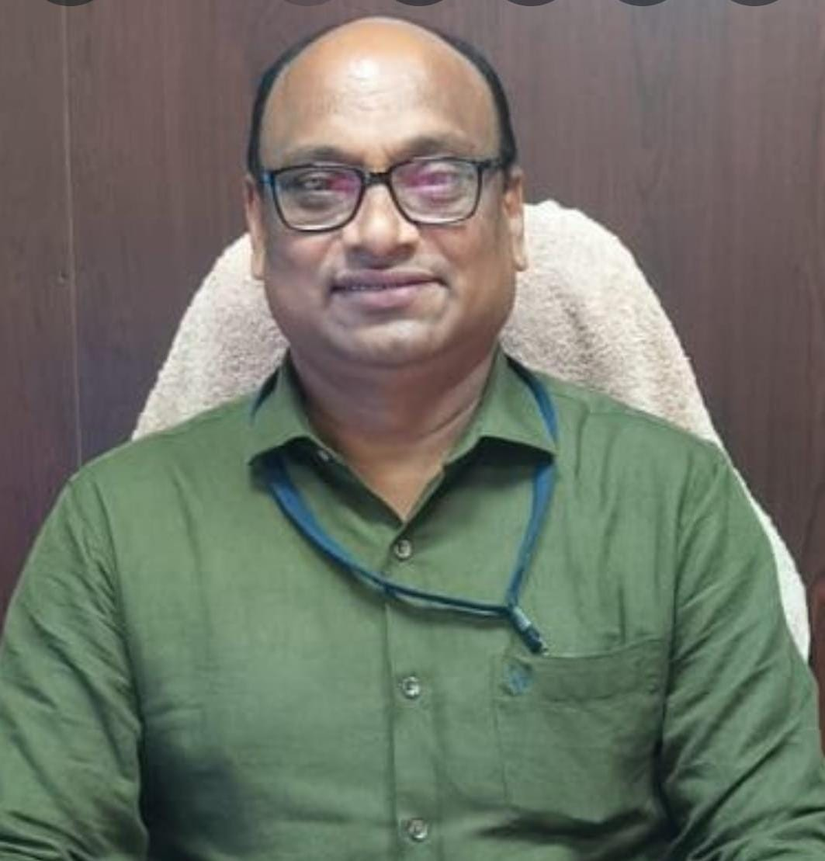

**The highest education is that which does not merely give us information but makes our life in harmony with all existence - Rabindranath Tagore.**

**We, at Gayatri Vidya Parishad College for Degree and P.G Courses strongly believe in this and hence focus on preparing intellectually trained, socially committed, morally up right individuals who would be the pillars of the society. The educational philosophy of our founders reflects in the Vision of the College – “creating human excellence for a better society” which underpins all the strategies and activities undertaken in the college.**

**The emphasis is on providing value based education and imparting necessary life skills for empowering our students lo lead a happy life. The rising graph of our results and the placement record over the years bear a testimony to the qualitative education provided by the College. The dedication, cooperation and concerted team work of the management, teaching as well as non-teaching staff and the students have helped the institution being recognized as a premier educational institution across the state.**

**Both physical and academic infrastructure is augmented regularly to keep pace with the growing size of the College and also the demands of higher education. No stone is left unturned to provide various opportunities for the students to realize their latent potential and convert them into their strengths. The faculty is motivated to continue their learning and enrich their academic and research capabilities.**

**Above all, Gayatri Vidya Parishad College for Degree and P.G courses enjoys the ambience of a large family, spreading its light and fragrance to the community around. As the Principal of this august institution, I seek the support of all stake holders in upholding the values of institution and delivering quality education.**

**Prof.K.S.Bose  
M.B.A,Ph.D  
I/C Principal**

**FOOTER-ABOUT-**[**Principal's Desk**](https://gvpcdpgc.edu.in/about/about_principal_desk.php)**:**

**Address: Gayatri Vidya Parishad College for Degree and P.G Courses(A),**

**Rushikonda, Visakhapatnam-530045, Andhra Pradesh.**

**Get In Touch:**

**mail principalgvpcdpgca@gmail.com**

**phone 0891-2955084**

**Working Hours:**

**Mon-Sat 10:00 AM-5:00 PM**

**phone 0891-2783722 (UG)**

**phone 0891-2955084 (PG)**

**phone 0891-2953719 (E&T)**

**College route map: photo**

**Follow Us: logo ( facebook, twitter, instagram,youtube)**

## **Sub Heading:** [**Director's Desk**](https://gvpcdpgc.edu.in/about/about_directorent_desk.php)

## **Sub-sub Heading:**[**Director Engineering & Technology**](https://gvpcdpgc.edu.in/about/about_directorent_desk.php)

**Director’s desk**

**The year 2011 marked the beginning of Engineering courses in Gayatri Vidya Parishad for Degree and PG Courses (A). This institution was created with an objective of providing an outstanding and holistic learning experience in education along with humanitarian aspects such as character building, leadership, extra and co-curricular activities. Gayatri Vidya Parishad is equipped with a very strong, dedicated and capable team of educators, who became the driving force in the growth of the institution.**

**We take pride in sharing that most of our students who graduated from the institution in 2015, 2016, 2017 and 2018 have acquired on-campus/off-campus jobs and accomplished awards/achievements in their respective organisations of work. Few graduates have completed/ joined higher institutions of learning in India and abroad and secured jobs. A couple of graduates have established own startup’s thus initiating a culture of entrepreneurship and innovative thinking. Along with their academic schedule students participate in hackathons, workshops and seminars by eminent persons from the industry to keep abreast of new technologies.**

**We also have NSS, NCC programs which help the present generation to stay disciplined and closely connected to the society.**

**I take this opportunity to ask all staff and students to take the most of this learning opportunity by investing time, hard work and dedication to keep up the quality and live up to the vision of the institution.**

##### Dr. P.V.Vinay

**I/C Director , Engineering & Technology Program**

**FOOTER-ABOUT-** [**Director Engineering & Technology**](https://gvpcdpgc.edu.in/about/about_directorent_desk.php)**:**

**Address: Gayatri Vidya Parishad College for Degree and P.G Courses(A),**

**Rushikonda, Visakhapatnam-530045, Andhra Pradesh.**

**Get In Touch:**

**mail principalgvpcdpgca@gmail.com**

**phone 0891-2955084**

**Working Hours:**

**Mon-Sat 10:00 AM-5:00 PM**

**phone 0891-2783722 (UG)**

**phone 0891-2955084 (PG)**

**phone 0891-2953719 (E&T)**

**College route map: photo**

**Follow Us: logo ( facebook, twitter, instagram,youtube)**

## **Sub-sub Heading:** [**Director UG Courses**](https://gvpcdpgc.edu.in/about/about_directorug_desk.php)

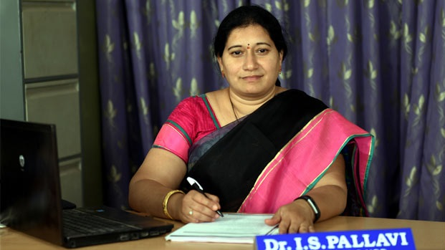

**As a Director of the , Gayatri Vidya Parishad College for Degree and PG. Courses(A), I have the privilege of working everyday with exceptional students, staff, and fellow faculty members to provide a rich educational experience unparalleled in scope and scale to any other program at this college. Everything we do is centered on our mission: *unfold in to a world class organization with strong academic and research base, producing responsible citizens to cater to the changing needs of the society***

**We at Gayatri Vidya Parishad College for Degree and PG. Courses(A) , strive to achieve the high degree of dynamism in different spheres of education. Preparing ourselves effectively requires a different dispensation. Preparing our students for life assumes top priority. It is very important to ensure that our students go beyond their individual competence and prepare for life. Developing a value system and integrity, acquiring social sensitivities, possessing cultural quotient assume a lot of importance, which will largely enable our students’ holistic development.**

**Our excellent crew of highly motivated faculty contributes effectively towards the vision of the college “Creating Human Excellence for a Better Society”. Achieving synergy between teaching and research, aiming for high levels of excellence make our campus more vibrant. We experience a highly rewarding and gratifying feeling when our students graduate from our institution in flying colours, who will effectively handle life and career.**

##### Dr. I. S .Pallavi

**Director, UG Courses**

**FOOTER-ABOUT-**[**Director UG Courses**](https://gvpcdpgc.edu.in/about/about_directorug_desk.php)**:**

**Address: Gayatri Vidya Parishad College for Degree and P.G Courses(A),**

**Rushikonda, Visakhapatnam-530045, Andhra Pradesh.**

**Get In Touch:**

**mail principalgvpcdpgca@gmail.com**

**phone 0891-2955084**

**Working Hours:**

**Mon-Sat 10:00 AM-5:00 PM**

**phone 0891-2783722 (UG)**

**phone 0891-2955084 (PG)**

**phone 0891-2953719 (E&T)**

**College route map: photo**

**Follow Us: logo ( facebook, twitter, instagram,youtube)**

## **Sub-sub Heading:** [**Director PG Courses**](https://gvpcdpgc.edu.in/about/about_directorpg_desk.php)



**As a Director of the , Gayatri Vidya Parishad College for Degree and PG. Courses(A), I have the privilege of working everyday with exceptional students, staff, and fellow faculty members to provide a rich educational experience unparalleled in scope and scale to any other program at this college. Everything we do is centered on our mission: *unfold in to a world class organization with strong academic and research base, producing responsible citizens to cater to the changing needs of the society***

**We at Gayatri Vidya Parishad College for Degree and PG. Courses(A) , strive to achieve the high degree of dynamism in different spheres of education. Preparing ourselves effectively requires a different dispensation. Preparing our students for life assumes top priority. It is very important to ensure that our students go beyond their individual competence and prepare for life. Developing a value system and integrity, acquiring social sensitivities, possessing cultural quotient assume a lot of importance, which will largely enable our students’ holistic development.**

**Our excellent crew of highly motivated faculty contributes effectively towards the vision of the college “Creating Human Excellence for a Better Society”. Achieving synergy between teaching and research, aiming for high levels of excellence make our campus more vibrant. We experience a highly rewarding and gratifying feeling when our students graduate from our institution in flying colours, who will effectively handle life and career.**

##### Prof B.S Bose

**Director, PG Courses**

**FOOTER-ABOUT-**[**Director PG Courses**](https://gvpcdpgc.edu.in/about/about_directorpg_desk.php)**:**

**Address: Gayatri Vidya Parishad College for Degree and P.G Courses(A),**

**Rushikonda, Visakhapatnam-530045, Andhra Pradesh.**

**Get In Touch:**

**mail principalgvpcdpgca@gmail.com**

**phone 0891-2955084**

**Working Hours:**

**Mon-Sat 10:00 AM-5:00 PM**

**phone 0891-2783722 (UG)**

**phone 0891-2955084 (PG)**

**phone 0891-2953719 (E&T)**

**College route map: photo**

**Follow Us: logo ( facebook, twitter, instagram,youtube)**

## **Sub Heading:** [**Administration**](https://gvpcdpgc.edu.in/about/about_administration.php)

#### College Administration

##### Members Present

| **S.No** | **Name** | **Designation** | **Phone no** | **Extension** | **E-mail** |
| --- | --- | --- | --- | --- | --- |
|  | **Prof. P. Srinivasa Rao**  **B.Tech. (Hons), M.Tech., Dr.Ing (Munich)** | **President** |  |  |  |
|  | **Prof.P.V Sarma** | **Secretary & Correspondent** | **0891-2950714** | **6301** | **secretarycorrespondent@gvpcdpgc.edu.in** |
|  | **Prof. S.Rajani**  **M.B.A, Ph.D** | **Principal** | **0891- 2955084/85** | **6307** | **rajani95s@gvpcdpgc.edu.in** |
|  | **Prof.D.Saritha** | **Vice - Principal** | **0891- 2955084/85** |  | **saritha@gvpcdpgc.edu.in** |
|  | **Mr. S. Seshagiri Kumar** | **Finance and Accounting** | **0891-2953719** | **370** | **kumarsampara@gvpcdpgc.edu.in** |

**FOOTER-ABOUT-**[**Administration**](https://gvpcdpgc.edu.in/about/about_administration.php) **:**

**Address: Gayatri Vidya Parishad College for Degree and P.G Courses(A),**

**Rushikonda, Visakhapatnam-530045, Andhra Pradesh.**

**Get In Touch:**

**mail principalgvpcdpgca@gmail.com**

**phone 0891-2955084**

**Working Hours:**

**Mon-Sat 10:00 AM-5:00 PM**

**phone 0891-2783722 (UG)**

**phone 0891-2955084 (PG)**

**phone 0891-2953719 (E&T)**

**College route map: photo**

**Follow Us: logo ( facebook, twitter, instagram,youtube)**

## **Sub Heading:** [**Academic Council**](https://gvpcdpgc.edu.in/about/about_academic_council.php)

#### Members of Academic Council

| **S.No** | **Name** | **Designation** |
| --- | --- | --- |
| **1** | **Prof. S. Rajani**  **Principal**  **Gayatri Vidya Parishad College for Degree and PG Courses** | **Chairperson** |
| **2** | **Prof. P. Srinivasa Rao**  **President**  **Gayatri Vidya Parishad** | **Special Invitee** |
| **3** | **Sri. D. Dakshina Murty**  **Vice President**  **Gayatri Vidya Parishad** | **Special Invitee** |
| **4** | **Prof. K.P.R. Sastry**  **Vice President**  **Gayatri Vidya Parishad** | **Special Invitee** |
| **5** | **Prof. P. Somaraju**  **Secretary**  **Gayatri Vidya Parishad** | **Special Invitee** |
| **6** | **Sri. V. R. K. S. Siva Prasad**  **Treasurer**  **Gayatri Vidya Parishad** | **Special Invitee** |
| **7** | **Prof. V.S.R.Krishna Prasad**  **Member**  **Gayatri Vidya Parishad** | **Special Invitee** |
| **8** | **Prof. P. V. Sarma**  **Member**  **Gayatri Vidya Parishad** | **Special Invitee** |
| **9** | **Prof. V.S.R.K. Prasad**  **Member**  **Gayatri Vidya Parishad** | **Special Invitee** |
| **10** | **Dr. B. Subba Rao**  **Member**  **Gayatri Vidya Parishad** | **Special Invitee** |

#### **ALL HEADS OF THE UG DEPARTMENTS**

| **S.No** | **Name** |
| --- | --- |
| **1** | **Dr. G. Vijaya Lakshmi**  **Head of the Department**  **Department of English**  **Gayatri Vidya Parishad College for Degree and PG Courses** |
| **2** | **Dr. U.V.S.S. Sastry**  **Head of the Department**  **Department of Telugu**  **Gayatri Vidya Parishad College for Degree and PG Courses** |
| **3** | **Dr. K. Anitha**  **Head of the Department**  **Department of Hindi**  **Gayatri Vidya Parishad College for Degree and PG Courses** |
| **4** | **Dr. V. Venkateswara Sarma**  **Head of the Department**  **Department of Sanskrit**  **Gayatri Vidya Parishad College for Degree and PG Courses** |
| **5** | **Sri. M.P.R. Murthy**  **Head of the Department**  **Department of Mathematics**  **Gayatri Vidya Parishad College for Degree and PG Courses** |
| **6** | **Dr. P.D. Lavanya**  **Head of the Department**  **Department of Physics**  **Gayatri Vidya Parishad College for Degree and PG Courses** |
| **7** | **Sri. K. Ravi Prasad**  **Head of the Department**  **Department of Chemistry**  **Gayatri Vidya Parishad College for Degree and PG Courses** |
| **8** | **Sri. K. Krishna Kumar**  **Head of the Department**  **Department of Computer Science**  **Gayatri Vidya Parishad College for Degree and PG Courses** |
| **9** | **Dr. D. Sridevi**  **Head of the Department**  **Department of Electronics**  **Gayatri Vidya Parishad College for Degree and PG Courses** |
| **10** | **Dr. P. Srinivasa Rao**  **Head of the Department**  **Department of Statistics**  **Gayatri Vidya Parishad College for Degree and PG Courses** |
| **11** | **Dr. L. Sujatha**  **Head of the Department**  **Department of Microbiology**  **Gayatri Vidya Parishad College for Degree and PG Courses** |
| **12** | **Dr. Hephzibah Rani Singh**  **Head of the Department**  **Department of Biotechnology**  **Gayatri Vidya Parishad College for Degree and PG Courses** |
| **13** | **Dr. Ilahi Shaik**  **Head of the Department**  **Department of Biochemistry**  **Gayatri Vidya Parishad College for Degree and PG Courses** |
| **14** | **Dr. G. Lakshmi Narayana**  **Head of the Department**  **Department of Environment Education**  **Gayatri Vidya Parishad College for Degree and PG Courses** |
| **15** | **Sri. K. Gowri Sankar**  **Head of the Department**  **Department of Commerce**  **Gayatri Vidya Parishad College for Degree and PG Courses** |
| **16** | **Prof. P.V.Mohini**  **Head of the Department**  **Department of B.B.A and B.B.A Digital marketing**  **Gayatri Vidya Parishad College for Degree and PG Courses** |
| **17** | **Sri. P. Venkata Rao**  **Head of the Department**  **Department of B.C.A& B.Sc Data Science**  **Gayatri Vidya Parishad College for Degree and PG Courses** |

#### **ALL HEADS OF THE PG DEPARTMENTS**

| **S.No** | **Name** |
| --- | --- |
| **1** | **Prof. K.S.Bose**  **Head of the Department**  **Department of M.B.A. and MBA Business Analytics**  **Gayatri Vidya Parishad College for Degree and PG Courses** |
| **2** | **Prof. I.S.Pallavi**  **Director**  **Department of M.C.A.**  **Gayatri Vidya Parishad College for Degree and PG Courses** |
| **3** | **Dr. A.V. Joga Rao**  **Head of the Department**  **Department of M.H.R.M**  **Gayatri Vidya Parishad College for Degree and PG Courses** |
| **4** | **Prof. I.S.Pallavi**  **Head of the Department**  **Department of M.Sc Computer Science**  **Gayatri Vidya Parishad College for Degree and PG Courses** |
| **5** | **Prof. P. Uma Devi**  **Head of the Department**  **Department of M.Sc Organic Chemistry**  **Gayatri Vidya Parishad College for Degree and PG Courses** |

#### **ALL HEADS OF THE B.TECH ENGINEERING AND TECHNOLOGY PROGRAMMES**

| **S.No** | **Name** |
| --- | --- |
| **1** | **Dr. S. Rajesh**  **Head of the Department**  **Department of Basic Sciences and Humanities**  **Gayatri Vidya Parishad College for Degree and PG Courses** |
| **2** | **Prof. P. Jyotsna Devi**  **Head of the Department**  **Department of Civil Engineering**  **Gayatri Vidya Parishad College for Degree and PG Courses** |
| **3** | **Prof. N.V.Ramana Murty**  **Head of the Department**  **Department of CSE and CSE (AI&ML)**  **Gayatri Vidya Parishad College for Degree and PG Courses** |
| **4** | **Dr. A. Nageswara Rao**  **Head of the Department**  **Department of ECE**  **Gayatri Vidya Parishad College for Degree and PG Courses** |
| **5** | **Dr. Ch. Himagireesh**  **Head of the Department**  **Department of Mechanical Engg**  **Gayatri Vidya Parishad College for Degree and PG Courses** |

#### **FACULTY OF THE M.TECH ENGINEERING AND TECHNOLOGY PROGRAMMES**

| **S.No** | **Name** |
| --- | --- |
| **1** | **Prof. P. Jyotsna Devi**  **Head of the Department**  **Department of Civil Engineering**  **Gayatri Vidya Parishad College for Degree and PG Courses** |
| **2** | **Prof. N.V.Ramana Murty**  **Head of the Department**  **Department of Computer Science and Technology (CST)**  **Gayatri Vidya Parishad College for Degree and PG Courses** |

#### **TEACHERS OF THE COLLEGE REPRESENTING DIFFERENT CATEGORIES**

| **S.No** | **Name** |
| --- | --- |
| **1** | **Prof. P.V.Vinay**  **I/c Director**  **Engineering & Technology Programs and Dean, Academic Affairs**  **Gayatri Vidya Parishad College for Degree and PG Courses** |
| **2** | **Dr. A. Anand**  **Director**  **UG Courses**  **Gayatri Vidya Parishad College for Degree and PG Courses** |
| **3** | **Dr. A. Sairoop**  **DEAN**  **Student Affairs**  **Gayatri Vidya Parishad College for Degree and PG Courses** |
| **4** | **Prof. K.V.V.Murali Someswara Rao**  **Controller of Examinations**  **Gayatri Vidya Parishad College for Degree and PG Courses** |
| **5** | **Sri. D. Giridhar**  **DEAN**  **Career Guidance and Training Placements**  **Gayatri Vidya Parishad College for Degree and PG Courses** |

#### **EXPERTS FROM OUTSIDE OF THE COLLEGE**

| **S.No** | **Name** |
| --- | --- |
| **1** | **Prof. V. Balamohan Das**  **Former Vice Chancellor**  **Acharya Nagarjuna University.** |
| **2** | **Dr. I. Vijaya Babu**  **Principal**  **Dr. V. S. Krishna Govt Degree College,** |
| **3** | **Mr. K. Nagesh**  **General Manager - HR**  **HPCL**  **Visakha Refinery, Visakhapatnam.** |
| **4** | **Mr. G. Prasad Reddy**  **Deputy General Manager**  **MSME, (Micro, Small & Medium Enterprises) Technology Centre**  **Visakhapatnam** |
| **5** | **Dr. Bijay Kumar Sahu**  **Sr. Manager & Officer Incharge**  **National Research Development Corporation**  **Madhurwada, Vishakhapatnam** |

#### **THREE NOMINEES OF THE UNIVERSITY**

| **S.No** | **Name** |
| --- | --- |
| **1** | **Prof. P. Shyamala**  **Dept of Chemistry**  **College of Science & Technology**  **Andhra University** |
| **2** | **Prof. PDN Srinivasu**  **Department of Mathematics**  **College of Science & Technology**  **Andhra University** |
| **3** | **Prof. G. Naga Raja**  **Department of Economics**  **College of Arts & Commerce**  **Andhra University** |

#### **MEMBER SECRETARY**

| **S.No** | **Name** |
| --- | --- |
| **1** | **Prof. P.V.Vinay,**  **I/c Director**  **Engineering & Technology Programs**  **Gayatri Vidya Parishad College for Degree and PG Courses(A)** |

**FOOTER-ABOUT-**[**Academic Council**](https://gvpcdpgc.edu.in/about/about_academic_council.php)**:**

**Address: Gayatri Vidya Parishad College for Degree and P.G Courses(A),**

**Rushikonda, Visakhapatnam-530045, Andhra Pradesh.**

**Get In Touch:**

**mail principalgvpcdpgca@gmail.com**

**phone 0891-2955084**

**Working Hours:**

**Mon-Sat 10:00 AM-5:00 PM**

**phone 0891-2783722 (UG)**

**phone 0891-2955084 (PG)**

**phone 0891-2953719 (E&T)**

**College route map: photo**

**Follow Us: logo ( facebook, twitter, instagram,youtube)**

## **Sub Heading:** [**Strategic Plan**](https://gvpcdpgc.edu.in/about/about_strategic_plan.php)

##### Strategic Plan

* Strategic Plan  [Click Here](https://gvpcdpgc.edu.in/about/Strategic_plan_website_new.pdf)
* Gvp Policies  [Click Here](https://gvpcdpgc.edu.in/about/GVP_Policies.pdf)

**FOOTER-ABOUT-**[**Strategic Plan**](https://gvpcdpgc.edu.in/about/about_strategic_plan.php) **:**

**Address: Gayatri Vidya Parishad College for Degree and P.G Courses(A),**

**Rushikonda, Visakhapatnam-530045, Andhra Pradesh.**

**Get In Touch:**

**mail principalgvpcdpgca@gmail.com**

**phone 0891-2955084**

**Working Hours:**

**Mon-Sat 10:00 AM-5:00 PM**

**phone 0891-2783722 (UG)**

**phone 0891-2955084 (PG)**

**phone 0891-2953719 (E&T)**

**College route map: photo**

**Follow Us: logo ( facebook, twitter, instagram,youtube)**

## **Sub Heading:** [**Organizational Structure**](https://gvpcdpgc.edu.in/about/about_organizational_structure.php)

##### Strategic Plan

* [**Organization Structure**](https://gvpcdpgc.edu.in/about/6.2.2_ORGANIZATION_STRUCTURE_website.pdf)

**FOOTER-ABOUT-**[**Organizational Structure**](https://gvpcdpgc.edu.in/about/about_organizational_structure.php)**:**

**Address: Gayatri Vidya Parishad College for Degree and P.G Courses(A),**

**Rushikonda, Visakhapatnam-530045, Andhra Pradesh.**

**Get In Touch:**

**mail principalgvpcdpgca@gmail.com**

**phone 0891-2955084**

**Working Hours:**

**Mon-Sat 10:00 AM-5:00 PM**

**phone 0891-2783722 (UG)**

**phone 0891-2955084 (PG)**

**phone 0891-2953719 (E&T)**

**College route map: photo**

**Follow Us: logo ( facebook, twitter, instagram,youtube)**

**Sub Heading:**[**Service Rules**](https://gvpcdpgc.edu.in/about/about_organizational_structure.php#)

##### Strategic Plan

* [**Organization Structure**](https://gvpcdpgc.edu.in/about/6.2.2_ORGANIZATION_STRUCTURE_website.pdf)

**FOOTER-ABOUT-**[**Service Rules**](https://gvpcdpgc.edu.in/about/about_organizational_structure.php#) **:**

**Address: Gayatri Vidya Parishad College for Degree and P.G Courses(A),**

**Rushikonda, Visakhapatnam-530045, Andhra Pradesh.**

**Get In Touch:**

**mail principalgvpcdpgca@gmail.com**

**phone 0891-2955084**

**Working Hours:**

**Mon-Sat 10:00 AM-5:00 PM**

**phone 0891-2783722 (UG)**

**phone 0891-2955084 (PG)**

**phone 0891-2953719 (E&T)**

**College route map: photo**

**Follow Us: logo ( facebook, twitter, instagram,youtube)**

**Sub Heading:** [**Committees**](https://gvpcdpgc.edu.in/about/about_committees.php)

### LIST OF COMMITTEES

1. [Academic Planning Committee](https://gvpcdpgc.edu.in/about/committee/2024/Academic_Planning_Committee.pdf)
2. [Training Placement Career Guidance Committee](https://gvpcdpgc.edu.in/about/committee/2024/Training_and_Placement,Career_Guidance_Committe.pdf)
3. [Research Development Committee](https://gvpcdpgc.edu.in/about/committee/2024/Research_and_Development_Committe.pdf)
4. [Library Committee](https://gvpcdpgc.edu.in/about/committee/2024/Library_Committe.pdf)
5. [Alumni Committee](https://gvpcdpgc.edu.in/about/committee/2024/Alumni_Committee.pdf)
6. [Capacity Building Among SC-ST Students](https://gvpcdpgc.edu.in/about/committee/2024/Committe_for_Capacity_Building.pdf)
7. [Grievance Redressal Committee](https://gvpcdpgc.edu.in/about/committee/2024/Greivence_Redressal_Committe.pdf)
8. [Internal Complaints Committee(ICC)](https://gvpcdpgc.edu.in/about/committee/2024/Internal_Complaints_Committe.pdf)
9. [IQAC Committee](https://gvpcdpgc.edu.in/about/committee/2024/IQAC_committee.pdf)
10. [Anti Ragging Committee](https://gvpcdpgc.edu.in/about/committee/2024/Anti_Ragging_Committe.pdf)
11. [IIC(Institution Innovation Council)](https://gvpcdpgc.edu.in/about/committee/2024/Institute_Innovation_Council.pdf)
12. [Finance Committee](https://gvpcdpgc.edu.in/about/committee/2024/Finance_Committee.pdf)
13. [Canteen Committee](https://gvpcdpgc.edu.in/about/committee/2024/Canteen_Committee.pdf)
14. [Minority Cell](https://gvpcdpgc.edu.in/about/committee/2024/Minority_Cell.pdf)
15. [OBC Cell](https://gvpcdpgc.edu.in/about/committee/2024/OBC_Cell.pdf)
16. [Intellectual Property Rights Cell](https://gvpcdpgc.edu.in/about/committee/2024/IPR_Cell.pdf)
17. [Sports Committee](https://gvpcdpgc.edu.in/about/committee/2024/Sports_Committe.pdf)
18. [Extension Activities Committee](https://gvpcdpgc.edu.in/about/committee/2024/Extension_Activities_Committe.pdf)
19. [Industry Institute Partnership Cell(IIPC) Committee](https://gvpcdpgc.edu.in/about/committee/2024/Industry_Institue_Partnership_Cell.pdf)
20. [Website Development and Maintainance Committee](https://gvpcdpgc.edu.in/about/committee/2024/Website_Committee.pdf)
21. [Entrepreneurship Committee](https://gvpcdpgc.edu.in/about/committee/2024/Entrepreurship_Development_Committee.pdf)
22. [Disciplinary Committee](https://gvpcdpgc.edu.in/about/committee/2024/Disciplinary_Committee.pdf)
23. [Academic Bank of Credits Committee](https://gvpcdpgc.edu.in/about/committee/2024/ABC_Committee.pdf)
24. [Literary and Cultural Committee](https://gvpcdpgc.edu.in/about/committee/2024/Literacy_and_Cultural.pdf)
25. [Admission Committee](https://gvpcdpgc.edu.in/about/committee/2024/admissions.pdf)
26. [Academic Audit Committee](https://gvpcdpgc.edu.in/about/committee/2024/IQAC.pdf)
27. [Examination Committee](https://gvpcdpgc.edu.in/about/committee/2024/Academic_Bank_of_Credits-Committe.pdf)
28. [IT Infrastructure Committee](https://gvpcdpgc.edu.in/about/committee/Infrastructure.pdf)

**FOOTER-ABOUT-**[**Committees**](https://gvpcdpgc.edu.in/about/about_committees.php)**:**

**Address: Gayatri Vidya Parishad College for Degree and P.G Courses(A),**

**Rushikonda, Visakhapatnam-530045, Andhra Pradesh.**

**Get In Touch:**

**mail principalgvpcdpgca@gmail.com**

**phone 0891-2955084**

**Working Hours:**

**Mon-Sat 10:00 AM-5:00 PM**

**phone 0891-2783722 (UG)**

**phone 0891-2955084 (PG)**

**phone 0891-2953719 (E&T)**

**College route map: photo**

**Follow Us: logo ( facebook, twitter, instagram,youtube**

**Administration:**

#### College Administration - Heading

##### Members Present - Sub heading

| **Photo** | **Name** | **Designation** | **Phone no** | **Extension** | **E-mail** |
| --- | --- | --- | --- | --- | --- |
|  | Prof.K.S.Bose  M.B.A, Ph.D | I/C Principal | 0891- 2955084/85 | 6307 | principal@gvpcdpgc.edu.in |
|  | Prof.D.Saritha | Vice - Principal | 0891- 2955084/85 |  | saritha@gvpcdpgc.edu.in |

**Directors**

| **Photo** | **Name** | **Designation** | **Phone no** | **Extension** | **E-mail** |
| --- | --- | --- | --- | --- | --- |
|  | Prof.K.S.Bose  M.B.A, Ph.D | Director-MBA | 0891- 2955084/85 | 6307 | ksbose@gvpcdpgc.edu.in |
|  | Prof. D. Giridhar | I/C Director - UG Courses |  |  | giridittakavi@gvpcdpgc.edu.in |
|  | Dr I .S. Pallavi | Director - MCA |  |  | ipallavi@gvpcdpgc.edu.in |
|  | Dr.A.V.Joga Rao | I/C Director - OPG |  |  | drvjrattota@gvpcdpgc.edu.in |
|  | Dr. P.V. Vinay | Incharge Director - E&T |  |  | vpragada@gvpcdpgc.edu.in |
|  | Dr. N.V.Ramana Murty | Director - Research & Development |  | 303 | drnvrmurty@gvpcdpgc.edu.in |
|  | Mr. P Venkata Krishna | Director - IIPC |  |  | venkatakrishna@gvpcdpgc.edu |
| **Deans** | | | | | |
| **Photo** | **Name** | **Designation** | **Phone no** | **Extension** | **E-mail** |
|  | Dr. K. V. V. Murali Someswara Rao | Dean - Academics |  |  | murali.koyyani@gvpcdpgc.edu.in |
|  | Dr. P. V. Mohini | Dean - Student Affairs |  |  | mohinipuni@gvpcdpgc.edu.in |
|  | Prof. D. Giridhar | Dean Career Guidance, Training & Placement |  |  | deanplacements@gvpcdpgc.edu.in |
| **Controller of Examinations** | | | | | |
| **Photo** | **Name** | **Designation** | **Phone no** | **Extension** | **E-mail** |
|  | Dr. A. Sairoop | Controller of Examinations |  |  | saiallena@gvpcdpgc.edu.in |
| **Head of the Departments - PG** | | | | | |
| **Photo** | **Name** | **Designation** | **Phone no** | **Extension** | **E-mail** |
|  | Dr. M.S.R. Seshagiri | HOD - MBA |  | 312 | seshagiri.msr@gvpcdpgc.edu.in |
|  | Dr. K. V. V. Murali Someswara Rao | HOD - MBA(Business Analytics) |  |  | murali.koyyani@gvpcdpgc.edu.in |
|  | Dr.Karteek Rao Amperayani | HOD - MSc Organic Chemistry |  | 346 | akarteekakrao@gvpcdpgc.edu.in |
|  | Dr.A.V.Joga Rao | HOD - MHRM |  | 358 | drvjrattota@gvpcdpgc.edu.in |
| **Head of the Departments - E&T** | | | | | |
| **Photo** | **Name** | **Designation** | **Phone no** | **Extension** | **E-mail** |
|  | Dr.S.Rajesh | HOD - Basic Sciences and Humanities |  | 390 | srajeshmaths@gvpcdpgc.edu.in |
|  | Dr. P. Jyotsna Devi | HOD - Civil Engineering |  | 386 | drjyotsnadevi@gvpcdpgc.edu.in |
|  | Dr.G.R.S Murthy | HOD - Computer Science & Engineering |  | 376 | murthy.grs@gvpcdpgc.edu.in |
|  | Dr. N.V. Ramana Murthy | HOD - CSE (Artificial Intelligence and Machine Learning) |  | 378 | drnvrmurty@gvpcdpgc.edu.in |
|  | Dr. P. A. Nageswara Rao | HOD - Electronics & Comunication Engineering |  | 381 | drnageswararao@gvpcdpgc.edu.in |
|  | Dr. Ch. Himagireesh | HOD - Mechanical Engineering |  | 388 | gireeshhima@gvpcdpgc.edu.in |
| Head of the Departemnts - UG | | | | | |
| **Photo** | **Name** | **Designation** | **Phone no** | **Extension** | **E-mail** |
|  | Dr. K.V. Nagaraj | HOD - BBA |  | 328 | nagaraj@gvpcdpgc.edu.in |
|  | P Ratna Pavani | HOD - BCA |  | 318 | ratnapavanip@gvpcdpgc.edu.in |
|  | Dr. V. Radhika | HOD - Mathematics |  |  | vradhika@gvpcdpgc.edu.in |
|  | Dr.P.D.Lavanya | HOD - Physics |  |  | drlavanya@gvpcdpgc.edu.in |
|  | Mr. K.Ravi Prasad | HOD - Chemistry |  |  | kallaraviprasad@gmail.com |
|  | Sri K.Krishna Kumar | HOD - Computer Science |  |  | kkrishna@gvpcdpgc.edu.in |
|  | Smt D.Sreedevi | HOD - Electronics |  |  | dsreedevi@gvpcdpgc.edu.in |
|  | Dr.P.Srinivasa Rao | HOD - Statistics |  |  | drsrinivasarao@gvpcdpgc.edu.in |
|  | Dr. L.Sujatha | HOD - Micro Biology |  |  | lsujatha@gvpcdpgc.edu.in |
|  | Dr.Hephzibah Rani Singh | HOD - Bio Technology |  |  | hephzibah@gvpcdpgc.edu.in |
|  | Dr. Ilahi Shaik | HOD - Bio Chemistry |  |  | ilahi@gvpcdpgc.edu.in |
|  | Dr D.S.S.N.Raju | HOD - B.Vocational |  |  | trijeth@gvpcdpgc.edu.in |
| **Coordinators** | | | | | |
| **Photo** | **Name** | **Designation** | **Phone no** | **Extension** | **E-mail** |
|  | Dr. Bh. Padma | IQAC |  |  | padmabh@gvpcdpgc.edu.in |
|  | Dr. K N Brahmaji Rao | IT Infrastructure & Website Development and Maintenance |  |  | brahmaji77@gvpcdpgc.edu.in |
|  | Dr. B. Vidya | Infrastructure |  |  | vidya@gvpcdpgc.edu.in |
|  | P Venkata Krishna | Finance Officer | 9063587140 |  | venkatakrishna@gvpcdpgc.edu |
|  | Mr. S. Seshagiri Kumar | Advisor, Administrative and Financial matters | 0891-2953719 | 370 | kumarsampara@gvpcdpgc.edu.in |

**FOOTER-Administration:**

**Address: Gayatri Vidya Parishad College for Degree and P.G Courses(A),**

**Rushikonda, Visakhapatnam-530045, Andhra Pradesh.**

**Get In Touch:**

**mail principalgvpcdpgca@gmail.com**

**phone 0891-2955084**

**Working Hours:**

**Mon-Sat 10:00 AM-5:00 PM**

**phone 0891-2783722 (UG)**

**phone 0891-2955084 (PG)**

**phone 0891-2953719 (E&T)**

**College route map: photo**

**Follow Us: logo ( facebook, twitter, instagram,youtube)**

### 

**Academics: -**

##### **Academic Calendar** :- Sub heading

1. Academic Calendar of All First Year Courses for AY 2023-2024[Click Here](https://www.gvpcdpgc.edu.in/academics/first_year_acad_calendar_2023-24.pdf)
2. Academic Calender for P.G and U.G Courses 2023-24 [Click Here](https://www.gvpcdpgc.edu.in/academics/Academic-Calendar_2023-24.pdf)
3. Academic Calender for P.G and U.G Courses 2022-23 [Click Here](https://www.gvpcdpgc.edu.in/academics/Academic_Calendar_22-23.pdf)
4. Academic Calendar of All First Year Courses for AY 2021-2022 [Click Her](https://www.gvpcdpgc.edu.in/academics/Academic_Calender_2020_2021_overall_20-12-2021-first_year_changed_17-03-22.pdf)
5. Academic Calendar for P.G and U.G Courses 2021-2022 [Click Here](https://www.gvpcdpgc.edu.in/academics/Academic_calendar_2021-2022.pdf)
6. Academic Calendar for P.G and U.G Courses 2020-2021 [Click Here](https://www.gvpcdpgc.edu.in/academics/Academic-Calendar-2020.pdf)
7. Academic Calendar for P.G and U.G Courses 2019-20 [Click Here](https://www.gvpcdpgc.edu.in/academics/Academic-Calendar-for-P.G-U.G-Courses_2019-20.pdf)
8. List of Holidays for P.G and U.G Courses 2019-20 [Click Here](https://www.gvpcdpgc.edu.in/academics/List-of-Holidays-for-P.G-and-U.G-Courses_2019-20.pdf)
9. Academic calendar and list of holidays Engineering & Technology Program- 2019-20 Even Semester [Click Here](https://www.gvpcdpgc.edu.in/academics/Academic-Calender-2019-20.pdf)

**FOOTER-Academics:**

**Address: Gayatri Vidya Parishad College for Degree and P.G Courses(A),**

**Rushikonda, Visakhapatnam-530045, Andhra Pradesh.**

**Get In Touch:**

**mail principalgvpcdpgca@gmail.com**

**phone 0891-2955084**

**Working Hours:**

**Mon-Sat 10:00 AM-5:00 PM**

**phone 0891-2783722 (UG)**

**phone 0891-2955084 (PG)**

**phone 0891-2953719 (E&T)**

**College route map: photo**

**Follow Us: logo ( facebook, twitter, instagram,youtube)**

##### [**Syllabus**](https://gvpcdpgc.edu.in/academics/academicsyllabi.php) :- Sub-sub heading

##### PostGraduate Programs

* **MBA - Master of Business Administration Syllabus** [**Click Here**](https://gvpcdpgc.edu.in/mba/mba_syllabus.php)
* **MCA- Master of Computer Applications Syllabus** [**Click Here**](https://gvpcdpgc.edu.in/academics/Final-Proposed%20Syllabus%20for%20MCA%5B2yrs%5D-2023-24%20admitted.pdf)
* **M.Sc. (Computer Science) Syllabus** [**Click Here**](https://gvpcdpgc.edu.in/academics/Final-Proposed%20Syllabus%20for%20M.Sc(CS)-2023-24%20batch.pdf)
* **MSc Organic Chemistry Syllabus** [**Click Here**](https://gvpcdpgc.edu.in/mscorganicchemistry/organic-chemistry_syllabus.php)
* **Master of Human Resource Management(MHRM) Syllabus** [**Click Here**](https://gvpcdpgc.edu.in/academics/MHRM.pdf)

##### U.G Engineering Programs

* **Engineering & Technology Civil Engineering Syllabus** [**Click Here**](https://gvpcdpgc.edu.in/civil/civil_syllabus.php)
* **Engineering & Technology Computer Science & Engineering Syllabus** [**Click Here**](https://gvpcdpgc.edu.in/cse/cse_syllabus.php)
* **Engineering & Technology Electronics and Communication Engineering Syllabus** [**Click Here**](https://gvpcdpgc.edu.in/ece/ece_syllabus.php)
* **Engineering & Technology Mechanical Engineering Syllabus** [**Click Here**](https://gvpcdpgc.edu.in/mech/mech_syllabus.php)

##### U.G Programs

* **B.Sc. Mathematics, Physics and Computer Science Syllabus** [**Click Here**](https://gvpcdpgc.edu.in/bscmpcs/bscmpcs_data/course_structureMathematics_Physics_and_Computer_Science.pdf)
* **B.Sc. Mathematics, Electronics and Computer Science Syllabus** [**Click Here**](https://gvpcdpgc.edu.in/bscmec/bscmec_data/course_structureMathematics_Electronics_and_Computer_Science.pdf)
* **B.Sc. Mathematics, Statistics and Computer Science Syllabus** [**Click Here**](https://gvpcdpgc.edu.in/bscmsc/bscmsc_data/course_structureMathematics_Statistics_and_Computer_Science.pdf)
* **B.Sc. Mathematics, Physics and Chemistry Syllabus** [**Click Here**](https://gvpcdpgc.edu.in/bscmpc/bscmpc_data/course_structureMathematics_Physics_and_Chemistry.pdf)
* **B.Sc. Microbiology, Biotechnology and Biochemistry Syllabus** [**Click Here**](https://gvpcdpgc.edu.in/bscbio/bscbio_data/course_structureMicrobiology-Biotechnology-Biochemistry.pdf)
* **Bachelor of Business Administration Syllabus** [**Click Here**](https://gvpcdpgc.edu.in/bba/.php)
* **Bachelor of Computer Applications Syllabus** [**Click Here**](https://gvpcdpgc.edu.in/academics/academicsyllabi.php#)
* **B.Com. (Computers) Syllabus** [**Click Here**](https://gvpcdpgc.edu.in/academics/academicsyllabi.php#)
* **B.Com. Syllabus** [**Click Here**](https://gvpcdpgc.edu.in/bcom/bcom_data/B.Com_coursestructure.pdf)
* **B.Vocational. Syllabus** [**Click Here**](https://gvpcdpgc.edu.in/bvoc/bvoc_data/bvoc_bos.pdf)

**FOOTER-Academics-**[**Syllabus**](https://gvpcdpgc.edu.in/academics/academicsyllabi.php)**:**

**Address: Gayatri Vidya Parishad College for Degree and P.G Courses(A),**

**Rushikonda, Visakhapatnam-530045, Andhra Pradesh.**

**Get In Touch:**

**mail principalgvpcdpgca@gmail.com**

**phone 0891-2955084**

**Working Hours:**

**Mon-Sat 10:00 AM-5:00 PM**

**phone 0891-2783722 (UG)**

**phone 0891-2955084 (PG)**

**phone 0891-2953719 (E&T)**

**College route map: photo**

**Follow Us: logo ( facebook, twitter, instagram,youtube)**

##### [**Regulations**](https://gvpcdpgc.edu.in/academics/regulations.php):- Sub-sub heading

##### Autonomous Regulation

* R19 Regulations [Click Here](https://gvpcdpgc.edu.in/academics/Regulations_B_Tech_Autonomous_2019-20.pdf)
* R20 Regulationsa [Click Here](https://gvpcdpgc.edu.in/academics/Regulations_B_Tech_Autonomous_2020-21.pdf)
* M.Tech R20 Regulationsa [Click Here](https://gvpcdpgc.edu.in/academics/Regulations_M_Tech_Autonomous_2020-21.pdf)

##### Non Autonomous Regulation

* Engineering & Technology Civil Engineering Syllabus [Click Here](https://gvpcdpgc.edu.in/academics/civil-academics)

**FOOTER-Academics-**[**Regulations**](https://gvpcdpgc.edu.in/academics/regulations.php)**:**

**Address: Gayatri Vidya Parishad College for Degree and P.G Courses(A),**

**Rushikonda, Visakhapatnam-530045, Andhra Pradesh.**

**Get In Touch:**

**mail principalgvpcdpgca@gmail.com**

**phone 0891-2955084**

**Working Hours:**

**Mon-Sat 10:00 AM-5:00 PM**

**phone 0891-2783722 (UG)**

**phone 0891-2955084 (PG)**

**phone 0891-2953719 (E&T)**

**College route map: photo**

**Follow Us: logo ( facebook, twitter, instagram,youtube)**

##### [**Archives**](https://gvpcdpgc.edu.in/academics/academic_arc.php):- Sub-sub heading

##### Archives

* Academic Calendar of P.G Courses 2018-19 [Click Here](https://www.gvpcdpgc.edu.in/wp-content/uploads/2018/12/academic-calendar-for-P.G.courses.pdf)
* List of Working days/ Holidays of P.G Courses [Click Here](https://www.gvpcdpgc.edu.in/wp-content/uploads/2018/12/list-of-working-holidays-of-P.G.cour_.ses_.pdf)
* Academic Calendar of U.G Courses 2018-19 [Click Here](https://www.gvpcdpgc.edu.in/wp-content/uploads/2018/12/academic-calendar-of-U.G.courses.pdf)
* List of Working days/ Holidays of U.G Courses [Click Here](https://www.gvpcdpgc.edu.in/wp-content/uploads/2018/12/list-of-working-holidays-of-U.G.cour_.ses_.pdf)
* Academic Calendar for Engineering & Technology 2016-17,2017-18,2018 -19 [Click Here](https://www.gvpcdpgc.edu.in/wp-content/uploads/2019/09/Academic-Calender-2019-20.pdf%22)
* Academic calendar and list of holidays Engineering & Technology Program- 2019 admitted autonomous batch [Click Here](https://www.gvpcdpgc.edu.in/wp-content/uploads/2019/09/Engineering-Academic-Calender-2019-20-for-autonomous-batch.pdf)

**FOOTER-Academics-**[**Archives**](https://gvpcdpgc.edu.in/academics/academic_arc.php)**:**

**Address: Gayatri Vidya Parishad College for Degree and P.G Courses(A),**

**Rushikonda, Visakhapatnam-530045, Andhra Pradesh.**

**Get In Touch:**

**mail principalgvpcdpgca@gmail.com**

**phone 0891-2955084**

**Working Hours:**

**Mon-Sat 10:00 AM-5:00 PM**

**phone 0891-2783722 (UG)**

**phone 0891-2955084 (PG)**

**phone 0891-2953719 (E&T)**

**College route map: photo**

**Follow Us: logo ( facebook, twitter, instagram,youtube)**

# **PROGRAMS:-**

**Programs**



**Engineering:-**



[**CIVIL ENGINEERING**](https://www.gvpcdpgc.edu.in/civil/aboutcivil.php)



[**COMPUTER SCIENCE & ENGINEERING**](https://gvpcdpgc.edu.in/cse/aboutcse.php)

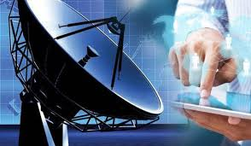

[**ELECTRONICS & COMMUNICATION ENGINEERING**](https://gvpcdpgc.edu.in/ece/aboutece.php)

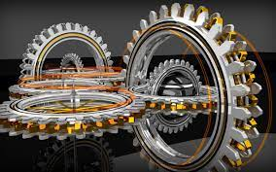

[**MECHANICAL ENGINEERING**](https://gvpcdpgc.edu.in/mech/aboutmech.php)



[**CSE - ARTIFICIAL INTELLIGENCE AND MACHINE LEARNING**](https://gvpcdpgc.edu.in/cse/aboutcse.php)



[**M.TECH STRUCTURAL ENGINEERING**](https://gvpcdpgc.edu.in/civil/aboutcivil.php)



[**M.TECH COMPUTER SCIENCE & TECHNOLOGY**](https://gvpcdpgc.edu.in/cse/aboutcse.php)

**FOOTER-Engineering:**

**Address: Gayatri Vidya Parishad College for Degree and P.G Courses(A),**

**Rushikonda, Visakhapatnam-530045, Andhra Pradesh.**

**Get In Touch:**

**mail principalgvpcdpgca@gmail.com**

**phone 0891-2955084**

**Working Hours:**

**Mon-Sat 10:00 AM-5:00 PM**

**phone 0891-2783722 (UG)**

**phone 0891-2955084 (PG)**

**phone 0891-2953719 (E&T)**

**College route map: photo**

**Follow Us: logo ( facebook, twitter, instagram,youtube)**

**CIVIL ENGINEERING:-**

**DEPARTMENT OF CIVIL ENGINEERING(Heading)**

**-> About Department-(sub-sub heading)**

**Department of Civil Engineering was started under Gayatri Vidya Parishad College for Degree & PG Courses during 2011. This department offers B.Tech in Civil Engineering course with a current intake of 60 students. The admission to the program is through EAPCET rankings.**

**M.Tech Structural Engineering course is introduced in the Department of Civil Engineering during the year 2020 with an intake of 18 students. The admission to the program is through PGECET/GATE rank.**

**Civil Engineering is a core engineering program which caters to the built environment needs of the common man. During the course of four years the students gain knowledge in design and construction of different types of buildings, bridges, roads, industries and irrigation projects. Apart from theoretical subjects the students work in Structural Engineering, Hydraulic Engineering and Material Testing laboratories to gain hands on experience.**

**Major Focus areas are Surveying, Structural Engineering, Fluid Mechanics, Geo-Technical Engineering, Environmental Engineering, Transportation Engineering, Remote sensing, GIS and Computer Aid Design (CAD).**

**About B.Tech Admission**

**EAPCET Counseling Code: GVPT**

**Admissions under Category "A" (Convener’s Quota-70% of intake in each branch):**

**A Candidate for admission to the four-year degree course in Engineering must have passed the Intermediate examination of the Board of Intermediate Education, Government of Andhra Pradesh with Mathematics, Physics and Chemistry as optional subjects. All the eligible applicants for admission into First Year shall have to qualify in the EAPCET Examination conducted by the Govt. of AP. The candidates will be admitted strictly in accordance with the merit secured at the Entrance Examination keeping in view the rules in force regarding the reservations of seats of various categories of candidates. The candidates should satisfy local/non-local status requirement as laid down in the AP Educational institutions (Regulation of Admissions) Order 1974 as amended from time to time.**

**Admissions under Category "B" (30% of intake in each branch):**

**The seats shall be filled as per the rules given by APSCHE.**

**About M.Tech Admission**

**PGECET/GATE Counseling Code: GVPT**

**A Candidate for admission to the two-year Post graduation course in Structural Engineering must have passed the B.Tech examination from the Recognized University as per AICTE. All the eligible applicants for admission into First Year shall have to qualify in the PGECET/GATE Examination conducted by respective exam boards. The candidates will be admitted strictly in accordance with the merit secured at the Entrance Examination keeping in view the rules in force regarding the reservations of seats of various categories of candidates.**

**FOOTER-Engineering-CIVIL ENGINEERING- About Department:**

**Address: Gayatri Vidya Parishad College for Degree and P.G Courses(A),**

**Rushikonda, Visakhapatnam-530045, Andhra Pradesh.**

**Get In Touch:**

**mail principalgvpcdpgca@gmail.com**

**phone 0891-2955084**

**Working Hours:**

**Mon-Sat 10:00 AM-5:00 PM**

**phone 0891-2783722 (UG)**

**phone 0891-2955084 (PG)**

**phone 0891-2953719 (E&T)**

**College route map: photo**

**Follow Us: logo ( facebook, twitter, instagram,youtube)**

**->** [**Vision & Mission \ PEOs \ PSOs \ POs**](https://gvpcdpgc.edu.in/civil/civil_vision.php)**-(sub-sub heading)**

**Vision**

**Empower civil engineers with high technical competence and social consciousness.**

**Mission**

**To inculcate fundamentals of Civil Engineering in design, construction and maintenance of projects at national and global level.**

**To excel in Design of economical and sustainable structures with due care for environment, public health and safety considering geo-technical bases and encourage in pursuing future careers.**

**To create conscientious engineers who would apply their knowledge critically and innovatively to solve professional and societal challenges.**

**Program Educational Objectives (PEOs)**

* **PEO1: IMPART: Application of Mathematical, physical, geotechnical, environmental, hydrological and structural knowledge for the formulation and framing of solution models in civil engineering.**
* **PEO2: COMPETENCE : Establish an understanding of theory and design practice in all disciplines of Civil Engineering.**
* **PEO3: DEVELOP: To enhance computer based knowledge for civil engineering applications and communication skills.**
* **PEO4: ADVANCE: Instill interest in lifelong learning and ethical thinking that cater the needs of the society .**

**Program Specific Outcomes (PSOs)**

* **PSO1: Graduates of Civil Engineering department should be able to identify, resolve and provide solutions for engineering problems.**
* **PSO2: Graduates should be able to communicate effectively, ue modern tools for cost-effective solutions and have environmental consciousness.**
* **PSO3: Develop engineers with ability to work in multidisciplinary environment and have interest in life long learning.**

**Program Outcomes (PSOs)**

* **Engineering knowledge: Apply the knowledge of mathematics, science, engineering fundamentals, and an engineering specialization to the solution of complex engineering problems.**
* **Problem analysis: Identify, formulate, review research literature, and analyze complex engineering problems reaching substantiated conclusions using first principles of mathematics, natural sciences, and engineering sciences.**
* **Design/Development of solutions: Design solutions for complex engineering problems and design system components or processes that meet the specified needs with appropriate consideration for the public health and safety, and the cultural, societal, and environmental considerations.**
* **Conduct investigations of complex problems: Use research-based knowledge and research methods including design of experiments, analysis and interpretation of data, and synthesis of the information to provide valid conclusions.**
* **Modern tool usage: Create, select, and apply appropriate techniques, resources, and modern engineering and IT tools including prediction and modeling to complex engineering activities with an understanding of the limitations.**
* **The engineer and society: Apply reasoning informed by the contextual knowledge to assess societal, health, safety, legal and cultural issues and the consequent responsibilities relevant to the professional engineering practice.**
* **Environment and sustainability: Understand the impact of the professional engineering solutions in societal and environmental contexts, and demonstrate the knowledge of, and need for sustainable development.**
* **Ethics: Apply ethical principles and commit to professional ethics and responsibilities and norms of the engineering practice.**
* **Individual and team work: Function effectively as an individual, and as a member or leader in diverse teams, and in multidisciplinary settings.**
* **Communication: Communicate effectively on complex engineering activities with the engineering community and with society at large, such as, being able to comprehend and write effective reports and design documentation, make effective presentations, and give and receive clear instructions.**
* **Project management and finance: Demonstrate knowledge and understanding of the engineering and management principles and apply these to one’s own work, as a member and leader in a team, to manage projects and in multidisciplinary environments.**
* **Life-long learning: Recognize the need for, and have the preparation and ability to engage in independent and life-long learning in the broadest context of technological change.**

**FOOTER-Engineering-CIVIL ENGINEERING-**[**Vision & Mission**](https://gvpcdpgc.edu.in/civil/civil_vision.php)**:**

**Address: Gayatri Vidya Parishad College for Degree and P.G Courses(A),**

**Rushikonda, Visakhapatnam-530045, Andhra Pradesh.**

**Get In Touch:**

**mail principalgvpcdpgca@gmail.com**

**phone 0891-2955084**

**Working Hours:**

**Mon-Sat 10:00 AM-5:00 PM**

**phone 0891-2783722 (UG)**

**phone 0891-2955084 (PG)**

**phone 0891-2953719 (E&T)**

**College route map: photo**

**Follow Us: logo ( facebook, twitter, instagram,youtube)**

**->**[**HOD's Message**](https://gvpcdpgc.edu.in/civil/civil_hod.php)**-(sub-sub heading)**

#### HOD's Message

<

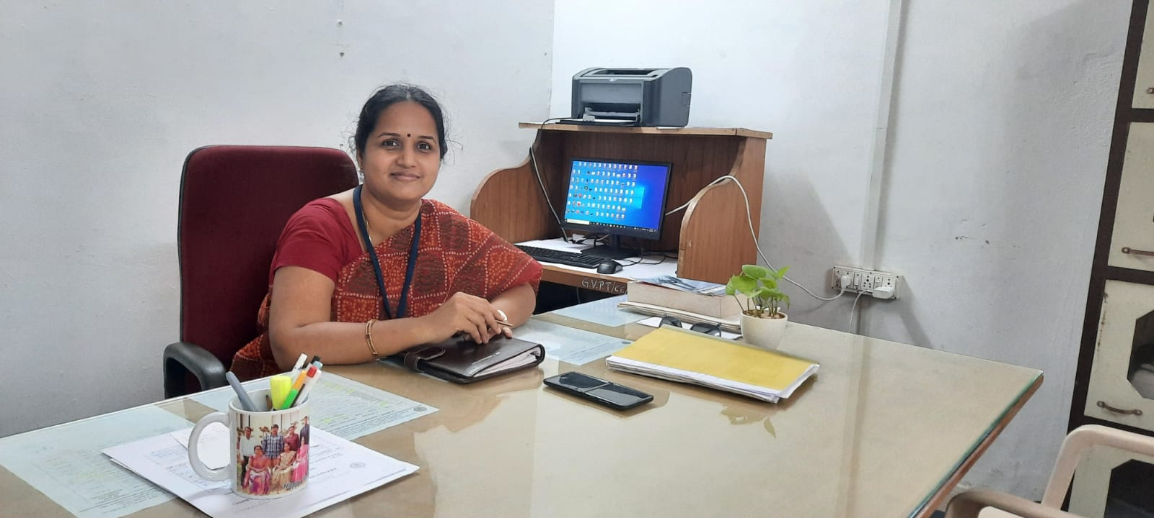

An affectionate welcome to the Civil Engineering discipline. Civil Engineering is considered to be the most versatile branch among all the engineering branches in the country. Being the oldest Engineering branch in the academic institutions in the world, it has a lot of diversity right from Geotechnical Engineering, Structural Engineering, Environmental Science, Transportation, Hydrology and Construction Engineering.

There are many career paths for civil engineers. Civil engineers are essential in government agencies, private and public sector undertakings to take up various mega projects like metro railway projects, express highway corridors, industrial structures, reservoir projects, flyovers, townships and mega city projects. Today, the world is undergoing vast changes in technological revolution, population growth and environmental concerns. All these changes create unique challenges for civil engineers.

Gayatri Vidya Parishad College for Degree and PG Courses (A) is one of the best engineering colleges in Visakhapatnam offering B.Tech and M.Tech in Civil Engineering. In our Department all the labs are well setup and equipped with mechanized equipment’s which includes Soil Mechanics Lab, Environmental Engineering Lab, Concrete Lab, Transportation Lab, Surveying Lab, strength of Materials Lab, Fluid Mechanics lab, Computer Aided Design & Drawing Lab. For better awareness and interest of student seminars, workshops and site visits are conducted at regular intervals thus students here are encouraged to engage extra-curricular and co-curricular activities which are essentials for personality development, nurturing of team spirit and development of organization skills.

Dr. P. Jyotsna Devi, **B.E, M. E, Ph. D,  
Professor & HOD.  
Contact: hodcivil@gvpcdpgc.edu.in**

**FOOTER-Engineering-CIVIL ENGINEERING-**[**HOD's Message**](https://gvpcdpgc.edu.in/civil/civil_hod.php)**:**

**Address: Gayatri Vidya Parishad College for Degree and P.G Courses(A),**

**Rushikonda, Visakhapatnam-530045, Andhra Pradesh.**

**Get In Touch:**

**mail principalgvpcdpgca@gmail.com**

**phone 0891-2955084**

**Working Hours:**

**Mon-Sat 10:00 AM-5:00 PM**

**phone 0891-2783722 (UG)**

**phone 0891-2955084 (PG)**

**phone 0891-2953719 (E&T)**

**College route map: photo**

**Follow Us: logo ( facebook, twitter, instagram,youtube)**

**->**[**Faculty**](https://gvpcdpgc.edu.in/civil/civil_faculty_list.php)**-(sub-sub heading)**

##### List of Faculty Members

|  | **Name-Designation-Qualification** | **Area-of-Specialization** | **E-mail** | **Date of Joining** | **Nature-of-Association** |
| --- | --- | --- | --- | --- | --- |
|  | [**Dr. P. Jyotsna Devi**](https://gvpcdpgc.edu.in/civil/civil_data/Jyotsna.pdf)  **Professor, & H.O.D,**  **B.E, M. E, Ph. D** | **Structural Engineering** | **drjyotsnadevi@gvpcdpgc.edu.in**  [**Profile**](https://gvpcdpgc.edu.in/civil/civil_data/Jyotsna.pdf) | **05-08-2016** | **Regular** |
|  | [**Dr. D. Manasa**](https://gvpcdpgc.edu.in/civil/Dr.D.Manasa.pdf)  **Professor ,**  **B.Tech, M. E, Ph. D** | **Structural Engineering** | **drmanasa@gvpcdpgc.edu.in**  [**Profile**](https://gvpcdpgc.edu.in/civil/civil_data/Dr_Manasa.pdf) | **01-01-2015** | **Regular** |
|  | [**Dr. B. Vidya**](https://gvpcdpgc.edu.in/civil/civil_data/VIDYA.pdf)  **Associate Professor,**  **B. E, M. E,.Ph. D** | **Structural Engineering** | **vidya@gvpcdpgc.edu.in**  [**Profile**](https://gvpcdpgc.edu.in/civil/civil_data/VIDYA.pdf) | **02-02-2015** | **Regular** |
|  | [**Smt. Vijaya L. Dittakavi**](https://gvpcdpgc.edu.in/civil/vijaya_cv.pdf)  **Sr. Assistant Professor,**  **B.Arch, MCRP** | **City and Regional Planning** | **vijaya@gvpcdpgc.edu.in**  [**Profile**](https://gvpcdpgc.edu.in/civil/civil_data/vijaya_cv.pdf) | **19-09-2018** | **Regular** |
|  | [**Smt. J. Renuka**](https://gvpcdpgc.edu.in/civil/civil_data/RENUKA.pdf)  **Assistant Professor,**  **B. Tech, M. E, MISTE** | **Structural Engineering** | **prenuka7@gvpcdpgc.edu.in**  [**Profile**](https://gvpcdpgc.edu.in/civil/civil_data/RENUKA.pdf) | **10-07-2014** | **Regular** |
|  | [**Mr. P. Manikanta**](https://gvpcdpgc.edu.in/civil/civil_data/MANIKANTA%20RESUME.pdf)  **Assistant Professor,**  **B.E, M.Tech** | **Structural Engineering** | **manikanta@gvpcdpgc.edu.in**  [**Profile**](https://gvpcdpgc.edu.in/civil/civil_data/MANIKANTA%20RESUME.pdf) | **02-11-2015** | **Regular** |
|  | [**Ms.G.Sravani**](https://gvpcdpgc.edu.in/civil/civil_data/SRAVANI%20RESUME.pdf)  **Assistant Professor,**  **B.E, M.Tech, AMIE** | **Soil Mechanics & Foundation Engineering** | **gsravani@gvpcdpgc.edu.in**  [**Profile**](https://gvpcdpgc.edu.in/civil/civil_data/sravani.pdf) | **01-09-2015** | **Regular** |
|  | [**Mrs.A. Satya Sunitha**](https://www.gvpcdpgc.edu.in/wp-content/uploads/2019/11/CIVIL/A_SATYA_SUNITHA.pdf)  **Assistant Professor,**  **B.Tech, M.E** | **Hydraulics, Coastal & Harbour Engineering** | **sunitha@gvpcdpgc.edu.in**  [**Profile**](https://gvpcdpgc.edu.in/civil/civil_data/Sunitha.pdf) | **01-07-2017** | **Regular** |
|  | [**Mr.Pinakana. Lakshman Rao**](https://gvpcdpgc.edu.in/civil/civil_data/p_laxman.pdf)  **Assistant Professor,**  **B.Tech, M.E** | **Water Resource Engineering** | **p_lakshmanrao@gvpcdpgc.edu.in**  [**Profile**](https://gvpcdpgc.edu.in/civil/civil_data/p_laxman.pdf) | **21-04-2021** | **Regular** |
|  | [**Dr.Sesha Ratnam Pasalapudi**](https://gvpcdpgc.edu.in/civil/civil_data/sesha%20Resume%202024.pdf)  **Assistant Professor,**  **B.Tech, M.E** | **Structural Engineering** | **sesharatnam@gvpcdpgc.edu.in**  [**Profile**](https://gvpcdpgc.edu.in/civil/civil_data/sesha%20Resume%202024.pdf) | **01-07-2017** | **Regular** |
|  | [**Mr. N. Manoj Kumar**](https://gvpcdpgc.edu.in/civil/civil_data/NMKRESUME.pdf)  **Assistant Professor,**  **B.Tech, M.Tech** | **Structural Engineering** | **manoj@gvpcdpgc.edu.in**  [**Profile**](https://gvpcdpgc.edu.in/civil/civil_data/NMKRESUME.pdf) | **01-01-2022** | **Regular** |
|  | [**Mrs. PASUMARTHI Pallavi**](https://gvpcdpgc.edu.in/civil/civil_data/pallaviresume.pdf)  **Assistant Professor,**  **B.Tech, M.Tech** | **Transportation Engineering** | **pallavipasumarthi@gvpcdpgc.edu.in**  [**Profile**](https://gvpcdpgc.edu.in/civil/civil_data/pallaviresume.pdf) | **21-01-2022** | **Regular** |
|  | [**Ms. S. Akhila**](https://gvpcdpgc.edu.in/civil/civil_data/RESUME_AKHILA.pdf)  **Assistant Professor,**  **B.Tech, M.Tech** | **Soil Mechanics and Foundation Engineering** | **akhila@gvpcdpgc.edu.in**  [**Profile**](https://gvpcdpgc.edu.in/civil/civil_data/RESUME_AKHILA.pdf) | **15-12-2022** | **Regular** |

**FOOTER-Engineering-CIVIL ENGINEERING-**[**Faculty**](https://gvpcdpgc.edu.in/civil/civil_faculty_list.php)**:**

**Address: Gayatri Vidya Parishad College for Degree and P.G Courses(A),**

**Rushikonda, Visakhapatnam-530045, Andhra Pradesh.**

**Get In Touch:**

**mail principalgvpcdpgca@gmail.com**

**phone 0891-2955084**

**Working Hours:**

**Mon-Sat 10:00 AM-5:00 PM**

**phone 0891-2783722 (UG)**

**phone 0891-2955084 (PG)**

**phone 0891-2953719 (E&T)**

**College route map: photo**

**Follow Us: logo ( facebook, twitter, instagram,youtube)**

**->**[**Syllabus**](https://gvpcdpgc.edu.in/civil/civil_syllabus.php)**-(sub-sub heading)**

##### M.Tech Syllabus

* **M.Tech Syllabus (With effect from 2020-2021 admitted batch) Autonomous** [**Click Here**](https://gvpcdpgc.edu.in/civil/civil_data/M.TechsyllabusGVPCDPGC.pdf)

##### B.Tech Syllabus

* **Civil Syllabus 1st YEAR R-22 (With effect from 2022-2023 admitted batch) Autonomous** [**Click Here**](https://gvpcdpgc.edu.in/civil/civil_data/R-22_1ST_YEAR_SYLLABUS.pdf)
* **Civil Syllabus 2nd YEAR R-22 (With effect from 2022-2023 admitted batch) Autonomous** [**Click Here**](https://gvpcdpgc.edu.in/civil/civil_data/R22_2nd_Year_Syllabus.pdf)
* **Civil Syllabus 4th YEAR R-20 (With effect from 2020-2021 admitted batch) Autonomous** [**Click Here**](https://gvpcdpgc.edu.in/civil/civil_data/R-20_4th_year_syllabus.pdf)
* **Civil Syllabus 3rd YEAR R-20 (With effect from 2020-2021 admitted batch) Autonomous** [**Click Here**](https://gvpcdpgc.edu.in/civil/civil_data/R-20_3RD_YEAR_SYLLABUS.pdf)
* **Civil Syllabus 2nd YEAR R-20 (With effect from 2020-2021 admitted batch) Autonomous** [**Click Here**](https://gvpcdpgc.edu.in/civil/civil_data/2Nnd%20year%20syllabusR-20.pdf)
* **Civil Syllabus First Year R-20(With effect from 2020-2021 admitted batch) Autonomous** [**Click Here**](https://gvpcdpgc.edu.in/civil/civil_data/Autonomous%20syllabus%20R20%20-%201st%20year.pdf)
* **Civil R-19 First Year Syllabus** [**Click Here**](https://gvpcdpgc.edu.in/civil/civil_data/Autonomous%20syllabus%20R19-%201st%20year.pdf)
* **Civil R-19 Second Year Syllabus** [**Click Here**](https://gvpcdpgc.edu.in/civil/civil_data/Autonomous%20syllabus%20R19%20-%202nd%20year.pdf)
* **Civil R-19 Third Year Syllabus** [**Click Here**](https://gvpcdpgc.edu.in/civil/civil_data/Autonomous%20syllabus%20R19%20-%203rd%20year.pdf)
* **Civil R-19 Fourth Year Syllabus** [**Click Here**](https://gvpcdpgc.edu.in/civil/civil_data/R19_IV_Year.pdf)
* **Civil AU syllabus 2nd to 4th year 2015-2016 onwards** [**Click Here**](https://gvpcdpgc.edu.in/civil/civil_data/AU%20syllabus%202nd%20to%204th%20year%202015-2016%20onwards.pdf)

**FOOTER-Engineering-CIVIL ENGINEERING-**[**Syllabus**](https://gvpcdpgc.edu.in/civil/civil_syllabus.php)**:**

**Address: Gayatri Vidya Parishad College for Degree and P.G Courses(A),**

**Rushikonda, Visakhapatnam-530045, Andhra Pradesh.**

**Get In Touch:**

**mail principalgvpcdpgca@gmail.com**

**phone 0891-2955084**

**Working Hours:**

**Mon-Sat 10:00 AM-5:00 PM**

**phone 0891-2783722 (UG)**

**phone 0891-2955084 (PG)**

**phone 0891-2953719 (E&T)**

**College route map: photo**

**Follow Us: logo ( facebook, twitter, instagram,youtube)**

**->**[**Academic Calender**](https://gvpcdpgc.edu.in/civil/civil_academic_cal.php)**-(sub-sub heading)**

##### Academic Calendar

* **Civil Academic calendar and list of holidays Engineering & Technology Program- 2023-24 admitted autonomous batch** [**Click Here**](https://gvpcdpgc.edu.in/civil/civil_data/2023-24_Even_Odd.pdf)
* **Civil Academic calendar and list of holidays Engineering & Technology Program- 2022-23 admitted autonomous batch** [**Click Here**](https://gvpcdpgc.edu.in/civil/civil_data/2022-23_even_odd.pdf)
* **Civil Academic calendar and list of holidays Engineering & Technology Program- 2021-22 admitted autonomous batch** [**Click Here**](https://gvpcdpgc.edu.in/civil/civil_data/2021-22_Odd_Even.pdf)
* **Civil Academic calendar and list of holidays Engineering & Technology Program- 2021 admitted autonomous batch** [**Click Here**](https://gvpcdpgc.edu.in/civil/civil_data/2020-21odd_semacademiccalender.pdf)
* **Civil Academic calendar and list of holidays Engineering & Technology Program- 2019 admitted autonomous batch**[**Click Here**](https://www.gvpcdpgc.edu.in/wp-content/uploads/2019/09/Engineering-Academic-Calender-2019-20-for-autonomous-batch.pdf)
* **Civil Academic Calendar for Academic Batch 2016-17,2017-18,2018 -19**[**Click Here**](https://www.gvpcdpgc.edu.in/wp-content/uploads/2019/09/Academic-Calender-2019-20.pdf%22)

##### TimeTables

* **Time Table-2020-2021-even-semester-cse** [**Click Here**](https://gvpcdpgc.edu.in/civil/civil_data/2ND_SEM_TIME%20TABLE_20-21.jpeg)
* **Time Table-2020-2021-odd-semester-cse** [**Click Here**](https://gvpcdpgc.edu.in/civil/civil_data/1ST_SEM_TIME_TABLE_20-21.pdf)
* **Time Table-2019-2020-even-semester-cse** [**Click Here**](https://gvpcdpgc.edu.in/civil/civil_data/2ND_SEM_TIME%20TABLE_2019-20.pdf)
* **Time Table-2019-2020-odd-semester-cse** [**Click Here**](https://gvpcdpgc.edu.in/civil/civil_data/1ST_SEM_TIME%20TABLE_2019-20.pdf)

**FOOTER-Engineering-CIVIL ENGINEERING-**[**Academic Calender**](https://gvpcdpgc.edu.in/civil/civil_academic_cal.php)**:**

**Address: Gayatri Vidya Parishad College for Degree and P.G Courses(A),**

**Rushikonda, Visakhapatnam-530045, Andhra Pradesh.**

**Get In Touch:**

**mail principalgvpcdpgca@gmail.com**

**phone 0891-2955084**

**Working Hours:**

**Mon-Sat 10:00 AM-5:00 PM**

**phone 0891-2783722 (UG)**

**phone 0891-2955084 (PG)**

**phone 0891-2953719 (E&T)**

**College route map: photo**

**Follow Us: logo ( facebook, twitter, instagram,youtube)**

**->**[**Infrastructure**](https://gvpcdpgc.edu.in/civil/civil_labs.php) **-(sub-sub heading)**

#### Labs Details

* Civil Department Labs List [**Click Here**](https://gvpcdpgc.edu.in/civil/civil_data/Civil-Labs-list.pdf)

#### **Labs Facilities**

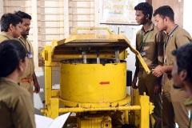

**CONCRETE LAB**

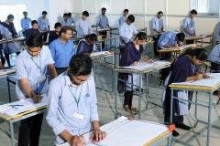

**DRAWING LAB**

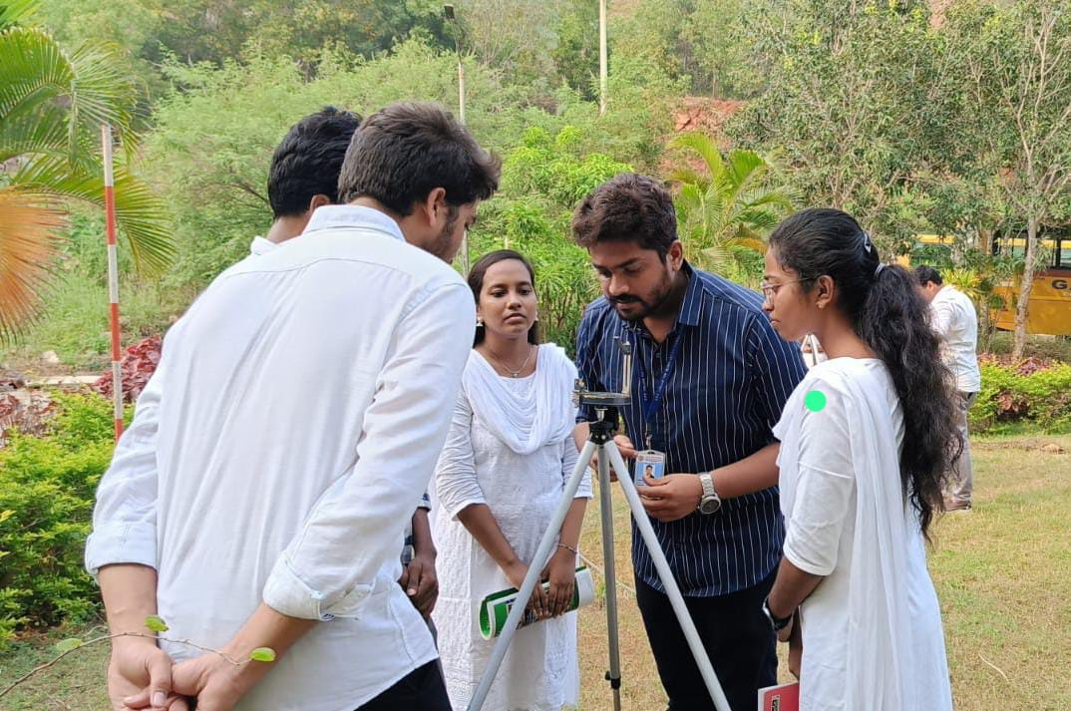

**SURVEY LAB**

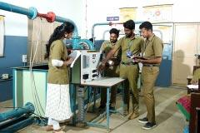

**FLUID MECHANICS LAB**

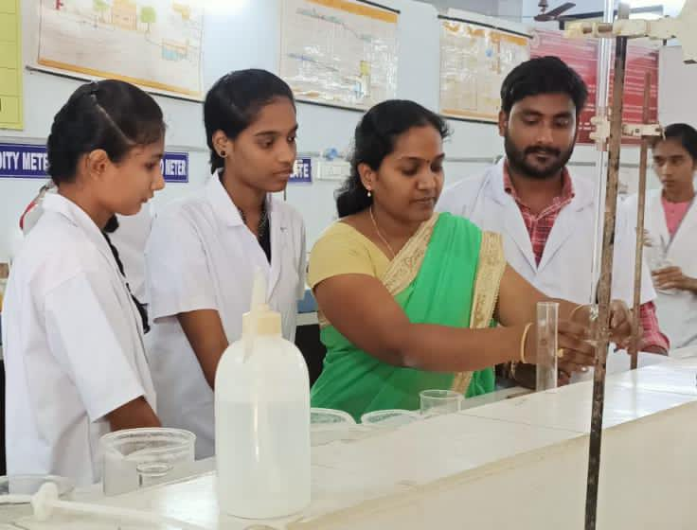

**ENVIRONMENTAL ENGG LAB**

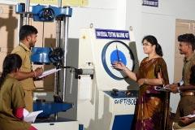

**STRENGTH OF MATERIALS LAB**

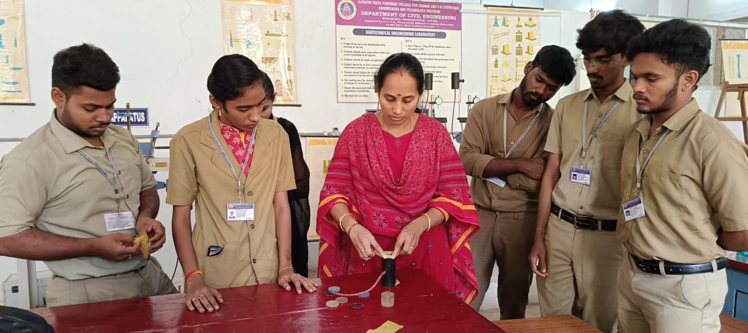

**GEOTECHNICAL ENGG LAB**

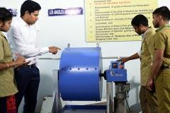

**TRANSPORTATION ENGG LAB**

**FOOTER-Engineering-CIVIL ENGINEERING-**[**Academic Calender**](https://gvpcdpgc.edu.in/civil/civil_academic_cal.php)**:**

**Address: Gayatri Vidya Parishad College for Degree and P.G Courses(A),**

**Rushikonda, Visakhapatnam-530045, Andhra Pradesh.**

**Get In Touch:**

**mail principalgvpcdpgca@gmail.com**

**phone 0891-2955084**

**Working Hours:**

**Mon-Sat 10:00 AM-5:00 PM**

**phone 0891-2783722 (UG)**

**phone 0891-2955084 (PG)**

**phone 0891-2953719 (E&T)**

**College route map: photo**

**Follow Us: logo ( facebook, twitter, instagram,youtube)**

**->**[**Department Committees**](https://gvpcdpgc.edu.in/civil/civil_dept_committe.php) **-(sub-sub heading)**

##### List of Departmantal Committees

**The purpose of the committee is to advise on how departmental leadership can be supported and enhanced in their administrative and faculty governance responsibilities. The committees work on all aspects of academic operations for the smooth functioning of the department.**

**De**[**partment**](https://gvpcdpgc.edu.in/civil/civil_dept_committe.php) **Academic** [**Committees**](https://gvpcdpgc.edu.in/civil/civil_dept_committe.php) **(DAC)**

**Objectives:**

**The DAC will have wide responsibility for oversight of all matters related to**

* **Student Admissions (Cat A, Cat B, ECET)**
* **Student Results Analysis (Regular, Supplementary)**
* **Time Tables**
* **Department Academic Calender and List of holidays**
* **Schedule of Events to be organised**
* **Examinations**
* **Professional Body Memberships and Activities**
* **Faculty Leave Status**
* **Any other Academic issues**

**Members:**

* **Dr. P. Jyotsna Devi (HoD & Chair)**
* **Mrs. A. Satya Sunitha (Member)**
* **Dr. D. Manasa (Member)**
* **Dr. P. Sesha Ratnam (Member)**

**De**[**partment**](https://gvpcdpgc.edu.in/civil/civil_dept_committe.php) **Class** [**Committees**](https://gvpcdpgc.edu.in/civil/civil_dept_committe.php) **(DCC)**

**Duties:**

* **Oversee class schedules and adjust time tables as needed**
* **Suggest Class discipline parameters**
* **Review and resolve Class/individual (faculty and student) discipline issues**
* **Suggest Student Counselling and PTM dates and times**

**Members:**

* **Dr. P. Jyotsna Devi (HoD & Chair)**
* **Mr. N. Manoj Kumar (Member)**

**De**[**partment**](https://gvpcdpgc.edu.in/civil/civil_dept_committe.php) **Project Review** [**Committees**](https://gvpcdpgc.edu.in/civil/civil_dept_committe.php) **(DCC)**

**Duties:**

* **Create Final year Project deadlines**
* **Conduct periodic project reviews**
* **Conduct Final Viva Voce and award grades**

**Members:**

* **Dr. P. Jyotsna Devi (HoD & Chair)**
* **Mrs. Vijaya L. Dittakavi (Coordinator)**

**De**[**partment**](https://gvpcdpgc.edu.in/civil/civil_dept_committe.php) **Placement** [**Committees**](https://gvpcdpgc.edu.in/civil/civil_dept_committe.php) **(DCC)**

**Objectives:**

* **To ensure placements to eligible students**
* **To ensure internship for all the students**
* **To develop skills by arranging various training programs**
* **Regular Field Visits**
* **Creating awareness among students towards importance of higher education**

**Members:**

* **Dr. P. Jyotsna Devi (HoD & Chair)**
* **Mr. P. Lakshman Rao (Coordinator)**
* **Mr. N. Manoj Kumar (Member)**

**FOOTER-Engineering-CIVIL ENGINEERING-**[**Department Committees**](https://gvpcdpgc.edu.in/civil/civil_dept_committe.php)**:**

**Address: Gayatri Vidya Parishad College for Degree and P.G Courses(A),**

**Rushikonda, Visakhapatnam-530045, Andhra Pradesh.**

**Get In Touch:**

**mail principalgvpcdpgca@gmail.com**

**phone 0891-2955084**

**Working Hours:**

**Mon-Sat 10:00 AM-5:00 PM**

**phone 0891-2783722 (UG)**

**phone 0891-2955084 (PG)**

**phone 0891-2953719 (E&T)**

**College route map: photo**

**Follow Us: logo ( facebook, twitter, instagram,youtube)**

**->**[**Placements**](https://gvpcdpgc.edu.in/civil/civil_placement.php)**-(sub-sub heading)**

##### Placements

* **Student Placements Details 2023-24**[**Click Here**](https://gvpcdpgc.edu.in/civil/civil_data/PLACEMENTS.jpg)
* **Student Placements Details** [**Click Here**](https://gvpcdpgc.edu.in/civil/civil_data/Placement%20data%20for%20year%20wise.pdf)
* **Student Placement Details 2019-23** [**Click Here**](https://gvpcdpgc.edu.in/civil/civil_data/RAja%20final.pdf)
* **Student Placement Details 2018-22** [**Click Here**](https://gvpcdpgc.edu.in/civil/civil_data/2018-22_Placements.JPG)

**FOOTER-Engineering-CIVIL ENGINEERING-**[**Placements**](https://gvpcdpgc.edu.in/civil/civil_placement.php)**:**

**Address: Gayatri Vidya Parishad College for Degree and P.G Courses(A),**

**Rushikonda, Visakhapatnam-530045, Andhra Pradesh.**

**Get In Touch:**

**mail principalgvpcdpgca@gmail.com**

**phone 0891-2955084**

**Working Hours:**

**Mon-Sat 10:00 AM-5:00 PM**

**phone 0891-2783722 (UG)**

**phone 0891-2955084 (PG)**

**phone 0891-2953719 (E&T)**

**College route map: photo**

**Follow Us: logo ( facebook, twitter, instagram,youtube)**

**->**[**Research & Innovations**](https://gvpcdpgc.edu.in/civil/civil_research.php)**-(sub-sub heading)**

#### Research

* CE List of publications in academic year 2023-2024 [**Click Here**](https://gvpcdpgc.edu.in/civil/civil_data/publications_2023-2024.pdf)
* **CE List of publications in academic year 2019-2023** [**Click Here**](https://gvpcdpgc.edu.in/civil/civil_data/publications_2019-2023.pdf)
* **CE List of publications in academic year 2015-2021** [**Click Here**](https://gvpcdpgc.edu.in/civil/civil_data/Research%20publications%202015-2021.pdf)

**FOOTER-Engineering-CIVIL ENGINEERING-**[**Research & Innovations**](https://gvpcdpgc.edu.in/civil/civil_research.php)**:**

**Address: Gayatri Vidya Parishad College for Degree and P.G Courses(A),**

**Rushikonda, Visakhapatnam-530045, Andhra Pradesh.**

**Get In Touch:**

**mail principalgvpcdpgca@gmail.com**

**phone 0891-2955084**

**Working Hours:**

**Mon-Sat 10:00 AM-5:00 PM**

**phone 0891-2783722 (UG)**

**phone 0891-2955084 (PG)**

**phone 0891-2953719 (E&T)**

**College route map: photo**

**Follow Us: logo ( facebook, twitter, instagram,youtube)**

**->**[**Activities**](https://gvpcdpgc.edu.in/civil/civil_facultyactivities.php)**-(sub-sub heading)**

**Faculty Activities**

* **List of FDP's/Workshop's Attended 2019-20, 2020-21, 2021-22 & 2022-23** [**Click Here**](https://gvpcdpgc.edu.in/civil/civil_data/fdp_23.pdf)

**Student Activities**

* **Students Seminars/Workshops- 2019-20, 2020-21, 2021-22 & 2022-23** [**Click Here**](https://gvpcdpgc.edu.in/civil/civil_data/2019-2023_activities.pdf)

**FOOTER-Engineering-CIVIL ENGINEERING-**[**Activities**](https://gvpcdpgc.edu.in/civil/civil_facultyactivities.php)**:**

**Address: Gayatri Vidya Parishad College for Degree and P.G Courses(A),**

**Rushikonda, Visakhapatnam-530045, Andhra Pradesh.**

**Get In Touch:**

**mail principalgvpcdpgca@gmail.com**

**phone 0891-2955084**

**Working Hours:**

**Mon-Sat 10:00 AM-5:00 PM**

**phone 0891-2783722 (UG)**

**phone 0891-2955084 (PG)**

**phone 0891-2953719 (E&T)**

**College route map: photo**

**Follow Us: logo ( facebook, twitter, instagram,youtube)**

[**COMPUTER SCIENCE & ENGINEERING**](https://gvpcdpgc.edu.in/cse/aboutcse.php)

**Sub Heading:** [**About Department**](https://gvpcdpgc.edu.in/cse/aboutcse.php)

**About Department**

**The Department of Computer Science and Engineering was started in the year 2011 in Engineering and Technology Program, Gayatri Vidya Parishad College for Degree & PG Courses (A). The Department offers B.Tech, Computer Science and Engineering program with a maximum intake of 60. MTech started in 2020-21 AY with an intake of 18. Recently from the Academic Year 2022-23 the intake of the Department is raised to 240 Seats (CSE 180 Seats and CSE AI & ML – 60 Seats). Computer Science and Engineering is the branch of Engineering in which the students trained in the science of practical and theoretical foundations of Information Technology and Computation. The students are exposed to sophisticated computer laboratories and latest trends in Computer Science and Engineering.**

**About B.Tech Admission**

**EAPCET Counseling Code: GVPT**

**Admissions under Category "A" (Convener’s Quota-70% of intake in each branch):**

**A Candidate for admission to the four-year degree program in Engineering must have passed the Intermediate examination of the Board of Intermediate Education, Government of Andhra Pradesh with Mathematics, Physics and Chemistry as optional subjects. All the eligible applicants for admission into First Year shall have to qualify in the EAPCET Examination conducted by the Govt. of AP. The candidates will be admitted strictly in accordance with the merit secured at the Entrance Examination keeping in view the rules in force regarding the reservations of seats of various categories of candidates. The candidates should satisfy local/non-local status requirement as laid down in the AP Educational institutions (Regulation of Admissions) Order 1974 as amended from time to time.**

**Admissions under Category "B" (30% of intake in each branch):**

**ECET Counseling Code: GVPT**

**The Engineering Diploma holders, based on their merit at ECET, are admitted into Lateral Entry (II year B. Tech Courses)**

**The seats shall be filled as per the rules given by APSCHE.**

**About M.Tech Program**

**MTech Computer Science & Technology Program started in the Academic Year 2020-21. It is a two - year Postgraduate program with four semesters. The main purpose behind crafting the M.Tech course is to equip students with the knowledge and abilities desirable to the modern computing industry. MTech in Computer Science & Technology have a wide range of job opportunities in sectors like Consultancy firms, IT companies, Corporate Industry, Multinational companies, Start ups, banking sectors etc.**

**M.Tech Admission Procedure :**

**A Candidate for admission to M.Tech Program by qualify in GATE/PGCET conducted by Govt. Total number of students Intake is 18 and Specialization is Computer Science & Technology.**

**FOOTER-Engineering-**[**COMPUTER SCIENCE & ENGINEERING**](https://gvpcdpgc.edu.in/cse/aboutcse.php)**-**[**About Department**](https://gvpcdpgc.edu.in/cse/aboutcse.php)**:**

**Address: Gayatri Vidya Parishad College for Degree and P.G Courses(A),**

**Rushikonda, Visakhapatnam-530045, Andhra Pradesh.**

**Get In Touch:**

**mail principalgvpcdpgca@gmail.com**

**phone 0891-2955084**

**Working Hours:**

**Mon-Sat 10:00 AM-5:00 PM**

**phone 0891-2783722 (UG)**

**phone 0891-2955084 (PG)**

**phone 0891-2953719 (E&T)**

**College route map: photo**

**Follow Us: logo ( facebook, twitter, instagram,youtube)**

**Sub-sub Heading:** [**Vision & Mission \ PEOs \ PSOs \ POs**](https://gvpcdpgc.edu.in/cse/cse_vision.php)

**Vision**

**The vision of the department is “Create and sustain as a Centre of excellence in Computer Science and Engineering and allied areas of research to pave the way for providing better technocrats to the society”.**

**Mission**

**The mission of the department is “To provide strong *conceptual base (M1)* for acquiring programming skills, to develop high *computational innovative skills (M2)* and to empower *leadership qualities* with strong *ethical base (M3)”*.**

#### **B.Tech:**

**Program Educational Objectives (PEOs)**

* **PEO1: Ability to develop hardware and software problem solving capabilities by inculcating strong fundamental, analytical, and communication skills.**
* **PEO2: Ability to build confidence to address the challenges in their work and to apply innovative technical tools through interaction with professional bodies.**
* **PEO3: Ability to gain sufficient depth of knowledge, Self-learning skills, technical skills and leadership qualities through participating in personality development activities, so as to sustain in multidisciplinary environment.**
* **PEO4: To be able to respond to societal needs in professional and ethical concerns.**

**Program Specific Outcomes (PSOs)**

* **PSO 1: System Inception and Elaboration: Conceptualize the software and/or hardware systems, system components and processes/procedures through requirement analysis, Modelling/Design of the system using various architectural/design patterns, Standard Notations, procedures and algorithms.**
* **PSO 2: System Construction: Implement the systems, Procedures and Processes using the state of the art technologies, standards, tools and Programming Paradigms.**
* **PSO 3: System Testing and Deployment: Verify and Validate the Systems, Procedures and Processes using various testing and verification techniques and tools.**
* **PSO 4: Quality and Maintenance: Manage the quality through various product development strategies under revision, transition and operation through maintainability, flexibility, testability, portability, reusability, interoperability, correctness, reliability, efficiency, integrity and usability to adapt the system to the changing structure and behavior of the systems/environments.**

**Program Outcomes (POs)**

* **Engineering knowledge: Apply the knowledge of mathematics, science, engineering fundamentals, and an engineering specialization to the solution of complex engineering problems.**
* **Problem analysis: Identify, formulate, review research literature, and analyze complex engineering problems reaching substantiated conclusions using first principles of mathematics, natural sciences, and engineering sciences.**
* **Design/development of solutions: Design solutions for complex engineering problems and design system components or processes that meet the specified needs with appropriate consideration for the public health and safety, and the cultural, societal, and environmental considerations.**
* **Conduct investigations of complex problems: Use research-based knowledge and research methods including design of experiments, analysis and interpretation of data, and synthesis of the information to provide valid conclusions.**
* **Modern tool usage: Create, select, and apply appropriate techniques, resources, and modern engineering and IT tools including prediction and modeling to complex engineering activities with an understanding of the limitations.**
* **The engineer and society: Apply reasoning informed by the contextual knowledge to assess societal, health, safety, legal and cultural issues and the consequent responsibilities relevant to the professional engineering practice.**
* **Environment and sustainability: Understand the impact of the professional engineering solutions in societal and environmental contexts, and demonstrate the knowledge of, and need for sustainable development.**
* **Ethics: Apply ethical principles and commit to professional ethics and responsibilities and norms of the engineering practice.**
* **Individual and team work: Function effectively as an individual, and as a member or leader in diverse teams, and in multidisciplinary settings.**
* **Communication: Communicate effectively on complex engineering activities with the engineering community and with society at large, such as, being able to comprehend and write effective reports and design documentation, make effective presentations, and give and receive clear instructions.**
* **Project management and finance: Demonstrate knowledge and understanding of the engineering and management principles and apply these to one’s own work, as a member and leader in a team, to manage projects and in multidisciplinary environments.**
* **Life-long learning: Recognize the need for, and have the preparation and ability to engage in independent and life-long learning in the broadest context of technological change.**

#### **M.Tech:**

**Program Educational Objectives (PEOs)**

* **PEO1: To motivate students in learning the advanced concepts to develop real world applications in the thrust areas of Computer Science and Technology.**
* **PEO2: To impart ethical practices in molding graduates to engage in research, leadership roles along diverse career paths and lifelong learning to adapt innovation.**

**Program Specific Outcomes (PSOs)**

* **PSO 1: Applying problem solving skills in a systematic way to Analyze software processes and employable in a product oriented Industry.**
* **PSO 2: Ability to publish research articles in the thrust areas of Computer Science and Technology in quality indexed journals.**

**Program Outcomes (POs)**

* **PO 1:An ability to independently carry out research /investigation and development work to solve practical problems.**
* **PO 2:An ability to write and present a substantial technical report/document.**
* **PO 3:Students should be able to demonstrate a degree of mastery over the area as per the specialization of the program. The mastery should be at a level higher than the requirements in the appropriate bachelor program.**

**FOOTER-Engineering-**[**COMPUTER SCIENCE & ENGINEERING**](https://gvpcdpgc.edu.in/cse/aboutcse.php)**-**[**Vision & Mission**](https://gvpcdpgc.edu.in/cse/cse_vision.php)**:**

**Address: Gayatri Vidya Parishad College for Degree and P.G Courses(A),**

**Rushikonda, Visakhapatnam-530045, Andhra Pradesh.**

**Get In Touch:**

**mail principalgvpcdpgca@gmail.com**

**phone 0891-2955084**

**Working Hours:**

**Mon-Sat 10:00 AM-5:00 PM**

**phone 0891-2783722 (UG)**

**phone 0891-2955084 (PG)**

**phone 0891-2953719 (E&T)**

**College route map: photo**

**Follow Us: logo ( facebook, twitter, instagram,youtube)**

**Sub-sub Heading:** [**HOD's Message**](https://gvpcdpgc.edu.in/cse/cse_hod.php)

#### HOD's Message

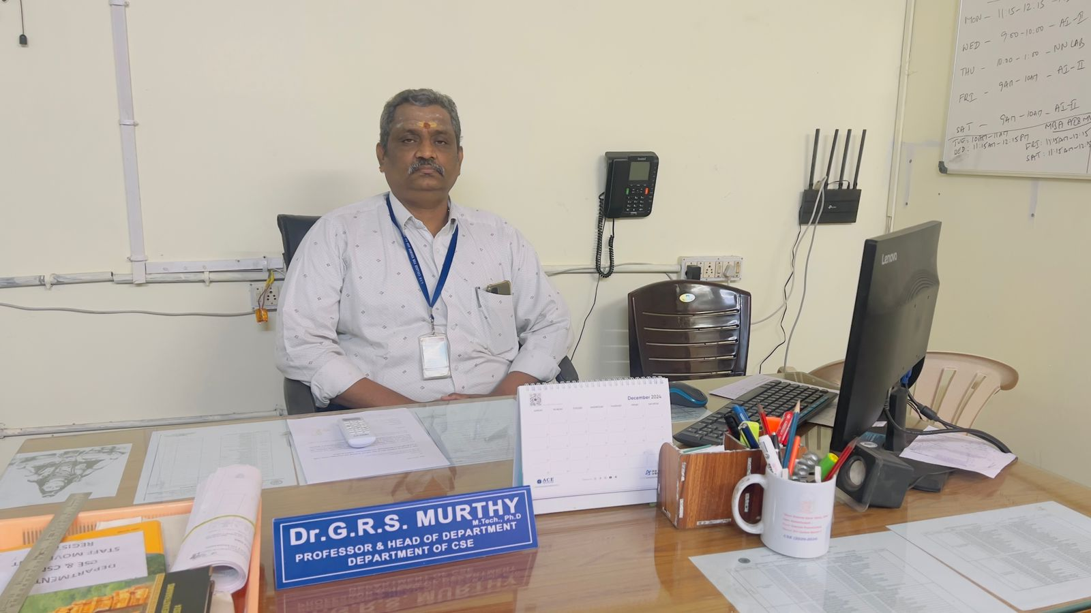

Careers in the field of Computer Science and Engineering undergo in very high demand, they offer not only the comforts of a high-paying job, but also the intellectual challenges of a creative and productive profession.

Welcome to Department of Computer Science and Engineering at Gayatri Vidya Parishad College for Degree and PG Courses. Our B.Tech and M.Tech Programs, which are at the forefront of technological advancements, are tailored to empower you with the necessary proficiencies to succeed in the ever-changing tech industry. The Department offers a regular four- year B. Tech in Computer Science and Engineering (CSE) course with an intake of 180 and M.Tech Computer Science & Technology with an intake of 12. Both B.Tech and M.Tech Programs are under the permanent affiliation of Andhra University.

Since 2011, the department is consistently striving hard to offer a high quality, state-of-the-art education in computer science and engineering with well-established laboratories suits to the Industry needs. The department is accredited by NBA and NAAC for its quality education and the institute is ISO certified. We are especially proud of the long and sustained placement records of our Bachelor students in various multinational software companies and our students are pursuing their higher education at different top-class international universities.

Here are some reasons that make CSE at Gayatri Vidya Parishad College exceptional: Curriculum Aligned with Industry Needs: Our curriculum is meticulously crafted to meet the current IT industry's requirements. We consistently revise our courses to ensure that you are proficient in the most pertinent programming languages, software development practices, and technical skills. Learn from Experts: Our faculty members are knowledgeable, dedicated, and many of them hold Ph.D.s. They are actively engaged in research, which allows them to bring current, real-world insights into the classroom. Practical Experience: We prioritize hands-on learning in addition to theoretical knowledge. Our program incorporates projects, labs, and internships where you'll create real-world software applications, solve intricate problems, and acquire the practical experience that employers seek. Collaboration with Industry: We narrow the gap between academia and industry by offering internships with leading companies. These opportunities enable you to apply your knowledge in practical settings and establish valuable professional connections. Dynamic Learning Opportunities: Improve your skills through various active learning avenues. Participate in coding competitions, hackathons, and student-led clubs like ACM (Association for Computing Machinery) to push your boundaries, collaborate with peers, and create an impressive technical portfolio. Innovation through Projects: Unlock your creativity by working on innovative projects under the guidance of our faculty. You'll address real-world issues in areas such as web development, mobile app creation, data science, and artificial intelligence. Stay Ahead of Tech Trends: Keep up-to-date with technological advancements through our workshops, guest lectures, and seminars featuring industry experts. These events will provide you with the latest trends and emerging technologies in computer science. Holistic Growth: We foster holistic development by encouraging participation in co-curricular and extracurricular activities to enhance your communication, teamwork, and leadership skills.

The Department of Computer Science and Engineering aims to create a Center of Excellence and prepare students to be skilled technologists and well-rounded individuals who positively impact society. This aligns with the college's mission of "Creating Human Excellence for a Better Society." The department believes a strong computer science foundation, critical thinking, and ethical practices empower graduates to be future leaders and innovators.

I welcome all the aspirants to be a part of CSE family and wish them a bright future!

Dr. G.R.S. Murthy,M. Tech, Ph. D

Professor & HOD  
Contact: hodcse@gvpcdpgc.edu.in

Predecessor: Dr.N.V.Ramana Murthy, Professor  
Duration: 01/07/2021 to 01/05/2024

Predecessor: Dr. T.M.N. Vamsi , Professor  
Duration: 11/01/2018 to 30/06/2021

**FOOTER-Engineering-**[**COMPUTER SCIENCE & ENGINEERING**](https://gvpcdpgc.edu.in/cse/aboutcse.php)**-**[**HOD's Message**](https://gvpcdpgc.edu.in/cse/cse_hod.php)**:**

**Address: Gayatri Vidya Parishad College for Degree and P.G Courses(A),**

**Rushikonda, Visakhapatnam-530045, Andhra Pradesh.**

**Get In Touch:**

**mail principalgvpcdpgca@gmail.com**

**phone 0891-2955084**

**Working Hours:**

**Mon-Sat 10:00 AM-5:00 PM**

**phone 0891-2783722 (UG)**

**phone 0891-2955084 (PG)**

**phone 0891-2953719 (E&T)**

**College route map: photo**

**Follow Us: logo ( facebook, twitter, instagram,youtube)**

**Sub-sub Heading:** [**Faculty**](https://gvpcdpgc.edu.in/cse/cse_faculty_list.php)

##### List of Faculty Members

|  | **Name-Designation-Qualification** | **Area-of-Specialization** | **E-mail** | **Date of Joining** | **Nature-of-Association** |
| --- | --- | --- | --- | --- | --- |
|  | [**Prof. D. Saritha**](https://gvpcdpgc.edu.in/cse/cse_data/saritha.pdf)  **Vice - Principal**  **B.E, M.Tech** | **Databases & Data Mining** | **sarithad@gvpcdpgc.edu.in**  [**Profile**](https://gvpcdpgc.edu.in/cse/cse_data/saritha.pdf) | **01-07-1995** | **Regular** |
|  | [**Dr. N.V. Ramana Murthy**](https://gvpcdpgc.edu.in/cse/cse_data/Dr.N.V.Ramana_Murty.pdf)  **Professor & H.O.D (CSE(AI&ML))**  **M. Tech, Ph. D** | **Artificial Intelligence & Robotics,**  **Machine Learning** | **drnvrmurty@gvpcdpgc.edu.in.edu.in**  [**Profile**](https://gvpcdpgc.edu.in/cse/cse_data/Dr.N%20V%20RAMANA%20MURTY%20latest%20RESUME.pdf) | **19-06-2004** | **Regular** |
|  | **Dr.G.R.S Murthy**  **Professor & H.O.D (CSE)**  **M.Tech,Ph.D** | **Computer Vision** | **murthy.grs@gvpcdpgc.edu.in**  [**Profile**](https://gvpcdpgc.edu.in/cse/cse_data/Dr.GRS_Murthy_CV.pdf) | **27-04-2021** | **Regular** |
|  | [**Dr. Bh. Padma**](https://gvpcdpgc.edu.in/cse/cse_data/Bh_Padma.pdf)  **Associate Professor**  **M.Tech ,Ph.D** | **Cryptography and Network Security** | **padmabh@gvpcdpgc.edu.in**  [**Profile**](https://gvpcdpgc.edu.in/cse/cse_data/BhP-profile%20by%20Aug%202021.pdf) | **22-08-2005** | **Regular** |
|  | [**Dr. D Chandravathi**](https://gvpcdpgc.edu.in/cse/cse_faculty_list.php#)  **Associate Professor**  **M.Tech,Ph.D** | **Cloud Security** | **chandravathid@gvpcdpgc.edu.in**  [**Profile**](https://gvpcdpgc.edu.in/mca/.pdf) | **30-09-2022** | **Regular** |
|  | [**Dr. K N Brahmaji Rao**](https://gvpcdpgc.edu.in/cse/cse_faculty_list.php#)  **Associate Professor**  **M.Tech,Ph.D** | **Aritificial Intelligence** | **brahmaji77@gvpcdpgc.edu.in**  [**Profile**](https://gvpcdpgc.edu.in/mca/.pdf) | **01-07-2023** | **Regular** |
|  | [**Dr D.S.S.N.Raju**](https://gvpcdpgc.edu.in/cse/cse_faculty_list.php#)  **Assistant Professor,**  **Ph.D** | **Wireless Sensor Networks, VLSI** | **trijeth@gvpcdpgc.edu.in**  [**Profile**](https://gvpcdpgc.edu.in/cse/cse_faculty_list.php#) | **30-09-2022** | **Regular** |
|  | [**Sri. G. Kalyan Chakravarthi**](https://gvpcdpgc.edu.in/cse/cse_data/G_Kalyan_Chakravarthi.pdf)  **Assistant Professor,**  **B. Tech, M. Tech** | **Computer Science & Technology** | **gkalyan@gvpcdpgc.edu.in**  [**Profile**](https://gvpcdpgc.edu.in/cse/cse_data/G_Kalyan.pdf) | **25-11-2016** | **Regular** |
|  | **Sri R.Kanaka Raju**  **Assistant Professor,**  **M.Tech** | **BIG DATA** | **rkanakaraju@gvpcdpgc.edu.in**  [**Profile**](https://gvpcdpgc.edu.in/cse/cse_faculty_list.php#) | **15-12-2022** | **Regular** |
|  | **Smt L.Pratibha**  **Assistant Professor,**  **M.C.A., M.Tech.** | **MACHINE LEARNING** | **pratibha@gvpcdpgc.edu.in**  [**Profile**](https://gvpcdpgc.edu.in/cse/cse_faculty_list.php#) | **15-04-2023** | **Regular** |
|  | **Mr. M. Anil**  **Assistant Professor,**  **B. Tech, M. Tech** | **Computer Science and Engineering** | **anilmeka@gvpcdpgc.edu.in**  [**Profile**](https://gvpcdpgc.edu.in/cse/cse_data/resumeanil.pdf) | **05-01-2022** | **Regular** |
|  | **Mr. S. Arun Kumar**  **Assistant Professor,**  **B. Tech, M. Tech** | **Computer Science and Technology** | **arunkumar@gvpcdpgc.edu.in**  [**Profile**](https://gvpcdpgc.edu.in/cse/cse_faculty_list.php#) | **15-12-2022** | **Regular** |
|  | **Ms. D M V Priya**  **Assistant Professor,**  **B. Tech, M. Tech** | **Artificial Intelligence and Robotics** | **priya@gvpcdpgc.edu.in**  [**Profile**](https://gvpcdpgc.edu.in/cse/cse_data/priya_resume.pdf) | **05-06-2023** | **Regular** |
|  | **Mr Ch.Bhanu Kumar**  **Assistant Professor,**  **B. Tech, M. Tech** | **Computer Science and Technology** | **bhanu.chappa@gvpcdpgc.edu.in**  [**Profile**](https://gvpcdpgc.edu.in/cse/cse_data/) | **01-12-2023** | **Regular** |

**FOOTER-Engineering-**[**COMPUTER SCIENCE & ENGINEERING**](https://gvpcdpgc.edu.in/cse/aboutcse.php)**-**[**Faculty**](https://gvpcdpgc.edu.in/cse/cse_faculty_list.php)**:**

**Address: Gayatri Vidya Parishad College for Degree and P.G Courses(A),**

**Rushikonda, Visakhapatnam-530045, Andhra Pradesh.**

**Get In Touch:**

**mail principalgvpcdpgca@gmail.com**

**phone 0891-2955084**

**Working Hours:**

**Mon-Sat 10:00 AM-5:00 PM**

**phone 0891-2783722 (UG)**

**phone 0891-2955084 (PG)**

**phone 0891-2953719 (E&T)**

**College route map: photo**

**Follow Us: logo ( facebook, twitter, instagram,youtube)**

**Sub-sub Heading:** [**Syllabus**](https://gvpcdpgc.edu.in/cse/cse_syllabus.php)

#### M.Tech Syllabus

* M.Tech Syllabus (With effect from 2020-2021 admitted batch) Autonomous [**Click Here**](https://drive.google.com/file/d/1tfqPbcJM35LyXSObm0_COhKvL67R_Ng8/view?usp=sharing)

#### B.Tech Syllabus

* B.TECH CSE-AIML R22 Regulation (From admitted batch 2022-2023)**B.Tech CSE-AIML R22 First Year and Second Year Syllabus (With effect from 2022-2023 admitted batch) Autonomous** [**Click Here**](https://gvpcdpgc.edu.in/cse/cse_data/R22_B.Tech_CSE_AI&ML_Structure_and_Syllabus.pdf)
* B.TECH CSE R22 Regulation (From admitted batch 2022-2023)**B.Tech CSE R22 First Year and Second Year Syllabus (With effect from 2022-2023 admitted batch) Autonomous** [**Click Here**](https://gvpcdpgc.edu.in/cse/cse_data/R22_B.Tech_CSE_Structure_and_Syllabus.pdf)
* B.TECH CSE R20 Regulation (From admitted batch 2020-2021)**B.Tech CSE R20 Syllabus(With effect from 2020-2021 admitted batch) Autonomous** [**Click Here**](https://gvpcdpgc.edu.in/cse/cse_data/B.Tech_CSE_R20_Syllabus.pdf)
* B.TECH CSE R19 Regulation (From admitted batch 2019-2020)**B.Tech CSE R19 Syllabus (With effect from 2019-2020 admitted batch) Autonomous** [**Click Here**](https://gvpcdpgc.edu.in/cse/cse_data/B.Tech_CSE_R19_Syllabus.pdf)
* B.TECH CSE AU Syllabus (From admitted batch 2015-2016)**CSE Syllabus (With effect from 2015-2016 admitted batch to 2018-19)** [**Click Here**](https://gvpcdpgc.edu.in/cse/cse_data/BTech_CSE_Syllabus_and_Schemes_2016-17.pdf)

**FOOTER-Engineering-**[**COMPUTER SCIENCE & ENGINEERING**](https://gvpcdpgc.edu.in/cse/aboutcse.php)**-** [**Syllabus**](https://gvpcdpgc.edu.in/cse/cse_syllabus.php) **:**

**Address: Gayatri Vidya Parishad College for Degree and P.G Courses(A),**

**Rushikonda, Visakhapatnam-530045, Andhra Pradesh.**

**Get In Touch:**

**mail principalgvpcdpgca@gmail.com**

**phone 0891-2955084**

**Working Hours:**

**Mon-Sat 10:00 AM-5:00 PM**

**phone 0891-2783722 (UG)**

**phone 0891-2955084 (PG)**

**phone 0891-2953719 (E&T)**

**College route map: photo**

**Follow Us: logo ( facebook, twitter, instagram,youtube)**

**Sub-sub Heading:** [**Academic Calendar and Class Time Tables**](https://gvpcdpgc.edu.in/cse/cse_academic_cal.php)

##### Academic Calendar

* **Academic Calendar for Academic Batch 2023-24**  [**Click Here**](https://gvpcdpgc.edu.in/cse/cse_data/DEPARTMENT%20CALENDAR%202023-2024.pdf)
* **Academic Calendar for Academic Batch 2022-23**  [**Click Here**](https://gvpcdpgc.edu.in/cse/cse_data/DEPARTMENT%20CALENDAR%202022-2023.pdf)
* **Academic Calendar for Academic Batch 2021-22**  [**Click Here**](https://gvpcdpgc.edu.in/cse/cse_data/DEPARTMENT_CALENDAR_2021-2022.pdf)
* **Academic Calendar for Academic Batch 2020-21**  [**Click Here**](https://gvpcdpgc.edu.in/cse/cse_data/academic_cal_202_21.pdf)
* **Academic Calendar for Academic Batch 2019-20 Even Semester** [**Click Here**](https://gvpcdpgc.edu.in/cse/cse_data/2019-20%20Even%20SEM%20Academic%20Calendar.pdf)
* **Academic Calendar for Academic Batch 2019-20 Odd Semester** [**Click Here**](https://gvpcdpgc.edu.in/cse/cse_data/2019-20%20Even%20SEM%20Academic%20Calendar.pdf)
* **Academic Calendar for Academic Batch 2018-19 Even Semester** [**Click Here**](https://gvpcdpgc.edu.in/cse/cse_data/Department_Calendar_2018-19_even_semester.pdf)
* **Academic Calendar for Academic Batch 2018-19 Odd Semester** [**Click Here**](https://gvpcdpgc.edu.in/cse/cse_data/DEPARTMENT_CALENDER_2018-19_Odd_Semester.pdf)

##### TimeTables

* **Time Table-2023-2024-odd-semester-csm** [**Click Here**](https://gvpcdpgc.edu.in/cse/cse_data/csm_23-24-odd_semester.pdf)
* **Time Table-2023-2024-odd-semester-cse** [**Click Here**](https://gvpcdpgc.edu.in/cse/cse_data/cse_23-24-odd_semester.pdf)
* **Time Table-2020-2021-even-semester-cse** [**Click Here**](https://gvpcdpgc.edu.in/cse/cse_data/timetable_20_21_even.pdf)
* **Time Table-2020-2021-odd-semester-cse** [**Click Here**](https://gvpcdpgc.edu.in/cse/cse_data/timetable_20_21_odd.pdf)
* **Time Table-2019-2020-even-semester-cse** [**Click Here**](https://gvpcdpgc.edu.in/cse/cse_data/CSE%20TIME_TABLE%20EVEN_SEM%2019_20.pdf)
* **Time Table-2019-2020-odd-semester-cse** [**Click Here**](https://gvpcdpgc.edu.in/cse/cse_data/CSE_TIME_TABLE__LATEST_ODD_SEM_19_20%20(2).pdf)
* **Time Table-2018-2019-even-semester-cse** [**Click Here**](https://gvpcdpgc.edu.in/cse/cse_data/CSE%20TIME%20TABLE%20%202018-19%20even%20sem.pdf)
* **Time Table-2018-2019-odd-semester-cse** [**Click Here**](https://gvpcdpgc.edu.in/cse/cse_data/odd%20sem%20Time%20table%20Version%202.0%20(2018-19).pdf)

**FOOTER-Engineering-**[**COMPUTER SCIENCE & ENGINEERING**](https://gvpcdpgc.edu.in/cse/aboutcse.php)**-**[**Academic Calendar and Class Time Tables**](https://gvpcdpgc.edu.in/cse/cse_academic_cal.php) **:**

**Address: Gayatri Vidya Parishad College for Degree and P.G Courses(A),**

**Rushikonda, Visakhapatnam-530045, Andhra Pradesh.**

**Get In Touch:**

**mail principalgvpcdpgca@gmail.com**

**phone 0891-2955084**

**Working Hours:**

**Mon-Sat 10:00 AM-5:00 PM**

**phone 0891-2783722 (UG)**

**phone 0891-2955084 (PG)**

**phone 0891-2953719 (E&T)**

**College route map: photo**

**Follow Us: logo ( facebook, twitter, instagram,youtube)**

**Sub-sub Heading:** [**Infrastructure**](https://gvpcdpgc.edu.in/cse/cse_labs.php)

##### Lab Details

| **Lab Name** | **Lab Configuration** | **Utilization** |
| --- | --- | --- |
| **Database Lab**  **(Lab-1)**  **Equipped with LCD Projector & Audio Visual System** | **Total No.of Systems: 75**  **No.of Systems:57**  **Core i3, 10GB RAM, 500GB HDD,**  **Lenovo M72e Model, Windows 7 Professional (64Bit)**  **No.of Systems :18**  **Pentium Dual Core, 2GB RAM, 500GB HDD,**  **Lenovo M60e Model, Windows 7 Professional (32Bit)** | **NPTEL MOOCS**  **WT Lab**  **Soft Skills Lab**  **Projects Lab** |
| **Operating Systems Lab**  **(Lab-2)** | **Total No.of Systems:34**  **Pentium Dual Core, 2GB RAM, 500GB HDD,**  **Lenovo M60e Model, Windows 7 Professional (32Bit)** | **KE Lab**  **DBMS Lab**  **OS Lab** |
| **Programming Lab**  **(Lab-3)** | **Total No.of Systems:30**  **Pentium Dual Core, 2GB RAM, 500GB HDD,**  **Lenovo M60e Model, Windows 7 Professional (32Bit)** | **OOPS Lab**  **DS Lab**  **CPNM Lab** |
| **Big Data Lab**  **(Lab-4)** | **Total No.of Systems:40**  **Core i3, 16GB RAM, 500GB HDD,**  **Lenovo S510 Model, Windows 7 Professional (64Bit)** | **BDA Lab**  **CN Lab**  **SE Mini Projects Lab** |
| **IoT Lab**  **(Lab-5)** | **ETS IoT Raspberry pi Training kits-10**  **Lora module-1,**  **Bluetooth LE Dev Kits-05,**  **Zigbee -01,**  **Total systems-06** | **IoT Lab**  **DC Lab**  **MP Lab** |
|  | **HP pro Desk 280 Intel G4400 6th Gen/1TB HDD/4GB RAM.**  **Monitors:10 -Compaq 18.5''.**  **Openlab systems - Pacific Universal Digital Kits -08** |  |

#### **Lab Facilities**

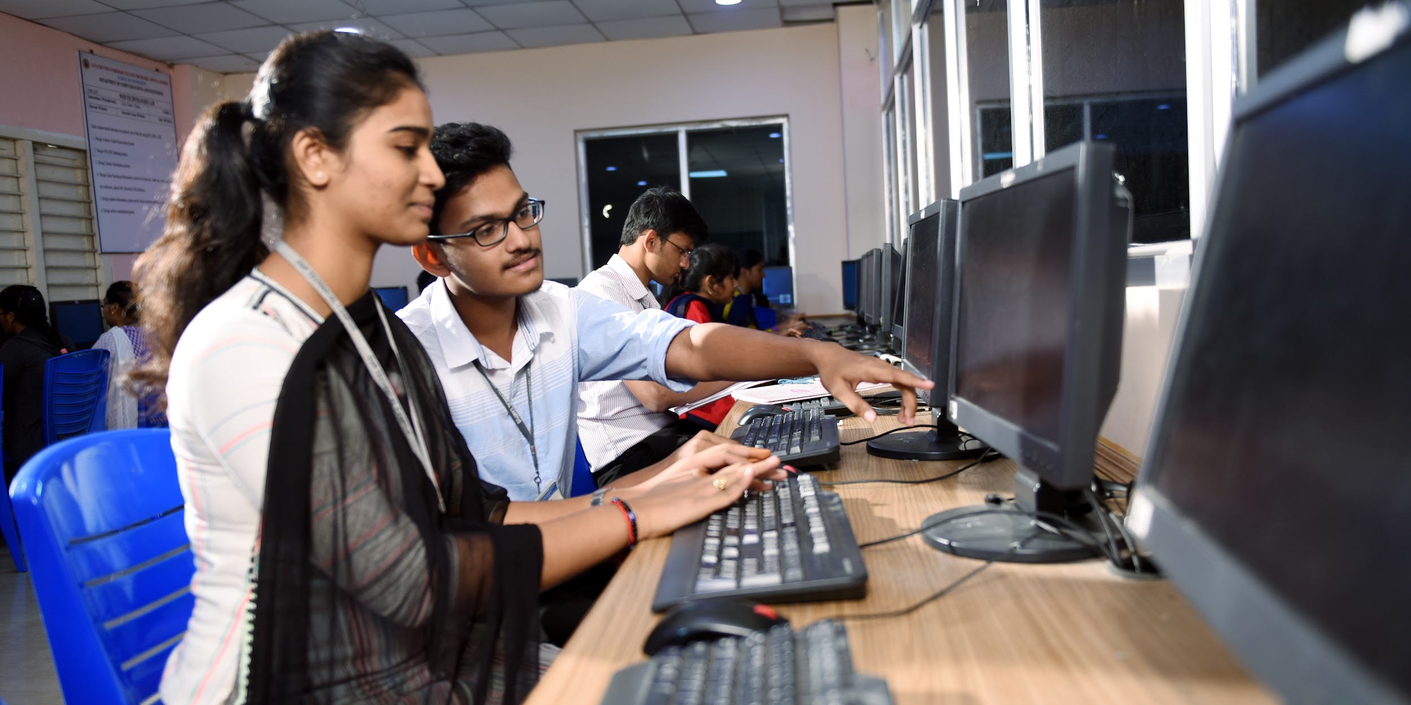

**OPEARTING SYSTEMS LAB**

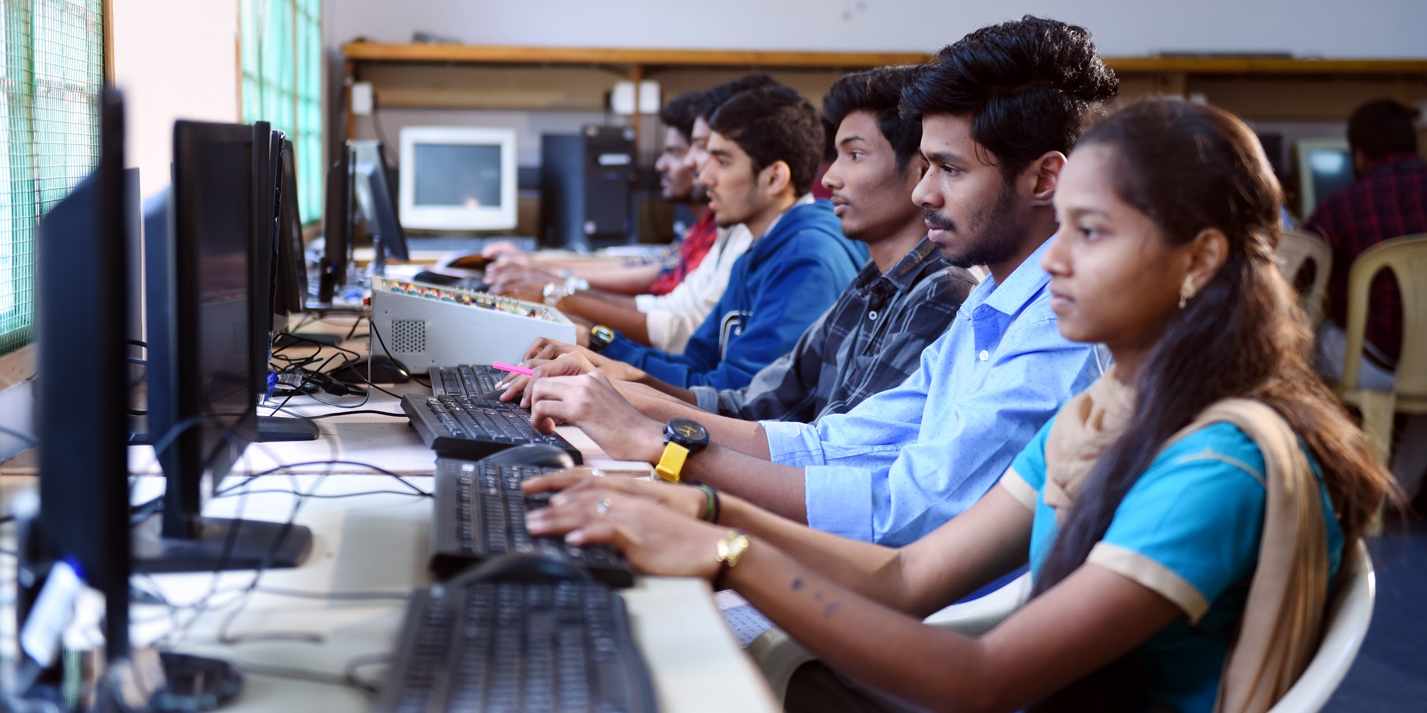

**DATA COMMUNICATION LAB**



**BIGDATA LAB**

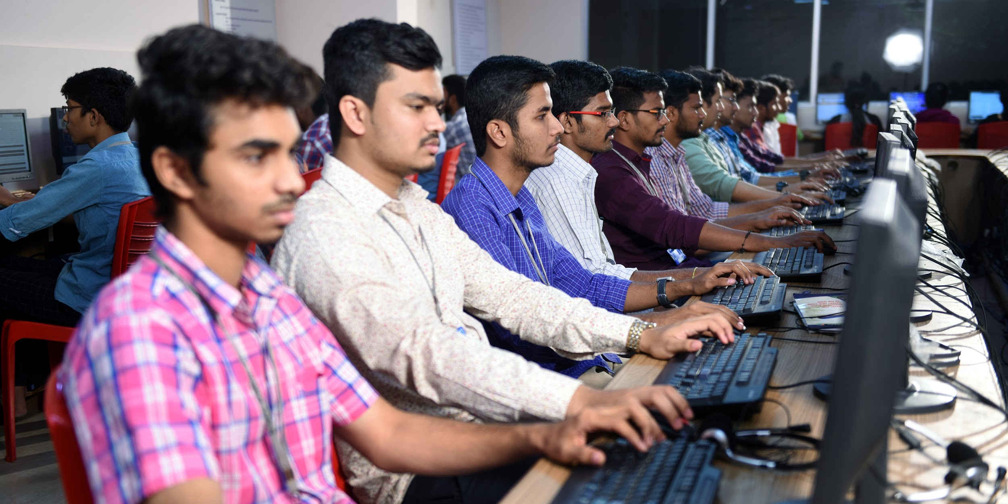

**DATABASE LAB**

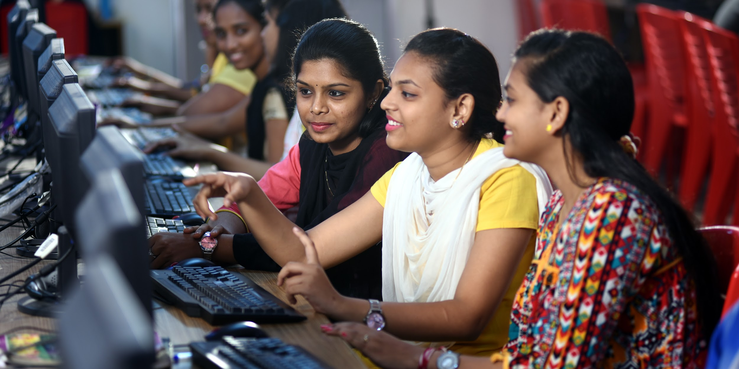

**C PROGRAMMING LAB**

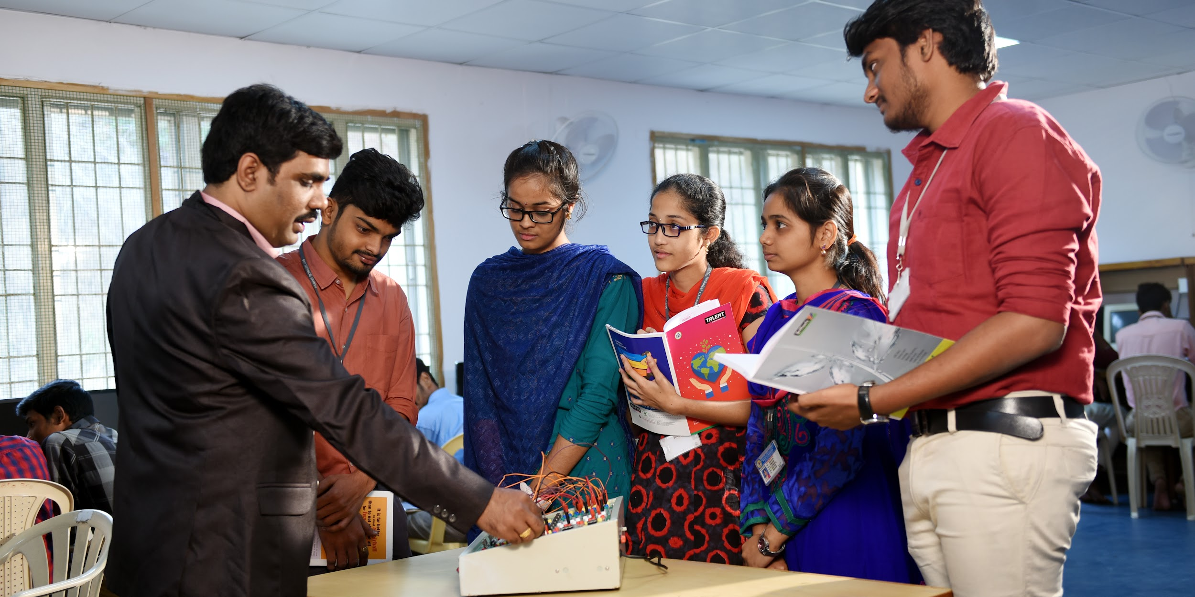

**MICROPROCESSOR & IoT LAB**

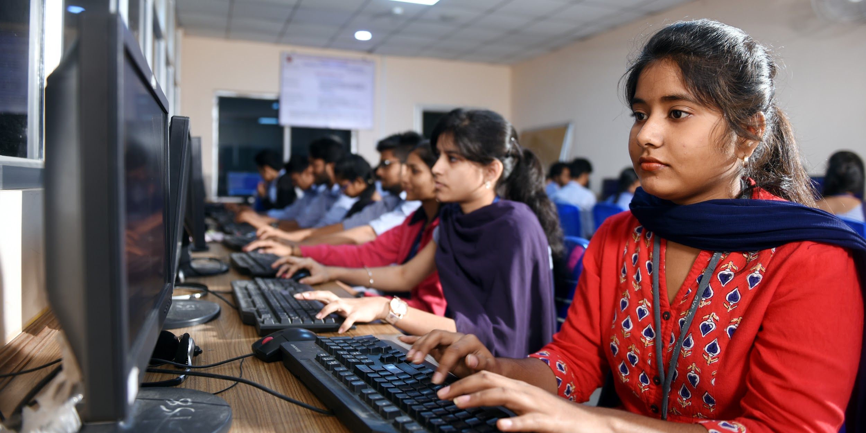

**PROGRAMMING LAB**



**SERVER ROOM**

**FOOTER-Engineering-**[**COMPUTER SCIENCE & ENGINEERING**](https://gvpcdpgc.edu.in/cse/aboutcse.php)**-**[**Infrastructure**](https://gvpcdpgc.edu.in/cse/cse_labs.php) **:**

**Address: Gayatri Vidya Parishad College for Degree and P.G Courses(A),**

**Rushikonda, Visakhapatnam-530045, Andhra Pradesh.**

**Get In Touch:**

**mail principalgvpcdpgca@gmail.com**

**phone 0891-2955084**

**Working Hours:**

**Mon-Sat 10:00 AM-5:00 PM**

**phone 0891-2783722 (UG)**

**phone 0891-2955084 (PG)**

**phone 0891-2953719 (E&T)**

**College route map: photo**

**Follow Us: logo ( facebook, twitter, instagram,youtube)**

**Sub-sub Heading:** [**Department Committees**](https://gvpcdpgc.edu.in/cse/cse_dept_committe.php)

##### List of Departmantal Committees

**The purpose of the committee is to advise on how departmental leadership can be supported and enhanced in their administrative and faculty governance responsibilities. The committees work on all aspects of academic operations for the smooth functioning of the department.**

## 1. Department Academic Committee (DAC)

Objectives:

The DAC will have wide responsibility for oversight of all matters related to

* Student Admissions (Cat A, Cat B, ECET)
* Student Results Analysis (Regular, Supplementary)
* Time Tables
* Department Academic Calender and List of holidays
* Schedule of Events to be organised
* Examinations
* Professional Body Memberships and Activities
* Faculty Leave Status
* Any other Academic issues

Members:

* Dr. N.V. Ramana Murthy (HoD & Chair)
* Dr. Bh. Padma (Coordinator)
* Dr. G.R.S.Murthy (Member)
* Dr. D Chandravathi (Member)
* Dr. K.N. Brahmaji Rao (Member)
* Sri G. Klayan Chakravarthi (Member)
* Mrs. L. Pratibha (Member)
* Mr. M. Anil(Member)

## 2. Department Class Committee(DCC)

Objectives:

To provide a two-way channel of communication between staff and all sections of the student cohort regarding all aspects of the student learning experience through

* Periodical Syllabus Review
* Academic relevant issues represented by students
* Student Progress
* Parent-Teacher Meeting (PTM)
* Counselors Allocation
* Identifying specific problems of students staying away from parents or in hostel
* Updating the faculty of any specific problem, issue of event like hospitalization or accident etc.

Members:

* Dr.N.V.Ramana Murty (HoD & Chair)
* Dr. K.N. Brahmaji Rao (Coordinator)
* All the Class Teachers of B.Tech II/IV, III/IV, IV/IV. (Coordinator)
* All the Class Representatives (CR) of B.Tech II/IV, III/IV, IV/IV. (Members)
* Student Members from all the B.Tech II/IV, III/IV, IV/IV. (Members)

## 3. Department Project Review Committee (DPRC)

Objectives:

DPRC pays close attention to the quality of Student projects. Students are divided into groups and propose an idea and solution(s) for a real-world problem. The idea should be brand new, and the solution should be innovative. This necessitates good planning for potential time and effort. Additionally, the graduation project is deemed to be a good test for the student. It reveals students problem-solving skills and capabilities. DPRC is charged with the responsibility of reviewing the following

* Identification & Finalization of Student Projects Groups
* Allocation of Project Guides
* Projects issued by industry
* To finalize list of projects and their synopsis
* Project Review Schedules
* Review and approve the projects
* Project Rules and Regulations & Project Assessment
* Implemented projects should be properly saved and documented for future use and display of strength of the department.

Members:

* Dr. N.V. Ramana Murthy (HoD & Chair)
* Sri. G. Kalyan Chakravarthi (Coordinator)
* Dr.G.R.S.Murthy (Member)
* Dr.Bh.Padma (Member)
* Dr. D Chandravathi (Member)
* Dr. K.N. Brahmaji Rao (Member)
* Respective Project Guides (At the time of Review)

## 4. Department Placements Committee (DPC)

Objectives:

DPC envisages an ideal interface between industry requirements and student aspirations, in that the right person for the right job is ensured. Making sure the industry benefits from the students, in terms of taking up roles and responsibilities and contributing to the growth of the Department and organization. Other responsibilities of DPC including

* To ensure 100% placements to eligible students
* Maintain the good liaison with the recruiters
* To ensure Internships to all the students
* To develop strong analytical and competitive skills by arranging various training programs
* Get in touch with corporate, start-ups for different sectors and tap in opportunities
* Conduct Mock Placement Drives
* Creating awareness among students towards higher studies
* Regular Visits to Companies

Members:

* Dr. N.V. Ramana Murthy (HoD & Chair)
* Dr. D Chandravathi (Coordinator)
* Sri G. Kalyan Chakravarthi (Member)
* Mr. M. Anil (Member)

## 5. Department Infrastructure Committee (DIC)

Objectives:

DIC Committee is responsible for maintaining the total infrastructure of the Department (AC’s, Fans, Desktop Computers, monitors, keyboards, mouses, Laptops, Printers, Scanners, Routers, and any other equipment in all Labs, faculty staff rooms etc…)

Other major responsibilities of DIC including:

* Proper maintenance activity of the labs must be held every week / once in two weeks.
* Software related to each lab must be properly loaded in systems in which that particular lab is scheduled.
* To ensure all systems working in proper manner.
* To ensure all keyboards and mouse are allocated to every system.
* To see that software renewals will be done before the due date.
* Conduct Mock Stock Verification expert visits

Members:

* Dr. N.V. Ramana Murthy (HoD & Chair)
* Dr.G.R.S.Murthy (Coordinator)
* Dr. D.S.S.N. Raju (Member)
* Sri R. Kanaka Raju (Member)
* Sri S. Arun Kumar (Member)
* Ms. D.M.V. Priya (Member)
* Sri D.V. Murali Krishna (Member)

**FOOTER-Engineering-**[**COMPUTER SCIENCE & ENGINEERING**](https://gvpcdpgc.edu.in/cse/aboutcse.php)**-** [**Department Committees**](https://gvpcdpgc.edu.in/cse/cse_dept_committe.php)**:**

**Address: Gayatri Vidya Parishad College for Degree and P.G Courses(A),**

**Rushikonda, Visakhapatnam-530045, Andhra Pradesh.**

**Get In Touch:**

**mail principalgvpcdpgca@gmail.com**

**phone 0891-2955084**

**Working Hours:**

**Mon-Sat 10:00 AM-5:00 PM**

**phone 0891-2783722 (UG)**

**phone 0891-2955084 (PG)**

**phone 0891-2953719 (E&T)**

**College route map: photo**

**Follow Us: logo ( facebook, twitter, instagram,youtube)**

**Sub-sub Heading:** [**Placements**](https://gvpcdpgc.edu.in/cse/cse_placement.php)

##### Placements

* **Placements-2021-22** [**Click Here**](https://gvpcdpgc.edu.in/cse/cse_data/Placements_21-22-CSE.pdf)
* **Placements-2020-21** [**Click Here**](https://gvpcdpgc.edu.in/cse/cse_data/Placements_20-21-CSE.pdf)
* **Placements-2019-20** [**Click Here**](https://gvpcdpgc.edu.in/cse/cse_data/Placements_19-20-CSE.pdf)
* **Placements-2018-19** [**Click Here**](https://gvpcdpgc.edu.in/cse/cse_data/Placements_18-19-CSE.pdf)
* **Placements-2017-18** [**Click Here**](https://gvpcdpgc.edu.in/cse/cse_data/Placements_17-18-CSE.pdf)
* **Placements-2016-17** [**Click Here**](https://gvpcdpgc.edu.in/cse/cse_data/Placements_16-17-CSE.pdf)

##### Higher Studies of Students

* **Higher Studies of Batch- 2016-20** [**Click Here**](https://gvpcdpgc.edu.in/cse/cse_data/2016-20%20Higher%20studies.pdf)
* **Higher Studies of Batch- 2015-19** [**Click Here**](https://gvpcdpgc.edu.in/cse/cse_data/2015-19%20Higher%20Studies.pdf)
* **Higher Studies of Batch- 2014-18** [**Click Here**](https://gvpcdpgc.edu.in/cse/cse_data/2014-18%20Higher%20Studies.pdf)

**FOOTER-Engineering-**[**COMPUTER SCIENCE & ENGINEERING**](https://gvpcdpgc.edu.in/cse/aboutcse.php)**-**[**Placements**](https://gvpcdpgc.edu.in/cse/cse_placement.php)**:**

**Address: Gayatri Vidya Parishad College for Degree and P.G Courses(A),**

**Rushikonda, Visakhapatnam-530045, Andhra Pradesh.**

**Get In Touch:**

**mail principalgvpcdpgca@gmail.com**

**phone 0891-2955084**

**Working Hours:**

**Mon-Sat 10:00 AM-5:00 PM**

**phone 0891-2783722 (UG)**

**phone 0891-2955084 (PG)**

**phone 0891-2953719 (E&T)**

**College route map: photo**

**Follow Us: logo ( facebook, twitter, instagram,youtube)**

**Sub-sub Heading:** [**Research & Innovations**](https://gvpcdpgc.edu.in/cse/cse_research.php)

#### Research

* List of Publications 2021-2022[Click Here](https://gvpcdpgc.edu.in/cse/cse_data/CSE%20Faculty%20Research%20Details%202021-22%20mod.pdf)
* List of Publications [Click Here](https://gvpcdpgc.edu.in/cse/images/CSE_Dept%20_ResearchPaperPublications.pdf)

**FOOTER-Engineering-**[**COMPUTER SCIENCE & ENGINEERING**](https://gvpcdpgc.edu.in/cse/aboutcse.php)**-**[**Research & Innovations**](https://gvpcdpgc.edu.in/cse/cse_research.php)**:**

**Address: Gayatri Vidya Parishad College for Degree and P.G Courses(A),**

**Rushikonda, Visakhapatnam-530045, Andhra Pradesh.**

**Get In Touch:**

**mail principalgvpcdpgca@gmail.com**

**phone 0891-2955084**

**Working Hours:**

**Mon-Sat 10:00 AM-5:00 PM**

**phone 0891-2783722 (UG)**

**phone 0891-2955084 (PG)**

**phone 0891-2953719 (E&T)**

**College route map: photo**

**Follow Us: logo ( facebook, twitter, instagram,youtube)**

**Sub-sub Heading:** [**Activities**](https://gvpcdpgc.edu.in/cse/facultyactivities.php)

##### Faculty Activities

* List of Events Organized 2021-2022[Click Here](https://gvpcdpgc.edu.in/cse/cse_data/All_events_2021_2022.pdf)
* List of Events Organized 2020-2021[Click Here](https://gvpcdpgc.edu.in/cse/cse_data/cse_events_20-21.pdf)
* List of Events Organized [Click Here](https://gvpcdpgc.edu.in/cse/images/cse_List-of-Events_organized.pdf)
* List of FDP's/Workshop's Attended 2021-22 [Click Here](https://gvpcdpgc.edu.in/cse/cse_data/CSE_Faculty_participations_2021-22%20mod.pdf)
* List of FDP's/Workshop's Attended 2020-21 [Click Here](https://gvpcdpgc.edu.in/cse/cse_data/FDPs-2020-21.pdf)
* List of FDP's/Workshop's Attended 2019-20 [Click Here](https://gvpcdpgc.edu.in/cse/cse_data/FDP-2019-20.pdf)

##### Student Activities

* Innovations in Teaching Learning [Click Here](https://drive.google.com/drive/folders/1Rz0l5pDQNoY7xXsQ3eQSa3_AjgGtG86T)
* Students Seminars/Workshops-2020-21 [Click Here](https://gvpcdpgc.edu.in/cse/cse_data/students-seminars-workshops-2018-19.pdf)
* Students Seminars/Workshops-2019-20 [Click Here](https://gvpcdpgc.edu.in/cse/cse_data/students-seminars-workshops-2018-19.pdf)
* Students Seminars/Workshops-2018-19 [Click Here](https://gvpcdpgc.edu.in/cse/cse_data/students-seminars-workshops-2018-19.pdf)
* Students Seminars/Workshops-2017-18 [Click Here](https://gvpcdpgc.edu.in/cse/cse_data/students-seminars-workshops-2017-18.pdf)
* Students Seminars/Workshops-2016-17 [Click Here](https://gvpcdpgc.edu.in/cse/cse_data/students-seminars-workshops-2016-17.pdf)

**FOOTER-Engineering-**[**COMPUTER SCIENCE & ENGINEERING**](https://gvpcdpgc.edu.in/cse/aboutcse.php)**-**[**Activities**](https://gvpcdpgc.edu.in/cse/facultyactivities.php)**:**

**Address: Gayatri Vidya Parishad College for Degree and P.G Courses(A),**

**Rushikonda, Visakhapatnam-530045, Andhra Pradesh.**

**Get In Touch:**

**mail principalgvpcdpgca@gmail.com**

**phone 0891-2955084**

**Working Hours:**

**Mon-Sat 10:00 AM-5:00 PM**

**phone 0891-2783722 (UG)**

**phone 0891-2955084 (PG)**

**phone 0891-2953719 (E&T)**

**College route map: photo**

**Follow Us: logo ( facebook, twitter, instagram,youtube)**

[**ELECTRONICS & COMMUNICATION ENGINEERING**](https://gvpcdpgc.edu.in/ece/aboutece.php)

**Sub-heading :** [**About Department**](https://gvpcdpgc.edu.in/ece/aboutece.php)

##### About Department

**The Department of Electronics and Communication Engineering (ECE),Gayatri Vidya Parishad College for Degree and PG Courses (A) was established in the year 2011 as an under graduate course (B.Tech) in the program of Engineering and Technology with an initial intake of 60 students. The intake was further propelled with an approval of another 60 seats in 2022-23 making a grand total of 120 students.**

**The B.Tech Program in Electronics and Communication Engineering (ECE) has been accredited by National Board of Accreditation (NBA) successfully in 20019-20, and re accredited in the yeart 2022-23 with a validation till 2025.**

**Electronics and Communication Engineering is the branch of Engineering in which the students are trained in the science of practical and theoretical foundations of Electronics Devices & Circuits, Communication Engineering, Analog & Digital ICs, Microprocessors, Digital Signal Processing and Microwave & Fiber Optic Communication. The students are exposed to sophisticated laboratories and latest trends in Communication Engineering.**

**The Electronics and communication engineering program strives to graduate engineers of the highest quality and to conduct state-of-the-art research. The Electronics and Communication Engineering program enables the students with a set of skills, knowledge and attitudes that will permit its graduates to succeed and thrive as engineers and leaders.**

**The Program is designed to prepare its graduates to pursue life-long learning, serve the profession and meet intellectual, ethical and career challenges and to maintain a vital, state-of- the-art research enterprise to provide its students and faculty with opportunities to create, interpret, apply and disseminate knowledge.**

**About B.Tech Admissions**

**EAPCET Counseling Code: GVPT**

**Admissions under Category "A" (Convener’s Quota-70% of intake in each branch):**

**Eligibility Criteria:**

**A Candidate who seeks admission in to the four-year degree course in Engineering shall pass the the Board of Intermediate examination, Government of Andhra Pradesh with Mathematics, Physics and Chemistry as optional subjects. All the eligible applicants for admission into First Year shall have to qualify in the EAPCET Examination conducted by the Govt. of AP. The candidates will be admitted strictly in accordance with the merit secured at the Entrance Examination keeping in view the rules in force regarding the reservations of seats of various categories of candidates. The candidates should satisfy local/non-local status requirement as laid down in the AP Educational institutions (Regulation of Admissions) Order 1974 as amended from time to time.**

**Admissions under Category "B" (30% of intake in each branch):**

**The Engineering Diploma holders, based on their merit at ECET, are admitted into Lateral Entry (II year B. Tech Courses)**

**The seats shall be filled as per the rules given by APSCHE.**

**Sub-heading :** [**Vision & Mission \ PEOs \ PSOs \ POs**](https://gvpcdpgc.edu.in/ece/ece_vision.php)

##### Vision

**The Vision of the Department is “To achieve academic excellence and make significant contribution to the society through quality education and research in the field of Electronics and Communication Engineering”.**

##### Mission

**The Mission of the Department is “To empower the students with quality education (M1), to achieve excellence in research to develop models that meet the needs of the society (M2) and to become team leaders with better communication skills, ethics and social responsibility (M3)”.**

##### Program Outcomes (POs)

* **Engineering knowledge: Apply the knowledge of mathematics, science, engineering fundamentals, and an engineering specialization to the solution of complex engineering problems.**
* **Problem analysis: Identify, formulate, review research literature, and analyze complex engineering problems reaching substantiated conclusions using first principles of mathematics, natural sciences, and engineering sciences.**
* **Design/development of solutions: Design solutions for complex engineering problems and design system components or processes that meet the specified needs with appropriate consideration for the public health and safety, and the cultural, societal, and environmental considerations.**
* **Conduct investigations of complex problems: Use research-based knowledge and research methods including design of experiments, analysis and interpretation of data, and synthesis of the information to provide valid conclusions.**
* **Modern tool usage: Create, select, and apply appropriate techniques, resources, and modern engineering and IT tools including prediction and modeling to complex engineering activities with an understanding of the limitations.**
* **The engineer and society: Apply reasoning informed by the contextual knowledge to assess societal, health, safety, legal and cultural issues and the consequent responsibilities relevant to the professional engineering practice.**
* **Environment and sustainability: Understand the impact of the professional engineering solutions in societal and environmental contexts, and demonstrate the knowledge of, and need for sustainable development.**
* **Ethics: Apply ethical principles and commit to professional ethics and responsibilities and norms of the engineering practice.**
* **Individual and team work: Function effectively as an individual, and as a member or leader in diverse teams, and in multidisciplinary settings.**
* **Communication: Communicate effectively on complex engineering activities with the engineering community and with society at large, such as, being able to comprehend and write effective reports and design documentation, make effective presentations, and give and receive clear instructions.**
* **Project management and finance: Demonstrate knowledge and understanding of the engineering and management principles and apply these to one’s own work, as a member and leader in a team, to manage projects and in multidisciplinary environments.**
* **Life-long learning: Recognize the need for, and have the preparation and ability to engage in independent and life-long learning in the broadest context of technological change.**

##### Program Educational Objectives (PEOs)

* **PEO1: Provide strong foundations in the domain of Electronics and Communication Engineering technologies.**
* **PEO2: Graduates shall provide appropriate solutions for society and industry relevant problems by using current engineering techniques and tools.**
* **PEO3: Graduates shall be employable by training them in domain Knowledge, soft skills and leadership /managerial skills.**
* **PEO4: Engage in professional development through Communication skills, Team spirit, integrity, social responsibility, lifelong learning, Professional ethics and human values in career.**

##### Program Specific Outcomes (PSOs)

* **PSO1: The ability to apply fundamental knowledge of core subjects in design and development of electronic circuits and communication systems.**
* **PSO2: Competence in using electronic modern IT tools (Simulation software) for design and analysis of complex electronic system for research activities.**
* **PSO3: Adaptability to change in work environment, good interpersonal skills and professional ethics.**

Sub - Heading : **HOD's Message**

#### HOD's Message

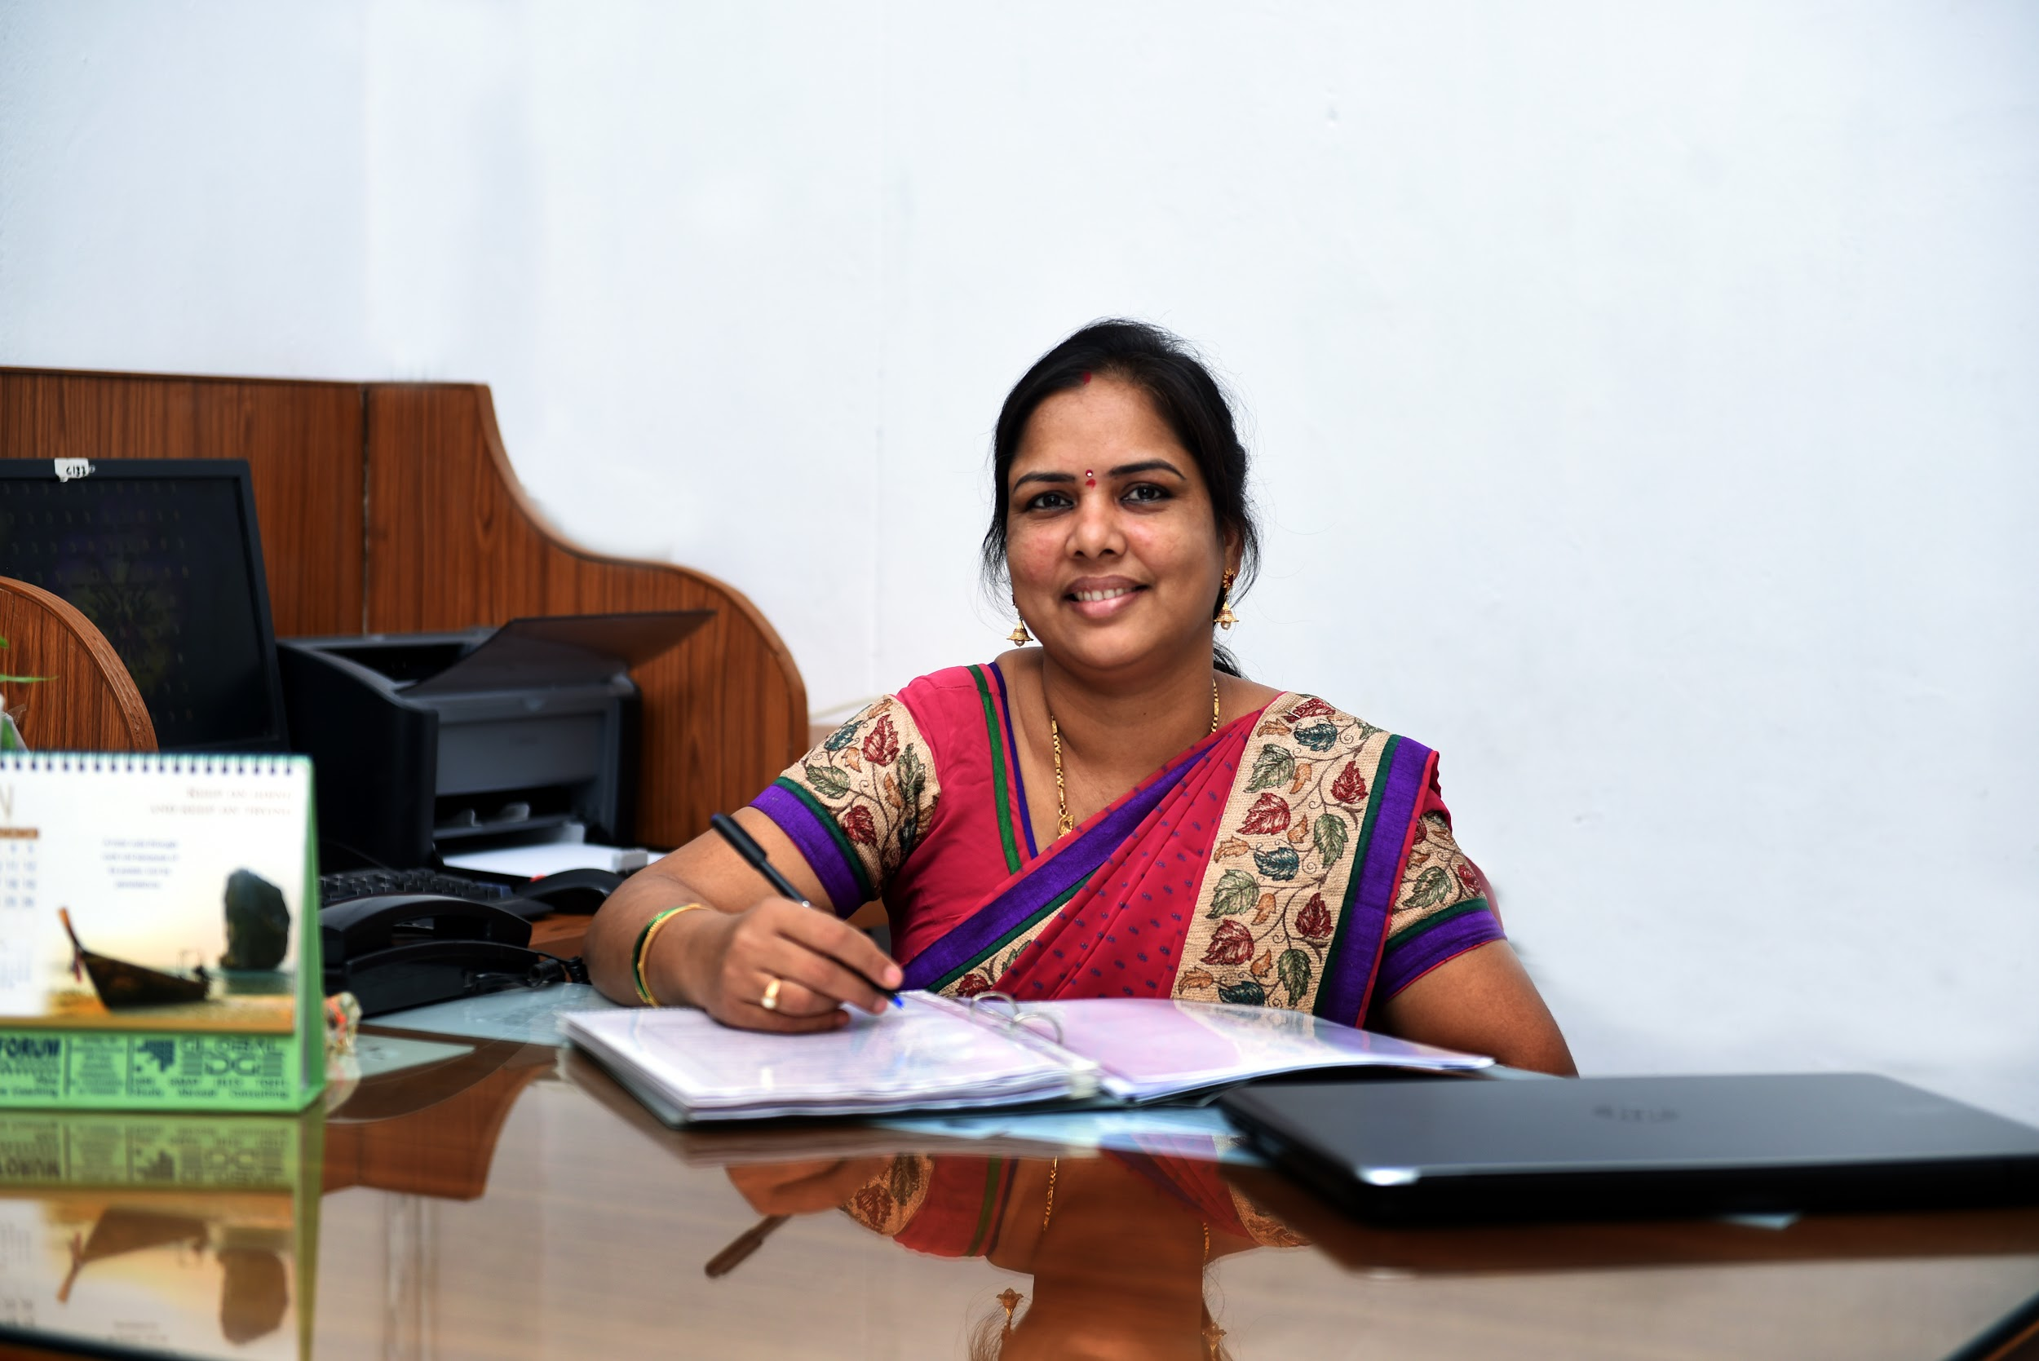

**Welcome to the Department of Electronics and Communication Engineering (ECE) at Gayatri Vidya Parishad College for Degree and PG Courses (A). The Department offers a regular four- year B. Tech in Electronics and Communication Engineering course with an intake of 120 in the Program of Engineering and Technology under the affiliation of Andhra University.**

**The Department currently has highly qualified and well experienced faculty on its roll with 4 doctorates and 6 pursuing their PhD degrees. Three Faculty are recognized as research guides by Andhra University and were allotted with 11 Ph. D Scholars.**

**The department is compiled with committed faculty who is equipped with smart teaching and learning process and always strives to impart the fundamental concepts and the latest trends in the young minds. This kind of teaching enables the student’s ability to enhance critical thinking and problem-solving skills and accommodates them with required confidence for a better employability.**

**To abridge the Industry-Lab-Academia, the department offers honors and minors courses in the curriculum.**

**The students are also given opportunities to involve in the professional bodies in the field of Electronics and Communications, IETE Student Forum (ISF) as well as department association activities(INTEC), which boosts the confidence of the students and nurtures them in to skilled engineering professionals. Students are provided internship facility in organizations like BSNL, DRDO, DLRL, AIR, HSL, HPCL and ECIL etc.**

**The department is having strong Industry Institute Interaction and ample number of MOU’s signed for the upskilling the students.**

**The student projects are conducted in-house with the guidance of department faculty and industrial trainers. The students are motivated to develop projects/ prototypes which are useful and meets the needs of the society like Drones, Solar operated Tri-cycle, Cold storage units for vegetables, two-way communication farmer assistance APP, Self-assisted Wheel Chairs and IoT Health Monitoring System Etc.**

**The department conducts various workshops, expert talks, industrial visits and value added training programs on recent trends in Electronics and Communication Engineering in collaboration with industries for the benefit of faculty as well as the students.**

**The students are encouraged to participate in co-curricular, extracurricular, NSS, and NCC activities which enriches the holistic development in them.**

**Ultimately the Department of Electronics and Communication Engineering is relentlessly working to make the Vison of the college “ Creating Human Excellence for a Better Society” true.**

**Dr. S. Krishna Veni**

**Professor & H.O.D,**

**M.Tech, Ph. D.**

Sub - Heading : **Faculty**

##### List of Faculty Members

|  | **Name-Designation-Qualification** | **Area-of-Specialization** | **E-mail** | **Date of Joining** | **Nature-of-Association** |
| --- | --- | --- | --- | --- | --- |
|  | [**Dr. S. Krishna Veni**](https://gvpcdpgc.edu.in/ece/images/ece_data/veni_resume.pdf)  **Professor & H.O.D,**  **M.Tech, Ph. D** | **Antenna Arrays** | **drkrishnaveni@gvpcdpgc.edu.in**  [**Profile**](https://gvpcdpgc.edu.in/ece/ece_data/veni_resume.pdf) | **15-07-2016** | **Regular** |
|  | [**Dr. P. A. Nageswara Rao**](https://gvpcdpgc.edu.in/ece/ece_data/Dr.P.A_NAGESWARA_RAO.pdf)  **Associate Professor,**  **M.E, Ph. D** | **Process Controlled Instrumentation,Antenna** | **drnageswararao@gvpcdpgc.edu.in**  [**Profile**](https://gvpcdpgc.edu.in/ece/ece_data/Dr.P.A_NAGESWARA_RAO.pdf) | **02-05-2018** | **Regular** |
|  | [**Dr.V.Adinarayana**](https://gvpcdpgc.edu.in/ece/ece_data/DrV%20Adi%20%20resume%2024%2007%2021.pdf)  **Associate Professor,**  **B.E, M.E, Ph.D** | **Wireless Communications** | **dradinarayana@gvpcdpgc.edu.in**  [**Profile**](https://gvpcdpgc.edu.in/ece/ece_data/DrV%20Adi%20%20resume%2024%2007%2021.pdf) | **27-04-2021** | **Regular** |
|  | [**Dr. Ch. Manohar Kumar**](https://gvpcdpgc.edu.in/ece/ece_data/Dr.ch_manohar_kumar_Resume.pdf)  **Associate Professor,**  **B. Tech, M. Tech, Ph.D** | **Radar & Microwave Engineering** | **manohar@gvpcdpgc.edu.in**  [**Profile**](https://gvpcdpgc.edu.in/ece/ece_data/Dr.ch_manohar_kumar_Resume.pdf) | **07-01-2014** | **Regular** |
|  | [**Mr. S. Venkatesh**](https://gvpcdpgc.edu.in/ece/ece_data/venkatesh.pdf)  **Assistant Professor,**  **B. Tech, M. Tech** | **V.L.S.I System Design** | **venkateshece@gvpcdpgc.edu.in**  [**Profile**](https://gvpcdpgc.edu.in/ece/ece_data/venkatesh.pdf) | **16-06-2014** | **Regular** |
|  | [**Mr. V. Ram Nishanth**](https://gvpcdpgc.edu.in/ece/ece_data/Resume_RNV.pdf)  **Assistant Professor,**  **B. Tech, M. Tech** | **Communication Systems** | **ramnishanthvanka@gvpcdpgc.edu.in**  [**Profile**](https://gvpcdpgc.edu.in/ece/ece_data/Resume_RNV.pdf) | **09-06-2014** | **Regular** |
|  | [**Mr. A. Mahesh Babu**](https://gvpcdpgc.edu.in/ece/ece_data/mahesh%20resume%20new.pdf)  **Assistant Professor,**  **B.Tech, M.Tech** | **Radar & Microwave Engineering** | **maheshbabu07402@gvpcdpgc.edu.in**  [**Profile**](https://gvpcdpgc.edu.in/ece/ece_data/mahesh%20resume%20new.pdf) | **24-09-2015** | **Regular** |
|  | [**Mrs.G.Sowjanya Lakshmi**](https://gvpcdpgc.edu.in/ece/ece_data/G.Sowjanya_Resume.pdf)  **Assistant Professor,**  **B.E, M.Tech** | **V.L.S.I System Design** | **G.Sowjanya@gvpcdpgc.edu.in**  [**Profile**](https://gvpcdpgc.edu.in/ece/ece_data/G.Sowjanya_Resume.pdf) | **16-07-2021** | **Regular** |
|  | [**Mrs.P.N.S Sailaja**](https://gvpcdpgc.edu.in/ece/ece_data/sailaja%20resume%2019-12_2020.pdf)  **Assistant Professor,**  **M.Tech** | **Digital Image Processing** | **Mrs.P.N.S Sailaja@gvpcdpgc.edu.in**  [**Profile**](https://gvpcdpgc.edu.in/ece/ece_data/sailaja%20resume%2019-12_2020.pdf) | **13-05-2021** | **Regular** |
|  | [**Mrs. Aruna. Adlaboina**](https://gvpcdpgc.edu.in/ece/ece_data/aruna.pdf)  **Assistant Professor,**  **B.Tech, M.Tech** | **Systems and Signal Processing** | **arunaece@gvpcdpgc.edu.in**  [**Profile**](https://gvpcdpgc.edu.in/ece/ece_data/aruna.pdf) | **14-02-2022** | **Regular** |
|  | [**Mrs. K. Deepthi**](https://gvpcdpgc.edu.in/ece/ece_faculty_list.php#)  **Assistant Professor,**  **B.Tech, M.Tech** | **VLSI** | **deepthi@gvpcdpgc.edu.in**  [**Profile**](https://gvpcdpgc.edu.in/ece/ece_faculty_list.php#) | **23-01-2023** | **Regular** |
|  | [**Mr. E. Raju**](https://gvpcdpgc.edu.in/ece/ece_faculty_list.php#)  **Assistant Professor,**  **B.Tech, M.Tech** | **Digital Systems and Signal Processing** | **rajuegala@gvpcdpgc.edu.in**  [**Profile**](https://gvpcdpgc.edu.in/ece/ece_faculty_list.php#) | **12-06-2023** | **Regular** |
|  | [**Mrs. M. Tharangini**](https://gvpcdpgc.edu.in/ece/ece_faculty_list.php#)  **Assistant Professor,**  **B.Tech, M.Tech** | **Embedded Systems** | **mtharangini@gvpcdpgc.edu.in**  [**Profile**](https://gvpcdpgc.edu.in/ece/ece_faculty_list.php#) | **12-06-2023** | **Regular** |
|  | [**Mrs. V. Sridevi**](https://gvpcdpgc.edu.in/ece/ece_faculty_list.php#)  **Assistant Professor,**  **B.Tech, M.Tech** | **Communication Systems** | **sridevivelaga@gvpcdpgc.edu.in**  [**Profile**](https://gvpcdpgc.edu.in/ece/ece_faculty_list.php#) | **12-06-2023** | **Regular** |

Sub - Heading : [**Syllabus**](https://gvpcdpgc.edu.in/ece/ece_syllabus.php)

##### B.Tech Syllabus

* **ECE Syllabus (With effect from 2022-2023 admitted batch) Autonomous** [**Click Here**](https://gvpcdpgc.edu.in/ece/ece_data/2022-23_Admitted_Batch_syllabus.pdf)
* **ECE Syllabus (With effect from 2020-2021 admitted batch) Autonomous** [**Click Here**](https://gvpcdpgc.edu.in/ece/ece_data/2020-24_Batch_Syllabus.pdf)
* **ECE Syllabus (With effect from 2019-2020 admitted batch) Autonomous** [**Click Here**](https://gvpcdpgc.edu.in/ece/ece_data/2019-23_Syllabus.pdf)
* **ECE First Year Syllabus for 2015-2016 Admitted Batch** [**Click Here**](https://gvpcdpgc.edu.in/ece/ece_data/ECE-First-Year-Syllabus-for-2015-2016-Admitted-Batch.pdf)
* **ECE Syllabus for 2015-2016 Admitted Batch** [**Click Here**](https://gvpcdpgc.edu.in/ece/ece_data/ECE-Syllabus-for-2015-2016-Admitted-Batch.pdf)

Sub - Heading : [**Academic Calender**](https://gvpcdpgc.edu.in/ece/ece_academic_cal.php)

##### Academic Calendar

* **Academic Calendar - 2023-24 Odd Sem -** [**Click Here**](https://gvpcdpgc.edu.in/ece/ece_data/2022-23_odd.pdf)
* **Academic Calendar - 2023-24 Even Sem -** [**Click Here**](https://gvpcdpgc.edu.in/ece/ece_data/2023-24_odd.pdf)
* **Academic Calendar - 2022-23 Odd Sem -** [**Click Here**](https://gvpcdpgc.edu.in/ece/ece_data/2022-23_odd.pdf)
* **Academic Calendar - 2022-23 Even Sem -** [**Click Here**](https://gvpcdpgc.edu.in/ece/ece_data/2022-23_even.pdf)
* **Academic Calendar - 2021-22 -** [**Click Here**](https://gvpcdpgc.edu.in/ece/ece_data/2021-22%20even_odd.pdf)
* **Academic Calendar - 2020-21 -** [**Click Here**](https://gvpcdpgc.edu.in/ece/ece_data/2020-21.pdf)
* **Academic Calendar - 2019-20 -** [**Click Here**](https://gvpcdpgc.edu.in/ece/ece_data/Engineering-Academic-Calender-2019-20-for-autonomous-batch.pdf)

##### TimeTables

* **Time Table-2021-22-Odd-Sem** [**Click Here**](https://gvpcdpgc.edu.in/ece/ece_data/2021-22%20-oddsem.pdf)
* **Time Table-2020-21-Even-Sem** [**Click Here**](https://gvpcdpgc.edu.in/ece/ece_data/2020-21%20II%20Semester%20Time%20Table.pdf)
* **Time Table-2020-21-Odd-Sem** [**Click Here**](https://gvpcdpgc.edu.in/ece/ece_data/2020-21%20I%20Semester%20Time%20Table%20.pdf)
* **Time Table-2019-20-Even-Sem** [**Click Here**](https://gvpcdpgc.edu.in/ece/ece_data/ece.pdf)
* **Time Table-2019-20-Odd-Sem** [**Click Here**](https://gvpcdpgc.edu.in/ece/ece_data/ece-time-table-2019-20-odd.pdf)

Sub - Heading : [**Infrastructure**](https://gvpcdpgc.edu.in/ece/ece_labs.php)

##### Lab Details

##### Facilities

Department of E.C.E, Gayatri Vidya Parishad College for Degree and PG Courses (A) has well equipped laboratories with various electronic, electrical, digital devices and simulation softwares. The labs provide good access for all students for long hours, making it possible for the students to work in a safe and progressive environment. The labs are taught through a combination of lectures, discussions, demonstrations and exercises led by experienced faculty. Here, the students receive practical and professional training in the fields of electronics and communication engineering. The role of teamwork and creativity are also highlighted in the laboratories. The students are made to do the experiments in such a way that they are able to analyse the results obtained and use the same for developing new ideas. E.C.E Department physically have five well ventilated laboratory rooms.

| **S. NO** | **ROOM NO.** | **NAME OF THE LABORATORY** | **DIMENSIONS** | **AREA (in sq.m)** |
| --- | --- | --- | --- | --- |
| 1 | 809 | DIGITAL ELECTRONICS & MICROPROCESSORS LABORATORY | 7.6 x 9.44 | 71.74 |
| 2 | 810 | COMMUNICATION SYSTEMS LABORATORY | 7.6 x 9.44 | 71.74 |
| 3 | 811 | DEPARTMENT LIBRARY & FACULTY ROOM | 7.6 x 3.15 | 23.94 |
| 4 | 812 | ANALOG ELECTRONICS LABORATORY | 7.6 x 8.9 | 67.64 |
| 5 | 813 | MICROWAVE ENGINEERING LABORATORY | 7.6 x 8.9 | 67.64 |
| 6 | 814 | SIMULATION LABORATORY | 7.6 x 9.4 | 71.44 |
| 7 | 627 | NETWORK THEORY & ELECTRICAL MACHIES LABORATORY | 7.34 x 11.89 | 87.27 |

Laboratories which comes under Analog Electronics Laboratory are:

* Electronic Devices and Circuits Laboratory:  
  This laboratory is intended for beginners for testing and practicing their theoretical knowledge in the working of basic electronic devices and simple circuits, which enables the students to visualize their thought process and deepen their understanding of the subject. The students are allowed to explore various equipment under the guidance of experienced faculty. To meet the requirements of the students, the college provides efficient laboratories containing a large variety of electronic components along with devices like cathode ray oscilloscopes, function generators, regulated power supply, multimeters, etc.,
* Analog Electronics circuits laboratory:  
  The Analog electronic circuit laboratory is the next version of the electronic devices and circuits laboratory. The aim of this laboratory is to make students familiar with the use of devices like transistors in amplifiers. The lab is well equipped and well arranged, creating a congenial atmosphere and hence promoting the interests of students in the aspect of designing. The students learn about various electronic devices in the E.D.C lab and implement their designing skills in this lab. The lab and the classes are taught in co-relation and at the same pace so that the students can experience the actual concept of learning!
* Linear IC's and pulse circuit laboratory:  
  It is a design laboratory which helps students design and analyze small circuits that are used in complex circuits or applications. This lab primarily helps the students to figure out how their design will integrate with the user requirement. The aspiring design course teaches the students to generate, develop and realize breakthrough ideas in electronics. The lab provides a variety of IC's to experiment with, and has a more analytic approach. When students carry out various kinds of experiments, they draw conclusions from their studies which raises their level of self-confidence.

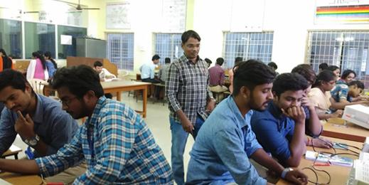

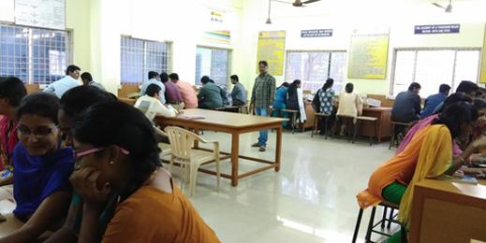

Laboratories which comes under Digital Electronics & Microprocessor Laboratory are:

* Digital Ic's laboratory:  
  This laboratory provides the basic experimentation required for gaining knowledge in computer architecture and organization. The lab provides various kinds of Ic's to work with. These labs make it possible for the students to apply reasoning informed by the contextual knowledge and allow them to perform a wide range of experiments. With Excellent facilities and under proper guidance, the students gain expertise in this field and cater to the growing needs of digital community.
* Microprocessors & Microcontroller laboratory:  
  The microprocessors & Microcontroller laboratory deals with assembly language programming using 8086 microprocessor and 8051 microcontroller. The lab is equipped with trainers in 8086, 8051 and its interfacing modules in order to enable the student to work with any kind of processor. The lab is led by experienced faculty who help the students to have a thorough grip on programming, so that they can apply their programming skills for the design of new applications. This lab gives an opportunity for students to build an ability to identify, formulate and analyze complex engineering problems related to Electronics & Communication and also the ability to function effectively as an individual.

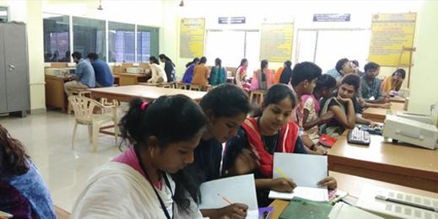

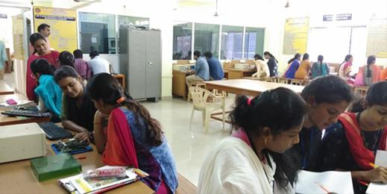

Laboratories which comes under Communication Laboratory are:

* Analog & Digital Communication Laboratory:  
  This well versed laboratory deals with experiments on different modes of communications both Analog and Digital and various processes involved for communication to occur. The labs are well equipped with all the necessary electronic components as well as demonstration kits to ensure that the students work with ease. These labs are handled by well-trained faculty who help the students to bridge the gap between engineering theory and practice through visualization. The students can also develop their designing skills in this lab.

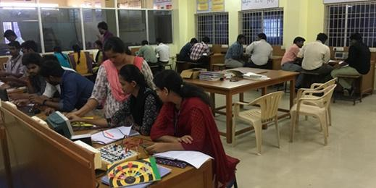

Laboratories which comes under Microwave Engineering & Antenna Laboratory are:

* Microwave Engineering Laboratory:  
  In this laboratory students will conduct experiments that generates signal in Microwave Frequencies and study the Reflex Klystron and Gunn. The students are also exposed to fibre communication and study the operation of Optical fibre. This lab gives an opportunity for students to build an ability to identify, formulate and analyze complex engineering problems related to Electronics & Communication.

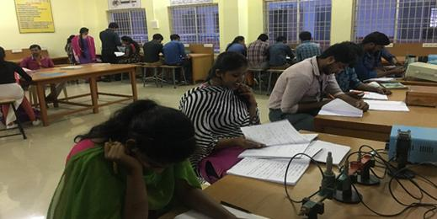

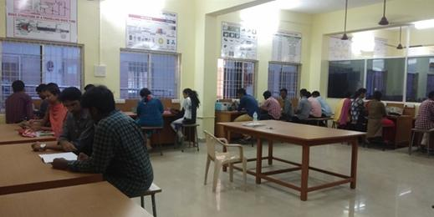

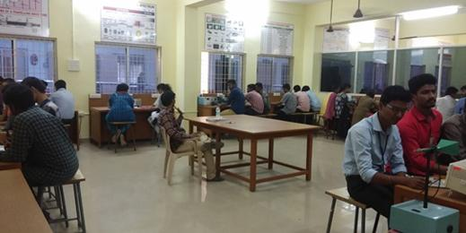

Laboratories which comes under Network theory and Machines Laboratory are:

* Simulation laboratories:  
  This lab contains latest simulation softwares like MATLAB, SIMULINK, XILINX, LABVIEW and MUTLISIM which can be used by the students to design experiments virtually, and perform analysis and interpretation of data and synthesis of information to provide valid conclusions, before performing the experiment on bread board. This lab tends to reduce complexity and time consumption for students.

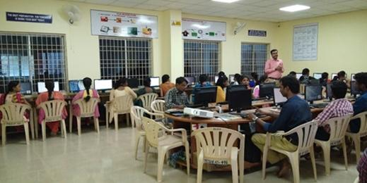

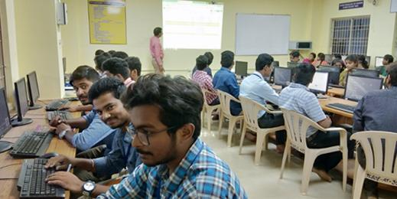

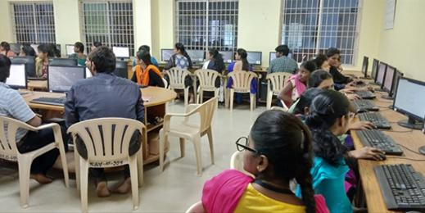

Laboratories which comes under Network theory and Machines Laboratory are:

* Network theory & Machines laboratory:  
  In this laboratory the students get the opportunity to analyse the basic electrical laws and understand terms like node, branch, mesh, port, circuit etc., Here the students verify their practical results with the theoretical results and understand the behaviour of circuits in the real world. Apart from the electrical components necessary for performing an experiment, the laboratory provides experimental kits to ensure that the students understand the experiment to a good extent. The labs and classes are taught in co-relation so that the students grasp the subject in the best manner. The electrical machines laboratory contains motors, generators and transformers of various kinds in a bright and spacious room. This laboratory allows the students to perform various tests and experiments on what they have already learnt about electrical machines. Since the students are liable to work with high voltages and currents, safety is made an integral part of this laboratory. The faculty who possess immense knowledge and experience in electrical field guide the students in the right direction.

Sub - Heading : [**Department Committees**](https://gvpcdpgc.edu.in/ece/ece_dept_committe.php)

##### List of Departmantal Committees

The purpose of the committee is to advise on how departmental leadership can be supported and enhanced in their administrative and faculty governance responsibilities. The committees work on all aspects of academic operations for the smooth functioning of the department.

## 1. Department Academic Committee (DAC)

Objectives: The Department Academic Committee will review the following Academic activities of the Department

* Academic Calender
* Time Table
* Professional Body Membership and Activities
* Examinations
* Result analysis
* Guest lectures/workshops

Members:

* Dr.S.Krishna Veni (Chair)
* Dr. V. Adinarayana (Cordinator)
* Dr. P. A. Nageswara Rao (Member)
* Mr. Ch. Manohar Kumar (Member)
* Mr. S. Venkatesh (Member)

## 2. Department Class Committee(DCC)

Objectives:

* To review the syllabus completion status
* Attendance
* Arrange PTM
* Counselling

Members:

* Dr.S.Krishna Veni (Chair)
* Mr. Ram Nishant V (Cordinator)
* II Year Class Teacher
* III Year Class Teacher
* IV Year Class Teacher

## 3. Department Project Review Committee (DPRC)

Objectives:

* To monitor the quality of projects
* Project Review Dates
* Project Guidelines
* Project Assessment
* Project Completion status and Documentation

Members:

* Dr. S. Krishna Veni (Chair)
* Dr. P. A. Nageswara Rao (Cordinator)
* Dr. V. Adinarayana (Member)
* Dr. N. Swathi (Member)
* Mr. A. Mahesh Babu (Member)

Sub - Heading : [**Placements**](https://gvpcdpgc.edu.in/ece/ece_placement.php)

##### Placements

* Placements-2022-23 [Click Here](https://gvpcdpgc.edu.in/ece/ece_data/ECE_2019-2023_Placements.jpg)
* Placements-2021-22 [Click Here](https://gvpcdpgc.edu.in/ece/ece_data/ECE_2018-22_Placements.jpg)
* Placements-2020-21 [Click Here](https://gvpcdpgc.edu.in/ece/ece_data/Students%20placed%20-batch%202017-2021.pdf)
* Placements-2019-20 [Click Here](https://gvpcdpgc.edu.in/ece/ece_data/Students%20placed%20-batch%202016-20.pdf)
* Placements-2018-19 [Click Here](https://gvpcdpgc.edu.in/ece/ece_data/Placements2018-19.pdf)
* Placements-2017-18 [Click Here](https://gvpcdpgc.edu.in/ece/ece_data/Placements2017-18.pdf)
* Placements-2016-17 [Click Here](https://gvpcdpgc.edu.in/ece/ece_data/Placements-2016-17.pdf)

##### Higher Studies of Students

* Higher Studies-2018-22 Batch [Click Here](https://gvpcdpgc.edu.in/ece/ece_data/2018-22_HigherStudies.pdf)
* Higher Studies-2017-21 Batch [Click Here](https://gvpcdpgc.edu.in/ece/ece_data/2017-21_HigherStudies.pdf)
* Higher Studies-2016-20 Batch [Click Here](https://gvpcdpgc.edu.in/ece/ece_data/Higher%20studies%202016-20%20batch.pdf)
* Higher Studies-2015-19 Batch [Click Here](https://gvpcdpgc.edu.in/ece/ece_data/Higher%20studies%202015-19%20batch.pdf)
* Higher Studies-2014-18 Batch [Click Here](https://gvpcdpgc.edu.in/ece/ece_data/Higher%20studies%202014-18%20batch.pdf)
* Higher Studies-2013-17 Batch [Click Here](https://gvpcdpgc.edu.in/ece/ece_data/Higher%20studies%202013-17%20batch.pdf)
* Higher Studies-2012-16 Batch [Click Here](https://gvpcdpgc.edu.in/ece/ece_data/Higher%20studies%202012-16%20batch.pdf)
* Higher Studies-2011-15 Batch [Click Here](https://gvpcdpgc.edu.in/ece/ece_data/Higher%20studies%202011-15%20batch.pdf)

Sub - Heading : [**Research & Innovations**](https://gvpcdpgc.edu.in/ece/ece_research.php)

##### Research

* Faculty Publications of Academic Year 2022-23 [Click Here](https://gvpcdpgc.edu.in/ece/ece_data/Journals_Published_2022-23.pdf)
* Faculty Publications of Academic Year 2021-22 [Click Here](https://gvpcdpgc.edu.in/ece/ece_data/Faculty_publications_21-22.pdf)
* Faculty Publications of Academic Year 2020-21 [Click Here](https://gvpcdpgc.edu.in/ece/ece_data/faculty_publications_2020_21.pdf)
* Faculty Publications of Academic Year 2019-20 [Click Here](https://gvpcdpgc.edu.in/ece/ece_data/faculty_publications_2019_20.pdf)
* Faculty Publications of Academic Year 2018-19 [Click Here](https://gvpcdpgc.edu.in/ece/ece_data/faculty_publications_2018_19.pdf)
* Faculty Publications of Academic Year 2017-18 [Click Here](https://gvpcdpgc.edu.in/ece/ece_data/faculty_publications_2017_18.pdf)
* Faculty Publications of Academic Year 2016-17 [Click Here](https://gvpcdpgc.edu.in/ece/ece_data/faculty_publications_2016_17.pdf)

Sub - Heading : [**Activities**](https://gvpcdpgc.edu.in/ece/ece_facultyactivities.php)

##### Faculty Activities

* List of Events Organized 2022-23 [Click Here](https://gvpcdpgc.edu.in/ece/ece_data/Activities_22-23.pdf)
* List of Events Organized 2021-22 [Click Here](https://gvpcdpgc.edu.in/ece/ece_data/listofevents_21_22.pdf)
* List of Events Organized 2020-21 [Click Here](https://gvpcdpgc.edu.in/ece/ece_data/events_20-21_mod.pdf)
* List of Events Organized 2019-20 [Click Here](https://gvpcdpgc.edu.in/ece/ece_data/events_19-20.pdf)
* List of Events Organized 2018-19 [Click Here](https://gvpcdpgc.edu.in/ece/ece_data/events_18-19.pdf)
* List of Events Organized 2017-18 [Click Here](https://gvpcdpgc.edu.in/ece/ece_data/events_17-18.pdf)
* List of Events Organized 2016-17 [Click Here](https://gvpcdpgc.edu.in/ece/ece_data/events_16-17.pdf)
* List of FDP/Workshop Attended 2022-23 [Click Here](https://gvpcdpgc.edu.in/ece/ece_data/Faculty_FDPs_2022-2023.pdf)
* List of FDP/Workshop Attended 2021-22 [Click Here](https://gvpcdpgc.edu.in/ece/ece_data/Faculty_FDPs_2021-2022.pdf)
* List of FDP/Workshop Attended 2020-21 [Click Here](https://gvpcdpgc.edu.in/ece/ece_data/Faculty%20participation%20in%20FDPs%20(2020-2021).pdf)
* List of FDP/Workshop Attended 2019-20 [Click Here](https://gvpcdpgc.edu.in/ece/ece_data/fdp%20attended%20in%20the%20year%2019-20.pdf)
* List of FDP/Workshop Attended 2018-19 [Click Here](https://gvpcdpgc.edu.in/ece/ece_data/fdp%20attended%20in%20the%20year%2018-19.pdf)
* List of FDP/Workshop Attended 2017-18 [Click Here](https://gvpcdpgc.edu.in/ece/ece_data/FDP%20attended%20in%20the%20year%2017-18.pdf)
* List of FDP/Workshop Attended 2016-17 [Click Here](https://gvpcdpgc.edu.in/ece/ece_data/fdp%20attended%20in%20the%20year%2016-17.pdf)

##### Student Activities

* Students Seminars/Workshops Attended -2022-23[Click Here](https://gvpcdpgc.edu.in/ece/ece_data/ELECTRIC_VEHICLEDESIGN_HANDS_ON_PRACTICE.pdf)
* Students Seminars/Workshops Attended -2020-21 [Click Here](https://gvpcdpgc.edu.in/ece/ece_data/Student%20Activities%202020-2021.pdf)
* Students Seminars/Workshops Attended -2019-20 [Click Here](https://gvpcdpgc.edu.in/ece/ece_data/Student%20Activitie%202019-2020.pdf)
* Students Seminars/Workshops-2018-19 [Click Here](https://gvpcdpgc.edu.in/ece/ece_data/Student-Acheivements_2018-2019.pdf)
* Students Seminars/Workshops-2017-18 [Click Here](https://gvpcdpgc.edu.in/ece/ece_data/Student-Acheivements_2017-2018.pdf)
* Students Seminars/Workshops-2016-17 [Click Here](https://gvpcdpgc.edu.in/ece/ece_data/Student-Acheivements_2016-2017.pdf)

Sub - Heading : [**Student Corner**](https://gvpcdpgc.edu.in/ece/ecestudent_corner.php)

* Technical Achievements of Students - 2018-2019 [Click Here](https://gvpcdpgc.edu.in/ece/ece_data/Student-Acheivements_-Technical-2018-2019.pdf)
* Technical Achievements of Students - 2017-18 [Click Here](https://gvpcdpgc.edu.in/ece/ece_data/Student-Acheivements_-Technical-2017-2018.pdf)
* Technical Achievements of Students - 2016-17 [Click Here](https://gvpcdpgc.edu.in/ece/ece_data/Student-Acheivements_-Technical-2016-2017.pdf)

[**MECHANICAL ENGINEERING**](https://gvpcdpgc.edu.in/mech/aboutmech.php)

**Sub - Heading :** [**About Department**](https://gvpcdpgc.edu.in/mech/aboutmech.php)

##### About Department

**The Department of Mechanical Engineering was started in the year 2011 in Gayatri Vidya Parishad College for Degree and PG Courses (A).**

**The department offers undergraduate programme (B.Tech) with an intake of 60. The admissions are made through AP EAPCET rankings. The faculty members of the department are a combination of both high qualification and experience. Professors: 03, Associate Professor: 01, Assistant Professors: 07, Technical staff: 04. Five faculty members have Ph.D. and four faculty members are undergoing Ph.D. programme. The Department received financial assistance from NSTEDB, Department of Science and Technology, New Delhi, India for organizing Entrepreneurship Awareness Camp in the year 2016 and financial aid from MSME in the year 2022. The students are exposed to the knowledge of designing and development of various products and systems to meet the needs of industry and society. The students are also exposed to various laboratories of Manufacturing Technology, Thermal Engineering, Heat transfer, Material Testing, Industrial Engineering, CAD, IoT, etc., for conducting experiments and research activities. The students are participating in national/international workshops/seminars and presenting papers at national/international level conferences under the guidance of faculty members. They are also encouraged to participate in NCC, NSS, sports and games at national and university level. The department is equipped with research based laboratories provided with stir casting equipment, TIG & MIG etc. Presently, professors of this department are guiding 10 PhD research scholars.**

**Publications of faculty: More than 120 Research papers appeared in International and National Journals / Conferences.**

##### Admission

**EAPCET Counseling Code: GVPT**

**Admissions under Category "A" (Convener’s Quota-70% of intake in each branch):**

**A Candidate for admission to the four-year degree course in Engineering must have passed the Intermediate examination of the Board of Intermediate Education, Government of Andhra Pradesh with Mathematics, Physics and Chemistry as optional subjects. All the eligible applicants for admission into First Year shall have to qualify in the EAPCET Examination conducted by the Govt. of AP. The candidates will be admitted strictly in accordance with the merit secured at the Entrance Examination keeping in view the rules in force regarding the reservations of seats of various categories of candidates. The candidates should satisfy local/non-local status requirement as laid down in the AP Educational institutions (Regulation of Admissions) Order 1974 as amended from time to time.**

**Admissions under Category "B" (30% of intake in each branch):**

**The seats shall be filled as per the rules given by APSCHE.**

**ECET Counseling Code: GVPT**

**The Engineering Diploma holders, based on their merit at ECET, are admitted into Lateral Entry (II year B. Tech Courses)**

**Sub - Heading :** [**Vision & Mission \ PEOs \ PSOs \ POs**](https://gvpcdpgc.edu.in/mech/mech_vision.php)

##### Vision

**To nurture Mechanical Engineering students by imparting value-based technical proficiency for addressing techno-human challenges of the society.**

##### Mission

**To Mould the young dynamic potential minds into emerging responsible technocrats by imparting total quality education with industry oriented research collaboration.**

##### Program Educational Objectives (PEOs)

* **PEO1: Graduates shall have consummate knowledge for solving techno-human related problems in the society**
* **PEO2: Graduates shall have good communication skills with good ethics and a sense of responsibility to serve the society**
* **PEO3:Graduates shall have a clear understanding of cutting edge technologies being used in the present day industry**
* **PEO4: Graduates shall possess self-motivation to work in a team as well as an individual and comprise the right attitude under rapidly changing socio-economic environment.**

##### Program Specific Outcomes (PSOs)

* **PSO 1: The student will be ready with the requisite basic understanding of the theoretical concepts for effective implementation in industries like manufacturing sector, process industries etc.**
* **PSO 2:The student will be capable of handling complex decision making environment when he/she is in the managerial cadre.**
* **PSO 3: The student will be equipped with entrepreneurial skills for channelizing his/her efforts towards initiating startups.**

##### Program Outcomes (POs)

* **Engineering knowledge: Apply the knowledge of mathematics, science, engineering fundamentals, and an engineering specialization to the solution of complex engineering problems.**
* **Problem analysis: Identify, formulate, review research literature, and analyze complex engineering problems reaching substantiated conclusions using first principles of mathematics, natural sciences, and engineering sciences.**
* **Design/development of solutions: Design solutions for complex engineering problems and design system components or processes that meet the specified needs with appropriate consideration for the public health and safety, and the cultural, societal, and environmental considerations.**
* **Conduct investigations of complex problems: Use research-based knowledge and research methods including design of experiments, analysis and interpretation of data, and synthesis of the information to provide valid conclusions.**
* **Modern tool usage: Create, select, and apply appropriate techniques, resources, and modern engineering and IT tools including prediction and modeling to complex engineering activities with an understanding of the limitations.**
* **The engineer and society: Apply reasoning informed by the contextual knowledge to assess societal, health, safety, legal and cultural issues and the consequent responsibilities relevant to the professional engineering practice.**
* **Environment and sustainability: Understand the impact of the professional engineering solutions in societal and environmental contexts, and demonstrate the knowledge of, and need for sustainable development.**
* **Ethics: Apply ethical principles and commit to professional ethics and responsibilities and norms of the engineering practice.**
* **Individual and team work: Function effectively as an individual, and as a member or leader in diverse teams, and in multidisciplinary settings.**
* **Communication: Communicate effectively on complex engineering activities with the engineering community and with society at large, such as, being able to comprehend and write effective reports and design documentation, make effective presentations, and give and receive clear instructions.**
* **Project management and finance: Demonstrate knowledge and understanding of the engineering and management principles and apply these to one’s own work, as a member and leader in a team, to manage projects and in multidisciplinary environments.**
* **Life-long learning: Recognize the need for, and have the preparation and ability to engage in independent and life-long learning in the broadest context of technological change.**

**Sub - Heading :**[**HOD's Message**](https://gvpcdpgc.edu.in/mech/mech_hod.php)

#### HOD's Message

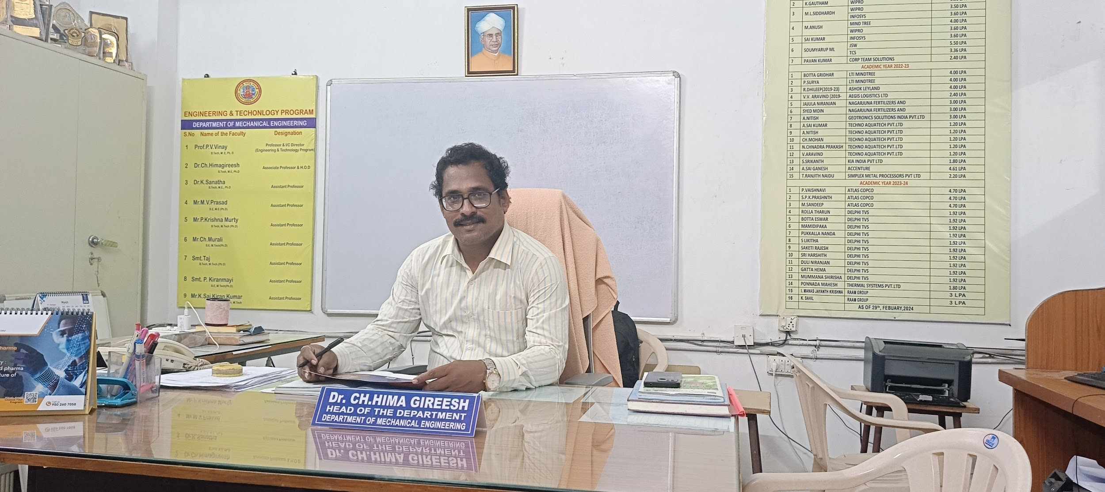

**Mechanical engineering is one of the oldest and broadest engineering disciplines, and plays a significant role in enhancing economic vitality, enjoyment and overall quality of life throughout the world. It is concerned with the design, development, manufacture, installation, testing, operation, maintenance and management of machines, mechanical and mechatronic systems, automated systems and robotic devices, materials and materials handling systems, process plant etc. Mechanical engineering is directly or indirectly involved in the creation of a large number of products for the human needs in almost all areas of life and work.**

**It is my pleasure and honour to welcome you to the Department of Mechanical Engineering. The department is spearheaded by a highly competent, dedicated, well qualified and experienced faculty who always strive for imparting quality in technical education. The department has sophisticated laboratory facilities to conduct experiments and research works on different specialized areas in Mechanical Engineering. Our faculty members are continuously attending various training programs, publishing research papers, book chapters and books. The department has been conducting seminars / conferences to keep the faculty and students abreast with the latest developments in the field of technical education. We are happy to share that many students are working in reputed industries and pursuing higher studies in leading universities in India and abroad.**

**Dr. Ch. Hima Gireesh**

**Associate Professor & H.O.D**

**B.Tech, M.E, Ph.D**

**Sub - Heading :**[**Faculty**](https://gvpcdpgc.edu.in/mech/mech_faculty_list.php)

##### List of Faculty Members

|  | **Name-Designation-Qualification** | **Area-of-Specialization** | **E-mail** | **Date of Joining** | **Nature-of-Association** |
| --- | --- | --- | --- | --- | --- |
|  | [**Dr. P.V. Vinay**](https://gvpcdpgc.edu.in/mech/mech_data/PVV.pdf)  **Professor & Dean Academic Affairs**  **B.Tech, M. E, Ph. D** | **Heat transfer in Energy Systems,**  **Manufacturing** | **vpragada@gvpcdpgc.edu.in**  [**Profile**](https://gvpcdpgc.edu.in/mech/mech_data/PVV.pdf) | **04-08-2011** | **Regular** |
|  | [**Dr. Ch. Himagireesh**](https://gvpcdpgc.edu.in/mech/mech_data/Dr.%20Ch.%20Himagireesh.pdf)  **Associate Professor & H.O.D**  **B.Tech, M.E, Ph.D** | **CAD/CAM** | **gireeshhima@gvpcdpgc.edu.in**  [**Profile**](https://gvpcdpgc.edu.in/mech/mech_data/Dr.%20Ch.%20Himagireesh.pdf) | **13-06-2013** | **Regular** |
|  | [**Sri. M.V.Prasad**](https://gvpcdpgc.edu.in/mech/mech_data/M.V.%20Prasad.pdf)  **Assistant Professor,**  **B. E, M. E** | **Industrial Engineering** | **prasad_mv@gvpcdpgc.edu.in**  [**Profile**](https://gvpcdpgc.edu.in/mech/mech_data/M.V.%20Prasad.pdf) | **18-06-2014** | **Regular** |
|  | [**Mr. P. Krishna Murty**](https://gvpcdpgc.edu.in/mech/mech_data/.pdf)  **Assistant Professor,**  **B.Tech, M.Tech** | **Machine Design** | **pkrishnamurthy@gvpcdpgc.edu.in**  [**Profile**](https://gvpcdpgc.edu.in/mech/mech_data/PKM.pdf) | **02-11-2016** | **Regular** |
|  | [**Mr. Ch.Murali**](https://gvpcdpgc.edu.in/mech/mech_data/CHM.pdf)  **Assistant Professor,**  **B.E, M.Tech** | **CAD/CAM** | **murali@gvpcdpgc.edu.in**  [**Profile**](https://gvpcdpgc.edu.in/mech/mech_data/CHM.pdf) | **09-07-2018** | **Regular** |
|  | [**Smt. Taj**](https://gvpcdpgc.edu.in/mech/mech_data/Taj.pdf)  **Assistant Professor,**  **B.Tech, M.Tech** | **CAD** | **taj@gvpcdpgc.edu.in**  [**Profile**](https://gvpcdpgc.edu.in/mech/mech_data/Taj.pdf) | **11-07-2019** | **Regular** |
|  | [**Smt. P.Kiranmayi**](https://gvpcdpgc.edu.in/mech/mech_data/kiranmayi%20resume.pdf)  **Assistant Professor,**  **B.E, M.Tech** | **Industrial Engineering** | **pkiranmayi@gvpcdpgc.edu.in**  [**Profile**](https://gvpcdpgc.edu.in/mech/mech_data/PK.pdf) | **02-08-2019** | **Regular** |
|  | [**Mr. K Sai Kiran Kumar**](https://gvpcdpgc.edu.in/mech/mech_data/sai%20kiran%20kumar%20k.pdf)  **Assistant Professor,**  **B.Tech, M.Tech** | **Design and Manufacturing** | **saikirankumar@gvpcdpgc.edu.in**  [**Profile**](https://gvpcdpgc.edu.in/mech/mech_faculty_list.php#) | **19-01-2023** | **Regular** |

**Sub - Heading :**[**Syllabus**](https://gvpcdpgc.edu.in/mech/mech_syllabus.php)

#### B.Tech Syllabus

* R22 Regulation (From admitted batch 2022-2023)R22_ME_I YEAR SYLLABUS[**Click Here**](https://gvpcdpgc.edu.in/mech/mech_data/Syllabus/R22%20Regulation/B.Tech_ME_R22_I_Year_I_Semester_and_II_Year_II_Semester_Syllabus_Autonomous.pdf)
* **R22_ME_II YEAR SYLLABUS**[**Click Here**](https://gvpcdpgc.edu.in/mech/mech_data/Syllabus/R22%20Regulation/R22_MECH_II-yr-syllabus.pdf)
* R20 Regulation (From admitted batch 2020-2021)R20_ME_I YEAR SYLLABUS[**Click Here**](https://gvpcdpgc.edu.in/mech/mech_data/Syllabus/R20%20Regulation/R20_ME_I%20YEAR%20SYLLABUS.pdf)
* **R20_ME_II YEAR SYLLABUS**[**Click Here**](https://gvpcdpgc.edu.in/mech/mech_data/Syllabus/R20%20Regulation/R20_ME_II%20YEAR%20SYLLABUS.pdf)
* **R20_ME_III YEAR SYLLABUS**[**Click Here**](https://gvpcdpgc.edu.in/mech/mech_data/Syllabus/R20%20Regulation/B.Tech_ME_R20_III_Year_I_Semester_II_Semester_Syllabus.pdf)
* **R20_ME_IV YEAR I SEM SYLLABUS**[**Click Here**](https://gvpcdpgc.edu.in/mech/mech_data/Syllabus/R20%20Regulation/B.Tech_ME_R20_IV_Year_I_Semester_and_IV_Year_II_Semester_Syllabus_Autonomous.pdf)
* R19 Regulation (From admitted batch 2019-2020)R19_ME_I YEAR SYLLABUS[**Click Here**](https://gvpcdpgc.edu.in/mech/mech_data/Syllabus/R19%20Regulation/R19_ME_I%20YEAR%20SYLLABUS.pdf)
* **R19_ME_II YEAR SYLLABUS**[**Click Here**](https://gvpcdpgc.edu.in/mech/mech_data/Syllabus/R19%20Regulation/R19_ME_II%20YEAR%20SYLLABUS.pdf)
* **R19_ME_III YEAR SYLLABUS**[**Click Here**](https://gvpcdpgc.edu.in/mech/mech_data/Syllabus/R19%20Regulation/R19_ME_III%20YEAR%20SYLLABUS.pdf)
* AU Syllabus (From admitted batch 2015-2016)ME AU SYLLABUS[**Click Here**](https://gvpcdpgc.edu.in/mech/mech_data/Syllabus/AU%20Syllabus/ME%20AU%20SYLLABUS.pdf)

**Sub - Heading :**[**Academic Calender**](https://gvpcdpgc.edu.in/mech/mech_academic_cal.php)

##### Academic Calendar

* **Academic Calendar for Academic Batch 2023-24 Odd & Even Semester** [**Click Here**](https://gvpcdpgc.edu.in/mech/mech_data/Academic-Calendar_2023-24%20(1).pdf)
* **Academic Calendar for Academic Batch 2022-23 Odd & Even Semester** [**Click Here**](https://gvpcdpgc.edu.in/mech/mech_data/Academic_Calendar_22-23.pdf)
* **Academic Calendar for Academic Batch 2021-22 Odd & Even Semester** [**Click Here**](https://gvpcdpgc.edu.in/mech/mech_data/Academic-Calendar-2020-21-Even.pdf)
* **Academic Calendar for Academic Batch 2020-21 Odd & Even Semester** [**Click Here**](https://gvpcdpgc.edu.in/mech/mech_data/Academic-Calendar-2020-21-Odd.pdf)
* **Academic Calendar for Academic Batch 2019-20 Even Semester** [**Click Here**](https://gvpcdpgc.edu.in/mech/mech_data/Academic%20Calender-2019-20-Even.pdf)
* **Academic Calendar for Academic Batch 2019-20 Odd Semester** [**Click Here**](https://gvpcdpgc.edu.in/mech/mech_data/Academic%20calender%202019-20%20-%20Odd.pdf)
* **Academic Calendar for Academic Batch 2018-19 Even Semester** [**Click Here**](https://gvpcdpgc.edu.in/mech/mech_data/Academic%20Calender-2018-19-Even.pdf)
* **Academic Calendar for Academic Batch 2018-19 Odd Semester** [**Click Here**](https://gvpcdpgc.edu.in/mech/mech_data/Academic%20Calender-2018-19-Odd)

##### Time Tables

* **Time Table 2021-22-Even-Sem** [**Click Here**](https://gvpcdpgc.edu.in/mech/mech_data/Time%20Table%202021-22-Even-Sem.pdf)
* **Time Table 2021-22-Odd-Sem** [**Click Here**](https://gvpcdpgc.edu.in/mech/mech_data/Timetable%202021-22%20odd.pdf)
* **Time Table 2020-21-Even-Sem** [**Click Here**](https://gvpcdpgc.edu.in/mech/mech_data/Timetable%202020-21%20even.pdf)
* **Time Table 2020-21-Odd-Sem** [**Click Here**](https://gvpcdpgc.edu.in/mech/mech_data/Timetable%202020-21%20odd.pdf)
* **Time Table 2019-20-Even-Sem** [**Click Here**](https://gvpcdpgc.edu.in/mech/mech_data/Timetable%202019-20even.pdf)
* **Time Table 2019-20-Odd-Sem** [**Click Here**](https://gvpcdpgc.edu.in/mech/mech_data/Timetable%202019-20odd.pdf)

**Sub - Heading :** [**Infrastructure**](https://gvpcdpgc.edu.in/mech/mech_labs.php)

#### Labs List

* Mechanical Department Labs List [**Click Here**](https://gvpcdpgc.edu.in/mech/mech_data/mech_Facilities_tab_website.pdf)

#### **Labs facilities**

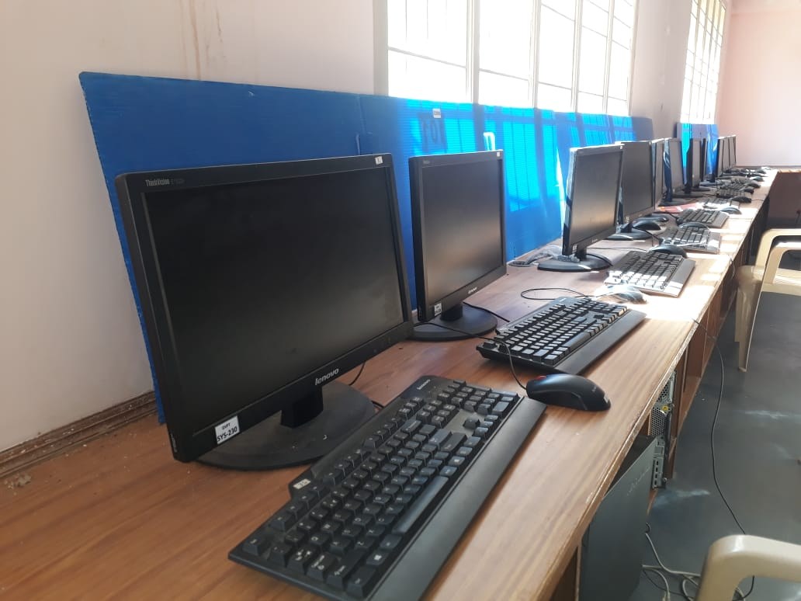

**CAD LAB**

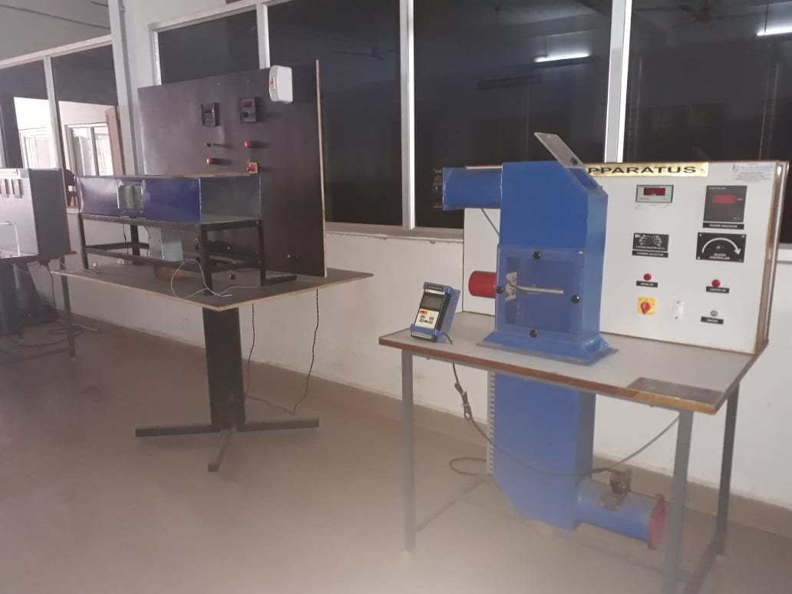

**HEAT AND MASS TRANSFER LAB**

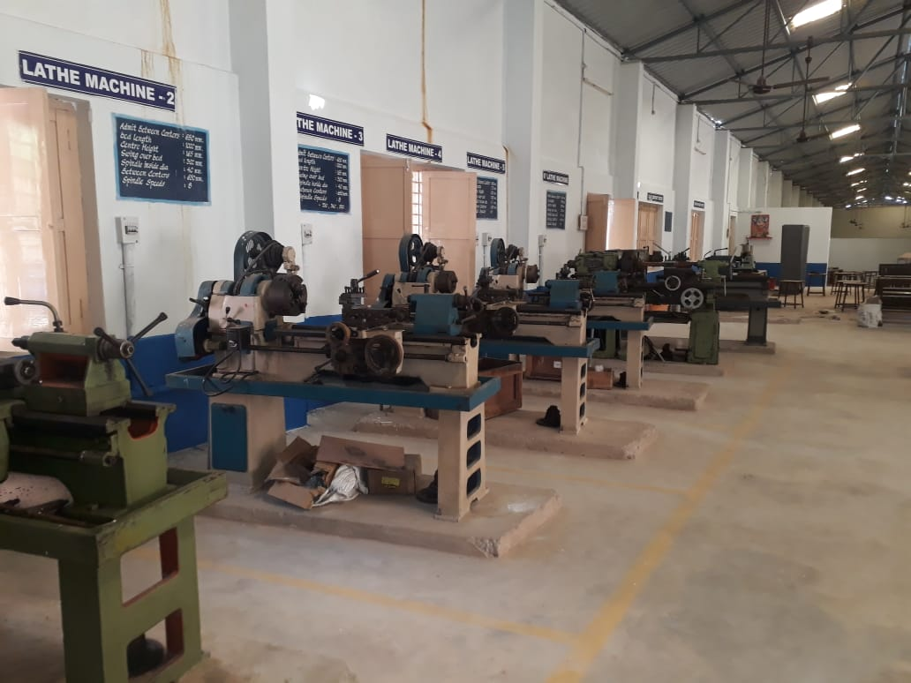

**MANUFACTURING TECHNOLOGY LAB I**

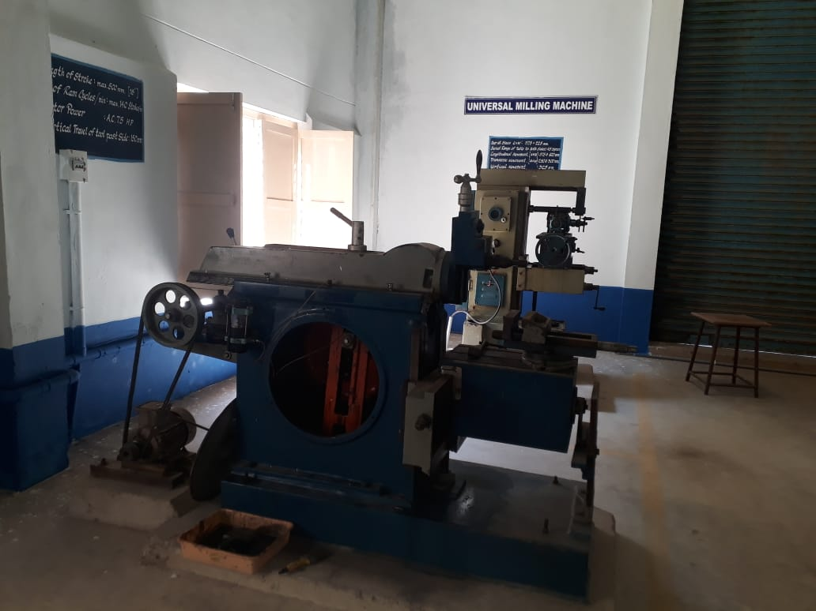

**MANUFACTURING TECHNOLOGY LAB II**

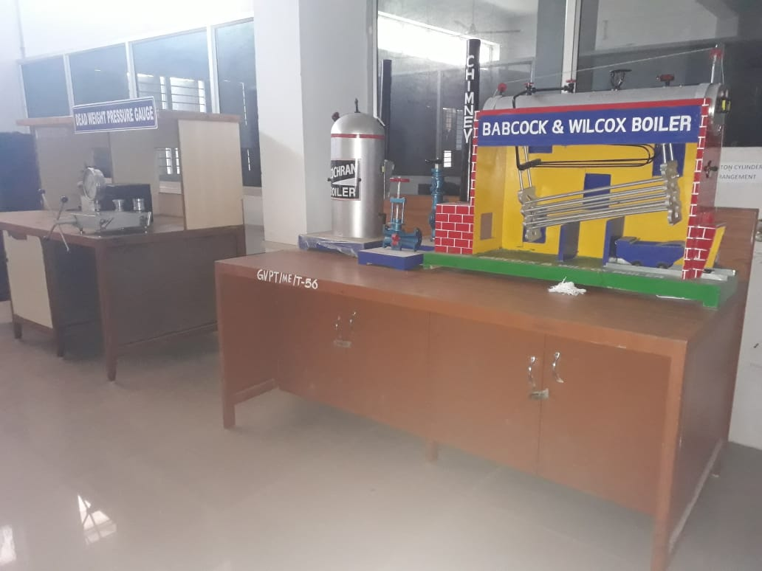

**MECHANICAL ENGINEERING LAB I**

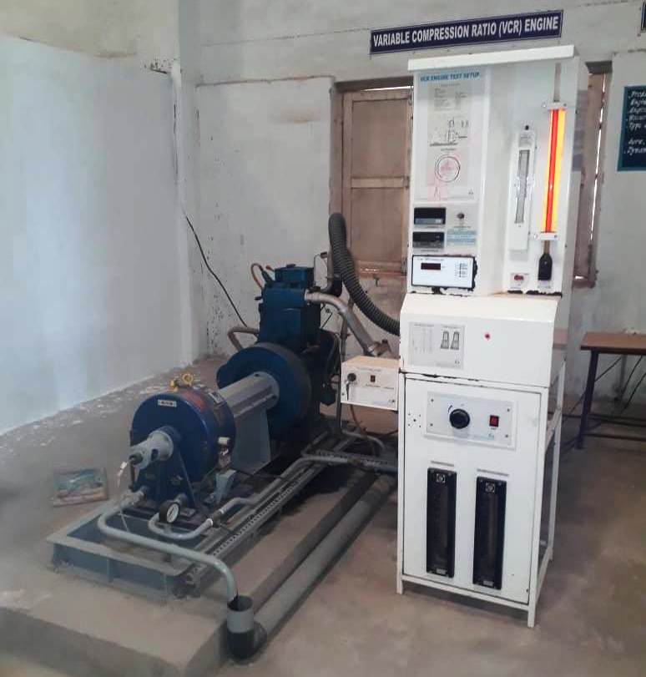

**MECHANICAL ENGINEERING LAB II**

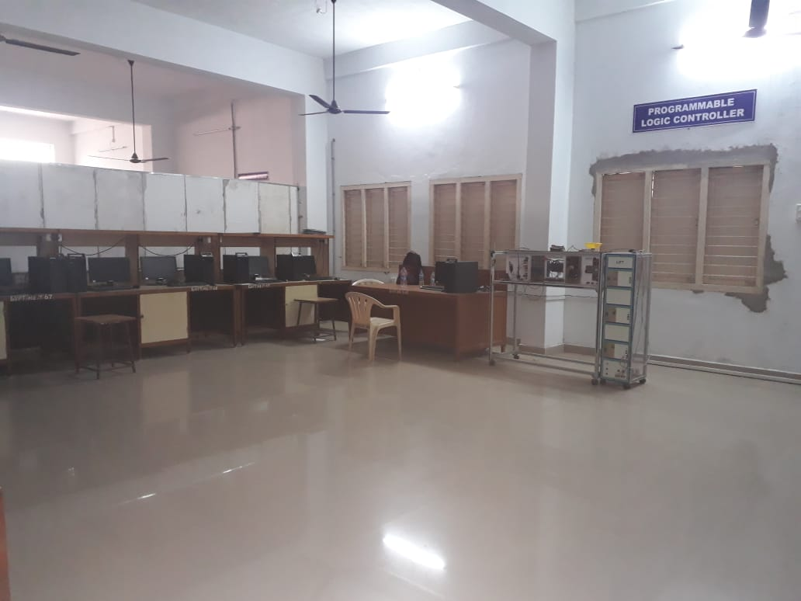

**METROLOGY AND MECHATRONICS LAB**

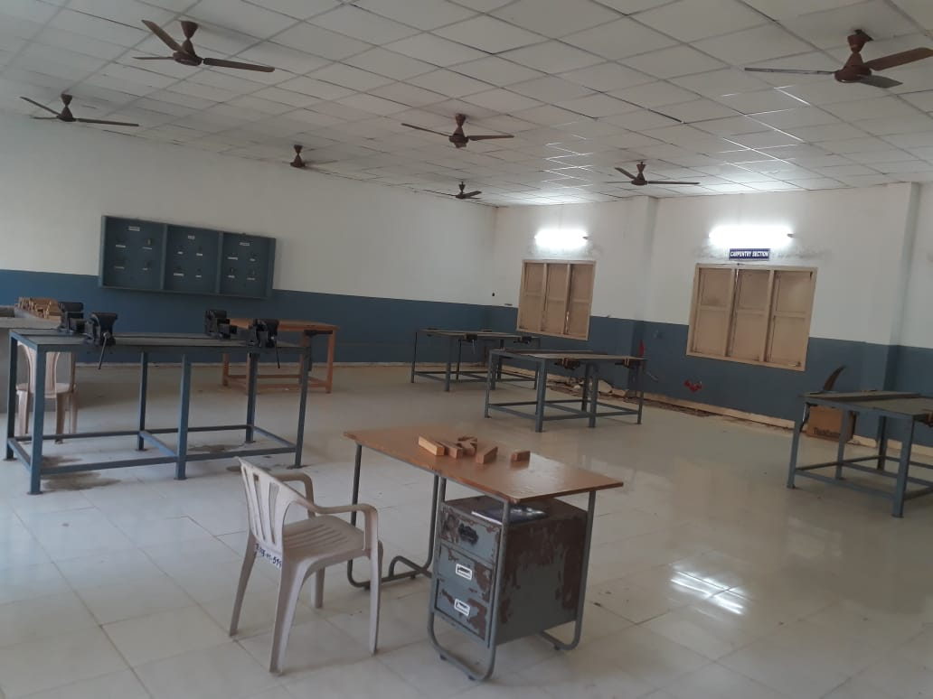

**WORKSHOP**

#### **Research Based Lab**

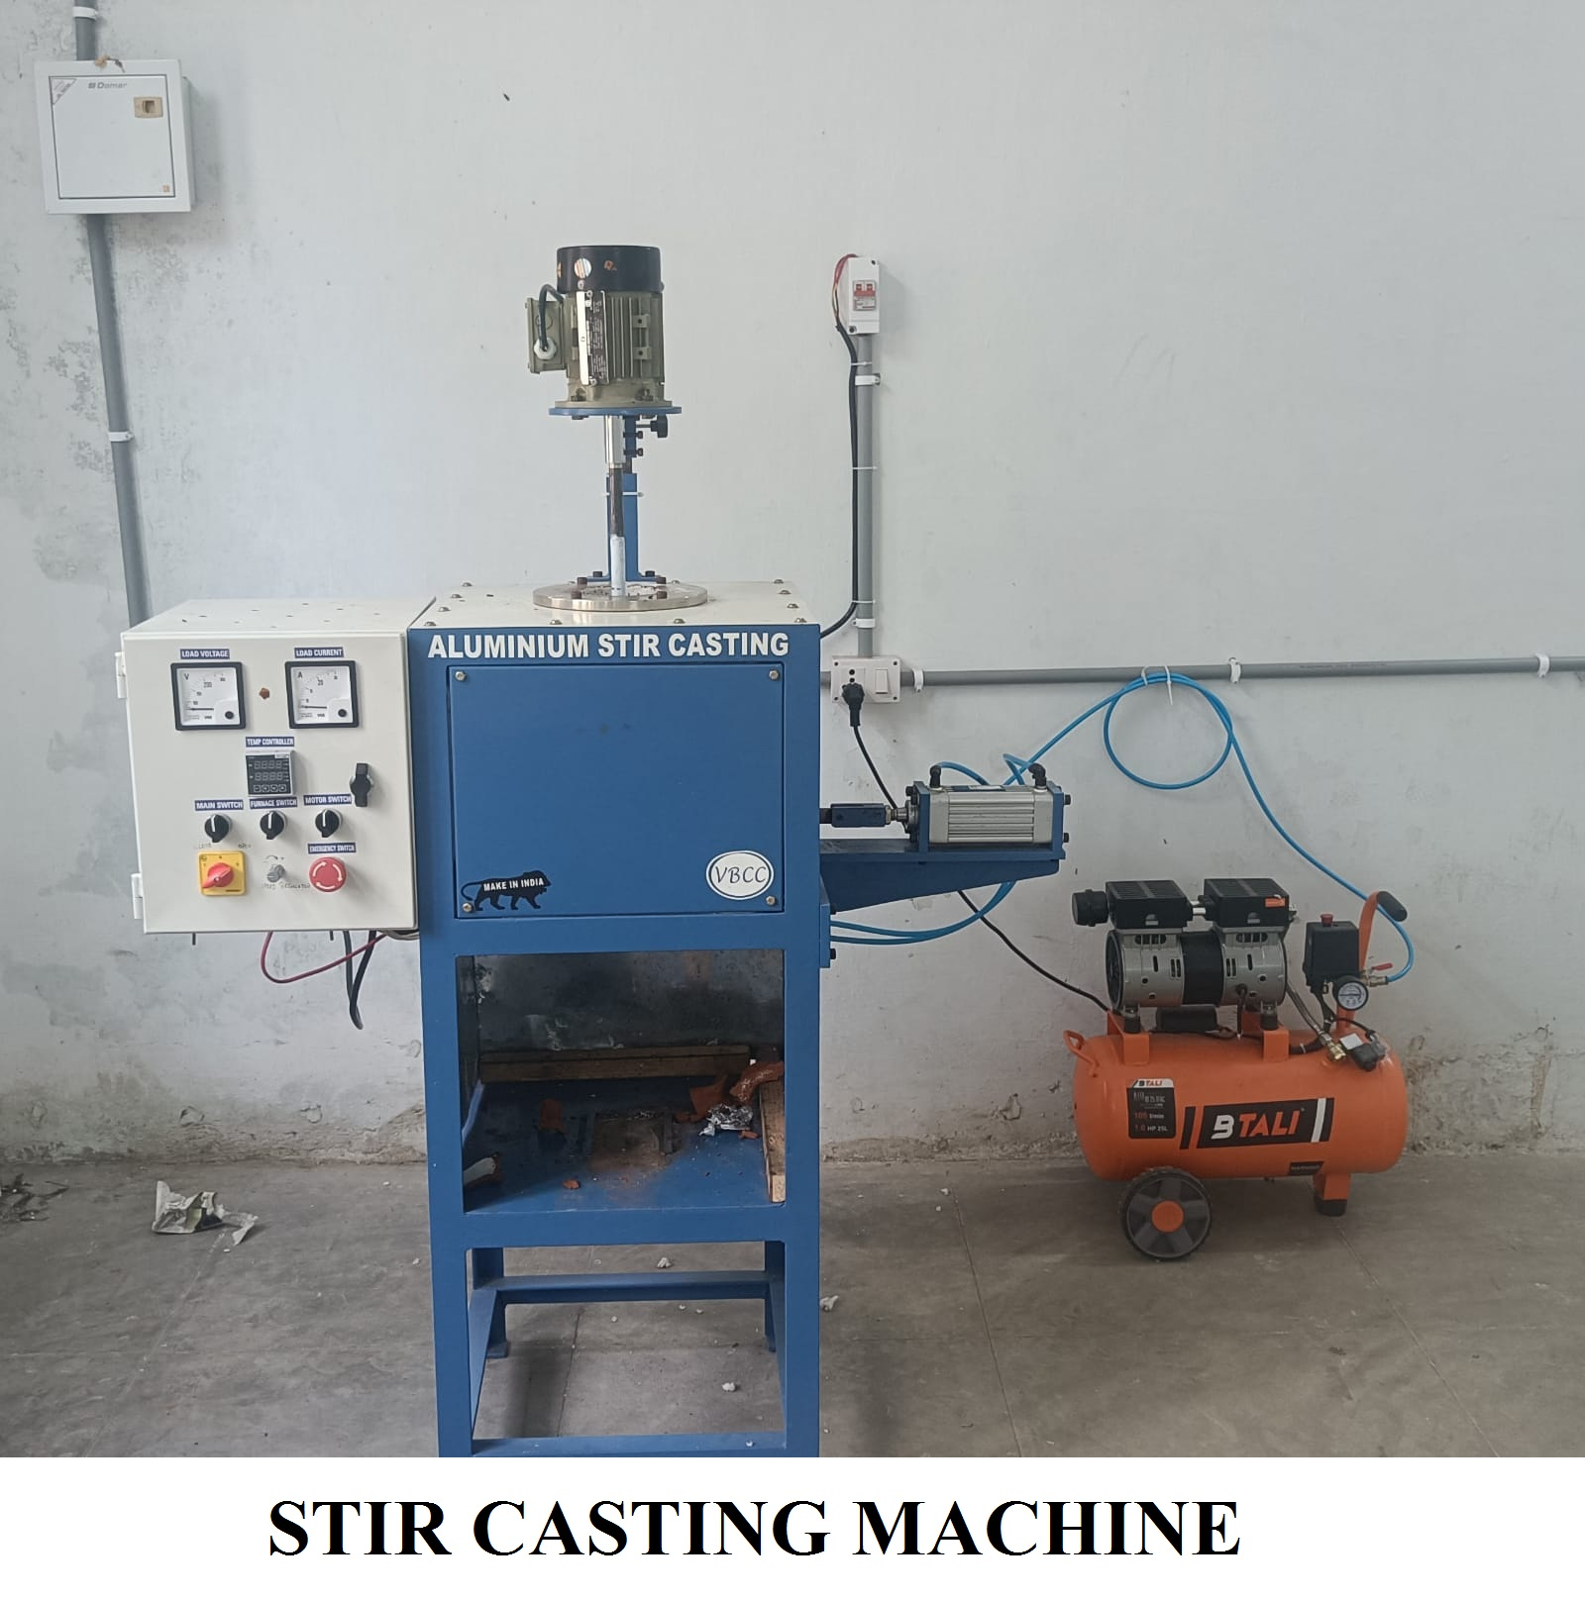

#### Nonteaching Staff

* List of non teaching staff [**Click Here**](https://gvpcdpgc.edu.in/mech/mech_data/list_of_NT.pdf)

**Sub - Heading :** [**Department Committees**](https://gvpcdpgc.edu.in/mech/mech_dept_committe.php)

##### List of Departmantal Committees

**The purpose of the committee is to advise on how departmental leadership can be supported and enhanced in their administrative and faculty governance responsibilities. The committees work on all aspects of academic operations for the smooth functioning of the department.**

## 1. Department Class Committees(DCC)

Objectives:

* Oversee class schedules and adjust time tables as needed
* Suggest class discipline parameters
* Review and resolve class/individual (faculty and student) discipline issues
* Suggest student counselling and PTM dates and times

Members:

* Mr. M V Prasad(Coordinator)
* Dr. Ch Himagireesh (Coordinator)
* Mrs. Taj (Coordinator)

## 2. Department Academic Committee (DAC)

The purpose of the committee is to advise on how departmental leadership can be supported and enhanced in their administrative and faculty governance responsibilities. The committees work on all aspects of academic operations for the smooth functioning of the department.

Objectives:

The DAC will have wide responsibility for oversight of all matters related to

* Student Admissions (Cat A, Cat B, ECET)
* Student Results Analysis (Regular, Supplementary)
* Time Tables
* Department Academic Calendar and List of holidays
* Schedule of Events to be organized
* Examinations
* Professional Body Memberships and Activities
* Faculty Leave Status
* Any other Academic issues

Members:

* Dr. K.G. Durga Prasad (Chair)
* Dr. Ch Himagireesh (Coordinator)
* Dr. B. V. Ramana Murthy (Member)
* Dr. P. V. Vinay (Member)
* Sri. M.V. Prasad (Member)
* Dr. K. Sanatha (Member)
* Mr. P. Krishna Murthy (Member)
* Mr. Ch. Murali (Member)
* Mrs. Taj (Member)
* Mrs. P. Kiranmayi (Member)
* Other Faculty members will be deputed whenever necessary

## 3. Department Project Review Committee (DPRC)

Objectives:

* Create Final year Project deadlines
* Conduct periodic project reviews
* Conduct Final Viva Voce and award grades

Members:

* Mr. M.V. Prasad(Coordinator)
* Dr. B.V. Ramana Murthy (Member)
* Dr. P.V. Vinay (Member)
* Dr. K.G. Durga Prasad (Member)

**Sub - Heading :** [**Placements**](https://gvpcdpgc.edu.in/mech/mech_placement.php)

##### Placements

* Placements-2023-24 [Click Here](https://gvpcdpgc.edu.in/mech/mech_data/Placements%2023-24.pdf)
* Placements-2022-23 [Click Here](https://gvpcdpgc.edu.in/mech/mech_data/Placements%2022-23.pdf)
* Placements-2021-22 [Click Here](https://gvpcdpgc.edu.in/mech/mech_data/Placements-2021-22.pdf)
* Placements-2020-21 [Click Here](https://gvpcdpgc.edu.in/mech/mech_data/Placements%202020-21.pdf)
* Placements-2019-20 [Click Here](https://gvpcdpgc.edu.in/mech/mech_data/Placements%202019-20.pdf)
* Placements-2018-19 [Click Here](https://gvpcdpgc.edu.in/mech/mech_data/Placements2018-19.pdf)

##### Higher Studies of Students

* Higher Studies-2020-21 [Click Here](https://gvpcdpgc.edu.in/mech/mech_data/Higher%20Studies%20Till%20Now%202020-21.pdf)
* Higher Studies-2019-20 [Click Here](https://gvpcdpgc.edu.in/mech/mech_data/Higher%20Studies%20Till%20Now%202019-20.pdf)
* Higher Studies-2018-19 [Click Here](https://gvpcdpgc.edu.in/mech/mech_data/Higher%20Studies%20Till%20Now%202018-19.pdf)
* Higher Studies-2017-18 [Click Here](https://gvpcdpgc.edu.in/mech/mech_data/Higher%20Studies%20Till%20Now%202017-18.pdf)

**Sub - Heading :** [**Research & Innovations**](https://gvpcdpgc.edu.in/mech/mech_research.php)

#### Faculty publications

* Faculty Publications of Academic Year 2022-23 [Click Here](https://gvpcdpgc.edu.in/mech/mech_data/Publication%20file%202022-2023.pdf)
* Faculty Publications of Academic Year 2021-22 [Click Here](https://gvpcdpgc.edu.in/mech/mech_data/Faculty%20Publications%20of%20Academic%20Year%202021-22.pdf)
* Faculty Publications of Academic Year 2020-21 [Click Here](https://gvpcdpgc.edu.in/mech/mech_data/Faculty%20Publications%20of%20Academic%20Year%202020-21.pdf)
* Faculty Publications of Academic Year 2019-20 [Click Here](https://gvpcdpgc.edu.in/mech/mech_data/Publication%202019-20.pdf)
* Faculty Publications of Academic Year 2018-19 [Click Here](https://gvpcdpgc.edu.in/mech/mech_data/Publication%202018-19.pdf)

#### Faculty as Research Supervisor

* Faculty as Research Supervisor[Click Here](https://gvpcdpgc.edu.in/mech/mech_data/FACULTY%20AS%20RESEARCH%20SUPERVISOR.pdf)

**Sub - Heading :** [**Activities**](https://gvpcdpgc.edu.in/mech/mech_facultyactivities.php)

##### Faculty Activities

* List of Events Organized for the Academic Year 2022-2023 [Click Here](https://gvpcdpgc.edu.in/mech/mech_data/Events%20organised%202022-23.pdf)
* List of Events Organized for the Academic Year 2021-2022 [Click Here](https://gvpcdpgc.edu.in/mech/mech_data/Event%20organised%202021-22.pdf)
* List of Events Organized for the Academic Year 2020-2021 [Click Here](https://gvpcdpgc.edu.in/mech/mech_data/Event%20organised%202020-21.pdf)
* List of Events Organized for the Academic Year 2019-2020 [Click Here](https://gvpcdpgc.edu.in/mech/mech_data/Event%20organised%202019-20.pdf)
* List of FDP/Seminars Attended 2022-23 [Click Here](https://gvpcdpgc.edu.in/mech/mech_data/seminor,FDP%20attended%202022-23.pdf)
* List of FDP/Seminars Attended 2021-22 [Click Here](https://gvpcdpgc.edu.in/mech/mech_data/List%20of%20FDP%20Seminars%20Attended%202021-22.pdf)
* List of FDP/Seminars Attended 2020-21 [Click Here](https://gvpcdpgc.edu.in/mech/mech_data/FDP%20Seminars%202020-21.pdf)
* List of FDP/Seminars Attended 2019-20 [Click Here](https://gvpcdpgc.edu.in/mech/mech_data/FDP%20Seminars%202019-20.pdf)

##### Student Activities

* Students Seminars/Workshops Attended -2020-21 [Click Here](https://gvpcdpgc.edu.in/mech/mech_data/Seminars%202020-21.pdf)
* Students Seminars/Workshops Attended -2019-20 [Click Here](https://gvpcdpgc.edu.in/mech/mech_data/Seminars%202019-20.pdf)
* Student internship in various industries AY 2021-22 [Click Here](https://gvpcdpgc.edu.in/mech/mech_data/Student%20internship%20in%20various%20industries%20AY%202021-22.pdf)
* Student Industry Visit AY 2021-22 [Click Here](https://gvpcdpgc.edu.in/mech/mech_data/Student%20Industry%20Visit%20AY%202021-22.pdf)

[**CSE - ARTIFICIAL INTELLIGENCE AND MACHINE LEARNING**](https://gvpcdpgc.edu.in/cse/aboutcse.php)

**Sub-Heading :** [**About Department**](https://gvpcdpgc.edu.in/cse/aboutcse.php)

**About Department**

**The Department of Computer Science and Engineering was started in the year 2011 in Engineering and Technology Program, Gayatri Vidya Parishad College for Degree & PG Courses (A). The Department offers B.Tech, Computer Science and Engineering program with a maximum intake of 60. MTech started in 2020-21 AY with an intake of 18. Recently from the Academic Year 2022-23 the intake of the Department is raised to 240 Seats (CSE 180 Seats and CSE AI & ML – 60 Seats). Computer Science and Engineering is the branch of Engineering in which the students trained in the science of practical and theoretical foundations of Information Technology and Computation. The students are exposed to sophisticated computer laboratories and latest trends in Computer Science and Engineering.**

**About B.Tech Admission**

**EAPCET Counseling Code: GVPT**

**Admissions under Category "A" (Convener’s Quota-70% of intake in each branch):**

**A Candidate for admission to the four-year degree program in Engineering must have passed the Intermediate examination of the Board of Intermediate Education, Government of Andhra Pradesh with Mathematics, Physics and Chemistry as optional subjects. All the eligible applicants for admission into First Year shall have to qualify in the EAPCET Examination conducted by the Govt. of AP. The candidates will be admitted strictly in accordance with the merit secured at the Entrance Examination keeping in view the rules in force regarding the reservations of seats of various categories of candidates. The candidates should satisfy local/non-local status requirement as laid down in the AP Educational institutions (Regulation of Admissions) Order 1974 as amended from time to time.**

**Admissions under Category "B" (30% of intake in each branch):**

**ECET Counseling Code: GVPT**

**The Engineering Diploma holders, based on their merit at ECET, are admitted into Lateral Entry (II year B. Tech Courses)**

**The seats shall be filled as per the rules given by APSCHE.**

**About M.Tech Program**

**MTech Computer Science & Technology Program started in the Academic Year 2020-21. It is a two - year Postgraduate program with four semesters. The main purpose behind crafting the M.Tech course is to equip students with the knowledge and abilities desirable to the modern computing industry. MTech in Computer Science & Technology have a wide range of job opportunities in sectors like Consultancy firms, IT companies, Corporate Industry, Multinational companies, Start ups, banking sectors etc.**

**M.Tech Admission Procedure :**

**A Candidate for admission to M.Tech Program by qualify in GATE/PGCET conducted by Govt. Total number of students Intake is 18 and Specialization is Computer Science & Technology.**

**Sub-Heading :** [**Vision & Mission \ PEOs \ PSOs \ POs**](https://gvpcdpgc.edu.in/ece/ece_vision.php)

**Vision**

**The vision of the department is “Create and sustain as a Centre of excellence in Computer Science and Engineering and allied areas of research to pave the way for providing better technocrats to the society”.**

**Mission**

**The mission of the department is “To provide strong *conceptual base (M1)* for acquiring programming skills, to develop high *computational innovative skills (M2)* and to empower *leadership qualities* with strong *ethical base (M3)”*.**

#### B.Tech:

**Program Educational Objectives (PEOs)**

* **PEO1: Ability to develop hardware and software problem solving capabilities by inculcating strong fundamental, analytical, and communication skills.**
* **PEO2: Ability to build confidence to address the challenges in their work and to apply innovative technical tools through interaction with professional bodies.**
* **PEO3: Ability to gain sufficient depth of knowledge, Self-learning skills, technical skills and leadership qualities through participating in personality development activities, so as to sustain in multidisciplinary environment.**
* **PEO4: To be able to respond to societal needs in professional and ethical concerns.**

**Program Specific Outcomes (PSOs)**

* **PSO 1: System Inception and Elaboration: Conceptualize the software and/or hardware systems, system components and processes/procedures through requirement analysis, Modelling/Design of the system using various architectural/design patterns, Standard Notations, procedures and algorithms.**
* **PSO 2: System Construction: Implement the systems, Procedures and Processes using the state of the art technologies, standards, tools and Programming Paradigms.**
* **PSO 3: System Testing and Deployment: Verify and Validate the Systems, Procedures and Processes using various testing and verification techniques and tools.**
* **PSO 4: Quality and Maintenance: Manage the quality through various product development strategies under revision, transition and operation through maintainability, flexibility, testability, portability, reusability, interoperability, correctness, reliability, efficiency, integrity and usability to adapt the system to the changing structure and behavior of the systems/environments.**

**Program Outcomes (POs)**

* **Engineering knowledge: Apply the knowledge of mathematics, science, engineering fundamentals, and an engineering specialization to the solution of complex engineering problems.**
* **Problem analysis: Identify, formulate, review research literature, and analyze complex engineering problems reaching substantiated conclusions using first principles of mathematics, natural sciences, and engineering sciences.**
* **Design/development of solutions: Design solutions for complex engineering problems and design system components or processes that meet the specified needs with appropriate consideration for the public health and safety, and the cultural, societal, and environmental considerations.**
* **Conduct investigations of complex problems: Use research-based knowledge and research methods including design of experiments, analysis and interpretation of data, and synthesis of the information to provide valid conclusions.**
* **Modern tool usage: Create, select, and apply appropriate techniques, resources, and modern engineering and IT tools including prediction and modeling to complex engineering activities with an understanding of the limitations.**
* **The engineer and society: Apply reasoning informed by the contextual knowledge to assess societal, health, safety, legal and cultural issues and the consequent responsibilities relevant to the professional engineering practice.**
* **Environment and sustainability: Understand the impact of the professional engineering solutions in societal and environmental contexts, and demonstrate the knowledge of, and need for sustainable development.**
* **Ethics: Apply ethical principles and commit to professional ethics and responsibilities and norms of the engineering practice.**
* **Individual and team work: Function effectively as an individual, and as a member or leader in diverse teams, and in multidisciplinary settings.**
* **Communication: Communicate effectively on complex engineering activities with the engineering community and with society at large, such as, being able to comprehend and write effective reports and design documentation, make effective presentations, and give and receive clear instructions.**
* **Project management and finance: Demonstrate knowledge and understanding of the engineering and management principles and apply these to one’s own work, as a member and leader in a team, to manage projects and in multidisciplinary environments.**
* **Life-long learning: Recognize the need for, and have the preparation and ability to engage in independent and life-long learning in the broadest context of technological change.**

#### M.Tech:

**Program Educational Objectives (PEOs)**

* **PEO1: To motivate students in learning the advanced concepts to develop real world applications in the thrust areas of Computer Science and Technology.**
* **PEO2: To impart ethical practices in molding graduates to engage in research, leadership roles along diverse career paths and lifelong learning to adapt innovation.**

**Program Specific Outcomes (PSOs)**

* **PSO 1: Applying problem solving skills in a systematic way to Analyze software processes and employable in a product oriented Industry.**
* **PSO 2: Ability to publish research articles in the thrust areas of Computer Science and Technology in quality indexed journals.**

**Program Outcomes (POs)**

* **PO 1:An ability to independently carry out research /investigation and development work to solve practical problems.**
* **PO 2:An ability to write and present a substantial technical report/document.**
* **PO 3:Students should be able to demonstrate a degree of mastery over the area as per the specialization of the program. The mastery should be at a level higher than the requirements in the appropriate bachelor program.**

**Sub - Heading :** **HOD's Message**

#### HOD's Message



Careers in the field of Computer Science and Engineering undergo in very high demand, they offer not only the comforts of a high-paying job, but also the intellectual challenges of a creative and productive profession.

Welcome to Department of Computer Science and Engineering at Gayatri Vidya Parishad College for Degree and PG Courses. Our B.Tech and M.Tech Programs, which are at the forefront of technological advancements, are tailored to empower you with the necessary proficiencies to succeed in the ever-changing tech industry. The Department offers a regular four- year B. Tech in Computer Science and Engineering (CSE) course with an intake of 180 and M.Tech Computer Science & Technology with an intake of 12. Both B.Tech and M.Tech Programs are under the permanent affiliation of Andhra University.

Since 2011, the department is consistently striving hard to offer a high quality, state-of-the-art education in computer science and engineering with well-established laboratories suits to the Industry needs. The department is accredited by NBA and NAAC for its quality education and the institute is ISO certified. We are especially proud of the long and sustained placement records of our Bachelor students in various multinational software companies and our students are pursuing their higher education at different top-class international universities.

Here are some reasons that make CSE at Gayatri Vidya Parishad College exceptional: Curriculum Aligned with Industry Needs: Our curriculum is meticulously crafted to meet the current IT industry's requirements. We consistently revise our courses to ensure that you are proficient in the most pertinent programming languages, software development practices, and technical skills. Learn from Experts: Our faculty members are knowledgeable, dedicated, and many of them hold Ph.D.s. They are actively engaged in research, which allows them to bring current, real-world insights into the classroom. Practical Experience: We prioritize hands-on learning in addition to theoretical knowledge. Our program incorporates projects, labs, and internships where you'll create real-world software applications, solve intricate problems, and acquire the practical experience that employers seek. Collaboration with Industry: We narrow the gap between academia and industry by offering internships with leading companies. These opportunities enable you to apply your knowledge in practical settings and establish valuable professional connections. Dynamic Learning Opportunities: Improve your skills through various active learning avenues. Participate in coding competitions, hackathons, and student-led clubs like ACM (Association for Computing Machinery) to push your boundaries, collaborate with peers, and create an impressive technical portfolio. Innovation through Projects: Unlock your creativity by working on innovative projects under the guidance of our faculty. You'll address real-world issues in areas such as web development, mobile app creation, data science, and artificial intelligence. Stay Ahead of Tech Trends: Keep up-to-date with technological advancements through our workshops, guest lectures, and seminars featuring industry experts. These events will provide you with the latest trends and emerging technologies in computer science. Holistic Growth: We foster holistic development by encouraging participation in co-curricular and extracurricular activities to enhance your communication, teamwork, and leadership skills.

The Department of Computer Science and Engineering aims to create a Center of Excellence and prepare students to be skilled technologists and well-rounded individuals who positively impact society. This aligns with the college's mission of "Creating Human Excellence for a Better Society." The department believes a strong computer science foundation, critical thinking, and ethical practices empower graduates to be future leaders and innovators.

I welcome all the aspirants to be a part of CSE family and wish them a bright future!

Dr. G.R.S. Murthy,M. Tech, Ph. D

Professor & HOD  
Contact: hodcse@gvpcdpgc.edu.in

Predecessor: Dr.N.V.Ramana Murthy, Professor  
Duration: 01/07/2021 to 01/05/2024

Predecessor: Dr. T.M.N. Vamsi , Professor  
Duration: 11/01/2018 to 30/06/2021

**Sub - Heading : Faculty**

##### List of Faculty Members

|  | **Name-Designation-Qualification** | **Area-of-Specialization** | **E-mail** | **Date of Joining** | **Nature-of-Association** |
| --- | --- | --- | --- | --- | --- |
|  | [**Prof. D. Saritha**](https://gvpcdpgc.edu.in/cse/cse_data/saritha.pdf)  **Vice - Principal**  **B.E, M.Tech** | **Databases & Data Mining** | **sarithad@gvpcdpgc.edu.in**  [**Profile**](https://gvpcdpgc.edu.in/cse/cse_data/saritha.pdf) | **01-07-1995** | **Regular** |
|  | [**Dr. N.V. Ramana Murthy**](https://gvpcdpgc.edu.in/cse/cse_data/Dr.N.V.Ramana_Murty.pdf)  **Professor & H.O.D (CSE(AI&ML))**  **M. Tech, Ph. D** | **Artificial Intelligence & Robotics,**  **Machine Learning** | **drnvrmurty@gvpcdpgc.edu.in.edu.in**  [**Profile**](https://gvpcdpgc.edu.in/cse/cse_data/Dr.N%20V%20RAMANA%20MURTY%20latest%20RESUME.pdf) | **19-06-2004** | **Regular** |
|  | **Dr.G.R.S Murthy**  **Professor & H.O.D (CSE)**  **M.Tech,Ph.D** | **Computer Vision** | **murthy.grs@gvpcdpgc.edu.in**  [**Profile**](https://gvpcdpgc.edu.in/cse/cse_data/Dr.GRS_Murthy_CV.pdf) | **27-04-2021** | **Regular** |
|  | [**Dr. Bh. Padma**](https://gvpcdpgc.edu.in/cse/cse_data/Bh_Padma.pdf)  **Associate Professor**  **M.Tech ,Ph.D** | **Cryptography and Network Security** | **padmabh@gvpcdpgc.edu.in**  [**Profile**](https://gvpcdpgc.edu.in/cse/cse_data/BhP-profile%20by%20Aug%202021.pdf) | **22-08-2005** | **Regular** |
|  | [**Dr. D Chandravathi**](https://gvpcdpgc.edu.in/cse/cse_faculty_list.php#)  **Associate Professor**  **M.Tech,Ph.D** | **Cloud Security** | **chandravathid@gvpcdpgc.edu.in**  [**Profile**](https://gvpcdpgc.edu.in/mca/.pdf) | **30-09-2022** | **Regular** |
|  | [**Dr. K N Brahmaji Rao**](https://gvpcdpgc.edu.in/cse/cse_faculty_list.php#)  **Associate Professor**  **M.Tech,Ph.D** | **Aritificial Intelligence** | **brahmaji77@gvpcdpgc.edu.in**  [**Profile**](https://gvpcdpgc.edu.in/mca/.pdf) | **01-07-2023** | **Regular** |
|  | [**Dr D.S.S.N.Raju**](https://gvpcdpgc.edu.in/cse/cse_faculty_list.php#)  **Assistant Professor,**  **Ph.D** | **Wireless Sensor Networks, VLSI** | **trijeth@gvpcdpgc.edu.in**  [**Profile**](https://gvpcdpgc.edu.in/cse/cse_faculty_list.php#) | **30-09-2022** | **Regular** |
|  | [**Sri. G. Kalyan Chakravarthi**](https://gvpcdpgc.edu.in/cse/cse_data/G_Kalyan_Chakravarthi.pdf)  **Assistant Professor,**  **B. Tech, M. Tech** | **Computer Science & Technology** | **gkalyan@gvpcdpgc.edu.in**  [**Profile**](https://gvpcdpgc.edu.in/cse/cse_data/G_Kalyan.pdf) | **25-11-2016** | **Regular** |
|  | **Sri R.Kanaka Raju**  **Assistant Professor,**  **M.Tech** | **BIG DATA** | **rkanakaraju@gvpcdpgc.edu.in**  [**Profile**](https://gvpcdpgc.edu.in/cse/cse_faculty_list.php#) | **15-12-2022** | **Regular** |
|  | **Smt L.Pratibha**  **Assistant Professor,**  **M.C.A., M.Tech.** | **MACHINE LEARNING** | **pratibha@gvpcdpgc.edu.in**  [**Profile**](https://gvpcdpgc.edu.in/cse/cse_faculty_list.php#) | **15-04-2023** | **Regular** |
|  | **Mr. M. Anil**  **Assistant Professor,**  **B. Tech, M. Tech** | **Computer Science and Engineering** | **anilmeka@gvpcdpgc.edu.in**  [**Profile**](https://gvpcdpgc.edu.in/cse/cse_data/resumeanil.pdf) | **05-01-2022** | **Regular** |
|  | **Mr. S. Arun Kumar**  **Assistant Professor,**  **B. Tech, M. Tech** | **Computer Science and Technology** | **arunkumar@gvpcdpgc.edu.in**  [**Profile**](https://gvpcdpgc.edu.in/cse/cse_faculty_list.php#) | **15-12-2022** | **Regular** |
|  | **Ms. D M V Priya**  **Assistant Professor,**  **B. Tech, M. Tech** | **Artificial Intelligence and Robotics** | **priya@gvpcdpgc.edu.in**  [**Profile**](https://gvpcdpgc.edu.in/cse/cse_data/priya_resume.pdf) | **05-06-2023** | **Regular** |
|  | **Mr Ch.Bhanu Kumar**  **Assistant Professor,**  **B. Tech, M. Tech** | **Computer Science and Technology** | **bhanu.chappa@gvpcdpgc.edu.in**  [**Profile**](https://gvpcdpgc.edu.in/cse/cse_data/) | **01-12-2023** | **Regular** |

Sub - Heading : [**Syllabus**](https://gvpcdpgc.edu.in/ece/ece_syllabus.php)

#### M.Tech Syllabus

* M.Tech Syllabus (With effect from 2020-2021 admitted batch) Autonomous [**Click Here**](https://drive.google.com/file/d/1tfqPbcJM35LyXSObm0_COhKvL67R_Ng8/view?usp=sharing)

#### B.Tech Syllabus

* B.TECH CSE-AIML R22 Regulation (From admitted batch 2022-2023)**B.Tech CSE-AIML R22 First Year and Second Year Syllabus (With effect from 2022-2023 admitted batch) Autonomous** [**Click Here**](https://gvpcdpgc.edu.in/cse/cse_data/R22_B.Tech_CSE_AI&ML_Structure_and_Syllabus.pdf)
* B.TECH CSE R22 Regulation (From admitted batch 2022-2023)**B.Tech CSE R22 First Year and Second Year Syllabus (With effect from 2022-2023 admitted batch) Autonomous** [**Click Here**](https://gvpcdpgc.edu.in/cse/cse_data/R22_B.Tech_CSE_Structure_and_Syllabus.pdf)
* B.TECH CSE R20 Regulation (From admitted batch 2020-2021)**B.Tech CSE R20 Syllabus(With effect from 2020-2021 admitted batch) Autonomous** [**Click Here**](https://gvpcdpgc.edu.in/cse/cse_data/B.Tech_CSE_R20_Syllabus.pdf)
* B.TECH CSE R19 Regulation (From admitted batch 2019-2020)**B.Tech CSE R19 Syllabus (With effect from 2019-2020 admitted batch) Autonomous** [**Click Here**](https://gvpcdpgc.edu.in/cse/cse_data/B.Tech_CSE_R19_Syllabus.pdf)
* B.TECH CSE AU Syllabus (From admitted batch 2015-2016)**CSE Syllabus (With effect from 2015-2016 admitted batch to 2018-19)** [**Click Here**](https://gvpcdpgc.edu.in/cse/cse_data/BTech_CSE_Syllabus_and_Schemes_2016-17.pdf)

Sub - Heading : [**Academic Calender**](https://gvpcdpgc.edu.in/ece/ece_academic_cal.php)

##### Academic Calendar

* **Academic Calendar for Academic Batch 2023-24**  [**Click Here**](https://gvpcdpgc.edu.in/cse/cse_data/DEPARTMENT%20CALENDAR%202023-2024.pdf)
* **Academic Calendar for Academic Batch 2022-23**  [**Click Here**](https://gvpcdpgc.edu.in/cse/cse_data/DEPARTMENT%20CALENDAR%202022-2023.pdf)
* **Academic Calendar for Academic Batch 2021-22**  [**Click Here**](https://gvpcdpgc.edu.in/cse/cse_data/DEPARTMENT_CALENDAR_2021-2022.pdf)
* **Academic Calendar for Academic Batch 2020-21**  [**Click Here**](https://gvpcdpgc.edu.in/cse/cse_data/academic_cal_202_21.pdf)
* **Academic Calendar for Academic Batch 2019-20 Even Semester** [**Click Here**](https://gvpcdpgc.edu.in/cse/cse_data/2019-20%20Even%20SEM%20Academic%20Calendar.pdf)
* **Academic Calendar for Academic Batch 2019-20 Odd Semester** [**Click Here**](https://gvpcdpgc.edu.in/cse/cse_data/2019-20%20Even%20SEM%20Academic%20Calendar.pdf)
* **Academic Calendar for Academic Batch 2018-19 Even Semester** [**Click Here**](https://gvpcdpgc.edu.in/cse/cse_data/Department_Calendar_2018-19_even_semester.pdf)
* **Academic Calendar for Academic Batch 2018-19 Odd Semester** [**Click Here**](https://gvpcdpgc.edu.in/cse/cse_data/DEPARTMENT_CALENDER_2018-19_Odd_Semester.pdf)

##### TimeTables

* **Time Table-2023-2024-odd-semester-csm** [**Click Here**](https://gvpcdpgc.edu.in/cse/cse_data/csm_23-24-odd_semester.pdf)
* **Time Table-2023-2024-odd-semester-cse** [**Click Here**](https://gvpcdpgc.edu.in/cse/cse_data/cse_23-24-odd_semester.pdf)
* **Time Table-2020-2021-even-semester-cse** [**Click Here**](https://gvpcdpgc.edu.in/cse/cse_data/timetable_20_21_even.pdf)
* **Time Table-2020-2021-odd-semester-cse** [**Click Here**](https://gvpcdpgc.edu.in/cse/cse_data/timetable_20_21_odd.pdf)
* **Time Table-2019-2020-even-semester-cse** [**Click Here**](https://gvpcdpgc.edu.in/cse/cse_data/CSE%20TIME_TABLE%20EVEN_SEM%2019_20.pdf)
* **Time Table-2019-2020-odd-semester-cse** [**Click Here**](https://gvpcdpgc.edu.in/cse/cse_data/CSE_TIME_TABLE__LATEST_ODD_SEM_19_20%20(2).pdf)
* **Time Table-2018-2019-even-semester-cse** [**Click Here**](https://gvpcdpgc.edu.in/cse/cse_data/CSE%20TIME%20TABLE%20%202018-19%20even%20sem.pdf)
* **Time Table-2018-2019-odd-semester-cse** [**Click Here**](https://gvpcdpgc.edu.in/cse/cse_data/odd%20sem%20Time%20table%20Version%202.0%20(2018-19).pdf)

Sub - Heading : [**Infrastructure**](https://gvpcdpgc.edu.in/ece/ece_labs.php)

##### Lab Details

| **Lab Name** | **Lab Configuration** | **Utilization** |
| --- | --- | --- |
| Database Lab  (Lab-1)  Equipped with LCD Projector & Audio Visual System | Total No.of Systems: 75  No.of Systems:57  Core i3, 10GB RAM, 500GB HDD,  Lenovo M72e Model, Windows 7 Professional (64Bit)  No.of Systems :18  Pentium Dual Core, 2GB RAM, 500GB HDD,  Lenovo M60e Model, Windows 7 Professional (32Bit) | NPTEL MOOCS  WT Lab  Soft Skills Lab  Projects Lab |
| Operating Systems Lab  (Lab-2) | Total No.of Systems:34  Pentium Dual Core, 2GB RAM, 500GB HDD,  Lenovo M60e Model, Windows 7 Professional (32Bit) | KE Lab  DBMS Lab  OS Lab |
| Programming Lab  (Lab-3) | Total No.of Systems:30  Pentium Dual Core, 2GB RAM, 500GB HDD,  Lenovo M60e Model, Windows 7 Professional (32Bit) | OOPS Lab  DS Lab  CPNM Lab |
| Big Data Lab  (Lab-4) | Total No.of Systems:40  Core i3, 16GB RAM, 500GB HDD,  Lenovo S510 Model, Windows 7 Professional (64Bit) | BDA Lab  CN Lab  SE Mini Projects Lab |
| IoT Lab  (Lab-5) | ETS IoT Raspberry pi Training kits-10  Lora module-1,  Bluetooth LE Dev Kits-05,  Zigbee -01,  Total systems-06 | IoT Lab  DC Lab  MP Lab |
|  | HP pro Desk 280 Intel G4400 6th Gen/1TB HDD/4GB RAM.  Monitors:10 -Compaq 18.5''.  Openlab systems - Pacific Universal Digital Kits -08 |  |

#### Lab Facilities



OPEARTING SYSTEMS LAB



DATA COMMUNICATION LAB



BIGDATA LAB



DATABASE LAB



C PROGRAMMING LAB



MICROPROCESSOR & IoT LAB



PROGRAMMING LAB



SERVER ROOM

**Sub - Heading :** [**Department Committees**](https://gvpcdpgc.edu.in/ece/ece_dept_committe.php)

##### List of Departmantal Committees

The purpose of the committee is to advise on how departmental leadership can be supported and enhanced in their administrative and faculty governance responsibilities. The committees work on all aspects of academic operations for the smooth functioning of the department.

## 1. Department Academic Committee (DAC)

Objectives:

The DAC will have wide responsibility for oversight of all matters related to

* Student Admissions (Cat A, Cat B, ECET)
* Student Results Analysis (Regular, Supplementary)
* Time Tables
* Department Academic Calender and List of holidays
* Schedule of Events to be organised
* Examinations
* Professional Body Memberships and Activities
* Faculty Leave Status
* Any other Academic issues

Members:

* Dr. N.V. Ramana Murthy (HoD & Chair)
* Dr. Bh. Padma (Coordinator)
* Dr. G.R.S.Murthy (Member)
* Dr. D Chandravathi (Member)
* Dr. K.N. Brahmaji Rao (Member)
* Sri G. Klayan Chakravarthi (Member)
* Mrs. L. Pratibha (Member)
* Mr. M. Anil(Member)

## 2. Department Class Committee(DCC)

Objectives:

To provide a two-way channel of communication between staff and all sections of the student cohort regarding all aspects of the student learning experience through

* Periodical Syllabus Review
* Academic relevant issues represented by students
* Student Progress
* Parent-Teacher Meeting (PTM)
* Counselors Allocation
* Identifying specific problems of students staying away from parents or in hostel
* Updating the faculty of any specific problem, issue of event like hospitalization or accident etc.

Members:

* Dr.N.V.Ramana Murty (HoD & Chair)
* Dr. K.N. Brahmaji Rao (Coordinator)
* All the Class Teachers of B.Tech II/IV, III/IV, IV/IV. (Coordinator)
* All the Class Representatives (CR) of B.Tech II/IV, III/IV, IV/IV. (Members)
* Student Members from all the B.Tech II/IV, III/IV, IV/IV. (Members)

## 3. Department Project Review Committee (DPRC)

Objectives:

DPRC pays close attention to the quality of Student projects. Students are divided into groups and propose an idea and solution(s) for a real-world problem. The idea should be brand new, and the solution should be innovative. This necessitates good planning for potential time and effort. Additionally, the graduation project is deemed to be a good test for the student. It reveals students problem-solving skills and capabilities. DPRC is charged with the responsibility of reviewing the following

* Identification & Finalization of Student Projects Groups
* Allocation of Project Guides
* Projects issued by industry
* To finalize list of projects and their synopsis
* Project Review Schedules
* Review and approve the projects
* Project Rules and Regulations & Project Assessment
* Implemented projects should be properly saved and documented for future use and display of strength of the department.

Members:

* Dr. N.V. Ramana Murthy (HoD & Chair)
* Sri. G. Kalyan Chakravarthi (Coordinator)
* Dr.G.R.S.Murthy (Member)
* Dr.Bh.Padma (Member)
* Dr. D Chandravathi (Member)
* Dr. K.N. Brahmaji Rao (Member)
* Respective Project Guides (At the time of Review)

## 4. Department Placements Committee (DPC)

Objectives:

DPC envisages an ideal interface between industry requirements and student aspirations, in that the right person for the right job is ensured. Making sure the industry benefits from the students, in terms of taking up roles and responsibilities and contributing to the growth of the Department and organization. Other responsibilities of DPC including

* To ensure 100% placements to eligible students
* Maintain the good liaison with the recruiters
* To ensure Internships to all the students
* To develop strong analytical and competitive skills by arranging various training programs
* Get in touch with corporate, start-ups for different sectors and tap in opportunities
* Conduct Mock Placement Drives
* Creating awareness among students towards higher studies
* Regular Visits to Companies

Members:

* Dr. N.V. Ramana Murthy (HoD & Chair)
* Dr. D Chandravathi (Coordinator)
* Sri G. Kalyan Chakravarthi (Member)
* Mr. M. Anil (Member)

## 5. Department Infrastructure Committee (DIC)

bjectives:

DIC Committee is responsible for maintaining the total infrastructure of the Department (AC’s, Fans, Desktop Computers, monitors, keyboards, mouses, Laptops, Printers, Scanners, Routers, and any other equipment in all Labs, faculty staff rooms etc…)

Other major responsibilities of DIC including:

* Proper maintenance activity of the labs must be held every week / once in two weeks.
* Software related to each lab must be properly loaded in systems in which that particular lab is scheduled.
* To ensure all systems working in proper manner.
* To ensure all keyboards and mouse are allocated to every system.
* To see that software renewals will be done before the due date.
* Conduct Mock Stock Verification expert visits

Members:

* Dr. N.V. Ramana Murthy (HoD & Chair)
* Dr.G.R.S.Murthy (Coordinator)
* Dr. D.S.S.N. Raju (Member)
* Sri R. Kanaka Raju (Member)
* Sri S. Arun Kumar (Member)
* Ms. D.M.V. Priya (Member)
* Sri D.V. Murali Krishna (Member)

Sub - Heading : [**Placements**](https://gvpcdpgc.edu.in/ece/ece_placement.php)

##### Placements

* Placements-2021-22 [Click Here](https://gvpcdpgc.edu.in/cse/cse_data/Placements_21-22-CSE.pdf)
* Placements-2020-21 [Click Here](https://gvpcdpgc.edu.in/cse/cse_data/Placements_20-21-CSE.pdf)
* Placements-2019-20 [Click Here](https://gvpcdpgc.edu.in/cse/cse_data/Placements_19-20-CSE.pdf)
* Placements-2018-19 [Click Here](https://gvpcdpgc.edu.in/cse/cse_data/Placements_18-19-CSE.pdf)
* Placements-2017-18 [Click Here](https://gvpcdpgc.edu.in/cse/cse_data/Placements_17-18-CSE.pdf)
* Placements-2016-17 [Click Here](https://gvpcdpgc.edu.in/cse/cse_data/Placements_16-17-CSE.pdf)

##### Higher Studies of Students

* Higher Studies of Batch- 2016-20 [Click Here](https://gvpcdpgc.edu.in/cse/cse_data/2016-20%20Higher%20studies.pdf)
* Higher Studies of Batch- 2015-19 [Click Here](https://gvpcdpgc.edu.in/cse/cse_data/2015-19%20Higher%20Studies.pdf)
* Higher Studies of Batch- 2014-18 [Click Here](https://gvpcdpgc.edu.in/cse/cse_data/2014-18%20Higher%20Studies.pdf)

Sub - Heading : [**Research & Innovations**](https://gvpcdpgc.edu.in/ece/ece_research.php)

#### Research

* List of Publications 2021-2022[Click Here](https://gvpcdpgc.edu.in/cse/cse_data/CSE%20Faculty%20Research%20Details%202021-22%20mod.pdf)
* List of Publications [Click Here](https://gvpcdpgc.edu.in/cse/images/CSE_Dept%20_ResearchPaperPublications.pdf)

Sub - Heading : [**Activities**](https://gvpcdpgc.edu.in/ece/ece_facultyactivities.php)

##### Faculty Activities

* List of Events Organized 2021-2022[Click Here](https://gvpcdpgc.edu.in/cse/cse_data/All_events_2021_2022.pdf)
* List of Events Organized 2020-2021[Click Here](https://gvpcdpgc.edu.in/cse/cse_data/cse_events_20-21.pdf)
* List of Events Organized [Click Here](https://gvpcdpgc.edu.in/cse/images/cse_List-of-Events_organized.pdf)
* List of FDP's/Workshop's Attended 2021-22 [Click Here](https://gvpcdpgc.edu.in/cse/cse_data/CSE_Faculty_participations_2021-22%20mod.pdf)
* List of FDP's/Workshop's Attended 2020-21 [Click Here](https://gvpcdpgc.edu.in/cse/cse_data/FDPs-2020-21.pdf)
* List of FDP's/Workshop's Attended 2019-20 [Click Here](https://gvpcdpgc.edu.in/cse/cse_data/FDP-2019-20.pdf)

##### Student Activities

* Innovations in Teaching Learning [Click Here](https://drive.google.com/drive/folders/1Rz0l5pDQNoY7xXsQ3eQSa3_AjgGtG86T)
* Students Seminars/Workshops-2020-21 [Click Here](https://gvpcdpgc.edu.in/cse/cse_data/students-seminars-workshops-2018-19.pdf)
* Students Seminars/Workshops-2019-20 [Click Here](https://gvpcdpgc.edu.in/cse/cse_data/students-seminars-workshops-2018-19.pdf)
* Students Seminars/Workshops-2018-19 [Click Here](https://gvpcdpgc.edu.in/cse/cse_data/students-seminars-workshops-2018-19.pdf)
* Students Seminars/Workshops-2017-18 [Click Here](https://gvpcdpgc.edu.in/cse/cse_data/students-seminars-workshops-2017-18.pdf)
* Students Seminars/Workshops-2016-17 [Click Here](https://gvpcdpgc.edu.in/cse/cse_data/students-seminars-workshops-2016-17.pdf)

[**M.TECH STRUCTURAL ENGINEERING**](https://gvpcdpgc.edu.in/civil/aboutcivil.php)

**Sub-Heading :** [**About Department**](https://gvpcdpgc.edu.in/cse/aboutcse.php)

About Department

Department of Civil Engineering was started under Gayatri Vidya Parishad College for Degree & PG Courses during 2011. This department offers B.Tech in Civil Engineering course with a current intake of 60 students. The admission to the program is through EAPCET rankings.

M.Tech Structural Engineering course is introduced in the Department of Civil Engineering during the year 2020 with an intake of 18 students. The admission to the program is through PGECET/GATE rank.

Civil Engineering is a core engineering program which caters to the built environment needs of the common man. During the course of four years the students gain knowledge in design and construction of different types of buildings, bridges, roads, industries and irrigation projects. Apart from theoretical subjects the students work in Structural Engineering, Hydraulic Engineering and Material Testing laboratories to gain hands on experience.

Major Focus areas are Surveying, Structural Engineering, Fluid Mechanics, Geo-Technical Engineering, Environmental Engineering, Transportation Engineering, Remote sensing, GIS and Computer Aid Design (CAD).

About B.Tech Admission

EAPCET Counseling Code: GVPT

Admissions under Category "A" (Convener’s Quota-70% of intake in each branch):

A Candidate for admission to the four-year degree course in Engineering must have passed the Intermediate examination of the Board of Intermediate Education, Government of Andhra Pradesh with Mathematics, Physics and Chemistry as optional subjects. All the eligible applicants for admission into First Year shall have to qualify in the EAPCET Examination conducted by the Govt. of AP. The candidates will be admitted strictly in accordance with the merit secured at the Entrance Examination keeping in view the rules in force regarding the reservations of seats of various categories of candidates. The candidates should satisfy local/non-local status requirement as laid down in the AP Educational institutions (Regulation of Admissions) Order 1974 as amended from time to time.

Admissions under Category "B" (30% of intake in each branch):

The seats shall be filled as per the rules given by APSCHE.

About M.Tech Admission

PGECET/GATE Counseling Code: GVPT

A Candidate for admission to the two-year Post graduation course in Structural Engineering must have passed the B.Tech examination from the Recognized University as per AICTE. All the eligible applicants for admission into First Year shall have to qualify in the PGECET/GATE Examination conducted by respective exam boards. The candidates will be admitted strictly in accordance with the merit secured at the Entrance Examination keeping in view the rules in force regarding the reservations of seats of various categories of candidates.

**Sub-Heading :** [**Vision & Mission \ PEOs \ PSOs \ POs**](https://gvpcdpgc.edu.in/ece/ece_vision.php)

Vision

Empower civil engineers with high technical competence and social consciousness.

Mission

To inculcate fundamentals of Civil Engineering in design, construction and maintenance of projects at national and global level.

To excel in Design of economical and sustainable structures with due care for environment, public health and safety considering geo-technical bases and encourage in pursuing future careers.

To create conscientious engineers who would apply their knowledge critically and innovatively to solve professional and societal challenges.

Program Educational Objectives (PEOs)

* PEO1: IMPART: Application of Mathematical, physical, geotechnical, environmental, hydrological and structural knowledge for the formulation and framing of solution models in civil engineering.
* PEO2: COMPETENCE : Establish an understanding of theory and design practice in all disciplines of Civil Engineering.
* PEO3: DEVELOP: To enhance computer based knowledge for civil engineering applications and communication skills.
* PEO4: ADVANCE: Instill interest in lifelong learning and ethical thinking that cater the needs of the society .

Program Specific Outcomes (PSOs)

* PSO1: Graduates of Civil Engineering department should be able to identify, resolve and provide solutions for engineering problems.
* PSO2: Graduates should be able to communicate effectively, ue modern tools for cost-effective solutions and have environmental consciousness.
* PSO3: Develop engineers with ability to work in multidisciplinary environment and have interest in life long learning.

Program Outcomes (PSOs)

* Engineering knowledge: Apply the knowledge of mathematics, science, engineering fundamentals, and an engineering specialization to the solution of complex engineering problems.
* Problem analysis: Identify, formulate, review research literature, and analyze complex engineering problems reaching substantiated conclusions using first principles of mathematics, natural sciences, and engineering sciences.
* Design/Development of solutions: Design solutions for complex engineering problems and design system components or processes that meet the specified needs with appropriate consideration for the public health and safety, and the cultural, societal, and environmental considerations.
* Conduct investigations of complex problems: Use research-based knowledge and research methods including design of experiments, analysis and interpretation of data, and synthesis of the information to provide valid conclusions.
* Modern tool usage: Create, select, and apply appropriate techniques, resources, and modern engineering and IT tools including prediction and modeling to complex engineering activities with an understanding of the limitations.
* The engineer and society: Apply reasoning informed by the contextual knowledge to assess societal, health, safety, legal and cultural issues and the consequent responsibilities relevant to the professional engineering practice.
* Environment and sustainability: Understand the impact of the professional engineering solutions in societal and environmental contexts, and demonstrate the knowledge of, and need for sustainable development.
* Ethics: Apply ethical principles and commit to professional ethics and responsibilities and norms of the engineering practice.
* Individual and team work: Function effectively as an individual, and as a member or leader in diverse teams, and in multidisciplinary settings.
* Communication: Communicate effectively on complex engineering activities with the engineering community and with society at large, such as, being able to comprehend and write effective reports and design documentation, make effective presentations, and give and receive clear instructions.
* Project management and finance: Demonstrate knowledge and understanding of the engineering and management principles and apply these to one’s own work, as a member and leader in a team, to manage projects and in multidisciplinary environments.
* Life-long learning: Recognize the need for, and have the preparation and ability to engage in independent and life-long learning in the broadest context of technological change.

**Sub - Heading :** **HOD's Message**

#### HOD's Message

**<**



**An affectionate welcome to the Civil Engineering discipline. Civil Engineering is considered to be the most versatile branch among all the engineering branches in the country. Being the oldest Engineering branch in the academic institutions in the world, it has a lot of diversity right from Geotechnical Engineering, Structural Engineering, Environmental Science, Transportation, Hydrology and Construction Engineering.**

**There are many career paths for civil engineers. Civil engineers are essential in government agencies, private and public sector undertakings to take up various mega projects like metro railway projects, express highway corridors, industrial structures, reservoir projects, flyovers, townships and mega city projects. Today, the world is undergoing vast changes in technological revolution, population growth and environmental concerns. All these changes create unique challenges for civil engineers.**

**Gayatri Vidya Parishad College for Degree and PG Courses (A) is one of the best engineering colleges in Visakhapatnam offering B.Tech and M.Tech in Civil Engineering. In our Department all the labs are well setup and equipped with mechanized equipment’s which includes Soil Mechanics Lab, Environmental Engineering Lab, Concrete Lab, Transportation Lab, Surveying Lab, strength of Materials Lab, Fluid Mechanics lab, Computer Aided Design & Drawing Lab. For better awareness and interest of student seminars, workshops and site visits are conducted at regular intervals thus students here are encouraged to engage extra-curricular and co-curricular activities which are essentials for personality development, nurturing of team spirit and development of organization skills.**

**Dr. P. Jyotsna Devi, B.E, M. E, Ph. D,  
Professor & HOD.  
Contact: hodcivil@gvpcdpgc.edu.in**

**Sub - Heading : Faculty**

##### List of Faculty Members

|  | **Name-Designation-Qualification** | **Area-of-Specialization** | **E-mail** | **Date of Joining** | **Nature-of-Association** |
| --- | --- | --- | --- | --- | --- |
|  | [**Dr. P. Jyotsna Devi**](https://gvpcdpgc.edu.in/civil/civil_data/Jyotsna.pdf)  **Professor, & H.O.D,**  **B.E, M. E, Ph. D** | **Structural Engineering** | **drjyotsnadevi@gvpcdpgc.edu.in**  [**Profile**](https://gvpcdpgc.edu.in/civil/civil_data/Jyotsna.pdf) | **05-08-2016** | **Regular** |
|  | [**Dr. D. Manasa**](https://gvpcdpgc.edu.in/civil/Dr.D.Manasa.pdf)  **Professor ,**  **B.Tech, M. E, Ph. D** | **Structural Engineering** | **drmanasa@gvpcdpgc.edu.in**  [**Profile**](https://gvpcdpgc.edu.in/civil/civil_data/Dr_Manasa.pdf) | **01-01-2015** | **Regular** |
|  | [**Dr. B. Vidya**](https://gvpcdpgc.edu.in/civil/civil_data/VIDYA.pdf)  **Associate Professor,**  **B. E, M. E,.Ph. D** | **Structural Engineering** | **vidya@gvpcdpgc.edu.in**  [**Profile**](https://gvpcdpgc.edu.in/civil/civil_data/VIDYA.pdf) | **02-02-2015** | **Regular** |
|  | [**Smt. Vijaya L. Dittakavi**](https://gvpcdpgc.edu.in/civil/vijaya_cv.pdf)  **Sr. Assistant Professor,**  **B.Arch, MCRP** | **City and Regional Planning** | **vijaya@gvpcdpgc.edu.in**  [**Profile**](https://gvpcdpgc.edu.in/civil/civil_data/vijaya_cv.pdf) | **19-09-2018** | **Regular** |
|  | [**Smt. J. Renuka**](https://gvpcdpgc.edu.in/civil/civil_data/RENUKA.pdf)  **Assistant Professor,**  **B. Tech, M. E, MISTE** | **Structural Engineering** | **prenuka7@gvpcdpgc.edu.in**  [**Profile**](https://gvpcdpgc.edu.in/civil/civil_data/RENUKA.pdf) | **10-07-2014** | **Regular** |
|  | [**Mr. P. Manikanta**](https://gvpcdpgc.edu.in/civil/civil_data/MANIKANTA%20RESUME.pdf)  **Assistant Professor,**  **B.E, M.Tech** | **Structural Engineering** | **manikanta@gvpcdpgc.edu.in**  [**Profile**](https://gvpcdpgc.edu.in/civil/civil_data/MANIKANTA%20RESUME.pdf) | **02-11-2015** | **Regular** |
|  | [**Ms.G.Sravani**](https://gvpcdpgc.edu.in/civil/civil_data/SRAVANI%20RESUME.pdf)  **Assistant Professor,**  **B.E, M.Tech, AMIE** | **Soil Mechanics & Foundation Engineering** | **gsravani@gvpcdpgc.edu.in**  [**Profile**](https://gvpcdpgc.edu.in/civil/civil_data/sravani.pdf) | **01-09-2015** | **Regular** |
|  | [**Mrs.A. Satya Sunitha**](https://www.gvpcdpgc.edu.in/wp-content/uploads/2019/11/CIVIL/A_SATYA_SUNITHA.pdf)  **Assistant Professor,**  **B.Tech, M.E** | **Hydraulics, Coastal & Harbour Engineering** | **sunitha@gvpcdpgc.edu.in**  [**Profile**](https://gvpcdpgc.edu.in/civil/civil_data/Sunitha.pdf) | **01-07-2017** | **Regular** |
|  | [**Mr.Pinakana. Lakshman Rao**](https://gvpcdpgc.edu.in/civil/civil_data/p_laxman.pdf)  **Assistant Professor,**  **B.Tech, M.E** | **Water Resource Engineering** | **p_lakshmanrao@gvpcdpgc.edu.in**  [**Profile**](https://gvpcdpgc.edu.in/civil/civil_data/p_laxman.pdf) | **21-04-2021** | **Regular** |
|  | [**Dr.Sesha Ratnam Pasalapudi**](https://gvpcdpgc.edu.in/civil/civil_data/sesha%20Resume%202024.pdf)  **Assistant Professor,**  **B.Tech, M.E** | **Structural Engineering** | **sesharatnam@gvpcdpgc.edu.in**  [**Profile**](https://gvpcdpgc.edu.in/civil/civil_data/sesha%20Resume%202024.pdf) | **01-07-2017** | **Regular** |
|  | [**Mr. N. Manoj Kumar**](https://gvpcdpgc.edu.in/civil/civil_data/NMKRESUME.pdf)  **Assistant Professor,**  **B.Tech, M.Tech** | **Structural Engineering** | **manoj@gvpcdpgc.edu.in**  [**Profile**](https://gvpcdpgc.edu.in/civil/civil_data/NMKRESUME.pdf) | **01-01-2022** | **Regular** |
|  | [**Mrs. PASUMARTHI Pallavi**](https://gvpcdpgc.edu.in/civil/civil_data/pallaviresume.pdf)  **Assistant Professor,**  **B.Tech, M.Tech** | **Transportation Engineering** | **pallavipasumarthi@gvpcdpgc.edu.in**  [**Profile**](https://gvpcdpgc.edu.in/civil/civil_data/pallaviresume.pdf) | **21-01-2022** | **Regular** |
|  | [**Ms. S. Akhila**](https://gvpcdpgc.edu.in/civil/civil_data/RESUME_AKHILA.pdf)  **Assistant Professor,**  **B.Tech, M.Tech** | **Soil Mechanics and Foundation Engineering** | **akhila@gvpcdpgc.edu.in**  [**Profile**](https://gvpcdpgc.edu.in/civil/civil_data/RESUME_AKHILA.pdf) | **15-12-2022** | **Regular** |

Sub - Heading : [**Syllabus**](https://gvpcdpgc.edu.in/ece/ece_syllabus.php)

##### M.Tech Syllabus

* **M.Tech Syllabus (With effect from 2020-2021 admitted batch) Autonomous** [**Click Here**](https://gvpcdpgc.edu.in/civil/civil_data/M.TechsyllabusGVPCDPGC.pdf)

##### B.Tech Syllabus

* **Civil Syllabus 1st YEAR R-22 (With effect from 2022-2023 admitted batch) Autonomous** [**Click Here**](https://gvpcdpgc.edu.in/civil/civil_data/R-22_1ST_YEAR_SYLLABUS.pdf)
* **Civil Syllabus 2nd YEAR R-22 (With effect from 2022-2023 admitted batch) Autonomous** [**Click Here**](https://gvpcdpgc.edu.in/civil/civil_data/R22_2nd_Year_Syllabus.pdf)
* **Civil Syllabus 4th YEAR R-20 (With effect from 2020-2021 admitted batch) Autonomous** [**Click Here**](https://gvpcdpgc.edu.in/civil/civil_data/R-20_4th_year_syllabus.pdf)
* **Civil Syllabus 3rd YEAR R-20 (With effect from 2020-2021 admitted batch) Autonomous** [**Click Here**](https://gvpcdpgc.edu.in/civil/civil_data/R-20_3RD_YEAR_SYLLABUS.pdf)
* **Civil Syllabus 2nd YEAR R-20 (With effect from 2020-2021 admitted batch) Autonomous** [**Click Here**](https://gvpcdpgc.edu.in/civil/civil_data/2Nnd%20year%20syllabusR-20.pdf)
* **Civil Syllabus First Year R-20(With effect from 2020-2021 admitted batch) Autonomous** [**Click Here**](https://gvpcdpgc.edu.in/civil/civil_data/Autonomous%20syllabus%20R20%20-%201st%20year.pdf)
* **Civil R-19 First Year Syllabus** [**Click Here**](https://gvpcdpgc.edu.in/civil/civil_data/Autonomous%20syllabus%20R19-%201st%20year.pdf)
* **Civil R-19 Second Year Syllabus** [**Click Here**](https://gvpcdpgc.edu.in/civil/civil_data/Autonomous%20syllabus%20R19%20-%202nd%20year.pdf)
* **Civil R-19 Third Year Syllabus** [**Click Here**](https://gvpcdpgc.edu.in/civil/civil_data/Autonomous%20syllabus%20R19%20-%203rd%20year.pdf)
* **Civil R-19 Fourth Year Syllabus** [**Click Here**](https://gvpcdpgc.edu.in/civil/civil_data/R19_IV_Year.pdf)
* **Civil AU syllabus 2nd to 4th year 2015-2016 onwards** [**Click Here**](https://gvpcdpgc.edu.in/civil/civil_data/AU%20syllabus%202nd%20to%204th%20year%202015-2016%20onwards.pdf)

Sub - Heading : [**Academic Calender**](https://gvpcdpgc.edu.in/ece/ece_academic_cal.php)

##### Academic Calendar

* **Civil Academic calendar and list of holidays Engineering & Technology Program- 2023-24 admitted autonomous batch** [**Click Here**](https://gvpcdpgc.edu.in/civil/civil_data/2023-24_Even_Odd.pdf)
* **Civil Academic calendar and list of holidays Engineering & Technology Program- 2022-23 admitted autonomous batch** [**Click Here**](https://gvpcdpgc.edu.in/civil/civil_data/2022-23_even_odd.pdf)
* **Civil Academic calendar and list of holidays Engineering & Technology Program- 2021-22 admitted autonomous batch** [**Click Here**](https://gvpcdpgc.edu.in/civil/civil_data/2021-22_Odd_Even.pdf)
* **Civil Academic calendar and list of holidays Engineering & Technology Program- 2021 admitted autonomous batch** [**Click Here**](https://gvpcdpgc.edu.in/civil/civil_data/2020-21odd_semacademiccalender.pdf)
* **Civil Academic calendar and list of holidays Engineering & Technology Program- 2019 admitted autonomous batch** [**Click Here**](https://www.gvpcdpgc.edu.in/wp-content/uploads/2019/09/Engineering-Academic-Calender-2019-20-for-autonomous-batch.pdf)
* **Civil Academic Calendar for Academic Batch 2016-17,2017-18,2018 -19**[**Click Here**](https://www.gvpcdpgc.edu.in/wp-content/uploads/2019/09/Academic-Calender-2019-20.pdf%22)

##### TimeTables

* **Time Table-2020-2021-even-semester-cse** [**Click Here**](https://gvpcdpgc.edu.in/civil/civil_data/2ND_SEM_TIME%20TABLE_20-21.jpeg)
* **Time Table-2020-2021-odd-semester-cse** [**Click Here**](https://gvpcdpgc.edu.in/civil/civil_data/1ST_SEM_TIME_TABLE_20-21.pdf)
* **Time Table-2019-2020-even-semester-cse** [**Click Here**](https://gvpcdpgc.edu.in/civil/civil_data/2ND_SEM_TIME%20TABLE_2019-20.pdf)
* **Time Table-2019-2020-odd-semester-cse** [**Click Here**](https://gvpcdpgc.edu.in/civil/civil_data/1ST_SEM_TIME%20TABLE_2019-20.pdf)

Sub - Heading : [**Infrastructure**](https://gvpcdpgc.edu.in/ece/ece_labs.php)

#### Labs Details

* Civil Department Labs List [Click Here](https://gvpcdpgc.edu.in/civil/civil_data/Civil-Labs-list.pdf)

#### Labs Facilities



CONCRETE LAB



DRAWING LAB



SURVEY LAB



FLUID MECHANICS LAB



ENVIRONMENTAL ENGG LAB



STRENGTH OF MATERIALS LAB



GEOTECHNICAL ENGG LAB



TRANSPORTATION ENGG LAB

**Sub - Heading :** [**Department Committees**](https://gvpcdpgc.edu.in/ece/ece_dept_committe.php)

##### List of Departmantal Committees

The purpose of the committee is to advise on how departmental leadership can be supported and enhanced in their administrative and faculty governance responsibilities. The committees work on all aspects of academic operations for the smooth functioning of the department.

## 1. Department Academic Committee (DAC)

Objectives:

The DAC will have wide responsibility for oversight of all matters related to

* Student Admissions (Cat A, Cat B, ECET)
* Student Results Analysis (Regular, Supplementary)
* Time Tables
* Department Academic Calender and List of holidays
* Schedule of Events to be organised
* Examinations
* Professional Body Memberships and Activities
* Faculty Leave Status
* Any other Academic issues

Members:

* Dr. P. Jyotsna Devi (HoD & Chair)
* Mrs. A. Satya Sunitha (Member)
* Dr. D. Manasa (Member)
* Dr. P. Sesha Ratnam (Member)

## 2. Department Class Committee(DCC)

Duties:

* Oversee class schedules and adjust time tables as needed
* Suggest Class discipline parameters
* Review and resolve Class/individual (faculty and student) discipline issues
* Suggest Student Counselling and PTM dates and times

Members:

* Dr. P. Jyotsna Devi (HoD & Chair)
* Mr. N. Manoj Kumar (Member)

## 3. Department Project Review Committee (DPRC)

Duties:

* Create Final year Project deadlines
* Conduct periodic project reviews
* Conduct Final Viva Voce and award grades

Members:

* Dr. P. Jyotsna Devi (HoD & Chair)
* Mrs. Vijaya L. Dittakavi (Coordinator)

## 4. Department Placements Committee (DPC)

Objectives:

* To ensure placements to eligible students
* To ensure internship for all the students
* To develop skills by arranging various training programs
* Regular Field Visits
* Creating awareness among students towards importance of higher education

Members:

* Dr. P. Jyotsna Devi (HoD & Chair)
* Mr. P. Lakshman Rao (Coordinator)
* Mr. N. Manoj Kumar (Member)

Sub - Heading : [**Placements**](https://gvpcdpgc.edu.in/ece/ece_placement.php)

##### Placements

* Student Placements Details 2023-24[Click Here](https://gvpcdpgc.edu.in/civil/civil_data/PLACEMENTS.jpg)
* Student Placements Details [Click Here](https://gvpcdpgc.edu.in/civil/civil_data/Placement%20data%20for%20year%20wise.pdf)
* Student Placement Details 2019-23 [Click Here](https://gvpcdpgc.edu.in/civil/civil_data/RAja%20final.pdf)
* Student Placement Details 2018-22 [Click Here](https://gvpcdpgc.edu.in/civil/civil_data/2018-22_Placements.JPG)

Sub - Heading : [**Research & Innovations**](https://gvpcdpgc.edu.in/ece/ece_research.php)

#### Research

* CE List of publications in academic year 2023-2024 [Click Here](https://gvpcdpgc.edu.in/civil/civil_data/publications_2023-2024.pdf)
* CE List of publications in academic year 2019-2023 [Click Here](https://gvpcdpgc.edu.in/civil/civil_data/publications_2019-2023.pdf)
* CE List of publications in academic year 2015-2021 [Click Here](https://gvpcdpgc.edu.in/civil/civil_data/Research%20publications%202015-2021.pdf)

Sub - Heading : [**Activities**](https://gvpcdpgc.edu.in/ece/ece_facultyactivities.php)

Faculty Activities

* List of FDP's/Workshop's Attended 2019-20, 2020-21, 2021-22 & 2022-23 [Click Here](https://gvpcdpgc.edu.in/civil/civil_data/fdp_23.pdf)

Student Activities

* Students Seminars/Workshops- 2019-20, 2020-21, 2021-22 & 2022-23 [Click Here](https://gvpcdpgc.edu.in/civil/civil_data/2019-2023_activities.pdf)

[**M.TECH COMPUTER SCIENCE & TECHNOLOGY**](https://gvpcdpgc.edu.in/cse/aboutcse.php)

**Sub-Heading :** [**About Department**](https://gvpcdpgc.edu.in/cse/aboutcse.php)

**About Department**

**The Department of Computer Science and Engineering was started in the year 2011 in Engineering and Technology Program, Gayatri Vidya Parishad College for Degree & PG Courses (A). The Department offers B.Tech, Computer Science and Engineering program with a maximum intake of 60. MTech started in 2020-21 AY with an intake of 18. Recently from the Academic Year 2022-23 the intake of the Department is raised to 240 Seats (CSE 180 Seats and CSE AI & ML – 60 Seats). Computer Science and Engineering is the branch of Engineering in which the students trained in the science of practical and theoretical foundations of Information Technology and Computation. The students are exposed to sophisticated computer laboratories and latest trends in Computer Science and Engineering.**

**About B.Tech Admission**

**EAPCET Counseling Code: GVPT**

**Admissions under Category "A" (Convener’s Quota-70% of intake in each branch):**

**A Candidate for admission to the four-year degree program in Engineering must have passed the Intermediate examination of the Board of Intermediate Education, Government of Andhra Pradesh with Mathematics, Physics and Chemistry as optional subjects. All the eligible applicants for admission into First Year shall have to qualify in the EAPCET Examination conducted by the Govt. of AP. The candidates will be admitted strictly in accordance with the merit secured at the Entrance Examination keeping in view the rules in force regarding the reservations of seats of various categories of candidates. The candidates should satisfy local/non-local status requirement as laid down in the AP Educational institutions (Regulation of Admissions) Order 1974 as amended from time to time.**

**Admissions under Category "B" (30% of intake in each branch):**

**ECET Counseling Code: GVPT**

**The Engineering Diploma holders, based on their merit at ECET, are admitted into Lateral Entry (II year B. Tech Courses)**

**The seats shall be filled as per the rules given by APSCHE.**

**About M.Tech Program**

**MTech Computer Science & Technology Program started in the Academic Year 2020-21. It is a two - year Postgraduate program with four semesters. The main purpose behind crafting the M.Tech course is to equip students with the knowledge and abilities desirable to the modern computing industry. MTech in Computer Science & Technology have a wide range of job opportunities in sectors like Consultancy firms, IT companies, Corporate Industry, Multinational companies, Start ups, banking sectors etc.**

**M.Tech Admission Procedure :**

**A Candidate for admission to M.Tech Program by qualify in GATE/PGCET conducted by Govt. Total number of students Intake is 18 and Specialization is Computer Science & Technology.**

**Sub-Heading :** [**Vision & Mission \ PEOs \ PSOs \ POs**](https://gvpcdpgc.edu.in/ece/ece_vision.php)

**Vision**

**The vision of the department is “Create and sustain as a Centre of excellence in Computer Science and Engineering and allied areas of research to pave the way for providing better technocrats to the society”.**

**Mission**

**The mission of the department is “To provide strong *conceptual base (M1)* for acquiring programming skills, to develop high *computational innovative skills (M2)* and to empower *leadership qualities* with strong *ethical base (M3)”*.**

#### B.Tech:

**Program Educational Objectives (PEOs)**

* **PEO1: Ability to develop hardware and software problem solving capabilities by inculcating strong fundamental, analytical, and communication skills.**
* **PEO2: Ability to build confidence to address the challenges in their work and to apply innovative technical tools through interaction with professional bodies.**
* **PEO3: Ability to gain sufficient depth of knowledge, Self-learning skills, technical skills and leadership qualities through participating in personality development activities, so as to sustain in multidisciplinary environment.**
* **PEO4: To be able to respond to societal needs in professional and ethical concerns.**

**Program Specific Outcomes (PSOs)**

* **PSO 1: System Inception and Elaboration: Conceptualize the software and/or hardware systems, system components and processes/procedures through requirement analysis, Modelling/Design of the system using various architectural/design patterns, Standard Notations, procedures and algorithms.**
* **PSO 2: System Construction: Implement the systems, Procedures and Processes using the state of the art technologies, standards, tools and Programming Paradigms.**
* **PSO 3: System Testing and Deployment: Verify and Validate the Systems, Procedures and Processes using various testing and verification techniques and tools.**
* **PSO 4: Quality and Maintenance: Manage the quality through various product development strategies under revision, transition and operation through maintainability, flexibility, testability, portability, reusability, interoperability, correctness, reliability, efficiency, integrity and usability to adapt the system to the changing structure and behavior of the systems/environments.**

**Program Outcomes (POs)**

* **Engineering knowledge: Apply the knowledge of mathematics, science, engineering fundamentals, and an engineering specialization to the solution of complex engineering problems.**
* **Problem analysis: Identify, formulate, review research literature, and analyze complex engineering problems reaching substantiated conclusions using first principles of mathematics, natural sciences, and engineering sciences.**
* **Design/development of solutions: Design solutions for complex engineering problems and design system components or processes that meet the specified needs with appropriate consideration for the public health and safety, and the cultural, societal, and environmental considerations.**
* **Conduct investigations of complex problems: Use research-based knowledge and research methods including design of experiments, analysis and interpretation of data, and synthesis of the information to provide valid conclusions.**
* **Modern tool usage: Create, select, and apply appropriate techniques, resources, and modern engineering and IT tools including prediction and modeling to complex engineering activities with an understanding of the limitations.**
* **The engineer and society: Apply reasoning informed by the contextual knowledge to assess societal, health, safety, legal and cultural issues and the consequent responsibilities relevant to the professional engineering practice.**
* **Environment and sustainability: Understand the impact of the professional engineering solutions in societal and environmental contexts, and demonstrate the knowledge of, and need for sustainable development.**
* **Ethics: Apply ethical principles and commit to professional ethics and responsibilities and norms of the engineering practice.**
* **Individual and team work: Function effectively as an individual, and as a member or leader in diverse teams, and in multidisciplinary settings.**
* **Communication: Communicate effectively on complex engineering activities with the engineering community and with society at large, such as, being able to comprehend and write effective reports and design documentation, make effective presentations, and give and receive clear instructions.**
* **Project management and finance: Demonstrate knowledge and understanding of the engineering and management principles and apply these to one’s own work, as a member and leader in a team, to manage projects and in multidisciplinary environments.**
* **Life-long learning: Recognize the need for, and have the preparation and ability to engage in independent and life-long learning in the broadest context of technological change.**

#### M.Tech:

**Program Educational Objectives (PEOs)**

* **PEO1: To motivate students in learning the advanced concepts to develop real world applications in the thrust areas of Computer Science and Technology.**
* **PEO2: To impart ethical practices in molding graduates to engage in research, leadership roles along diverse career paths and lifelong learning to adapt innovation.**

**Program Specific Outcomes (PSOs)**

* **PSO 1: Applying problem solving skills in a systematic way to Analyze software processes and employable in a product oriented Industry.**
* **PSO 2: Ability to publish research articles in the thrust areas of Computer Science and Technology in quality indexed journals.**

**Program Outcomes (POs)**

* **PO 1:An ability to independently carry out research /investigation and development work to solve practical problems.**
* **PO 2:An ability to write and present a substantial technical report/document.**
* **PO 3:Students should be able to demonstrate a degree of mastery over the area as per the specialization of the program. The mastery should be at a level higher than the requirements in the appropriate bachelor program.**

**Sub - Heading :** **HOD's Message**

#### HOD's Message



Careers in the field of Computer Science and Engineering undergo in very high demand, they offer not only the comforts of a high-paying job, but also the intellectual challenges of a creative and productive profession.

Welcome to Department of Computer Science and Engineering at Gayatri Vidya Parishad College for Degree and PG Courses. Our B.Tech and M.Tech Programs, which are at the forefront of technological advancements, are tailored to empower you with the necessary proficiencies to succeed in the ever-changing tech industry. The Department offers a regular four- year B. Tech in Computer Science and Engineering (CSE) course with an intake of 180 and M.Tech Computer Science & Technology with an intake of 12. Both B.Tech and M.Tech Programs are under the permanent affiliation of Andhra University.

Since 2011, the department is consistently striving hard to offer a high quality, state-of-the-art education in computer science and engineering with well-established laboratories suits to the Industry needs. The department is accredited by NBA and NAAC for its quality education and the institute is ISO certified. We are especially proud of the long and sustained placement records of our Bachelor students in various multinational software companies and our students are pursuing their higher education at different top-class international universities.

Here are some reasons that make CSE at Gayatri Vidya Parishad College exceptional: Curriculum Aligned with Industry Needs: Our curriculum is meticulously crafted to meet the current IT industry's requirements. We consistently revise our courses to ensure that you are proficient in the most pertinent programming languages, software development practices, and technical skills. Learn from Experts: Our faculty members are knowledgeable, dedicated, and many of them hold Ph.D.s. They are actively engaged in research, which allows them to bring current, real-world insights into the classroom. Practical Experience: We prioritize hands-on learning in addition to theoretical knowledge. Our program incorporates projects, labs, and internships where you'll create real-world software applications, solve intricate problems, and acquire the practical experience that employers seek. Collaboration with Industry: We narrow the gap between academia and industry by offering internships with leading companies. These opportunities enable you to apply your knowledge in practical settings and establish valuable professional connections. Dynamic Learning Opportunities: Improve your skills through various active learning avenues. Participate in coding competitions, hackathons, and student-led clubs like ACM (Association for Computing Machinery) to push your boundaries, collaborate with peers, and create an impressive technical portfolio. Innovation through Projects: Unlock your creativity by working on innovative projects under the guidance of our faculty. You'll address real-world issues in areas such as web development, mobile app creation, data science, and artificial intelligence. Stay Ahead of Tech Trends: Keep up-to-date with technological advancements through our workshops, guest lectures, and seminars featuring industry experts. These events will provide you with the latest trends and emerging technologies in computer science. Holistic Growth: We foster holistic development by encouraging participation in co-curricular and extracurricular activities to enhance your communication, teamwork, and leadership skills.

The Department of Computer Science and Engineering aims to create a Center of Excellence and prepare students to be skilled technologists and well-rounded individuals who positively impact society. This aligns with the college's mission of "Creating Human Excellence for a Better Society." The department believes a strong computer science foundation, critical thinking, and ethical practices empower graduates to be future leaders and innovators.

I welcome all the aspirants to be a part of CSE family and wish them a bright future!

Dr. G.R.S. Murthy,M. Tech, Ph. D

Professor & HOD  
Contact: hodcse@gvpcdpgc.edu.in

Predecessor: Dr.N.V.Ramana Murthy, Professor  
Duration: 01/07/2021 to 01/05/2024

Predecessor: Dr. T.M.N. Vamsi , Professor  
Duration: 11/01/2018 to 30/06/2021

**Sub - Heading : Faculty**

##### List of Faculty Members

|  | **Name-Designation-Qualification** | **Area-of-Specialization** | **E-mail** | **Date of Joining** | **Nature-of-Association** |
| --- | --- | --- | --- | --- | --- |
|  | [**Prof. D. Saritha**](https://gvpcdpgc.edu.in/cse/cse_data/saritha.pdf)  **Vice - Principal**  **B.E, M.Tech** | **Databases & Data Mining** | **sarithad@gvpcdpgc.edu.in**  [**Profile**](https://gvpcdpgc.edu.in/cse/cse_data/saritha.pdf) | **01-07-1995** | **Regular** |
|  | [**Dr. N.V. Ramana Murthy**](https://gvpcdpgc.edu.in/cse/cse_data/Dr.N.V.Ramana_Murty.pdf)  **Professor & H.O.D (CSE(AI&ML))**  **M. Tech, Ph. D** | **Artificial Intelligence & Robotics,**  **Machine Learning** | **drnvrmurty@gvpcdpgc.edu.in.edu.in**  [**Profile**](https://gvpcdpgc.edu.in/cse/cse_data/Dr.N%20V%20RAMANA%20MURTY%20latest%20RESUME.pdf) | **19-06-2004** | **Regular** |
|  | **Dr.G.R.S Murthy**  **Professor & H.O.D (CSE)**  **M.Tech,Ph.D** | **Computer Vision** | **murthy.grs@gvpcdpgc.edu.in**  [**Profile**](https://gvpcdpgc.edu.in/cse/cse_data/Dr.GRS_Murthy_CV.pdf) | **27-04-2021** | **Regular** |
|  | [**Dr. Bh. Padma**](https://gvpcdpgc.edu.in/cse/cse_data/Bh_Padma.pdf)  **Associate Professor**  **M.Tech ,Ph.D** | **Cryptography and Network Security** | **padmabh@gvpcdpgc.edu.in**  [**Profile**](https://gvpcdpgc.edu.in/cse/cse_data/BhP-profile%20by%20Aug%202021.pdf) | **22-08-2005** | **Regular** |
|  | [**Dr. D Chandravathi**](https://gvpcdpgc.edu.in/cse/cse_faculty_list.php#)  **Associate Professor**  **M.Tech,Ph.D** | **Cloud Security** | **chandravathid@gvpcdpgc.edu.in**  [**Profile**](https://gvpcdpgc.edu.in/mca/.pdf) | **30-09-2022** | **Regular** |
|  | [**Dr. K N Brahmaji Rao**](https://gvpcdpgc.edu.in/cse/cse_faculty_list.php#)  **Associate Professor**  **M.Tech,Ph.D** | **Aritificial Intelligence** | **brahmaji77@gvpcdpgc.edu.in**  [**Profile**](https://gvpcdpgc.edu.in/mca/.pdf) | **01-07-2023** | **Regular** |
|  | [**Dr D.S.S.N.Raju**](https://gvpcdpgc.edu.in/cse/cse_faculty_list.php#)  **Assistant Professor,**  **Ph.D** | **Wireless Sensor Networks, VLSI** | **trijeth@gvpcdpgc.edu.in**  [**Profile**](https://gvpcdpgc.edu.in/cse/cse_faculty_list.php#) | **30-09-2022** | **Regular** |
|  | [**Sri. G. Kalyan Chakravarthi**](https://gvpcdpgc.edu.in/cse/cse_data/G_Kalyan_Chakravarthi.pdf)  **Assistant Professor,**  **B. Tech, M. Tech** | **Computer Science & Technology** | **gkalyan@gvpcdpgc.edu.in**  [**Profile**](https://gvpcdpgc.edu.in/cse/cse_data/G_Kalyan.pdf) | **25-11-2016** | **Regular** |
|  | **Sri R.Kanaka Raju**  **Assistant Professor,**  **M.Tech** | **BIG DATA** | **rkanakaraju@gvpcdpgc.edu.in**  [**Profile**](https://gvpcdpgc.edu.in/cse/cse_faculty_list.php#) | **15-12-2022** | **Regular** |
|  | **Smt L.Pratibha**  **Assistant Professor,**  **M.C.A., M.Tech.** | **MACHINE LEARNING** | **pratibha@gvpcdpgc.edu.in**  [**Profile**](https://gvpcdpgc.edu.in/cse/cse_faculty_list.php#) | **15-04-2023** | **Regular** |
|  | **Mr. M. Anil**  **Assistant Professor,**  **B. Tech, M. Tech** | **Computer Science and Engineering** | **anilmeka@gvpcdpgc.edu.in**  [**Profile**](https://gvpcdpgc.edu.in/cse/cse_data/resumeanil.pdf) | **05-01-2022** | **Regular** |
|  | **Mr. S. Arun Kumar**  **Assistant Professor,**  **B. Tech, M. Tech** | **Computer Science and Technology** | **arunkumar@gvpcdpgc.edu.in**  [**Profile**](https://gvpcdpgc.edu.in/cse/cse_faculty_list.php#) | **15-12-2022** | **Regular** |
|  | **Ms. D M V Priya**  **Assistant Professor,**  **B. Tech, M. Tech** | **Artificial Intelligence and Robotics** | **priya@gvpcdpgc.edu.in**  [**Profile**](https://gvpcdpgc.edu.in/cse/cse_data/priya_resume.pdf) | **05-06-2023** | **Regular** |
|  | **Mr Ch.Bhanu Kumar**  **Assistant Professor,**  **B. Tech, M. Tech** | **Computer Science and Technology** | **bhanu.chappa@gvpcdpgc.edu.in**  [**Profile**](https://gvpcdpgc.edu.in/cse/cse_data/) | **01-12-2023** | **Regular** |

Sub - Heading : [**Syllabus**](https://gvpcdpgc.edu.in/ece/ece_syllabus.php)

#### M.Tech Syllabus

* M.Tech Syllabus (With effect from 2020-2021 admitted batch) Autonomous [**Click Here**](https://drive.google.com/file/d/1tfqPbcJM35LyXSObm0_COhKvL67R_Ng8/view?usp=sharing)

#### B.Tech Syllabus

* B.TECH CSE-AIML R22 Regulation (From admitted batch 2022-2023)**B.Tech CSE-AIML R22 First Year and Second Year Syllabus (With effect from 2022-2023 admitted batch) Autonomous** [**Click Here**](https://gvpcdpgc.edu.in/cse/cse_data/R22_B.Tech_CSE_AI&ML_Structure_and_Syllabus.pdf)
* B.TECH CSE R22 Regulation (From admitted batch 2022-2023)**B.Tech CSE R22 First Year and Second Year Syllabus (With effect from 2022-2023 admitted batch) Autonomous** [**Click Here**](https://gvpcdpgc.edu.in/cse/cse_data/R22_B.Tech_CSE_Structure_and_Syllabus.pdf)
* B.TECH CSE R20 Regulation (From admitted batch 2020-2021)**B.Tech CSE R20 Syllabus(With effect from 2020-2021 admitted batch) Autonomous** [**Click Here**](https://gvpcdpgc.edu.in/cse/cse_data/B.Tech_CSE_R20_Syllabus.pdf)
* B.TECH CSE R19 Regulation (From admitted batch 2019-2020)**B.Tech CSE R19 Syllabus (With effect from 2019-2020 admitted batch) Autonomous** [**Click Here**](https://gvpcdpgc.edu.in/cse/cse_data/B.Tech_CSE_R19_Syllabus.pdf)
* B.TECH CSE AU Syllabus (From admitted batch 2015-2016)**CSE Syllabus (With effect from 2015-2016 admitted batch to 2018-19)** [**Click Here**](https://gvpcdpgc.edu.in/cse/cse_data/BTech_CSE_Syllabus_and_Schemes_2016-17.pdf)

Sub - Heading : [**Academic Calender**](https://gvpcdpgc.edu.in/ece/ece_academic_cal.php)

##### Academic Calendar

* **Academic Calendar for Academic Batch 2023-24**  [**Click Here**](https://gvpcdpgc.edu.in/cse/cse_data/DEPARTMENT%20CALENDAR%202023-2024.pdf)
* **Academic Calendar for Academic Batch 2022-23**  [**Click Here**](https://gvpcdpgc.edu.in/cse/cse_data/DEPARTMENT%20CALENDAR%202022-2023.pdf)
* **Academic Calendar for Academic Batch 2021-22**  [**Click Here**](https://gvpcdpgc.edu.in/cse/cse_data/DEPARTMENT_CALENDAR_2021-2022.pdf)
* **Academic Calendar for Academic Batch 2020-21**  [**Click Here**](https://gvpcdpgc.edu.in/cse/cse_data/academic_cal_202_21.pdf)
* **Academic Calendar for Academic Batch 2019-20 Even Semester** [**Click Here**](https://gvpcdpgc.edu.in/cse/cse_data/2019-20%20Even%20SEM%20Academic%20Calendar.pdf)
* **Academic Calendar for Academic Batch 2019-20 Odd Semester** [**Click Here**](https://gvpcdpgc.edu.in/cse/cse_data/2019-20%20Even%20SEM%20Academic%20Calendar.pdf)
* **Academic Calendar for Academic Batch 2018-19 Even Semester** [**Click Here**](https://gvpcdpgc.edu.in/cse/cse_data/Department_Calendar_2018-19_even_semester.pdf)
* **Academic Calendar for Academic Batch 2018-19 Odd Semester** [**Click Here**](https://gvpcdpgc.edu.in/cse/cse_data/DEPARTMENT_CALENDER_2018-19_Odd_Semester.pdf)

##### TimeTables

* **Time Table-2023-2024-odd-semester-csm** [**Click Here**](https://gvpcdpgc.edu.in/cse/cse_data/csm_23-24-odd_semester.pdf)
* **Time Table-2023-2024-odd-semester-cse** [**Click Here**](https://gvpcdpgc.edu.in/cse/cse_data/cse_23-24-odd_semester.pdf)
* **Time Table-2020-2021-even-semester-cse** [**Click Here**](https://gvpcdpgc.edu.in/cse/cse_data/timetable_20_21_even.pdf)
* **Time Table-2020-2021-odd-semester-cse** [**Click Here**](https://gvpcdpgc.edu.in/cse/cse_data/timetable_20_21_odd.pdf)
* **Time Table-2019-2020-even-semester-cse** [**Click Here**](https://gvpcdpgc.edu.in/cse/cse_data/CSE%20TIME_TABLE%20EVEN_SEM%2019_20.pdf)
* **Time Table-2019-2020-odd-semester-cse** [**Click Here**](https://gvpcdpgc.edu.in/cse/cse_data/CSE_TIME_TABLE__LATEST_ODD_SEM_19_20%20(2).pdf)
* **Time Table-2018-2019-even-semester-cse** [**Click Here**](https://gvpcdpgc.edu.in/cse/cse_data/CSE%20TIME%20TABLE%20%202018-19%20even%20sem.pdf)
* **Time Table-2018-2019-odd-semester-cse** [**Click Here**](https://gvpcdpgc.edu.in/cse/cse_data/odd%20sem%20Time%20table%20Version%202.0%20(2018-19).pdf)

Sub - Heading : [**Infrastructure**](https://gvpcdpgc.edu.in/ece/ece_labs.php)

##### Lab Details

| **Lab Name** | **Lab Configuration** | **Utilization** |
| --- | --- | --- |
| Database Lab  (Lab-1)  Equipped with LCD Projector & Audio Visual System | Total No.of Systems: 75  No.of Systems:57  Core i3, 10GB RAM, 500GB HDD,  Lenovo M72e Model, Windows 7 Professional (64Bit)  No.of Systems :18  Pentium Dual Core, 2GB RAM, 500GB HDD,  Lenovo M60e Model, Windows 7 Professional (32Bit) | NPTEL MOOCS  WT Lab  Soft Skills Lab  Projects Lab |
| Operating Systems Lab  (Lab-2) | Total No.of Systems:34  Pentium Dual Core, 2GB RAM, 500GB HDD,  Lenovo M60e Model, Windows 7 Professional (32Bit) | KE Lab  DBMS Lab  OS Lab |
| Programming Lab  (Lab-3) | Total No.of Systems:30  Pentium Dual Core, 2GB RAM, 500GB HDD,  Lenovo M60e Model, Windows 7 Professional (32Bit) | OOPS Lab  DS Lab  CPNM Lab |
| Big Data Lab  (Lab-4) | Total No.of Systems:40  Core i3, 16GB RAM, 500GB HDD,  Lenovo S510 Model, Windows 7 Professional (64Bit) | BDA Lab  CN Lab  SE Mini Projects Lab |
| IoT Lab  (Lab-5) | ETS IoT Raspberry pi Training kits-10  Lora module-1,  Bluetooth LE Dev Kits-05,  Zigbee -01,  Total systems-06 | IoT Lab  DC Lab  MP Lab |
|  | HP pro Desk 280 Intel G4400 6th Gen/1TB HDD/4GB RAM.  Monitors:10 -Compaq 18.5''.  Openlab systems - Pacific Universal Digital Kits -08 |  |

#### Lab Facilities



OPEARTING SYSTEMS LAB



DATA COMMUNICATION LAB



BIGDATA LAB



DATABASE LAB



C PROGRAMMING LAB



MICROPROCESSOR & IoT LAB



PROGRAMMING LAB



SERVER ROOM

**Sub - Heading :** [**Department Committees**](https://gvpcdpgc.edu.in/ece/ece_dept_committe.php)

##### List of Departmantal Committees

The purpose of the committee is to advise on how departmental leadership can be supported and enhanced in their administrative and faculty governance responsibilities. The committees work on all aspects of academic operations for the smooth functioning of the department.

## 1. Department Academic Committee (DAC)

Objectives:

The DAC will have wide responsibility for oversight of all matters related to

* Student Admissions (Cat A, Cat B, ECET)
* Student Results Analysis (Regular, Supplementary)
* Time Tables
* Department Academic Calender and List of holidays
* Schedule of Events to be organised
* Examinations
* Professional Body Memberships and Activities
* Faculty Leave Status
* Any other Academic issues

Members:

* Dr. N.V. Ramana Murthy (HoD & Chair)
* Dr. Bh. Padma (Coordinator)
* Dr. G.R.S.Murthy (Member)
* Dr. D Chandravathi (Member)
* Dr. K.N. Brahmaji Rao (Member)
* Sri G. Klayan Chakravarthi (Member)
* Mrs. L. Pratibha (Member)
* Mr. M. Anil(Member)

## 2. Department Class Committee(DCC)

Objectives:

To provide a two-way channel of communication between staff and all sections of the student cohort regarding all aspects of the student learning experience through

* Periodical Syllabus Review
* Academic relevant issues represented by students
* Student Progress
* Parent-Teacher Meeting (PTM)
* Counselors Allocation
* Identifying specific problems of students staying away from parents or in hostel
* Updating the faculty of any specific problem, issue of event like hospitalization or accident etc.

Members:

* Dr.N.V.Ramana Murty (HoD & Chair)
* Dr. K.N. Brahmaji Rao (Coordinator)
* All the Class Teachers of B.Tech II/IV, III/IV, IV/IV. (Coordinator)
* All the Class Representatives (CR) of B.Tech II/IV, III/IV, IV/IV. (Members)
* Student Members from all the B.Tech II/IV, III/IV, IV/IV. (Members)

## 3. Department Project Review Committee (DPRC)

Objectives:

DPRC pays close attention to the quality of Student projects. Students are divided into groups and propose an idea and solution(s) for a real-world problem. The idea should be brand new, and the solution should be innovative. This necessitates good planning for potential time and effort. Additionally, the graduation project is deemed to be a good test for the student. It reveals students problem-solving skills and capabilities. DPRC is charged with the responsibility of reviewing the following

* Identification & Finalization of Student Projects Groups
* Allocation of Project Guides
* Projects issued by industry
* To finalize list of projects and their synopsis
* Project Review Schedules
* Review and approve the projects
* Project Rules and Regulations & Project Assessment
* Implemented projects should be properly saved and documented for future use and display of strength of the department.

Members:

* Dr. N.V. Ramana Murthy (HoD & Chair)
* Sri. G. Kalyan Chakravarthi (Coordinator)
* Dr.G.R.S.Murthy (Member)
* Dr.Bh.Padma (Member)
* Dr. D Chandravathi (Member)
* Dr. K.N. Brahmaji Rao (Member)
* Respective Project Guides (At the time of Review)

## 4. Department Placements Committee (DPC)

Objectives:

DPC envisages an ideal interface between industry requirements and student aspirations, in that the right person for the right job is ensured. Making sure the industry benefits from the students, in terms of taking up roles and responsibilities and contributing to the growth of the Department and organization. Other responsibilities of DPC including

* To ensure 100% placements to eligible students
* Maintain the good liaison with the recruiters
* To ensure Internships to all the students
* To develop strong analytical and competitive skills by arranging various training programs
* Get in touch with corporate, start-ups for different sectors and tap in opportunities
* Conduct Mock Placement Drives
* Creating awareness among students towards higher studies
* Regular Visits to Companies

Members:

* Dr. N.V. Ramana Murthy (HoD & Chair)
* Dr. D Chandravathi (Coordinator)
* Sri G. Kalyan Chakravarthi (Member)
* Mr. M. Anil (Member)

## 5. Department Infrastructure Committee (DIC)

bjectives:

DIC Committee is responsible for maintaining the total infrastructure of the Department (AC’s, Fans, Desktop Computers, monitors, keyboards, mouses, Laptops, Printers, Scanners, Routers, and any other equipment in all Labs, faculty staff rooms etc…)

Other major responsibilities of DIC including:

* Proper maintenance activity of the labs must be held every week / once in two weeks.
* Software related to each lab must be properly loaded in systems in which that particular lab is scheduled.
* To ensure all systems working in proper manner.
* To ensure all keyboards and mouse are allocated to every system.
* To see that software renewals will be done before the due date.
* Conduct Mock Stock Verification expert visits

Members:

* Dr. N.V. Ramana Murthy (HoD & Chair)
* Dr.G.R.S.Murthy (Coordinator)
* Dr. D.S.S.N. Raju (Member)
* Sri R. Kanaka Raju (Member)
* Sri S. Arun Kumar (Member)
* Ms. D.M.V. Priya (Member)
* Sri D.V. Murali Krishna (Member)

Sub - Heading : [**Placements**](https://gvpcdpgc.edu.in/ece/ece_placement.php)

##### Placements

* Placements-2021-22 [Click Here](https://gvpcdpgc.edu.in/cse/cse_data/Placements_21-22-CSE.pdf)
* Placements-2020-21 [Click Here](https://gvpcdpgc.edu.in/cse/cse_data/Placements_20-21-CSE.pdf)
* Placements-2019-20 [Click Here](https://gvpcdpgc.edu.in/cse/cse_data/Placements_19-20-CSE.pdf)
* Placements-2018-19 [Click Here](https://gvpcdpgc.edu.in/cse/cse_data/Placements_18-19-CSE.pdf)
* Placements-2017-18 [Click Here](https://gvpcdpgc.edu.in/cse/cse_data/Placements_17-18-CSE.pdf)
* Placements-2016-17 [Click Here](https://gvpcdpgc.edu.in/cse/cse_data/Placements_16-17-CSE.pdf)

##### Higher Studies of Students

* Higher Studies of Batch- 2016-20 [Click Here](https://gvpcdpgc.edu.in/cse/cse_data/2016-20%20Higher%20studies.pdf)
* Higher Studies of Batch- 2015-19 [Click Here](https://gvpcdpgc.edu.in/cse/cse_data/2015-19%20Higher%20Studies.pdf)
* Higher Studies of Batch- 2014-18 [Click Here](https://gvpcdpgc.edu.in/cse/cse_data/2014-18%20Higher%20Studies.pdf)

Sub - Heading : [**Research & Innovations**](https://gvpcdpgc.edu.in/ece/ece_research.php)

#### Research

* List of Publications 2021-2022[Click Here](https://gvpcdpgc.edu.in/cse/cse_data/CSE%20Faculty%20Research%20Details%202021-22%20mod.pdf)
* List of Publications [Click Here](https://gvpcdpgc.edu.in/cse/images/CSE_Dept%20_ResearchPaperPublications.pdf)

Sub - Heading : [**Activities**](https://gvpcdpgc.edu.in/ece/ece_facultyactivities.php)

##### Faculty Activities

* List of Events Organized 2021-2022[Click Here](https://gvpcdpgc.edu.in/cse/cse_data/All_events_2021_2022.pdf)
* List of Events Organized 2020-2021[Click Here](https://gvpcdpgc.edu.in/cse/cse_data/cse_events_20-21.pdf)
* List of Events Organized [Click Here](https://gvpcdpgc.edu.in/cse/images/cse_List-of-Events_organized.pdf)
* List of FDP's/Workshop's Attended 2021-22 [Click Here](https://gvpcdpgc.edu.in/cse/cse_data/CSE_Faculty_participations_2021-22%20mod.pdf)
* List of FDP's/Workshop's Attended 2020-21 [Click Here](https://gvpcdpgc.edu.in/cse/cse_data/FDPs-2020-21.pdf)
* List of FDP's/Workshop's Attended 2019-20 [Click Here](https://gvpcdpgc.edu.in/cse/cse_data/FDP-2019-20.pdf)

##### Student Activities

* Innovations in Teaching Learning [Click Here](https://drive.google.com/drive/folders/1Rz0l5pDQNoY7xXsQ3eQSa3_AjgGtG86T)
* Students Seminars/Workshops-2020-21 [Click Here](https://gvpcdpgc.edu.in/cse/cse_data/students-seminars-workshops-2018-19.pdf)
* Students Seminars/Workshops-2019-20 [Click Here](https://gvpcdpgc.edu.in/cse/cse_data/students-seminars-workshops-2018-19.pdf)
* Students Seminars/Workshops-2018-19 [Click Here](https://gvpcdpgc.edu.in/cse/cse_data/students-seminars-workshops-2018-19.pdf)
* Students Seminars/Workshops-2017-18 [Click Here](https://gvpcdpgc.edu.in/cse/cse_data/students-seminars-workshops-2017-18.pdf)
* Students Seminars/Workshops-2016-17 [Click Here](https://gvpcdpgc.edu.in/cse/cse_data/students-seminars-workshops-2016-17.pdf)



 [**SCIENCES**](https://gvpcdpgc.edu.in/science_groups.php)  [**COMMERCE**](https://gvpcdpgc.edu.in/commerce_groups.php)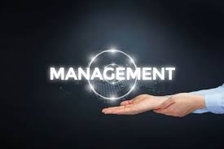 [**MANAGEMENT**](https://gvpcdpgc.edu.in/mgmt_groups.php)

[**SCIENCES**](https://gvpcdpgc.edu.in/science_groups.php)

B.Sc Mathematics, Physics & ComputerScience

Sub-Heading : [**PO's & PSO's**](https://gvpcdpgc.edu.in/bscmpcs/bscmpcs_popso.php)

Program Specific Outcomes (PSOs)

* PSO 1: Effectively utilizing the knowledge of computing principles and Mathematics theory to develop sustainable solutions to current and future computing problems and also knowledge of general Physics like sound, wave mechanics, friction, forces and laws of motion and use of mathematics and also create interest towards the area of research.
* PSO 2: Be able to demonstrate basic knowledge in the core areas of Physics (Classical Mechanics, Waves & Acoustics, Optics & Lasers, Thermodynamics, Electricity Magnetism & Electronics, and Modern Physics). Be versatile in laboratory techniques in using modern as well as conventional apparatus.
* PSO 3: The ability to understand, analyze and develop computer programs in the areas related to algorithms, system software, and multimedia and big data analytics for efficient design of computer-based systems of varying complexity. They develop the ability to employ modern platforms in creating innovative career paths to be an entrepreneur and a zest for higher studies.

Program Outcomes (POs)

* Critical thinking skills: Students able to take informed actions by differentiating between fact and opinion, recognize and evaluate, develop inferential skills and distinguish logical assumption from different perceptive allow making decisions and judgments by using scientific-based reasoning.
* Analytical skills: Students able to analyze and interpret concepts from a variety of methods apply these methods to analogous situations. They assess the elements of a problem and become competent at problem solving.
* Usage of modern tools and technologies: Students develop scientific orientation and are at ease in the adoption of modern techniques.
* Effective communication: Students develop skills like listening, speaking, reading and writing in their respective domains and become communicators.
* Ethics: Students develop ethical values and contribute to nation building as responsible citizens.
* Self-directed and life –long learning: Acquire the ability to engage in independent and lifelong learning in the broadest context socio-technological changes.
* Social interaction and sustainability: Students develop empathy towards the societal needs and are able to contribute sustainable development and gain knowledge and skill to understand and solve environmental issues and problems

[**Admissions**](https://gvpcdpgc.edu.in/bscmpcs/bscmpcs_data/admission_2016-17%20to%202020-21.xlsx)**, course , department and placements are pdf**

[**SCIENCES**](https://gvpcdpgc.edu.in/science_groups.php)

[B.Sc Mathematics, Electronics & Computer Science](https://gvpcdpgc.edu.in/bscmec/bscmec_popso.php)

Sub-Heading : [**PO's & PSO's**](https://gvpcdpgc.edu.in/bscmpcs/bscmpcs_popso.php)

Program Specific Outcomes (PSOs)

* PSO 1: An ability to apply mathematical foundations, algorithmic principles and computer science theory in the modelling and design of computer based systems in a way that demonstrates comprehension of the tradeoffs involved in design choices and create interest towards the area of research.
* PSO 2:Students equip themselves with embedded knowledge of hardware and software. The course will enrich the students with a comprehensive understanding of basic circuits to advanced emerging technologies of the Electronics industry that makes him a successful technocrat.
* PSO 3: The ability to understand, analyze and develop computer programs in the areas related to algorithms, system software, and multimedia and big data analytics for efficient design of computer-based systems of varying complexity. They develop the ability to employ modern platforms in creating innovative career paths to be an entrepreneur and a zest for higher studies.

Program Outcomes (POs)

* Critical thinking skills: Students able to take informed actions by differentiating between fact and opinion, recognize and evaluate, develop inferential skills and distinguish logical assumption from different perceptive allow making decisions and judgments by using scientific-based reasoning.
* Analytical skills: Students able to analyze and interpret concepts from a variety of methods apply these methods to analogous situations. They assess the elements of a problem and become competent at problem solving.
* Usage of modern tools and technologies: Students develop scientific orientation and are at ease in the adoption of modern techniques.
* Effective communication: Students develop skills like listening, speaking, reading and writing in their respective domains and become communicators.
* Ethics: Students develop ethical values and contribute to nation building as responsible citizens.
* Self-directed and life –long learning: Acquire the ability to engage in independent and lifelong learning in the broadest context socio-technological changes.
* Social interaction and sustainability: Students develop empathy towards the societal needs and are able to contribute sustainable development and gain knowledge and skill to understand and solve environmental issues and problems

[**Admissions**](https://gvpcdpgc.edu.in/bscmpcs/bscmpcs_data/admission_2016-17%20to%202020-21.xlsx)**, course , department and placements are pdf**

[**SCIENCES**](https://gvpcdpgc.edu.in/science_groups.php)

[B.Sc Mathematics, Statistics & Computer Science](https://gvpcdpgc.edu.in/bscmsc/bscmsc_popso.php)

Sub-Heading : [**PO's & PSO's**](https://gvpcdpgc.edu.in/bscmpcs/bscmpcs_popso.php)

Program Specific Outcomes (PSOs)

* PSO 1: An ability to apply mathematical foundations, algorithmic principles and computer science theory in the modelling and design of computer based systems in a way that demonstrates comprehension of the tradeoffs involved in design choices and create interest towards the area of research.
* PSO 2:Students equip themselves with embedded knowledge of hardware and software. The course will enrich the students with a comprehensive understanding of basic circuits to advanced emerging technologies of the Electronics industry that makes him a successful technocrat.
* PSO 3: The ability to understand, analyze and develop computer programs in the areas related to algorithms, system software, and multimedia and big data analytics for efficient design of computer-based systems of varying complexity. They develop the ability to employ modern platforms in creating innovative career paths to be an entrepreneur and a zest for higher studies.

Program Outcomes (POs)

* Critical thinking skills: Students able to take informed actions by differentiating between fact and opinion, recognize and evaluate, develop inferential skills and distinguish logical assumption from different perceptive allow making decisions and judgments by using scientific-based reasoning.
* Analytical skills: Students able to analyze and interpret concepts from a variety of methods apply these methods to analogous situations. They assess the elements of a problem and become competent at problem solving.
* Usage of modern tools and technologies: Students develop scientific orientation and are at ease in the adoption of modern techniques.
* Effective communication: Students develop skills like listening, speaking, reading and writing in their respective domains and become communicators.
* Ethics: Students develop ethical values and contribute to nation building as responsible citizens.
* Self-directed and life –long learning: Acquire the ability to engage in independent and lifelong learning in the broadest context socio-technological changes.
* Social interaction and sustainability: Students develop empathy towards the societal needs and are able to contribute sustainable development and gain knowledge and skill to understand and solve environmental issues and problems

[**Admissions**](https://gvpcdpgc.edu.in/bscmpcs/bscmpcs_data/admission_2016-17%20to%202020-21.xlsx)**, course , department and placements are pdf**

[**SCIENCES**](https://gvpcdpgc.edu.in/science_groups.php)

[B.Sc Mathematics, Physics & Chemistry](https://gvpcdpgc.edu.in/bscmpc/bscmpc_popso.php)

Sub-Heading : [**PO's & PSO's**](https://gvpcdpgc.edu.in/bscmpcs/bscmpcs_popso.php)

Program Specific Outcomes (PSOs)

* PSO 1: An ability to apply mathematical foundations, algorithmic principles and computer science theory in the modelling and design of computer based systems in a way that demonstrates comprehension of the tradeoffs involved in design choices and create interest towards the area of research.
* PSO 2:Students equip themselves with embedded knowledge of hardware and software. The course will enrich the students with a comprehensive understanding of basic circuits to advanced emerging technologies of the Electronics industry that makes him a successful technocrat.
* PSO 3: The ability to understand, analyze and develop computer programs in the areas related to algorithms, system software, and multimedia and big data analytics for efficient design of computer-based systems of varying complexity. They develop the ability to employ modern platforms in creating innovative career paths to be an entrepreneur and a zest for higher studies.

Program Outcomes (POs)

* Critical thinking skills: Students able to take informed actions by differentiating between fact and opinion, recognize and evaluate, develop inferential skills and distinguish logical assumption from different perceptive allow making decisions and judgments by using scientific-based reasoning.
* Analytical skills: Students able to analyze and interpret concepts from a variety of methods apply these methods to analogous situations. They assess the elements of a problem and become competent at problem solving.
* Usage of modern tools and technologies: Students develop scientific orientation and are at ease in the adoption of modern techniques.
* Effective communication: Students develop skills like listening, speaking, reading and writing in their respective domains and become communicators.
* Ethics: Students develop ethical values and contribute to nation building as responsible citizens.
* Self-directed and life –long learning: Acquire the ability to engage in independent and lifelong learning in the broadest context socio-technological changes.
* Social interaction and sustainability: Students develop empathy towards the societal needs and are able to contribute sustainable development and gain knowledge and skill to understand and solve environmental issues and problems

[**Admissions**](https://gvpcdpgc.edu.in/bscmpcs/bscmpcs_data/admission_2016-17%20to%202020-21.xlsx)**, course , department and placements are pdf**

[**SCIENCES**](https://gvpcdpgc.edu.in/science_groups.php)

[B.Sc Biotechnology, Microbiology & Bio chemistry](https://gvpcdpgc.edu.in/bscbio/bscbio_popso.php)

Sub-Heading : [**PO's & PSO's**](https://gvpcdpgc.edu.in/bscmpcs/bscmpcs_popso.php)

Program Specific Outcomes (PSOs)

* PSO 1: An ability to apply mathematical foundations, algorithmic principles and computer science theory in the modelling and design of computer based systems in a way that demonstrates comprehension of the tradeoffs involved in design choices and create interest towards the area of research.
* PSO 2:Students equip themselves with embedded knowledge of hardware and software. The course will enrich the students with a comprehensive understanding of basic circuits to advanced emerging technologies of the Electronics industry that makes him a successful technocrat.
* PSO 3: The ability to understand, analyze and develop computer programs in the areas related to algorithms, system software, and multimedia and big data analytics for efficient design of computer-based systems of varying complexity. They develop the ability to employ modern platforms in creating innovative career paths to be an entrepreneur and a zest for higher studies.

Program Outcomes (POs)

* Critical thinking skills: Students able to take informed actions by differentiating between fact and opinion, recognize and evaluate, develop inferential skills and distinguish logical assumption from different perceptive allow making decisions and judgments by using scientific-based reasoning.
* Analytical skills: Students able to analyze and interpret concepts from a variety of methods apply these methods to analogous situations. They assess the elements of a problem and become competent at problem solving.
* Usage of modern tools and technologies: Students develop scientific orientation and are at ease in the adoption of modern techniques.
* Effective communication: Students develop skills like listening, speaking, reading and writing in their respective domains and become communicators.
* Ethics: Students develop ethical values and contribute to nation building as responsible citizens.
* Self-directed and life –long learning: Acquire the ability to engage in independent and lifelong learning in the broadest context socio-technological changes.
* Social interaction and sustainability: Students develop empathy towards the societal needs and are able to contribute sustainable development and gain knowledge and skill to understand and solve environmental issues and problems

[**Admissions**](https://gvpcdpgc.edu.in/bscmpcs/bscmpcs_data/admission_2016-17%20to%202020-21.xlsx)**, course , department and placements are pdf**

**B.sc Honours**

**Majors:**

[**B.Sc Honours (Computer Science)**](https://gvpcdpgc.edu.in/bschonours_cs/bsccs_popso.php)

**Sub-Heading :** [**PO's & PSO's**](https://gvpcdpgc.edu.in/bschonours_cs/bsccs_popso.php)

Program Outcomes (POs)

* Critical thinking skills: Students able to take informed actions by differentiating between fact and opinion, recognize and evaluate, develop inferential skills and distinguish logical assumption from different perceptive allow making decisions and judgments by using scientific-based reasoning.
* Analytical skills: Students able to analyze and interpret concepts from a variety of methods apply these methods to analogous situations. They assess the elements of a problem and become competent at problem solving.
* Usage of modern tools and technologies: Students develop scientific orientation and are at ease in the adoption of modern techniques.
* Effective communication: Students develop skills like listening, speaking, reading and writing in their respective domains and become communicators.
* Ethics: Students develop ethical values and contribute to nation building as responsible citizens.
* Self-directed and life –long learning: Acquire the ability to engage in independent and lifelong learning in the broadest context socio-technological changes.
* Social interaction and sustainability: Students develop empathy towards the societal needs and are able to contribute sustainable development and gain knowledge and skill to understand and solve environmental issues and problems

Program Specific Outcomes (PSOs)

* PSO 1: Effectively utilizing the knowledge of computing principles and Mathematics theory to develop sustainable solutions to current and future computing problems and also knowledge of general Physics like sound, wave mechanics, friction, forces and laws of motion and use of mathematics and also create interest towards the area of research.
* PSO 2: Be able to demonstrate basic knowledge in the core areas of Physics (Classical Mechanics, Waves & Acoustics, Optics & Lasers, Thermodynamics, Electricity Magnetism & Electronics, and Modern Physics). Be versatile in laboratory techniques in using modern as well as conventional apparatus.
* PSO 3: The ability to understand, analyze and develop computer programs in the areas related to algorithms, system software, and multimedia and big data analytics for efficient design of computer-based systems of varying complexity. They develop the ability to employ modern platforms in creating innovative career paths to be an entrepreneur and a zest for higher studies**.**

**Sub-Heading :** [**Admissions**](https://gvpcdpgc.edu.in/bschonours_cs/bsccs_admission.php)

##### Admissions

* Eligibility : Students who passed 10+2 or equivalent with Mathematics as one subject are eligible for applying this program
* STUDENT INTAKE : In B.Sc. HONOURS(Computer Science) intake of 390 Students per year.
* ADMISSIONS PROCESS : Admission into this program is done on the merit basis. Total of 390 Seats are available. Out of which 273 seats will be filled through online following the procedure given by OAMDC and remaining 117 will come under management quota and 10% of seats will come under EWS quota.

**Sub-Heading :** [**Faculty**](https://gvpcdpgc.edu.in/gvp_faculty/computerscience_faculty_list.php)

#### Department of Computer Science

**The Department of Computer Science was established in the year 1989. In the beginning it has a combination with traditional subjects Mathematics, Physics, Electronics and Statistics in accordance with the demand of the students. The Department has equipped with latest Configuration systems in two labs which enables the students to have the best practical Knowledge to compete with the Industrial needs.**

**As three decades on, the department is a force for innovation, and global impact. The department takes pride of its graduating students and many of whom are leaders in industry. The Courses offered in the department meet the requirements of both industry and research. The department has 89 Systems, 3 projectors, a Laptop and a Server.**

##### HoD’s message

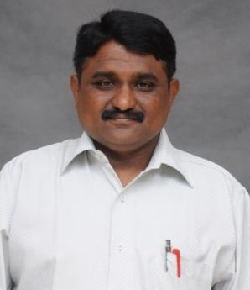

**Sri K.Krishna Kumar  
M.Sc. (IT)  
Assistant Professor in Computers, HOD**

**It is a pleasure to head the department of CS. The department has a team of highly experienced and motivated faculty members who are in process of tuning the young minds to make them globally competitive. The strength of the department is highly motivated students who understand the dynamics of the industry and upgrade their skills accordingly. The scope of computer science is endless. The students of the computer science are highly demanded by the recruiters of the top companies. Depending upon the interest of the student, he/she may choose to go for higher studies or if employed can choose to do development, design, production, application, testing or management in the Information Technology industry. Our Computer Science graduate employment rate is very high and we continue to work hard to make sure that all our graduates acquire the knowledge and skills that are essential in today’s competitive international workplace.**

##### List of Faculty Members

|  | **Name** | **Designation** | **Qualification** | **Area of Specialization** | **Email Id** | **DOJ** |
| --- | --- | --- | --- | --- | --- | --- |
|  | **Sri K.Krishna Kumar** | **Assistant Professor in Computers, HOD** | **M.Sc. (IT)** | **BIG DATA** | **kkrishna@gvpcdpgc.edu.in**  [**Profile**](https://gvpcdpgc.edu.in/gvp_faculty/all_ug_resumes/computerscience/.pdf) | **14-06-2000** |
|  | **Smt.Y.S.Vijaya Lakshmi** | **Assistant Professor in Computers** | **M.Sc. (CS)., M.Tech. (CS)** | **MACHINE LEARNING** | **ysvijaya@gvpcdpgc.edu.in**  [**Profile**](https://gvpcdpgc.edu.in/gvp_faculty/all_ug_resumes/computerscience/Vijaya-profile.pdf) | **03-12-2012** |
|  | **Smt. M. Lakshmi Madhuri** | **Assistant Professor in Computers** | **M.Sc. (CS), M.Tech. (CS)** | **NETWORK SECURITY** | **lakshmimadhurim@gvpcdpgc.edu.in**  [**Profile**](https://gvpcdpgc.edu.in/gvp_faculty/all_ug_resumes/computerscience/profile(MLM)-july%202024.pdf) | **02-07-2018** |
|  | **Smt.N.J.L.Prasanna** | **Assistant Professor in Computers** | **M.C.A.,**  **M.Tech.(CS)** | **MACHINE LEARNING** | **njlprasanna@gvpcdpgc.edu.in**  [**Profile**](https://gvpcdpgc.edu.in/gvp_faculty/all_ug_resumes/computerscience/Resume_prasanna%20(2).pdf) | **23-12-2019** |
|  | **Smt. P. Lavanya** | **Assistant Professor in Computers** | **M.C.A.** | **NETWORK SECURITY** | **lavanya.p@gvpcdpgc.edu.in**  [**Profile**](https://gvpcdpgc.edu.in/gvp_faculty/all_ug_resumes/computerscience/PL..PROFILE.pdf) | **31-12-2022** |
|  | **Smt. J. Haritha** | **Assistant Professor in Computers** | **MSc (CS), B.Ed.** | **COMPUTER SCIENCE** | **@gvpcdpgc.edu.in**  [**Profile**](https://gvpcdpgc.edu.in/gvp_faculty/all_ug_resumes/computerscience/jhprofile-pdf.pdf) | **03-01-2023** |
|  | **Sri T.Sri Krishna** | **Sr.Asst.Professor** | **M.Sc., M.Tech.** | **ARTIFICIAL INTELLIGENCE & EMBEDDED SYSTEMS** | **srikrishna@gvpcdpgc.edu.in**  [**Profile**](https://gvpcdpgc.edu.in/gvp_faculty/all_ug_resumes/computerscience/srikrishnathota.pdf) | **05-10-2009** |

**B.sc Honours**

**Majors:**

[**B.Sc Honours (Biochemistry)**](https://gvpcdpgc.edu.in/bschonours_bc/bscbc_popso.php)

**Sub-Heading :** [**PO's & PSO's**](https://gvpcdpgc.edu.in/bschonours_cs/bsccs_popso.php)

**Program Outcomes (POs)**

* **Critical thinking skills: Students able to take informed actions by differentiating between fact and opinion, recognize and evaluate, develop inferential skills and distinguish logical assumption from different perceptive allow making decisions and judgments by using scientific-based reasoning.**
* **Analytical skills: Students able to analyze and interpret concepts from a variety of methods apply these methods to analogous situations. They assess the elements of a problem and become competent at problem solving.**
* **Usage of modern tools and technologies: Students develop scientific orientation and are at ease in the adoption of modern techniques.**
* **Effective communication: Students develop skills like listening, speaking, reading and writing in their respective domains and become communicators.**
* **Ethics: Students develop ethical values and contribute to nation building as responsible citizens.**
* **Self-directed and life –long learning: Acquire the ability to engage in independent and lifelong learning in the broadest context socio-technological changes.**
* **Social interaction and sustainability: Students develop empathy towards the societal needs and are able to contribute sustainable development and gain knowledge and skill to understand and solve environmental issues and problems**

**Program Specific Outcomes (PSOs)**

* **PSO 1: Understand the fundamentals of biological processes of human body by applying the knowledge of chemical structures of the biomolecules and mechanisms to interpret their role in metabolic pathways.**
* **PSO 2: Comprehend the biochemical techniques such as chromatography, electrophoresis, spectroscopic and Molecular methods to isolate, identify, purify and characterize natural compounds for the benefit of the society.**
* **PSO 3: Develop research competence by reviewing science literature, developing research methodology and executing research projects by integrating the knowledge of bioinformatics and biostatics.**
* **PSO 4: Grow as entrepreneurs in the fields of health, nutrition, biotech industries and agriculture by adopting the knowledge of Biochemistry.**

**Sub-Heading :** [**Admissions**](https://gvpcdpgc.edu.in/bschonours_cs/bsccs_admission.php)

##### Admissions

* **Eligibility : Students who passed 10+2 or equivalent with Bi.P.C, M.Bi.P.C as one subject are eligible for applying this program**
* **STUDENT INTAKE : In B.Sc. HONOURS(Biochemistry) intake of 30 Students per year.**
* **ADMISSIONS PROCESS : Admission into this program is done on the merit basis. Total of 30 Seats are available. Out of which 21 seats will be filled through online following the procedure given by OAMDC and remaining 9 will come under management quota and 10% of seats will come under EWS quota.**

**Sub-Heading :** [**Faculty**](https://gvpcdpgc.edu.in/gvp_faculty/computerscience_faculty_list.php)

#### Department of Bio Chemistry

Previously, LIFESCIENCES was chosen by the students as an alternative to the medical education but in recent year LIFE SCIENCES has explored the world with new technologies, new innovations and ignited young minds a lust towards science. Still there is gap between industrial needs and academics, to fill up the gap and provide a quality of education with a practical exposure to meet the industrial needs, the department of LIFE SCIENCE was established in 2005 with an intake of 40 students.

The department has grown as one of the elite departments of the institute. To meet the challenges of the rapidly growing discipline the department has started a unique Bachelor’s degree with MICROBIOLOGY, BIOTECHNOLOGY, and BIOCHEMISTRY combination. At present there are 220 students in the department. The department has grown as one of the elite departments of the institute. To meet the challenges of the rapidly growing discipline the department has started a unique Bachelor’s degree with MICROBIOLOGY, BIOTECHNOLOGY, and BIOCHEMISTRY combination. At present there are 220 students in the department.

##### HoD’s message

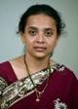

**Dr. Ilahi shaik  
M.SC, Ph.D  
Sr.Asst.Professor, HOD**

##### List of Faculty Members

|  | **Name** | **Designation** | **Qualification** | **Email Id** | DOJ |
| --- | --- | --- | --- | --- | --- |
|  | **Dr. Ilahi shaik** | **Senior Assistant Professor & HOD** | **M.SC, Ph.D** | **ilahi@gvpcdpgc.edu.in**  [**Profile**](https://gvpcdpgc.edu.in/gvp_faculty/all_ug_resumes/biochemistry/.pdf) | **21-06-2005** |
|  | **D.V.SUSHMA CHANDRA** | **Assistant Professor** | **M.Sc.** | **dvsushma@gvpcdpgc.edu.in**  [**Profile**](https://gvpcdpgc.edu.in/gvp_faculty/all_ug_resumes/biochemistry/sushmamam.pdf) | **4-7-2016** |

**B.sc Honours**

**Majors:**

[**B.Sc Honours (Microbiology)**](https://gvpcdpgc.edu.in/bschonours_mb/bscmb_popso.php)

**Sub-Heading :** [**PO's & PSO's**](https://gvpcdpgc.edu.in/bschonours_cs/bsccs_popso.php)

Program Outcomes (POs)

* Critical thinking skills: Students able to take informed actions by differentiating between fact and opinion, recognize and evaluate, develop inferential skills and distinguish logical assumption from different perceptive allow making decisions and judgments by using scientific-based reasoning.
* Analytical skills: Students able to analyze and interpret concepts from a variety of methods apply these methods to analogous situations. They assess the elements of a problem and become competent at problem solving.
* Usage of modern tools and technologies: Students develop scientific orientation and are at ease in the adoption of modern techniques.
* Effective communication: Students develop skills like listening, speaking, reading and writing in their respective domains and become communicators.
* Ethics: Students develop ethical values and contribute to nation building as responsible citizens.
* Self-directed and life –long learning: Acquire the ability to engage in independent and lifelong learning in the broadest context socio-technological changes.
* Social interaction and sustainability: Students develop empathy towards the societal needs and are able to contribute sustainable development and gain knowledge and skill to understand and solve environmental issues and problems

Program Specific Outcomes (PSOs)

* PSO 1: Able to identify and classify microorganisms by using various microbial techniques like Microscopy & Staining. Student will isolate the microorganisms from different sources and culture them efficiently using pure culture isolation techniques.
* PSO 2: Understand the principles and methods used in pathogen detection and different diagnostic tools and tests used for their identification. Appreciate the versatility and significance of microorganisms in the various fields such as Agriculture, Pharmaceuticals, Medical, Food, Dairy and Fermentation technology and Immunodiagnostics.
* PSO 3: Understand the Principles and gain Knowledge on different Analytical Techniques like Chromatography, Electrophoresis, Centrifugation, Immuno techniques and Microscopy. Develop zeal and skill towards research, entrepreneurship and employability in industries to understand the significance of Microbiology.

**Sub-Heading :** [**Admissions**](https://gvpcdpgc.edu.in/bschonours_cs/bsccs_admission.php)

##### Admissions

* Eligibility : Students who passed 10+2 or equivalent with Bi.P.C / M.Bi.P.C as one subject are eligible for applying this program
* STUDENT INTAKE : In B.Sc. HONOURS(Microbiology) intake of 33 Students per year.
* ADMISSIONS PROCESS : A Candidate for admission to the four-year degree program in B.Sc. Honours (Microbiology) Major program must have passed the Higher Secondary Education from any board with Biology, Physics and Chemistry (Bi.P.C) or Biology, Physics and Chemistry with Mathematics (M.Bi.P.C) as optional subjects. The process of admission to this course is online through AP-OAMDC website. A total of 33 seats have been sanctioned to this course of which 3 seats are for OC Category with Economically weaker Section. The 20 seats are to be filled through convenor quota and remaining 10 seats are filled through Management quota. The seats shall be filled as per the rules given by APSCHE.

**Sub-Heading :** [**Faculty**](https://gvpcdpgc.edu.in/gvp_faculty/computerscience_faculty_list.php)

#### Department of Microbiology

The Department of Microbiology at Gayatri vidya parishad college for Degree and P.G. Courses (A) was established in the year 2005 and inaugurated by Dr. B. Swamy, President, Gayatri Vidya Parishad. The Department offers B.Sc. Honours (Microbiology) Major program with a maximum intake of 33. It also offers Microbiology and Food Science & Technology as Minors from the academic Year 2023-24. Microbiology is the Applied branch of Biological Science in which the students are trained in the practical and theoretical Knowledge on Microorganisms, their Physiology & Metabolism and Economic importance of Microorganisms in various fields like Agriculture, Medical, Industrial and Environment. The students are given hands on training on latest technologies in Microbiology.

Major Focus areas are Microbial Diversity, Microbial and Molecular Techniques, Medical Microbiology, Industrial Microbiology, Environmental and Agricultural Microbiology, Food and Dairy Microbiology, Pharmaceutical Microbiology and Drug Design and Discovery

##### HoD’s message

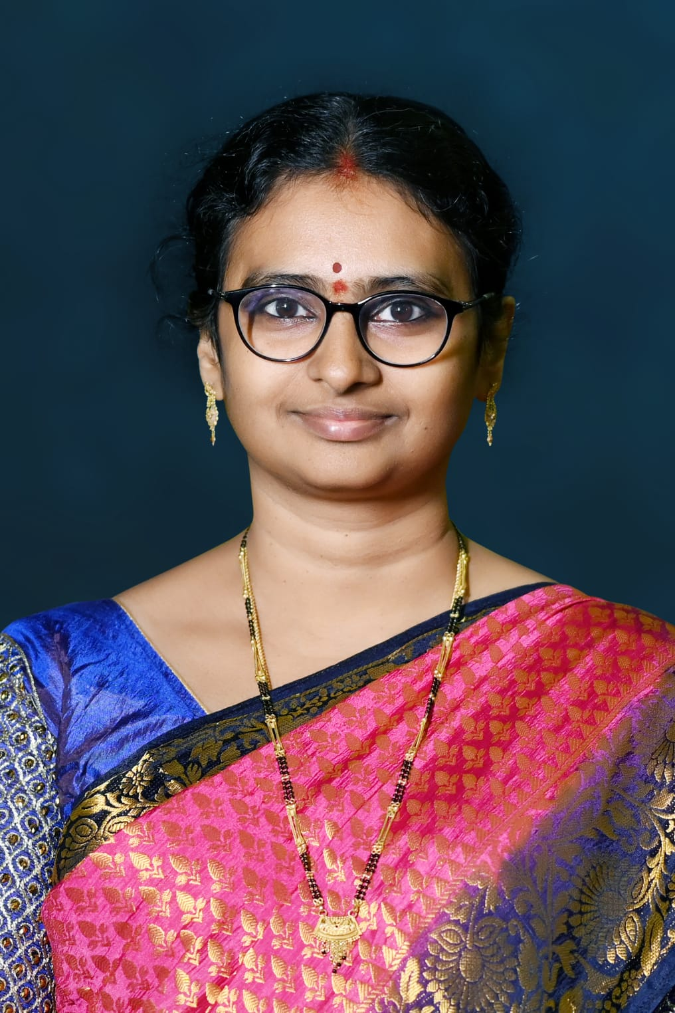

**Dr. L. Sujatha  
M.Sc., M.Phil., Ph.D  
Asst.Professor, HOD**

##### List of Faculty Members

|  | **Name** | **Designation** | **Qualification** | **Area of Specialization** | **Email Id** | DOJ |
| --- | --- | --- | --- | --- | --- | --- |
|  | **Dr. L.Sujatha** | **Assistant Professor, HOD** | **M.Sc., M.Phil., Ph.D** | **Microbial Biotechnology** | **lsujatha@gvpcdpgc.edu.in**  [**Profile**](https://gvpcdpgc.edu.in/gvp_faculty/all_ug_resumes/micro_biol/suja_resume_2024.pdf) | **.** |
|  | **Dr. D.Syamala** | **Sr.Asst.Professor** | **M.Sc, Ph.D** | **Microbiology** | **dsyamala@gvpcdpgc.edu.in**  [**Profile**](https://gvpcdpgc.edu.in/gvp_faculty/all_ug_resumes/micro_biol/syamala_bio.pdf) | **.** |

**B.sc Honours**

**Majors:**

[**B.Sc Honours (Electronics)**](https://gvpcdpgc.edu.in/bschonours_elec/bscelec_popso.php)

**Sub-Heading :** [**PO's & PSO's**](https://gvpcdpgc.edu.in/bschonours_cs/bsccs_popso.php)

**Program Outcomes (POs)**

* Critical thinking skills: Students able to take informed actions by differentiating between fact and opinion, recognize and evaluate, develop inferential skills and distinguish logical assumption from different perceptive allow making decisions and judgments by using scientific-based reasoning.
* Analytical skills: Students able to analyze and interpret concepts from a variety of methods apply these methods to analogous situations. They assess the elements of a problem and become competent at problem solving.
* Usage of modern tools and technologies: Students develop scientific orientation and are at ease in the adoption of modern techniques.
* Effective communication: Students develop skills like listening, speaking, reading and writing in their respective domains and become communicators.
* Ethics: Students develop ethical values and contribute to nation building as responsible citizens.
* Self-directed and life –long learning: Acquire the ability to engage in independent and lifelong learning in the broadest context socio-technological changes.
* Social interaction and sustainability: Students develop empathy towards the societal needs and are able to contribute sustainable development and gain knowledge and skill to understand and solve environmental issues and problems

Program Specific Outcomes (PSOs)

* PSO 1: Effectively equip the students with a solid foundation in the core principles of Electronics to enrich the students with a comprehensive understanding of theoretical and practical concepts from basics to advanced emerging technologies of the Electronics industries to transform an ordinary student into a successful technocrat.
* PSO 2: Promote a research mindset along with the ability to adapt to technological advancements and changing industry needs by engaging students in value added seminars and workshops.
* PSO 3: Encourage the development of innovative solutions to real-world problems through project-based learning, community service projects, internships and industry collaborations.

**Sub-Heading :** [**Admissions**](https://gvpcdpgc.edu.in/bschonours_cs/bsccs_admission.php)

##### Admissions

* Eligibility : Students who passed 10+2 or equivalent with Mathematics as one subject are eligible for applying this program
* STUDENT INTAKE : In B.Sc. HONOURS(Electronics) intake of 30 Students per year.
* ADMISSIONS PROCESS : Admission into this program is done on the merit basis. Total of 30 Seats are available. Out of which 21 seats will be filled through online following the procedure given by OAMDC and remaining 9 will come under management quota and 10% of seats will come under EWS quota.

**Sub-Heading :** [**Faculty**](https://gvpcdpgc.edu.in/gvp_faculty/computerscience_faculty_list.php)

#### Department of Electronics

With a vision of providing quality education and to develop technocrats, the Department of Electronics is successfully organizing a Bachelor’s program in science with Maths, Electronics and Computer Science as elective subjects from the year 1997 with an intake of 180 students. This Undergraduate program is a blend of both hardware and software. It is diversified greatly in order to keep in pace with recent trends and developments and the fast changing needs of the society.

The course is designed with a view to catering to the present day requirements in Industries, R&D fields, higher studies and Self-employment. Moreover the course structure intends to inculcate strong laboratory skills. The three years of study starts from the fundamentals of Electronics, Circuit Analysis, Semiconductor devices and applications, Digital Electronics, Analog and digital IC applications, Microprocessors, Microcontrollers, Electronic Instrumentation, PCB designing, Bio medical Instrumentation and consumer Electronics.

The department organizes a Career Oriented Program (COP) in Embedded Systems Design which has received a grant of 10 Lakh Rupees from U.G.C. The department also organizes a student run club E-Club which gives a platform for the students to upgrade themselves outside the textbook.

Eligibility:  
  
A student passed his/her Intermediate with Maths, Physics and Chemistry is eligible to join in this course.  
  
Scope:  
  
For Higher Studies

* Students with background of Electronics, student can undergo training in Chip Designing courses like Verilog, VHDL etc,
* Higher learning students deeply interested in pursuit of advanced studies in M.Sc., Electronics, Physics, Mathematics and Computer Science can find opportunities in the respective disciplines after which they can move either into research or do their M.Tech. in Electronics or Computer Science
* Eligible to do any interdisciplinary post-graduate courses like Master of Computer Applications (M.C.A.) and Master of Business Administration (M.B.A.) in many prestigious institutions all over India and abroad.
* Student interested in teaching schools can pursue B.Ed in mathematical Sciences and English Methods

Employability:

Private sector jobs:

* The graduates of the department stream have been selected by some of the leading software and hardware companies of the country through campus drive every year and were being employed as Electronic design engineers, Hardware and networking engineers etc. Many students are in leading roles in MNCs like AMAZON, TCS, WIPRO, INFOSYS, L&T, Cognizant, Tessolve etc in and out the country.

Public sector jobs:

* Careers in organizations like BSNL, BHEL etc or eligible for any competitive examinations.

Career abroad:

* Need to have a certification in networking Cisco Certified Network Associate (CCNA), Microsoft Certified Professional (MCP) Cisco Certified Design Associate (CCDA).

##### HoD’s message

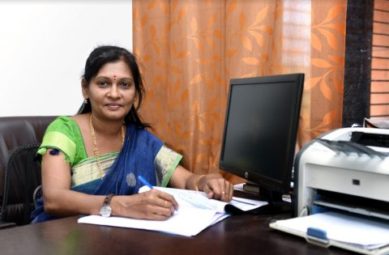

Dr. D.Sreedevi  
M.Sc.,M.Phil.,Ph.D  
Sr.Asst.Professor & HOD

In recent years, Electronics the world over has made unprecedented growth in terms of new technologies, new ideas and principles. The rate of obsolescence of technologies also has been extremely high.

The department has grown as one of the elite departments of the institute due to its significant infrastructural design, well-equipped laboratories & hi-tech computers with high-speed internet facility with all qualified faculty members ensure superlative standard of education delivered from our department.

In order to ensure high standards of education for its students, the department has constantly upgraded itself by adding well-equipped and fully furnished laboratories to supplement the theory courses. The students can include them under different type of club like E-Club, NCC, NSS, and Sports.

To inculcate practical skills along with theoretical knowledge the Department conducts an additional practical course “Certificate course in embedded systems design” as Career Oriented Program (COP), other than the curriculum which is essential from the industry point of view. The institute is collaborated with “Indo German Institute of Advanced Technology” which helps to upgrade the students technically.

The student projects are conducted in-house with the guidance of department faculty and industrial trainers. Many students graduated from the department are pursuing successful ventures / careers. The available diversity of expertise of the faculty who work with zeal and enthusiasm with the support of the Management, Principal and Director we provide vibrant and optimum learning environment to the students and help them acquire the skills to work in global multicultural environment.

##### List of Faculty Members

|  | **Name** | **Designation** | **Qualification** | **Email Id** | **DOJ** |
| --- | --- | --- | --- | --- | --- |
|  | **Dr. D.Sreedevi** | **Sr.Asst.Professor & HOD** | **M.Sc.,M.Phil.,Ph.D** | **dsreedevi@gvpcdpgc.edu.in**  [**Profile**](https://gvpcdpgc.edu.in/gvp_faculty/all_ug_resumes/electronics/Dr.D.SREEDEVI.pdf) | **05.10.2009** |
|  | **Sri K.Nataraju** | **Sr.Asst.Professor** | **M.Sc.(Elec.), M.Tech.** | **knataraju@gvpcdpgc.edu.in**  [**Profile**](https://gvpcdpgc.edu.in/gvp_faculty/all_ug_resumes/electronics/Nataraj.pdf) | **05.07.2006** |
|  | **Smt A.Subhashini** | **Sr.Asst.Professor** | **M.Sc.,M.Phil.,Ph.D(cl)** | **asubhashini@gvpcdpgc.edu.in**  [**Profile**](https://gvpcdpgc.edu.in/gvp_faculty/all_ug_resumes/electronics/Subashini.pdf) | **21.07.2006** |
|  | **Sri M.Tirumala Rao** | **Assistant Professor** | **M.Sc. Instrumentation** | **mtirumalarao@gvpcdpgc.edu.in**  [**Profile**](https://gvpcdpgc.edu.in/gvp_faculty/all_ug_resumes/electronics/M.Tirumala%20Rao.pdf) | **03.12.2012** |
|  | **Smt.S.Swaroop Rani** | **Assistant Professor** | **M.Sc.** | **swarooparani@gvpcdpgc.edu.in**  [**Profile**](https://gvpcdpgc.edu.in/gvp_faculty/all_ug_resumes/electronics/swaroopa.pdf) | **02.07.2018** |

**B.sc Honours**

**Majors:**

[**B.Sc Honours (Chemistry)**](https://gvpcdpgc.edu.in/bschonors_chem/bscchem_popso.php)

**Sub-Heading :** [**PO's & PSO's**](https://gvpcdpgc.edu.in/bschonours_cs/bsccs_popso.php)

Program Outcomes (POs)

* Critical thinking skills: Students able to take informed actions by differentiating between fact and opinion, recognize and evaluate, develop inferential skills and distinguish logical assumption from different perceptive allow making decisions and judgments by using scientific-based reasoning.
* Analytical skills: Students able to analyze and interpret concepts from a variety of methods apply these methods to analogous situations. They assess the elements of a problem and become competent at problem solving.
* Usage of modern tools and technologies: Students develop scientific orientation and are at ease in the adoption of modern techniques.
* Effective communication: Students develop skills like listening, speaking, reading and writing in their respective domains and become communicators.
* Ethics: Students develop ethical values and contribute to nation building as responsible citizens.
* Self-directed and life –long learning: Acquire the ability to engage in independent and lifelong learning in the broadest context socio-technological changes.
* Social interaction and sustainability: Students develop empathy towards the societal needs and are able to contribute sustainable development and gain knowledge and skill to understand and solve environmental issues and problems

Program Specific Outcomes (PSOs)

* PSO 1: The chemistry graduates are expected to gain knowledge of the fundamental concepts of chemistry through theory and practical. These fundamental concepts would be reflected in the latest understanding of the field to keep continues its progression.
* PSO 2: Chemistry graduates are expected to possess minimum standards of communication skills to read and understand documents so that they can solve their problems very methodically, independently and with logical argument. Graduates are expected to build good communication skills so that they can easily share their ideas and concepts to others.
* PSO 3: Chemistry graduates are expected to achieve critical thinking ability to design, carry out, record and analyze the results of chemical reactions. They can have that much potential and confidence that they can overcome many difficulties with the help of their sharp scientific knowledge and logical approaches.

**Sub-Heading :** [**Admissions**](https://gvpcdpgc.edu.in/bschonours_cs/bsccs_admission.php)

##### Admissions

* **Eligibility : Students who passed 10+2 or equivalent with Mathematics as one subject are eligible for applying this program**
* **STUDENT INTAKE : In B.Sc. HONOURS(Chemistry) intake of 30 Students per year.**
* **ADMISSIONS PROCESS : Admission into this program is done on the merit basis. Total of 30 Seats are available. Out of which 21 seats will be filled through online following the procedure given by OAMDC and remaining 9 will come under management quota and 10% of seats will come under EWS quota.**

**Sub-Heading :** [**Faculty**](https://gvpcdpgc.edu.in/gvp_faculty/computerscience_faculty_list.php)

#### Department of Chemistry

**Welcome to the Department of Chemistry. It is a privilege to lead this distinguished Department as we move towards a new era of exploration in the chemical sciences. While a brief history of the Department of Chemistry at Gayatri Vidya Parishad is detailed here, our earliest origins-This department was Established in 1989 and first served by eminent persons like Dr. R. Rambabu, Sri T.Ravishankar, Sri G. Ramasastry, Smt V. Sree Devi, Sri M. Pavan Kumar, Dr. T. Sandhya and presently heading by Sri K. Ravi Prasad. The Department has independent laboratories fully equipped with instruments and consumables, and advanced equipments for teaching.**

**The Department of Chemistry is committed to providing an open, safe, and engaging environment in which all persons are welcome and respected. We strive hard to cultivate a fair environment where our students can thrive as they advance new chemical frontiers through research, innovation, collaboration and scholarship.**

**Eligibility:  
  
Students with Chemistry as one of the subjects in intermediate or 10+2 level.  
  
Scope:  
  
For Higher Studies**

* **Students with Chemistry background are eligible to do any post-graduate courses like M. Sc. in Mathematics/ Physics /Chemistry, Master of Computer Applications (M.C.A.) and Master of Business Administration (M.B.A.) in any State and Central Universities.**
* **The course will be an added advantage for those opting for defense services.**
* **Student interested in teaching at school level can pursue B.Ed in Physical Sciences and English.**

**Employability:**

**Private sector jobs:**

* **The graduates of the core departments have been selected by some of the leading software companies through campus drives and placed as data analysts.**

**Public sector jobs:**

* **After completion of the courses there will be multiple career avenues for the students such as UPPSC (Union Public Service Commission) and SSC (Staff Selection Commission)**
* **The graduates of Chemistry with a combination of mathematics can opt for bank jobs, both private and nationalized.**

##### HoD’s message

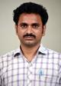

**Mr. K.Ravi Prasad  
M.Sc. (Org. Chem.) Assistant Professor & HOD**

**Chemistry is often called the central science because it deals with the fundamental building blocks of life and the inanimate materials we encounter daily. Chemists develop new materials for sustainable energy, new therapeutics for the treatment of disease, better ways of understanding polymer reactions and more accurate approaches to measuring pollutants. Chemistry is a very collaborative undertaking and as a student in the Chemistry Program, you will learn to think critically with other scientists from all fields. You will create new molecules and understand the theory behind doing so. Our graduates find great careers in widely varying fields from energy to medicine to teaching and learning and beyond. They can achieve placements in pharmaceutical companies as production administrators and quality control analysts. They can serve medical representatives as well to mediate between doctors and medical market. The Department prides itself on preparing the students for creative careers in industries academia and Government agencies.**

##### List of Faculty Members

|  | **Name** | **Designation** | **Qualification** | **Email Id** | **DOJ** |
| --- | --- | --- | --- | --- | --- |
|  | **Sri K.Ravi Prasad** | **Assistant Professor** | **M.Sc. (Org. Chem.)** | **kallaraviprasad@gmail.com**  [**Profile**](https://gvpcdpgc.edu.in/gvp_faculty/all_ug_resumes/chemistry/KRP%20RESUME.pdf) | **01-08-2015** |
|  | **Mr. S.S.R.S. S.N. Murty** | **Assistant Professor** | **M.Sc** | **ssrssnmurty@gvpcdpgc.edu.in**  [**Profile**](https://gvpcdpgc.edu.in/mscorganicchemistry/msc_oc_data/MURTY.pdf) | **22-07-2016** |

**B.sc Honours**

**Majors:**

[**B.Sc Honours (Physics)**](https://gvpcdpgc.edu.in/bschonors_phy/bsc_phy_pso.php)

**Sub-Heading :** [**PO's & PSO's**](https://gvpcdpgc.edu.in/bschonours_cs/bsccs_popso.php)

**Program Outcomes (POs)**

* Critical thinking skills: Students able to take informed actions by differentiating between fact and opinion, recognize and evaluate, develop inferential skills and distinguish logical assumption from different perceptive allow making decisions and judgments by using scientific-based reasoning.
* Analytical skills: Students able to analyze and interpret concepts from a variety of methods apply these methods to analogous situations. They assess the elements of a problem and become competent at problem solving.
* Usage of modern tools and technologies: Students develop scientific orientation and are at ease in the adoption of modern techniques.
* Effective communication: Students develop skills like listening, speaking, reading and writing in their respective domains and become communicators.
* Ethics: Students develop ethical values and contribute to nation building as responsible citizens.
* Self-directed and life –long learning: Acquire the ability to engage in independent and lifelong learning in the broadest context socio-technological changes.
* Social interaction and sustainability: Students develop empathy towards the societal needs and are able to contribute sustainable development and gain knowledge and skill to understand and solve environmental issues and problems

Program Specific Outcomes (PSOs)

* PSO 1: Acquire a comprehensive knowledge and sound understanding of fundamentals of Physics.
* PSO 2: Develop practical, analytical and mathematical skills in Physics.
* PSO 3: Prepared to acquire a range of general skills, to solve problems, to evaluate information, to use computers productively, to communicate with society effectively and learn independently.
* PSO 4: Acquire necessary skills to enable them to crack competitive examination for career progression or seeking employment.

**Sub-Heading :** [**Admissions**](https://gvpcdpgc.edu.in/bschonours_cs/bsccs_admission.php)

##### Admissions

* Eligibility : Students who passed 10+2 or equivalent with Mathematics as one subject are eligible for applying this program
* STUDENT INTAKE : In B.Sc. HONOURS(Physics) intake of 30 Students per year.
* ADMISSIONS PROCESS : Admission into this program is done on the merit basis. Total of 30 Seats are available. Out of which 21 seats will be filled through online following the procedure given by OAMDC and remaining 9 will come under management quota and 10% of seats will come under EWS quota.

**Sub-Heading : Department**

#### Department of Physics

Students with Mathematics as one of the subjects in intermediate or 10+2 level.

Scope:  
  
For Higher Studies

* Students with Physics background are eligible to do any post-graduate courses like M. Sc. in Mathematics/ Physics /computer science, Master of Computer Applications (M.C.A.) and Master of Business Administration (M.B.A.) in any State and Central Universities.
* The course will be an added advantage for those opting for defense services.
* Student interested in teaching schools can pursue B.Ed in mathematical Sciences and English Methods.

Employability:

Private sector jobs:

* The graduates of the department stream have been selected by some of the leading software companies through campus drives and placed as data analysts.

Public sector jobs:

* After completion of the courses there will be many career avenues for the students such as UPPSC (Union Public Service Commission) and SSC (Staff Selection Commission)
* The graduates of physics with a combination of mathematics can opt for bank jobs, both private and nationalized.

##### HoD’s message



**Dr.P.D.Lavanya  
M.Sc.(Phys), Ph.D  
Assistant Professor, HOD**

**“It is a pleasure to head the department of Physics. The department offers one of the basic Sciences Physics. The department has a team of highly experienced and motivated faculty members who are in process of tuning the young minds to make them globally and “Physic”ally competitive. The strength of the department is highly motivated students who understand the dynamics of the subject and upgrade their skills accordingly.” The scope of physics is the hope of the science” .The students of the department may choose to go for higher studies or if employed can choose to do research depending upon their interest. In the department we not only give emphasis on studies but also apply our knowledge in understanding what physics is,and how it’s applied. Our students gain vital communication and critical-thinking skills, through innovative teaching-learning process. Our department provides a platform for the students to enhance their employability skills through Industry Institute Collaboration.”**

##### List of Faculty Members

|  | **Name** | **Designation** | **Qualification** | **E-mail** | **DOJ** |
| --- | --- | --- | --- | --- | --- |
|  | **Dr.P.D.Lavanya** | **Assistant Professor, HOD** | **M.Sc.(Phys), Ph.D** | **drlavanya@gvpcdpgc.edu.in**  [**Profile**](https://gvpcdpgc.edu.in/gvp_faculty/all_ug_resumes/physics/PDL.pdf) | **09-10-2009** |
|  | **Sri D.Lakshmana Rao** | **Assistant Professor in Physics** | **M.Sc. (Phys)** | **dlakshmanarao@gvpcdpgc.edu.in**  [**Profile**](https://gvpcdpgc.edu.in/gvp_faculty/all_ug_resumes/physics/DL.pdf) | **02-07-2018** |
|  | **Sri.K.Ayyaraju** | **Assistant Professor** | **M.Sc.,M.Tech.** | **kayyaraj@gvpcdpgc.edu.in**  [**Profile**](https://gvpcdpgc.edu.in/gvp_faculty/all_ug_resumes/physics/KAR.pdf) | **19.07.2019** |

**B.sc Honours**

**Majors:**

[**B.Sc Honours (Mathematics)**](https://gvpcdpgc.edu.in/bschonours_math/bscmath_popso.php)

**Sub-Heading :** [**PO's & PSO's**](https://gvpcdpgc.edu.in/bschonours_cs/bsccs_popso.php)

**Program Outcomes (POs)**

* Critical thinking skills: Students able to take informed actions by differentiating between fact and opinion, recognize and evaluate, develop inferential skills and distinguish logical assumption from different perceptive allow making decisions and judgments by using scientific-based reasoning.
* Analytical skills: Students able to analyze and interpret concepts from a variety of methods apply these methods to analogous situations. They assess the elements of a problem and become competent at problem solving.
* Usage of modern tools and technologies: Students develop scientific orientation and are at ease in the adoption of modern techniques.
* Effective communication: Students develop skills like listening, speaking, reading and writing in their respective domains and become communicators.
* Ethics: Students develop ethical values and contribute to nation building as responsible citizens.
* Self-directed and life –long learning: Acquire the ability to engage in independent and lifelong learning in the broadest context socio-technological changes.
* Social interaction and sustainability: Students develop empathy towards the societal needs and are able to contribute sustainable development and gain knowledge and skill to understand and solve environmental issues and problems

Program Specific Outcomes (PSOs)

* PSO: With the help of this solid geometry for example we can visualize the axes drawn on a floor of a room but we cannot locate a point on the roof of that room. this is due to room having three dimensional which we call length, breadth and height. A box, a ball, a pillar, a conical funnel etc.., are objects which occupy points in three-dimensional space (R^3 ). The branch which deals with the nature and finding of such object in (R^3 ), is three dimensional or solid geometry. We can describe various forms of equations of different three-dimensional objects like plane, Straight line, Sphere, Cone and Conicoid etc... Imagining a moving point to trace on a surface does not seem to be natural. We can trace the point by using this three-dimensional geometry.

**Sub-Heading :** [**Admissions**](https://gvpcdpgc.edu.in/bschonours_cs/bsccs_admission.php)

##### Admissions

* Eligibility : Students who passed 10+2 or equivalent with Mathematics as one subject are eligible for applying this program
* STUDENT INTAKE : In B.Sc. HONOURS(Mathematics) intake of 30 Students per year.
* ADMISSIONS PROCESS : Admission into this program is done on the merit basis. Total of 30 Seats are available. Out of which 21 seats will be filled through online following the procedure given by OAMDC and remaining 9 will come under management quota and 10% of seats will come under EWS quota.

**Sub-Heading : Faculty**

#### Department of Mathematics

**The Department of Mathematics was established in the year 1989, since the inception of the Institution. It offers Mathematical sciences in various B.Sc., Degree courses in combination with Physics & Chemistry, Physics & Computers, Statistics & Computers and Electronics & Computers. The Curriculum is designed to suit the requirement of the Industry and as per the norms prescribed by the Andhra University.**

**The Department is having 8 well experienced and dedicated members of faculty and one teaching assistant. Out of 8 faculty members 2 members are having doctoral degree and 2 members submitted their Ph.D. thesis. One member is AP SET qualified. One of the faculty members has Minor Research Project in Mathematics. The faculty members have published 30 research papers in peer reviewed National and International Journals.**

**The Department is having its own library and Computers with internet facility to update the knowledge of faculty members. The faculty members provide personal counseling to the students for better career.**

##### HoD’s message



**Dr. V. Radhika  
M.Sc., Ph.D,  
Sr. Assistant professor, HOD**

**Mathematics is a methodical application of matter. Mathematics makes our life orderly and prevents chaos. Certain qualities that are mathematics are power of reasoning, creativity, abstract or spatial thinking, critical thinking, problem-solving ability and even effective communication skills.**

**Mathematics is used to computing and to analytical and structured thinking who have a high level of competence in problem solving skills are in considerable demand in a wide variety of areas of employment. This degree programme will provide you with both mathematical knowledge and these skills, while at the same time allowing you to pursue your own interests within mathematics.**

##### List of Faculty Members

|  | **Name of the Faculty** | **Qualification** | **Designation** | **Area of Specialization** | **Email Id** | **DOJ** |
| --- | --- | --- | --- | --- | --- | --- |
|  | **Dr. V. Radhika** | **M. Sc.,Ph.D.** | **Sr. Assistant professor, HOD** | **Impulsive Fractional Differential Equations** | **vradhika@gvpcdpgc.edu.in**  [**Profile**](https://gvpcdpgc.edu.in/gvp_faculty/all_ug_resumes/maths/Radhika.pdf) | **01-09-2003** |
|  | **Smt P.Syalaja Rani** | **M. Sc.** | **Assistant Professor** | **Applied maths** | **psyalaja@gvpcdpgc.edu.in**  [**Profile**](https://gvpcdpgc.edu.in/gvp_faculty/all_ug_resumes/maths/SailajaRani.pdf) | **03-07-2014** |
|  | **Dr.S.Ashok Kumar** | **M.Sc.(Maths), M.Phil.,Ph.D** | **Assistant Professor** | **CRYPTOGRAPHY** | **sashok@gvpcdpgc.edu.in**  [**Profile**](https://gvpcdpgc.edu.in/gvp_faculty/all_ug_resumes/maths/ashok.pdf) | **01-08-2015** |
|  | **L.Kishore Kumar** | **M.Sc.(Maths), M.Phil.,** | **Assistant Professor** | **CRYPTOGRAPHY** | **lkishorekumar@gvpcdpgc.edu.in**  [**Profile**](https://gvpcdpgc.edu.in/gvp_faculty/all_ug_resumes/maths/kishore.pdf) | **5-7-2019** |

**B.sc Honours**

**Majors:**

[**B.Sc Honours (Statistics)**](https://gvpcdpgc.edu.in/bschonours_stat/bscstat_popso.php)

**Sub-Heading :** [**PO's & PSO's**](https://gvpcdpgc.edu.in/bschonours_cs/bsccs_popso.php)

**Program Outcomes (POs)**

* **Critical thinking skills: Students able to take informed actions by differentiating between fact and opinion, recognize and evaluate, develop inferential skills and distinguish logical assumption from different perceptive allow making decisions and judgments by using scientific-based reasoning.**
* **Analytical skills: Students able to analyze and interpret concepts from a variety of methods apply these methods to analogous situations. They assess the elements of a problem and become competent at problem solving.**
* **Usage of modern tools and technologies: Students develop scientific orientation and are at ease in the adoption of modern techniques.**
* **Effective communication: Students develop skills like listening, speaking, reading and writing in their respective domains and become communicators.**
* **Ethics: Students develop ethical values and contribute to nation building as responsible citizens.**
* **Self-directed and life –long learning: Acquire the ability to engage in independent and lifelong learning in the broadest context socio-technological changes.**
* **Social interaction and sustainability: Students develop empathy towards the societal needs and are able to contribute sustainable development and gain knowledge and skill to understand and solve environmental issues and problems**

**Program Specific Outcomes (PSOs)**

* **PSO 1: Students with a thorough understanding of statistical theories and methodologies, equipping them with practical skills to analyse real-world. Students also cultivate critical thinking and problem-solving skills and enabling them to approach complex data related challenges systematically.**
* **PSO 2: Students to apply statistical methods in various fields and develop the ability to effectively communicate statistical findings to both technical and non-technical audiences. Foster research skills by engaging students in projects that require them to formulate hypotheses, design experiments or surveys, collect data and analyse results.**
* **PSO 3: Train the students to use statistical software packages like MS Excel, R, Python, SPSS and STATA for data analysis. Provide a strong foundation for students interested in pursuing further studies in statistics or related fields, such as data science or actuarial science.**

**Sub-Heading :** [**Admissions**](https://gvpcdpgc.edu.in/bschonours_cs/bsccs_admission.php)

##### Admissions

* **Eligibility : Students who passed 10+2 or equivalent with Mathematics as one subject are eligible for applying this program**
* **STUDENT INTAKE : In B.Sc. HONOURS(Statistics) intake of 30 Students per year.**
* **ADMISSIONS PROCESS : Admission into this program is done on the merit basis. Total of 30 Seats are available. Out of which 21 seats will be filled through online following the procedure given by OAMDC and remaining 9 will come under management quota and 10% of seats will come under EWS quota.**

**Sub-Heading : Faculty**

#### Department of Statistics

**Department of Statistics started in the year 1989 at the inception of the college. In the beginning it has a combination of Mathematics, Economics and later emerged with a combination of Mathematics, and Computer Science with an aim to train the students who are oriented towards research and teaching in advanced areas of Statistics. The department offers Descriptive Statistics, Inference, Regression and Correlation, Reliability, Sampling and Operation Research. Students enhance the theory knowledge into real problems as practical by doing the project in the end of the semester which enables the students to gain the practical knowledge which later helps them to bag the Public Sector Recruitments such as RRB(Railway Recruitment Board) ,IBPS ( Institute of Banking Personal Selection), CGL (Combine Graduate Level)**

**The department takes up the interdisciplinary topics to support the co-departments. It contributes a lot in the data analysis of the research scholars of the neighbouring departments. It actively takes part in evaluating the result trends of the examination cell.**

**Eligibility:  
  
Students with Mathematics as one of the subjects in intermediate or 10+2 level.  
  
Scope:  
  
For Higher Studies**

* **Students with Statistics background may apply for Prestigious Indian Statistical Institutes all over the world.**
* **Students may also apply for Population Study Centers in the country as well as the foreign countries.**
* **Eligible to do any interdisciplinary post-graduate courses like M. Sc. in Mathematics/ Statistics /computer science, Master of Computer Applications (M.C.A.) and Master of Business Administration (M.B.A.) in any State and Central Universities.**
* **The course will be an added advantage for research in any discipline as it demands data analysis.**
* **Student interested in teaching schools can pursue B.Ed in mathematical Sciences and English Methods.**

**Employability:**

**Private sector jobs:**

* **The graduates of the department stream have been selected by some of the leading software companies through campus drives and placed as data analysts.**
* **The research institutions like NSSO,CSO,CESS etc, opt the stat graduates for the data collection and analysis.**

**Public sector jobs:**

* **After completion of the courses there will be many career avenues for the students such as The post of Statistical Investigator through UPPSC (Union Public Service Commission) and SSC (Staff Selection Commission)**
* **The graduates of statistics are eligible for appearing (ISS) Indian Statistical Service which is equal to Civil examinations.**
* **For the post of Assistant Statistical Officer (ASO) which will be taken all the State Governments through their Service Commissions.**

##### HoD’s message

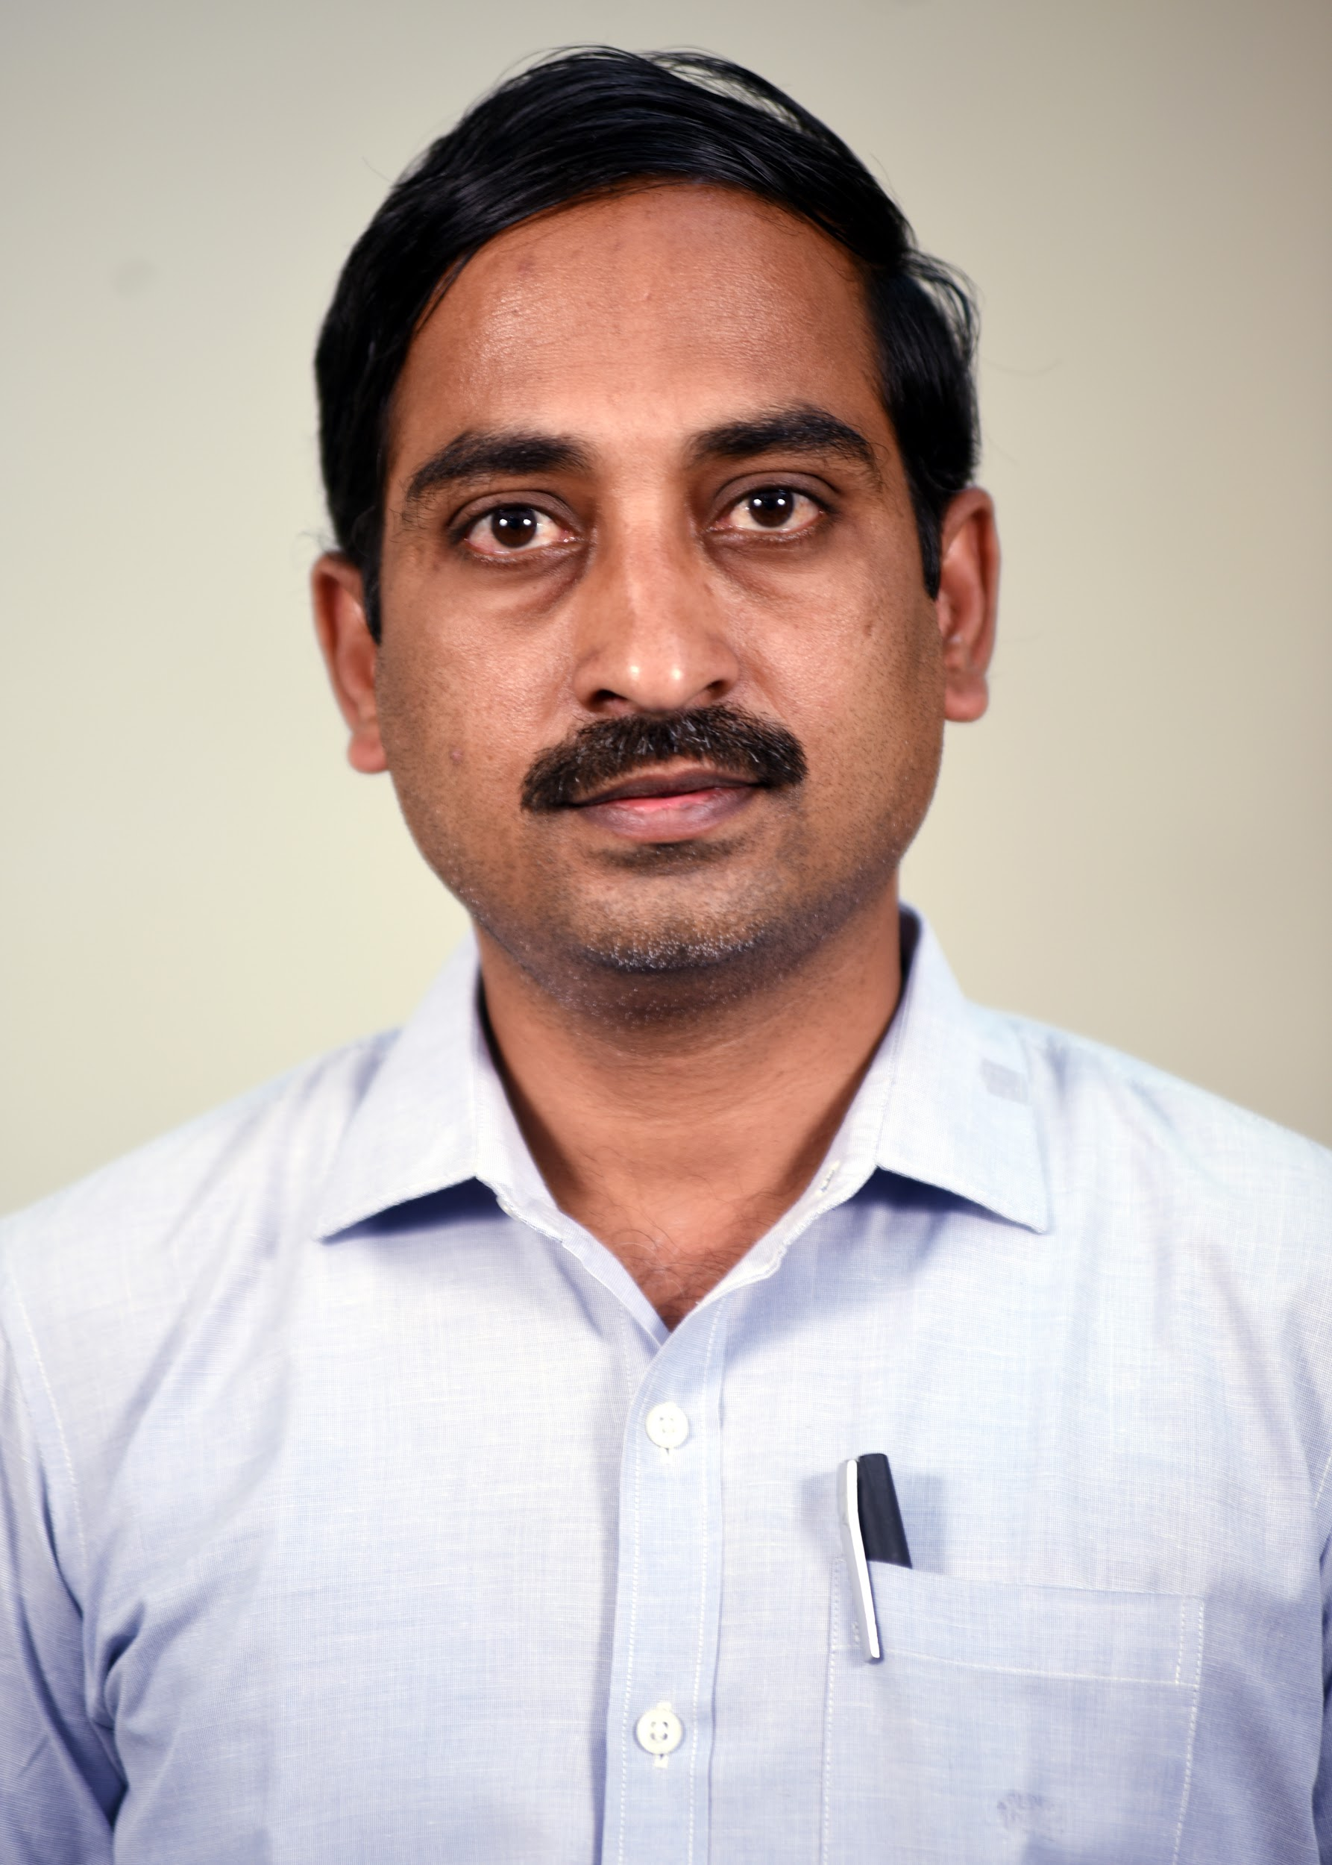

**Dr.P.Srinivasa Rao  
M.Sc (Q.Eco)., M.Sc (Stat)., Ph.D  
Econometrics, Testing of Hypothesis, Sampling  
Sr.Assistant Professor & HOD**

**The Department imparts rigorous training and exposure to the students in statistics education with computer based by way of introducing the latest state-of-the-art in view of the market needs to enable to the students to perform statistical data analysis. In addition to that preparing higher studies with view of local & central universities and research background of the students, and the same has been continually updated covering most of the areas of Theoretical and Applied Statistics at the specialization level. Students are doing projects by getting hands on experience of theoretical to reality.**

##### List of Faculty Members

|  | **Name** | **Designation** | **Qualification** | **Area of Specialization** | **Email Id** | **DOJ** |
| --- | --- | --- | --- | --- | --- | --- |
|  | **Dr.P.Srinivasa Rao** | **Sr.Assistant Professor & HOD** | **M.Sc (Q.Eco)., M.Sc (Stat)., Ph.D** | **Econometrics, Testing of Hypothesis, Sampling** | **drsrinivasarao@gvpcdpgc.edu.in**  [**Profile**](https://gvpcdpgc.edu.in/gvp_faculty/all_ug_resumes/statistics/PSR.pdf) | **11.08.2009** |
|  | **Miss.S.Lavanya** | **Assistant Professor** | **M.Sc., M.Tech** | **Operations Research, Testing of Hypothesis, Quality and Reliability** | **slavanya@gvpcdpgc.edu.in**  [**Profile**](https://gvpcdpgc.edu.in/gvp_faculty/all_ug_resumes/statistics/lavanya.pdf) | **10.12.2018** |

**BCA**

**Sub-Heading :** [**PO's & PSO's**](https://gvpcdpgc.edu.in/bca/bca_popso.php)

**Program Specific Outcomes (PSOs)**

* **PSO 1: Create, select and supply appropriate techniques, resources and modern technology in multidisciplinary environment and also able to setup mathematical models of real world problems and obtain solutions in structured and analytical approaches with independent judgement and also create interest towards the area of research.**
* **PSO 2: Acquire knowledge about the theory of statistics with Computer Science as one of the subject in graduation level, the students have research empower in any discipline like engineering, management, bio- sciences, finance etc,. It leads to the students as a data scientist.**
* **PSO 3: The ability to understand, analyze and develop computer programs in the areas related to algorithms, system software, and multimedia and big data analytics for efficient design of computer-based systems of varying complexity. They develop the ability to employ modern platforms in creating innovative career paths to be an entrepreneur and a zest for higher studies.**

**Program Outcomes (POs)**

* **Critical thinking skills: Students able to take informed actions by differentiating between fact and opinion, recognize and evaluate, develop inferential skills and distinguish logical assumption from different perceptive allow making decisions and judgments by using scientific-based reasoning.**
* **Analytical skills: Students able to analyze and interpret concepts from a variety of methods apply these methods to analogous situations. They assess the elements of a problem and become competent at problem solving.**
* **Usage of modern tools and technologies: Students develop scientific orientation and are at ease in the adoption of modern techniques.**
* **Effective communication: Students develop skills like listening, speaking, reading and writing in their respective domains and become communicators.**
* **Ethics: Students develop ethical values and contribute to nation building as responsible citizens.**
* **Self-directed and life –long learning: Acquire the ability to engage in independent and lifelong learning in the broadest context socio-technological changes.**
* **Social interaction and sustainability: Students develop empathy towards the societal needs and are able to contribute sustainable development and gain knowledge and skill to understand and solve environmental issues and problems**

**BCA Data-Science:**

**Sub-Heading :** [**PO's & PSO's**](https://gvpcdpgc.edu.in/bca_datascience/bca_popso.php)

Program Specific Outcomes (PSOs)

* PSO 1: Create, select and supply appropriate techniques, resources and modern technology in multidisciplinary environment and also able to setup mathematical models of real world problems and obtain solutions in structured and analytical approaches with independent judgement and also create interest towards the area of research.
* PSO 2: Acquire knowledge about the theory of statistics with Computer Science as one of the subject in graduation level, the students have research empower in any discipline like engineering, management, bio- sciences, finance etc,. It leads to the students as a data scientist.
* PSO 3: The ability to understand, analyze and develop computer programs in the areas related to algorithms, system software, and multimedia and big data analytics for efficient design of computer-based systems of varying complexity. They develop the ability to employ modern platforms in creating innovative career paths to be an entrepreneur and a zest for higher studies.

Program Outcomes (POs)

* Critical thinking skills: Students able to take informed actions by differentiating between fact and opinion, recognize and evaluate, develop inferential skills and distinguish logical assumption from different perceptive allow making decisions and judgments by using scientific-based reasoning.
* Analytical skills: Students able to analyze and interpret concepts from a variety of methods apply these methods to analogous situations. They assess the elements of a problem and become competent at problem solving.
* Usage of modern tools and technologies: Students develop scientific orientation and are at ease in the adoption of modern techniques.
* Effective communication: Students develop skills like listening, speaking, reading and writing in their respective domains and become communicators.
* Ethics: Students develop ethical values and contribute to nation building as responsible citizens.
* Self-directed and life –long learning: Acquire the ability to engage in independent and lifelong learning in the broadest context socio-technological changes.
* Social interaction and sustainability: Students develop empathy towards the societal needs and are able to contribute sustainable development and gain knowledge and skill to understand and solve environmental issues and problems

[**COMMERCE**](https://gvpcdpgc.edu.in/commerce_groups.php)

**B.com :**

**Sub-Heading:**[**PO's & PSO's**](https://gvpcdpgc.edu.in/bcom/bcom_popso.php)

**program Specific Outcomes (PSOs)**

* **PSO 1: Create, select and supply appropriate techniques, resources and modern technology in multidisciplinary environment and also able to setup mathematical models of real world problems and obtain solutions in structured and analytical approaches with independent judgement and also create interest towards the area of research.**
* **PSO 2: Acquire knowledge about the theory of statistics with Computer Science as one of the subject in graduation level, the students have research empower in any discipline like engineering, management, bio- sciences, finance etc,. It leads to the students as a data scientist.**
* **PSO 3: The ability to understand, analyze and develop computer programs in the areas related to algorithms, system software, and multimedia and big data analytics for efficient design of computer-based systems of varying complexity. They develop the ability to employ modern platforms in creating innovative career paths to be an entrepreneur and a zest for higher studies.**

**Program Outcomes (POs)**

* **Critical thinking skills: Students able to take informed actions by differentiating between fact and opinion, recognize and evaluate, develop inferential skills and distinguish logical assumption from different perceptive allow making decisions and judgments by using scientific-based reasoning.**
* **Analytical skills: Students able to analyze and interpret concepts from a variety of methods apply these methods to analogous situations. They assess the elements of a problem and become competent at problem solving.**
* **Usage of modern tools and technologies: Students develop scientific orientation and are at ease in the adoption of modern techniques.**
* **Effective communication: Students develop skills like listening, speaking, reading and writing in their respective domains and become communicators.**
* **Ethics: Students develop ethical values and contribute to nation building as responsible citizens.**
* **Self-directed and life –long learning: Acquire the ability to engage in independent and lifelong learning in the broadest context socio-technological changes.**
* **Social interaction and sustainability: Students develop empathy towards the societal needs and are able to contribute sustainable development and gain knowledge and skill to understand and solve environmental issues and problems**

[**COMMERCE**](https://gvpcdpgc.edu.in/commerce_groups.php)

**B.com (Computer Science):**

**Sub-Heading:**[**PO's & PSO's**](https://gvpcdpgc.edu.in/bcom/bcom_popso.php)

**Program Specific Outcomes (PSOs)**

* **PSO 1: Create, select and supply appropriate techniques, resources and modern technology in multidisciplinary environment and also able to setup mathematical models of real world problems and obtain solutions in structured and analytical approaches with independent judgement and also create interest towards the area of research.**
* **PSO 2: Acquire knowledge about the theory of statistics with Computer Science as one of the subject in graduation level, the students have research empower in any discipline like engineering, management, bio- sciences, finance etc,. It leads to the students as a data scientist.**
* **PSO 3: The ability to understand, analyze and develop computer programs in the areas related to algorithms, system software, and multimedia and big data analytics for efficient design of computer-based systems of varying complexity. They develop the ability to employ modern platforms in creating innovative career paths to be an entrepreneur and a zest for higher studies.**

**Program Outcomes (POs)**

* **Critical thinking skills: Students able to take informed actions by differentiating between fact and opinion, recognize and evaluate, develop inferential skills and distinguish logical assumption from different perceptive allow making decisions and judgments by using scientific-based reasoning.**
* **Analytical skills: Students able to analyze and interpret concepts from a variety of methods apply these methods to analogous situations. They assess the elements of a problem and become competent at problem solving.**
* **Usage of modern tools and technologies: Students develop scientific orientation and are at ease in the adoption of modern techniques.**
* **Effective communication: Students develop skills like listening, speaking, reading and writing in their respective domains and become communicators.**
* **Ethics: Students develop ethical values and contribute to nation building as responsible citizens.**
* **Self-directed and life –long learning: Acquire the ability to engage in independent and lifelong learning in the broadest context socio-technological changes.**
* **Social interaction and sustainability: Students develop empathy towards the societal needs and are able to contribute sustainable development and gain knowledge and skill to understand and solve environmental issues and problems**

[**COMMERCE**](https://gvpcdpgc.edu.in/commerce_groups.php)

**B.com Honours (Computer Applications):**

**Sub-Heading:**[**PO's & PSO's**](https://gvpcdpgc.edu.in/bcom/bcom_popso.php)

Program Outcomes (POs)

* Critical thinking skills: Students able to take informed actions by differentiating between fact and opinion, recognize and evaluate, develop inferential skills and distinguish logical assumption from different perceptive allow making decisions and judgments by using scientific-based reasoning.
* Analytical skills: Students able to analyze and interpret concepts from a variety of methods apply these methods to analogous situations. They assess the elements of a problem and become competent at problem solving.
* Usage of modern tools and technologies: Students develop scientific orientation and are at ease in the adoption of modern techniques.
* Effective communication: Students develop skills like listening, speaking, reading and writing in their respective domains and become communicators.
* Ethics: Students develop ethical values and contribute to nation building as responsible citizens.
* Self-directed and life –long learning: Acquire the ability to engage in independent and lifelong learning in the broadest context socio-technological changes.
* Social interaction and sustainability: Students develop empathy towards the societal needs and are able to contribute sustainable development and gain knowledge and skill to understand and solve environmental issues and problems

Program Specific Outcomes (PSOs)

* PSO 1: Create, select and supply appropriate techniques, resources and modern technology in multidisciplinary environment and also able to setup mathematical models of real world problems and obtain solutions in structured and analytical approaches with independent judgement and also create interest towards the area of research.
* PSO 2: Acquire knowledge about the theory of statistics with Computer Science as one of the subject in graduation level, the students have research empower in any discipline like engineering, management, bio- sciences, finance etc,. It leads to the students as a data scientist.
* PSO 3: The ability to understand, analyze and develop computer programs in the areas related to algorithms, system software, and multimedia and big data analytics for efficient design of computer-based systems of varying complexity. They develop the ability to employ modern platforms in creating innovative career paths to be an entrepreneur and a zest for higher studies.

**MANAGEMENT**

#### [**BBA :**](https://gvpcdpgc.edu.in/bba/bba_popso.php)

**Sub-Heading:**[**PO's & PSO's**](https://gvpcdpgc.edu.in/bcom/bcom_popso.php)

**Program Specific Outcomes (PSOs)**

* **PSO 1: Create, select and supply appropriate techniques, resources and modern technology in multidisciplinary environment and also able to setup mathematical models of real world problems and obtain solutions in structured and analytical approaches with independent judgement and also create interest towards the area of research.**
* **PSO 2: Acquire knowledge about the theory of statistics with Computer Science as one of the subject in graduation level, the students have research empower in any discipline like engineering, management, bio- sciences, finance etc,. It leads to the students as a data scientist.**
* **PSO 3: The ability to understand, analyze and develop computer programs in the areas related to algorithms, system software, and multimedia and big data analytics for efficient design of computer-based systems of varying complexity. They develop the ability to employ modern platforms in creating innovative career paths to be an entrepreneur and a zest for higher studies.**

**Program Outcomes (POs)**

* **PO1. Critical Thinking: Take informed actions after identifying the assumptions that frame our thinking and actions, checking out the degree to which these assumptions are accurate and valid, and looking at our ideas and decisions (intellectual, organizational, and personal) from different perspectives.**
* **PO2. Effective Communication: Speak, read, write and listen clearly in person and through electronic media in English and in one Indian language, and make meaning of the world by connecting people, ideas, books, media and technology.**
* **PO3. Social Interaction: Elicit views of others, mediate disagreements and help reach conclusions in group settings.**
* **PO4. Effective Citizenship: Demonstrate empathetic social concern and equity centered national development, and the ability to act with an informed awareness of issues and participate in civic life through volunteering.**
* **PO5. Ethics: Recognize different value systems including your own, understand the moral dimensions of your decisions, and accept responsibility for them.**
* **PO6. Environment and Sustainability: Understand the issues of environmental contexts and sustainable development.**
* **PO7. Self-directed and Life-long Learning: Acquire the ability to engage in independent and lifelong learning in the broadest.**



1. [**Department of Master of Business Administration**](https://gvpcdpgc.edu.in/mba/aboutmba.php)
2. [**DEPARTMENT OF MASTER OF COMPUTER APPLICATIONS**](https://gvpcdpgc.edu.in/mca/aboutmca.php)
3. [**DEPARTMENT OF M.Sc ORGANIC CHEMISTRY**](https://gvpcdpgc.edu.in/mscorganicchemistry/aboutorganicchemistry.php)
4. [**MHRM**](https://gvpcdpgc.edu.in/mhrm/aboutmhrm.php)
5. [**Department of MBA - Business Analytics**](https://gvpcdpgc.edu.in/mba-ba/aboutmbaba.php)
6. [**DEPARTMENT OF MASTER OF COMMERCE**](https://gvpcdpgc.edu.in/postdegree.php#)
7. [**Department of Master of Computer Science**](https://gvpcdpgc.edu.in/msc/aboutmsc.php)

[**Department of Master of Business Administration**](https://gvpcdpgc.edu.in/mba/aboutmba.php)

Sub-Heading : [**About Department**](https://gvpcdpgc.edu.in/mba/aboutmba.php)

About Department

GAYATRI VIDYA PARISHAD COLLEGE FOR DEGREE AND PG COURSES (Autonomous) introduced a professional program in Business Management at masters level, Master of Business Administration (MBA) in 1995 affiliated to Andhra University, Visakhapatnam.

The PG Department of Management Studies (MBA) has a special status in the academic stream of GAYATRI VIDYA PARISHAD. It stands as a replica of the vision and mission of the parent organization.

The MBA program, Department of Management Studies, has a special status in the academic streams of GAYATRI VIDYA PARISHAD with the aim of producing competent management professionals to meet the requirements of the corporate world. Since day one, the department has been constantly striving to achieve excellence in the field of management education by focusing on qualitative teaching. The department has been successful in adopting innovative methods of imparting management education and nurturing the students to meet the challenges of the industry.

The department has been very fortunate in having the expertise of several senior academicians and intellectuals who have been instrumental in shaping the institution to its present status with their vision and teaching. The research work done by faculty of any master’s program contributes significantly to the department and to the college as well. The progress of the management department towards this is highly significant with a total of 12 Doctorates and all faculty members have qualified UGC-NET/SET. The faculty members undertake consultancy assignments at various levels and sectors to support the industry. The Department has been recognized as a research centre by Andhra University to guide Ph.D. scholars

The department has Entrepreneurship Development Cell (EDC), and an Industry Institute Partnership Cell (IIPC) funded by AICTE. There is constant encouragement to the faculty and students to participate in National and International Seminars, workshops and various academic development programs. The Training and Placement Cell (TPC) coordinates training and placement activities of the students.

The Department of Management Studies has started offering Choice Based Credit System (CBCS) from 2016-17 admitted batches wherein the students can choose one functional specialization among Marketing, Finance & HR and one sectorial specialization among Retail Management, Banking & Financial Services, Hospital Management & Logistics and Supply Chain Management. Further the department is offering open electives in emerging areas such as Soft Skills, Advanced Excel and French in first semester and Business Analytics, Yoga, Digital Marketing and Tally in second semester. The department has excellent academic infrastructure like smart classrooms, digital library, computer centre, media centre, seminar halls, linguistic lab, etc. Experts from Industry and Parent University are invited to deliver lectures on different courses to share their hands on experience to the students

The management department is located in the 8.7-acre lush green Rushikonda campus with well- ventilated spacious class rooms, well equipped laboratories, library, play fields, canteen, vehicle parking , gym, staff rooms, waiting halls, auditorium, seminar halls, etc.

* [FY 2021-22 MBA Financial Audit Report](https://gvpcdpgc.edu.in/mba/mba_data/FY_2021-22_MBA_Financial_Audit_Report.pdf)
* [FY 2020-21 MBA Financial Audit Report](https://gvpcdpgc.edu.in/mba/mba_data/FY_2020-21_MBA_Financial_Audit_Report.pdf)
* [FY 2019-20 MBA Financial Audit Report](https://gvpcdpgc.edu.in/mba/mba_data/FY_2019-20_MBA_Financial_Audit_Report.pdf)
* [FY 2018-19 MBA Financial Audit Report](https://gvpcdpgc.edu.in/mba/mba_data/FY_2018-19_MBA_Financial_Audit_Report.pdf)
* [POLICIES AND PROCEDURES](https://gvpcdpgc.edu.in/mba/mba_data/POLICIES%20AND%20PROCEDURES%20(1).pdf)
* [GVPCDPGC GOVERNANCE](https://gvpcdpgc.edu.in/mba/mba_data/GVPCDPGC%20GOVERNANCE%20(1).pdf)

Sub-Heading : [**Vision & Mission \ PEOs \ PSOs \ POs**](https://gvpcdpgc.edu.in/mba/mba_vision.php)

**Vision**

**“Provide value based management education to nurture global business leaders.”**

**Mission**

**Transform into a premier management institution in pursuit of global knowledge and pragmatic orientation for grooming leadership, entrepreneurial talent and corporate acumen to nurture socially responsible business leaders.**

**Program Outcomes (POs)**

* **PO 1: Apply knowledge of management theories and practices to solve business problems**
* **PO 2: Foster analytical and critical thinking abilities for data based decision making.**
* **PO 3: Ability to develop value based leadership ability.**
* **PO 4: Ability to understand analyse and communicate global, economic, legal and ethical aspects of business.**
* **PO 5: Ability to lead themselves and others in the achievement of organizational goals, contributing effectively to a team environment.**
* **PO 6: Ability to continuously learn and adapt to the dynamics of business and society.**
* **PO 7: Acquire entrepreneurial skills to establish and manage enterprises.**

**Program Educational Objectives( PEOs)**

* **The Educational objectives of the two years MBA program of this institution arePEO 1:To impart a general level of competence in management and to orient the students to acquire creative, innovative and entrepreneurial potential.**
* **PEO 2:To equip the students with requisite knowledge, skills, right attitude and orientation towards Continuous Learning and to develop efficient managers.**
* **PEO 3:To prepare them to adapt to a rapidly changing environment by applying their conceptual knowledge and become socially responsible and value driven citizens committed to sustainable development.**
* **PEO 4:Students of this program will be equipped with quantitative and qualitative skills to identify, analyze, design and create business opportunities in a globally dynamic environment.**

**Sub-Heading :** [**HOD's Message**](https://gvpcdpgc.edu.in/mba/mba_hod.php)

#### HOD's Message

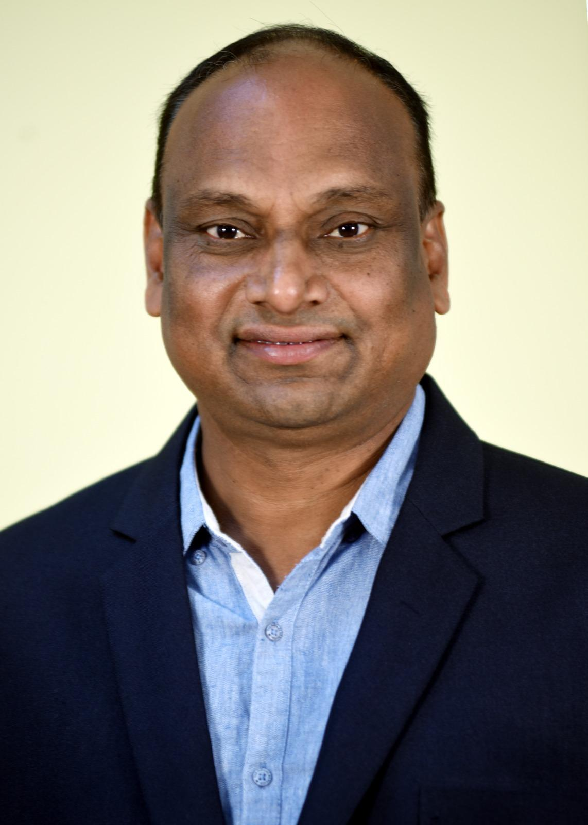

**Welcome to the Department of Master of Business Administration (MBA),Department of Management Studies was established in the year 1995 with aVision “to provide value based management education to nurture global business leaders”.**

**The Department’s strength lies in well qualified and experienced faculty who always thrive to deliver professional knowledge and impart interpersonal skills for the overall development of students to meet the expectations of the corporate world.**

**MBA Department offers a two year Management program with a dual specialization consisting of 4 semesters. The curriculum consists of core papers with specialization such as Marketing, Finance and Human Resource Management along with sectoral specializations with electives like Retail Management, Banking and Financial Services and Hospital Management.**

**The Department has all the necessary infrastructure for carrying academic activities and it also consists of Industry Institution Partnership Cell (IIPC), Entrepreneurship Cell (EDC), English Lab, and Training and Placement cell. The placement cell has a good record of providing placement to students into reputed companies.**

**Students come from different backgrounds and the Department strives to bring them to a common platform to explore the subject knowledge and overall personality development. Students are exposed to undertake project works both in their specializations and also on contemporary relevant issues during their two year span. We also offer open electives of Excel, Tally, Business Analytics, Yoga, Ethics and French, to improve job enhancing skills.**

**With all these inputs, we always strive to provide value based education for the overall development of student personality. We adopt modern techniques of teaching pedagogy in delivering the subject and also through guest lectures, seminars, workshops, industrial visits and personality development activities.**

**The Department also encourages students to organize management events like ASTHRA- a Management Student’s meet, and also make them participate in management events elsewhere. With this introduction, the Department welcomes you to join in exploring the new horizons of Management Education.**

**Welcome to the MBA Department…..,  
Prof.K.S Bose  
Head of the Department**

**Sub-Heading :** [**Faculty**](https://gvpcdpgc.edu.in/mba/mba_faculty_list.php)

##### List of Faculty Members

|  | **Name-Designation-Qualification** | **Area-of-Specialization** | **E-mail** | **Date of Joining** | **Nature-of-Association** |
| --- | --- | --- | --- | --- | --- |
|  | [**Prof. P. V. Sarma**](https://gvpcdpgc.edu.in/mba/mba_faculty_list.php#)  **Honorary Professor**  **& Director**  **MA, MSc, Ph.D.** | **Quantitative Methods** | **vyaghreswarasarma@gvpcdpgc.edu.in**  [**Profile**](https://gvpcdpgc.edu.in/mba/mba_faculty_list.php#) | **03-01-2005** | **Regular** |
|  | [**Prof. S. Rajani**](https://gvpcdpgc.edu.in/mba/mba_data/Prof.S.Rajani.pdf)  **Senior Professor**  **MBA, Ph.D, UGCNET(JRF)** | **Human Resource Management** | **rajani95s@gvpcdpgc.edu.in**  [**Profile**](https://gvpcdpgc.edu.in/mba/mba_faculty_list.php#) | **05-09-2001** | **Regular** |
|  | [**Prof. K. S. Bose**](https://gvpcdpgc.edu.in/mba/mba_data/Prof.K.S.Bose.pdf)  **Professor , HOD**  **MBA, Ph.D, NET** | **Marketing Management** | **ksbose@gvpcdpgc.edu.in**  [**Profile**](https://gvpcdpgc.edu.in/mba/mba_faculty_list.php#) | **27-01-1998** | **Regular** |
|  | [**Dr. P. V. Mohini**](https://gvpcdpgc.edu.in/mba/mba_data/Dr.P_V_Mohini.pdf)  **Professor**  **MBA, M.Com, M.Phil, Ph.D** | **Finance** | **mohinipuni@gvpcdpgc.edu.in**  [**Profile**](https://gvpcdpgc.edu.in/mba/mba_faculty_list.php#) | **20-12-2000** | **Regular** |
|  | [**Dr. K. V. V. Murali Someswara Rao**](https://gvpcdpgc.edu.in/mba/mba_data/Dr.K.V.V.MURALI_%20SOMESWARA_RAO.pdf)  **Professor**  **MBA, M.Phil, Ph.D, APSET** | **Systems and Marketing** | **murali.koyyani@gvpcdpgc.edu.in**  [**Profile**](https://gvpcdpgc.edu.in/mba/mba_faculty_list.php#) | **02-08-2004** | **Regular** |
|  | [**Dr. A. Sairoop**](https://gvpcdpgc.edu.in/mba/mba_data/Dr.A_Sairoop.pdf)  **Associate Professor**  **BL, MBA, Ph.D** | **Human Resource Management** | **saiallena@gvpcdpgc.edu.in**  [**Profile**](https://gvpcdpgc.edu.in/mba/mba_faculty_list.php#) | **01-07-2007** | **Regular** |
|  | [**Dr. N. Vijaya Jyothi**](https://gvpcdpgc.edu.in/mba/mba_data/Dr.N.Vijaya_Jyothi.pdf)  **Associate Professor**  **MBA, Ph.D** | **Finance** | **vijayajyothi@gvpcdpgc.edu.in**  [**Profile**](https://gvpcdpgc.edu.in/mba/mba_faculty_list.php#) | **30-09-2013** | **Regular** |
|  | [**Dr. A. Anand**](https://gvpcdpgc.edu.in/mba/mba_data/Dr.ANAND_AYYAGARI.pdf)  **Associate Professor**  **M.Sc(Stat), Ph.D, UGCNET** | **Statistical Quality Control** | **anandayyagari@gvpcdpgc.edu.in**  [**Profile**](https://gvpcdpgc.edu.in/mba/mba_faculty_list.php#) | **28-09-1991** | **Regular** |
|  | **Mr.P.Venkata Krishna**  **MBA**  **Director IIPC** | **Marketing Management** | **venkatakrishna@gvpcdpgc.edu.in**  [**Profile**](https://gvpcdpgc.edu.in/mba/mba_faculty_list.php#) | **03-04-2021** | **Regular** |
|  | [**Dr. N. V. S. Anil Kumar**](https://gvpcdpgc.edu.in/mba/mba_data/N.V.S.ANIL_KUMAR.pdf)  **Assistant Professor**  **MBA, Ph.D** | **Finance** | **anil@gvpcdpgc.edu.in**  [**Profile**](https://gvpcdpgc.edu.in/mba/mba_faculty_list.php#) | **01-08-2012** | **Regular** |
|  | [**Dr. A. Nooka Raju**](https://gvpcdpgc.edu.in/mba/mba_data/A_Nooka_Raju.pdf)  **Assistant Professor**  **MBA, M.Com, M.Phil, Ph.D, UGCNET** | **Finance** | **anrajuammu@gvpcdpgc.edu.in**  [**Profile**](https://gvpcdpgc.edu.in/mba/mba_faculty_list.php#) | **30-09-2013** | **Regular** |
|  | [**Mr. K. Gowri Shankar**](https://gvpcdpgc.edu.in/mba/mba_data/Gowri_Shankar.pdf)  **Assistant Professor**  **M.Com, MBA, M.Phil, APSET** | **Finance** | **gowrisankar@gvpcdpgc.edu.in**  [**Profile**](https://gvpcdpgc.edu.in/mba/mba_faculty_list.php#) | **01-06-2018** | **Regular** |
|  | [**Dr. D. Saibala Pallavi**](https://gvpcdpgc.edu.in/mba/mba_data/Dr.D.S.B.PALLAVI.pdf)  **Assistant Professor**  **MBA, M.Com, M.Phil, Ph.D** | **Human Resource Management** | **dsbpallavi@gvpcdpgc.edu.in**  [**Profile**](https://gvpcdpgc.edu.in/mba/mba_faculty_list.php#) | **10-09-2015** | **Regular** |
|  | [**Dr. V. Rajesh**](https://gvpcdpgc.edu.in/mba/mba_data/Rajesh_Vemula.pdf)  **Assistant Professor**  **M.Com, MBA, APSET, Ph.D** | **Marketing Management** | **rajeshvemula@gvpcdpgc.edu.in**  [**Profile**](https://gvpcdpgc.edu.in/mba/mba_faculty_list.php#) | **22-07-2015** | **Regular** |
|  | [**Ms. K. Gouthami**](https://gvpcdpgc.edu.in/mba/mba_data/K.GOWTHAMI.pdf)  **Assistant Professor**  **MBA, APSET** | **HRM** | **gowthamik@gvpcdpgc.edu.in**  [**Profile**](https://gvpcdpgc.edu.in/mba/mba_faculty_list.php#) | **18-09-2015** | **Regular** |
|  | [**Mr. B. Mahendra Reddy**](https://gvpcdpgc.edu.in/mba/mba_data/MAHENDRA_REDDY_BOGALA.pdf)  **Assistant Professor**  **B.Tech, MBA, APSET, UGCNET** | **Marketing Management** | **mahendra@gvpcdpgc.edu.in**  [**Profile**](https://gvpcdpgc.edu.in/mba/mba_faculty_list.php#) | **11-09-2017** | **Regular** |
|  | [**Dr. K.V. Nagaraj**](https://gvpcdpgc.edu.in/mba/mba_data/Dr.K.VENKATA_NAGARAJ.pdf)  **Assistant Professor**  **MBA, M.Com, APSET, Ph.D** | **Marketing Management** | **nagaraj@gvpcdpgc.edu.in**  [**Profile**](https://gvpcdpgc.edu.in/mba/mba_faculty_list.php#) | **18-06-2018** | **Regular** |
|  | **Dr.B.Ashok**  **MBA, APSET, Ph.D**  **Assistant Professor** | **Finance** | **ashokbotta@gvpcdpgc.edu.in**  [**Profile**](https://gvpcdpgc.edu.in/mba/mba_faculty_list.php#) | **03-04-2021** | **Regular** |
|  | **Dr. S. Vara Lakshmi**  **MBA, Ph.D**  **Assistant Professor** | **Marketing** | **varalakshmi@gvpcdpgc.edu.in**  [**Profile**](https://gvpcdpgc.edu.in/mba/mba_faculty_list.php#) | **01-05-2023** | **Regular** |

**Sub-Heading :** [**Syllabus**](https://gvpcdpgc.edu.in/mba/mba_syllabus.php)

##### Syllabus

* **MBA Syllabus (Under CBCS Pattern) (With effect from 2022 – 2023 Admitted Batch)** [**Click Here**](https://gvpcdpgc.edu.in/mba/mba_data/MBA_(General)_Syllabus_2022-23_Admitted_Batch.pdf)
* **MBA Syllabus (Under CBCS Pattern) (With effect from 2021 – 2022 Admitted Batch)** [**Click Here**](https://gvpcdpgc.edu.in/mba/mba_data/MBA_(General)_Syllabus_2021-22_Admitted_Batch.pdf)
* **MBA Syllabus (Under CBCS Pattern) (With effect from 2018 – 2019 Admitted Batch)** [**Click Here**](https://gvpcdpgc.edu.in/mba/mba_data/MBA-Syllabus-%20Book_2018-19.pdf)

**Sub-Heading :** [**Academic Calender**](https://gvpcdpgc.edu.in/mba/mba_academic_cal.php)

##### Academic Calendar

* **Academic Calendar PG 2022-23** [**Click Here**](https://gvpcdpgc.edu.in/mba/mba_data/Academic_Calendar_2022-23.pdf)
* **Academic Calendar PG 2021-22** [**Click Here**](https://gvpcdpgc.edu.in/mba/mba_data/Academic_Calendar_2021-22.pdf)
* **Academic Calendar PG 2020-21** [**Click Here**](https://gvpcdpgc.edu.in/mba/mba_data/Academic_Calendar_2020-21.pdf)
* **Academic Calendar 2019-20_Sem_2_and_Sem 4** [**Click Here**](https://gvpcdpgc.edu.in/mba/mba_data/Academic_Calendar_2019-20_Sem_2_and_Sem%204.pdf)
* **Academic Calendar 2019-20_Sem_1_and_Sem 3** [**Click Here**](https://gvpcdpgc.edu.in/mba/mba_data/Academic_Calendar_2019-20_Sem_1_and_Sem_3.pdf)
* **Academic Calendar 2018-19_Sem_2_and_Sem 4** [**Click Here**](https://gvpcdpgc.edu.in/mba/mba_data/Academic_Calendar_2018-19_Sem_2_and_Sem_4.pdf)
* **Academic Calendar 2018-19_Sem_1_and_Sem 3** [**Click Here**](https://gvpcdpgc.edu.in/mba/mba_data/Academic_Calendar_2018-19_Sem_1_and_Sem_3.pdf)
* **Academic Calendar PG 2019-20 (Tentative)** [**Click Here**](https://gvpcdpgc.edu.in/mba/mba_data/MBA-Academic-Calendar-2019-20.pdf)
* **Academic Calendar 2017-18.pdf** [**Click Here**](https://gvpcdpgc.edu.in/mba/mba_data/Academic_Calendar_2017-18.pdf)

**Sub-Heading :** [**Infrastructure**](https://gvpcdpgc.edu.in/mba/mba_labs.php)

#### Infrastructure Details

Gayatri Vidya Parishad Degree College for Degree and PG Courses (Autonomous) is located in the 8.7-acre lush green Rushikonda campus with well- ventilated spacious class rooms, well equipped laboratories, Library, play fields, canteen, parking places, gym, staff rooms, waiting halls, auditorium, seminar halls, etc. It has the distinction of having highly scholastic and experienced professors and principals on its management. These members are visionary and capable of planning for the future and predicting the infrastructure requirements. They have always ensured adequate availability of infrastructure and its optimal utilization. The College is well equipped with state-of-the-art infrastructure facilities to cater to the needs of the students and staff in the teaching-learning process.

Ever since the inception, the Department of Management Studies (MBA program) has been focusing on the development of its infrastructure to commensurate with its brand image in this region. The department has adequate facilitates along with necessary amenities catering to the diverse needs of the students and staff to create effective teaching - learning ambiance. The department ensures optimal utilization of the physical infrastructure available on the campus. It plans well in advance to ensure adequate availability of additional infrastructure commensurate with the requirement of further intake also.

The infrastructure planning and development is being done as per the curriculum requirements of MBA Program:

Class Rooms:

All the class rooms are well equipped with LCD projector, Screen, Black Board, Podium, UPS, Wi-Fi. All the class rooms are architected in such a way that a healthy teaching learning environment.

Tutorial Rooms

There are tutorial rooms which are exclusively allocated to the MBA program which are utilised by the students when the specialization course, tutorial courses, bridge courses and open elective courses are been conducted as per the requirements of the program curriculum.

Seminar Halls:

The Department of Management Studies (MBA program) is having three exclusive seminar halls which are effectively utilised to organize seminars, conferences, symposiums, workshops, training programs, guest lectures, faculty development programs, and student personality development activities. All the seminar halls are fully air conditioned and well equipped with latest ICT equipment, audio/visual aids, Unlimited Power Supply (UPS) facility, white board, podium and Wi-Fi facility.

The infrastructure of the seminar halls is designed in such a way that the communication skills, leadership skills, planning and organising skills of the students can be developed during the conduct of personality development activities for the students.

Computer Lab

The MBA program is provided with a state of art centrally airconditioned computer lab with 90 computer systems on 1:2 ratio. The lab is fully equipped with latest hardware configuration and software applications. The computer lab is utilised specially to deliver open elective courses like Advanced Excel, Business Analytics and Tally for the first year MBA students. All MBA students utilise the computer lab to carry out the preparations for the conduct of personality development activities. The computer lab facility is effectively used by the students in preparing the project work report, carrying out data analysis and interpretations, accessing online learning resources like EBSCO database, NPTEL, etc.

Communication Lab

For a management student, language proficiency is as important as knowledge of the subject and it plays a vital role in the student success. To enhance the pronunciation skills, vocabulary and other language skills of students, the MBA program is provided with a sophisticated communication lab equipped with communication devices. Students are encouraged to enhance their skills at their convenient pace. They can practice as well and get the feedback on their language efficiency. This facility has helped the students to perform well in the interviews and get good job offers.

Training and Placement Cell

An exclusive Training and Placement Cell is dedicated for the student placement and related training programs. The Training and Placement Officer (TPO) will be taking care of the conduct of on-campus placement drives by different recruiting companies. The Training and Placement Cell is equipped with required furniture and infrastructure to conduct personal interviews, group discussions, screening, etc. to the students in the placement drives.

Entrepreneurship Development Cell

The MBA program was sponsored with an Entrepreneurship Development Cell (EDC) by AICTE during 2008-2010. The MBA program is still running the cell successfully by producing entrepreneurs from student community by inculcating start-up culture and organising on-campus and off-campus entrepreneurship development programs for the upcoming entrepreneurs and start-up companies.

Industry-Institute Partnership Cell

The MBA program was also sponsored with an Industry Institute Partnership Cell (IIPC) by AICTE during 2008-2012. The MBA program is still running the cell successfully by arranging summer project works for the students, arranging guest lectures for the students, arranging industrial visits for the students as per the curriculum requirements.

Research and Development Cell

The Department of Management Studies (MBA program) is a recognised research centre by its affiliating university i.e. Andhra University to offer Part Time PhD program for the management faculty. An exclusive Research and Development Cell is been run by the program to carry out research by PhD scholars. The R&D cell provides all basic and advanced necessary facilities to carry out research and also provides a separate research library division which maintains the copies of dissertation reports, research reports of sponsored minor and major research, consultancy reports etc. The learning and infrastructure facilities of R&D cell are made available for the MBA students also in order to carry out student research work, paper presentations, etc.

Central Library

The MBA program is also provided with a state of art central library facility with an area of 1000 sqm. The management studies division of the library is equipped with more than 29893 volumes, 7064 titles and 36 National Journals. The Central Library is also provided with digital library, reading room, Wi-Fi, Journals and Magazines division and managed with DELNET software. The utilisation of library facility by the students is contiguous even on holidays also. The library facility is well utilised by the students during their regular studies and examinations, preparation of personality development activities, during the project work (review of literature and collection of secondary data) etc.

LIBRARY RESOURCES:

EBSCO Database:

EBSCO is an intuitive online research platform used by thousands of institutions and millions of students worldwide. With quality databases and search features, EBSCO helps researchers of all kinds find the information they need fast.

DELNET:

DELNET has been established with the prime objective of promoting resource sharing among the libraries through the development of a network of libraries. It aims to collect, store, and disseminate information besides offering computerised services to users, to coordinate efforts for suitable collection development and to reduce unnecessary duplication wherever possible.

NPTEL:

NPTEL provides E-learning through online Web and Video courses various streams. NPTEL is an acronym for National Programme on Technology Enhanced Learning which is an initiative by seven Indian Institutes of Technology.

INFLIBNET:

The N-LIST project provides access to e-resources to students, researchers and faculty from Colleges and other beneficiary institutions through server(s) installed at the INFLIBNET Centre. The authorized users from the College can now access e-resources and download articles required by them directly from the publisher's website once they are duly authenticated as authorized users through servers deployed at the INFLIBNET Centre.

INDEST-AICTE:

IIT Delhi provides for i) cross-subscription to e-resources subscribed by the two Consortia, i.e. subscription to INDEST-AICTE resources for universities and UGCINFONET resources for technical institutions; and ii) access to selected e-resources to Colleges.

IT INFRASTRUCTURE

High speed internet facility is provided through 40 Mbps BSNL broadband connection and 100 Mbps dedicated VOL leased line. The entire campus is Wi-Fi enabled including girls hostel facility. The College has 11 dedicated land line telephones and 4 fax machines for external communication. For internal communication there is 64-line NEC intercom exchange (expandable up to 128 line). The College has an agreement with Microsoft Corporation under “Microsoft Campus agreement” which facilitates access to various software packages

SOFTWARE

The Technical Campus has an agreement with Microsoft Corporation titled as “Microsoft Campus Agreement” where six operating systems and twenty four other software packages of Microsoft Corporation are available for students to improve their IT skill base. As part of this agreement, these thirty softwares are regularly getting updated and managed by the vendor (Microsoft) only. Apart from this asset management, The Technical Campus has purchased licensed original softwares as its assets like Oracle 9i, Tally, etc. These softwares are managed by Systems Engineers and Lab programmers to get updated with current market technology.

Medical Facility:

The Department of Management Studies (MBA Program) has a health care center functioning under the Supervision of a medical officer deputed by Gayatri Vidya Parishad Institute of Health Care. The health center is provided with an emergency bed and other medical amenities like first-aid treatment. The health center has necessary medicines, pills and potions to serve the urgent medical needs of the students and staff. The services of the health center are extended to the students who are staying in the campus hostels. Beyond the campus, there is an opportunity for both teaching and non-teaching members of staff and for their members of family to have free medical check-up programmes like ECG scanning etc in the Gayatri Vidya Parishad Institute of Health Care located at Madhurawada.

**Sub-Heading :** [**Department Committees**](https://gvpcdpgc.edu.in/mba/mba_dept_committe.php)

##### List of Departmantal Committees

* **Departmental Committees - MBA** [**Click Here**](https://gvpcdpgc.edu.in/mba/mba_data/Departmental%20Committees%20(2)%20(1).pdf)

**Sub-Heading** : [**Placements**](https://gvpcdpgc.edu.in/mba/mba_placement.php)

#### Recruiters

* 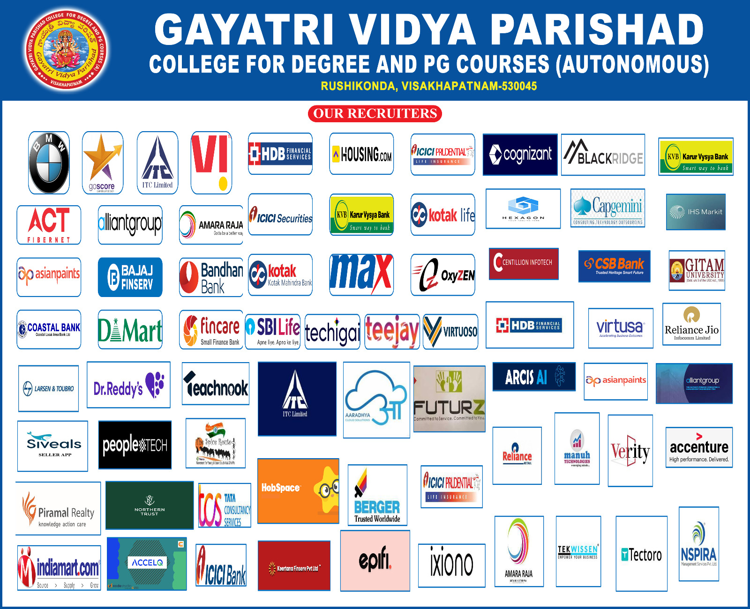  
    
  Recruiters [Click Here](https://gvpcdpgc.edu.in/mba/mba_data/MBA-Placement-Recruiters-Logos.pdf)
* Recruiters 2023 [Click Here](https://gvpcdpgc.edu.in/mba/mba_data/OUR%20RECRUITERS%202023.pdf)

##### Placements Data

* 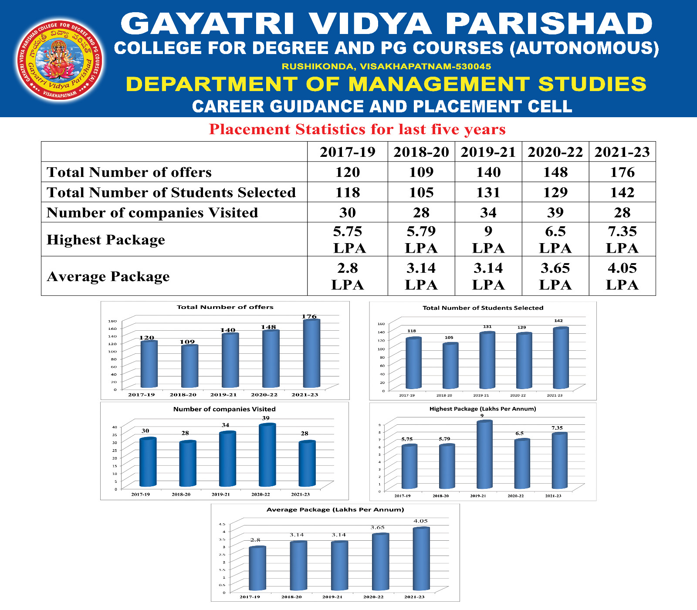  
    
  MBA 2021-2023 Batch Placement Data [Click Here](https://gvpcdpgc.edu.in/mba/mba_data/MBA_Student_Placement_Data_2021-23_Batch.pdf)
* MBA 2020-2022 Batch Placement Data [Click Here](https://gvpcdpgc.edu.in/mba/mba_data/MBA_Student_Placement_Data_2020-22_Batch.pdf)
* MBA 2019-2021 Batch Placement Data [Click Here](https://gvpcdpgc.edu.in/mba/mba_data/MBA_Student_Placement_Data_2019-21_Batch.pdf)
* MBA 2018-2020 Batch Placement Data [Click Here](https://gvpcdpgc.edu.in/mba/mba_data/MBA_Student_Placement_Data_2018-20_Batch.pdf)
* MBA 2017-2019 Batch Placement Data [Click Here](https://gvpcdpgc.edu.in/mba/mba_data/MBA-2017-2019-Batch-Placement-Data.pdf)
* MBA 2016-2018 Batch Placement Data [Click Here](https://gvpcdpgc.edu.in/mba/mba_data/MBA-2016-2018-Batch-Placement-Data.pdf)
* MBA 2015-2017 Batch Placement Data [Click Here](https://gvpcdpgc.edu.in/mba/mba_data/MBA-2015-2017-Batch-Placement-Data.pdf)
* MBA 2014-2016 Batch Placement Data [Click Here](https://gvpcdpgc.edu.in/mba/mba_data/MBA-2014-2016-Batch-Placement-Data.pdf)

##### Placements Brochure

* MBA Placement Brochure [Click Here](https://gvpcdpgc.edu.in/mba/mba_data/MBA-Placement-Brochure.pdf)

##### List of MBA Students

* List of MBA Students 2018-2020 BATCH[Click Here](https://gvpcdpgc.edu.in/mba/mba_data/List-of-MBA-Students-2018-2020-BATCH.pdf)
* List of MBA Students 2019-2021 BATCH[Click Here](https://gvpcdpgc.edu.in/mba/mba_data/List-of-MBA-Students-2019-2021-BATCH.pdf)
* List of MBA Students 2020-2022 BATCH[Click Here](https://gvpcdpgc.edu.in/mba/mba_data/List_of_MBA_Students_2020-2022_BATCH.pdf)
* List of MBA Students 2021-2023 BATCH[Click Here](https://gvpcdpgc.edu.in/mba/mba_data/List_of_MBA_Students_2021-2023_BATCH.pdf)
* List of MBA Students 2022-2024 BATCH[Click Here](https://gvpcdpgc.edu.in/mba/mba_data/List_of_MBA_Students_2022-2024_BATCH.pdf)

**Sub-Heading :** [**Research & Innovations**](https://gvpcdpgc.edu.in/mba/mba_research.php)

##### Research

* Curricular Activities
  + Sponsored Research Projects [Click Here](https://gvpcdpgc.edu.in/mba/mba_data/Sponsored-Research-Projects-Department-of-Management-Studies.pdf)
* Publications
  + Faculty Publications - Academic Year 2021-2022 [Click Here](https://gvpcdpgc.edu.in/mba/mba_data/Faculty%20Publications%20-%20Academic%20Year%202021%202022.pdf)
  + Faculty Publications - Academic Year 2020-2021 [Click Here](https://gvpcdpgc.edu.in/mba/mba_data/Faculty%20Publications%20-%20Academic%20Year%202020%202021.pdf)
  + Faculty Publications - Academic Year 2019-2020 [Click Here](https://gvpcdpgc.edu.in/mba/mba_data/Faculty%20Publications%20-%20Academic%20Year%202019%202020.pdf)
  + Books Published - Academic Year 2021-2022 [Click Here](https://gvpcdpgc.edu.in/mba/mba_data/Books%20Published%20-%20Academic%20Year%202021%202022.pdf)
  + Books Published - Academic Year 2020-2021 [Click Here](https://gvpcdpgc.edu.in/mba/mba_data/Books%20Published%20-%20Academic%20Year%202020%202021.pdf)
  + Books Published - Academic Year 2019-2020 [Click Here](https://gvpcdpgc.edu.in/mba/mba_data/Books%20Published%20-%20Academic%20Year%202019%202020.pdf)
  + Archives  
    List of Books Published [Click Here](https://gvpcdpgc.edu.in/mba/mba_data/List-of-Books-Published-%E2%80%93-MBA-Faculty.pdf)
  + List of Research Journal Publications [Click Here](https://gvpcdpgc.edu.in/mba/mba_data/List-of-Research-Journal-Publications-MBA-Faculty.pdf)
  + List of Papers Presented in Conferences[Click Here](https://gvpcdpgc.edu.in/mba/mba_data/List-of-Papers-Presented-in-Conferences-MBA-Faculty.pdf)
  + Paper Publications by Faculty (2018-19)[Click Here](https://gvpcdpgc.edu.in/mba/mba_data/2018-2019-Paper-Publications-by-MBA-Faculty.pdf)
  + Participation in Seminars/Workshops (2018-19)[Click Here](https://gvpcdpgc.edu.in/mba/mba_data/2018-2019-MBA-Faculty-Participation-in-Seminars-and-Workshops.pdf)
* Research Cell
  + Research Scholars List [Click Here](https://gvpcdpgc.edu.in/mba/mba_data/Research-Scholars-list.pdf)
* Research Consultancy  
  List of Consultancy Work [Click Here](https://gvpcdpgc.edu.in/mba/mba_data/List_of_Consultancy_Work.pdf)

**Sub-Heading :** **Research**

* Curricular Activities
  + Sponsored Research Projects [Click Here](https://gvpcdpgc.edu.in/mba/mba_data/Sponsored-Research-Projects-Department-of-Management-Studies.pdf)
* Publications
  + Faculty Publications - Academic Year 2021-2022 [Click Here](https://gvpcdpgc.edu.in/mba/mba_data/Faculty%20Publications%20-%20Academic%20Year%202021%202022.pdf)
  + Faculty Publications - Academic Year 2020-2021 [Click Here](https://gvpcdpgc.edu.in/mba/mba_data/Faculty%20Publications%20-%20Academic%20Year%202020%202021.pdf)
  + Faculty Publications - Academic Year 2019-2020 [Click Here](https://gvpcdpgc.edu.in/mba/mba_data/Faculty%20Publications%20-%20Academic%20Year%202019%202020.pdf)
  + Books Published - Academic Year 2021-2022 [Click Here](https://gvpcdpgc.edu.in/mba/mba_data/Books%20Published%20-%20Academic%20Year%202021%202022.pdf)
  + Books Published - Academic Year 2020-2021 [Click Here](https://gvpcdpgc.edu.in/mba/mba_data/Books%20Published%20-%20Academic%20Year%202020%202021.pdf)
  + Books Published - Academic Year 2019-2020 [Click Here](https://gvpcdpgc.edu.in/mba/mba_data/Books%20Published%20-%20Academic%20Year%202019%202020.pdf)
  + Archives  
    List of Books Published [Click Here](https://gvpcdpgc.edu.in/mba/mba_data/List-of-Books-Published-%E2%80%93-MBA-Faculty.pdf)
  + List of Research Journal Publications [Click Here](https://gvpcdpgc.edu.in/mba/mba_data/List-of-Research-Journal-Publications-MBA-Faculty.pdf)
  + List of Papers Presented in Conferences[Click Here](https://gvpcdpgc.edu.in/mba/mba_data/List-of-Papers-Presented-in-Conferences-MBA-Faculty.pdf)
  + Paper Publications by Faculty (2018-19)[Click Here](https://gvpcdpgc.edu.in/mba/mba_data/2018-2019-Paper-Publications-by-MBA-Faculty.pdf)
  + Participation in Seminars/Workshops (2018-19)[Click Here](https://gvpcdpgc.edu.in/mba/mba_data/2018-2019-MBA-Faculty-Participation-in-Seminars-and-Workshops.pdf)
* Research Cell
  + Research Scholars List [Click Here](https://gvpcdpgc.edu.in/mba/mba_data/Research-Scholars-list.pdf)
* Research Consultancy  
  List of Consultancy Work [Click Here](https://gvpcdpgc.edu.in/mba/mba_data/List_of_Consultancy_Work.pdf)

**Sub-Heading :** [**Activities**](https://gvpcdpgc.edu.in/mba/mba_facultyactivities.php)

**IIPC Activities**

* **List of Guest Lectures 2022 to 2018 -** [**CLICK HERE**](https://gvpcdpgc.edu.in/mba/mba_data/List_of_Guest_Lectures_2022to2018.pdf)
* **List of Industrial Visits 2022 to 2018 -** [**CLICK HERE**](https://gvpcdpgc.edu.in/mba/mba_data/List_of_industrial_Visits_2022to2018.pdf)

**Archives**

* **JUNE 2019**
  + [**International Yoga Day**](https://gvpcdpgc.edu.in/mba/mba_data/YOGA.pdf)
* **JULY 2019**
  + [**Alumni Meet**](https://gvpcdpgc.edu.in/mba/mba_data/Alumni-Meet.pdf)
  + [**Hospital Management Workshop**](https://gvpcdpgc.edu.in/mba/mba_data/Hospital-Management-Workshop.pdf)
* **AUGUST 2019**
  + [**Guest Lecture - Importance of Technology And Work-Life Balance To Managers**](https://gvpcdpgc.edu.in/mba/mba_data/Guest-Lecture-Importance-of-Technology-And-Work-Life-Balance-To-Managers.pdf)
  + [**Guest Lecture - Learning and Development**](https://gvpcdpgc.edu.in/mba/mba_data/Guest-Lecture-Learning-and-Development.pdf)
  + [**Guest Lecture - Study Skills**](https://gvpcdpgc.edu.in/mba/mba_data/Guest-Lecture-Study-Skills.pdf)
  + [**India First Leadership Talk Series (Web Talk)- Union Minister for HRD**](https://gvpcdpgc.edu.in/mba/mba_data/India-First-Leadership-Talk-Series-Web-Talk-Union-Minister-for-HRD.pdf)
  + [**Guest Lecture - Disruptive Technology**](https://gvpcdpgc.edu.in/mba/mba_data/MBA-Guest-Lecture-Disruptive-Technology.pdf)
  + [**Moodle Training For MBA Faculty**](https://gvpcdpgc.edu.in/mba/mba_data/Moodle-Training-For-MBA-Faculty.pdf)
  + [**Panel Discussion on National Education Policy**](https://gvpcdpgc.edu.in/mba/mba_data/Panel-Discussion-on-National-Education-Policy.pdf)
* **SEPTEMBER 2019**
  + [**Fresher's Day**](https://gvpcdpgc.edu.in/mba/mba_data/Freshers-Day.pdf)
  + [**Guest Lecture - Career Planning and Future Orientation**](https://gvpcdpgc.edu.in/mba/mba_data/Guest-Lecture-Career-Planning-and-Future-Orientation.pdf)
  + [**Guest Lecture - Career Planning**](https://gvpcdpgc.edu.in/mba/mba_data/Guest-Lecture-Career-Planning.pdf)
  + [**Guest Lecture - Enhancing Performance, Goal Setting**](https://gvpcdpgc.edu.in/mba/mba_data/Guest-Lecture-Enhancing-Performance-Goal-Setting.pdf)
  + [**Guest Lecture - Nutrition For a Healthy World and You**](https://gvpcdpgc.edu.in/mba/Guest%20Lecture%20-%20Nutrition%20For%20a%20Healthy%20World%20and%20You)
  + [**Guest Lecture Preparedness for the Corporate Sector**](https://gvpcdpgc.edu.in/mba/mba_data/Guest-Lecture-Preparedness-for-the-Corporate-Sector.pdf)
  + [**Soham Inner Development Workshop**](https://gvpcdpgc.edu.in/mba/mba_data/Soham-Inner-Development-Workshop.pdf)
  + [**Usage of E-Resources and EBSCO**](https://gvpcdpgc.edu.in/mba/mba_data/Usage-of-E-Resources-and-EBSCO.pdf)
* **OCTOBER 2019**
  + [**Guest Lecture - Career Opportunities for Students in Wealth Management**](https://gvpcdpgc.edu.in/mba/mba_data/Guest-Lecture-Career-Opportunities-for-Students-in-Wealth-Management.pdf)
  + [**Guest Lecture - HR@HPCL Transactional to Transformation**](https://gvpcdpgc.edu.in/mba/mba_data/Guest-Lecture-HR@HPCL-Transactional-to-Transformation.pdf)
  + [**Guest Lecture by Mr. Masafumi Mizuno, CEO, Japan Automatic Machine Co. Ltd.**](https://gvpcdpgc.edu.in/mba/mba_data/Guest_Lecture_by_Mr.Masafumi-Mizuno,CEO,Japan_Automatic_Machine_Co.Ltd.pdf)
  + [**MoA Between NRDC and GVPCDPGC(A)**](https://gvpcdpgc.edu.in/mba/mba_data/MoA_Between_NRDC_and_GVPCDPGC(A).pdf)
* **NOVEMBER 2019**
  + [**Guest Lecture-Commodity Derivatives**](https://www.gvpcdpgc.edu.in/wp-content/uploads/2019/12/Guest-Lecture-Commodity-Derivatives.pdf)
* **DECEMBER 2019**
  + [**Department of Management Studies - MBA Alumni Newsletter**](https://www.gvpcdpgc.edu.in/wp-content/uploads/2019/12/Department_of_Management_Studies-MBA_Alumni_Newsletter.pdf)
  + [**MBA Alumni - Hyderabad Chapter Inauguration**](https://www.gvpcdpgc.edu.in/wp-content/uploads/2019/12/MBA_Alumni-Hyderabad_Chapter_Inauguration.pdf)
  + [**NBA peer Visit to 5 AICTE programs**](https://gvpcdpgc.edu.in/mba/mba_facultyactivities.php)
  + [**Guest Lecture-Data Science in India**](https://www.gvpcdpgc.edu.in/wp-content/uploads/2020/03/Data-Science-in-India.pdf)
* **JANUARY 2020**
  + [**Guest Lecture - Management Career Opportunities in Digital Space and IOT**](https://www.gvpcdpgc.edu.in/wp-content/uploads/2020/03/Guest-Lecture-Management-Career-Opportunities-in-Digital-Space-and-IOT.pdf)
  + [**Guest Lecture - Startup Career Opportunities**](https://www.gvpcdpgc.edu.in/wp-content/uploads/2020/03/Guest-Lecture-Startup-Career-Opportunities.pdf)
  + [**Pariksha Pe Charcha-Online Live Telecast Session by Hon'bl Prime Minister**](https://www.gvpcdpgc.edu.in/wp-content/uploads/2020/03/Pariksha-Pe-Charcha-Online-Live-Telecast-Session-by-Honbl-Prime-Minister.pdf)
* **FEBRUARY 2020**
  + [**Guest Lecture - An Analysis on Union Budget 2020**](https://www.gvpcdpgc.edu.in/wp-content/uploads/2020/03/Guest-Lecture-An-Analysis-on-Union-Budget-2020.pdf)
  + [**Guest Lecture - Awareness on Digital Marketing**](https://www.gvpcdpgc.edu.in/wp-content/uploads/2020/03/Guest-Lecture-Awareness-on-Digital-Marketing.pdf)
* **MARCH 2020**
  + [**International Women's Day 2020 Celebrations - KASTURBA CENTRE FOR WOMEN’S STUDIES**](https://www.gvpcdpgc.edu.in/wp-content/uploads/2020/03/International-Women's-Day-2020.pdf)

[**DEPARTMENT OF MASTER OF COMPUTER APPLICATIONS**](https://gvpcdpgc.edu.in/mca/aboutmca.php)

Sub-Heading : [**About Department**](https://gvpcdpgc.edu.in/mba/aboutmba.php)

**About Department**

**Department of Computer Applications Offers the fallowing Course:**

**Master of Computer Applications (MCA)**

**The department of Computer Applications was started in the year 1993. The first batch passed out in 1996. So far 27 batches of students have graduated from our MCA program as of 2022. The MCA program attracts some of the best students from the MCA Integrated Common Entrance Test (ICET) rankings. The current intake of MCA Program is 60. MCA is a two year program.**

**Our MCA program has made reputation for themselves among the student community for a variety of reasons. To state a few we have Experienced Faculty, Good Infrastructure Facilities, Seminar Hall, State-of-the-art Computer Center, Well-stocked Library, Results of MCA batches, Catch the Vision, Teaching Methodology and Placement in Software Industry.**

Sub-Heading : [**Vision & Mission \ PEOs \ PSOs \ POs**](https://gvpcdpgc.edu.in/mca/mca_vision.php)

**Vision**

**Creating Human Excellence For A Better Society.**

**Mission**

**Unfold Into A World-Class Organization With Strong Academic And Research Base, Producing Responsible Citizens To Cater To The Changing Needs Of The Society.**

**Program Outcomes (POs)**

* **PO1:: Apply Knowledge of Computing fundamentals and domain logic in Problem solving..**
* **PO2: Ability to identify computing problems and formulate a strategy in solving domain specific problems**
* **PO3: Ability to acquire, adapt and relate the application of modern tools in computing activities**
* **PO4: Ability to engage in continuous learning to transform into a computing Professional**
* **PO5: To Understand and commit to the Societal and Professional ethics relevant to professional Computing Practice.**
* **PO6: Ability to function effectively as an individual, Member or Leader in diverse teams.**
* **PO7: Ability to apply Innovation to cater to the development of individual or and society**

**Program Specific Outcomes (PSOs)**

* **PSO1: Enhance the skill set to communicate effectively in professional and diverse groups.**
* **PSO2: Enrich their computer savvy and possess strong foundation of their professional empathetic**
* **PSO3: Inculcate Employability and Entrepreneur skills among students and train them in developing customized solutions for Enterprises.**

**Sub-Heading :** [**Director's Message**](https://gvpcdpgc.edu.in/mca/mca_hod.php)

##### Director's Message



**Welcome to MCA Department of Gayatri Vidya Parishad college for degree and P.G Courses . We are dedicated to ensuring great careers for our students. There are several ways to present the canonical core of computer science which involves building deeper industry relations than before. Crafting a research culture from day one using the best technology’s available is one of the basic techniques.  
Evolution of technology changes rapidly over the years have industrialized to bridge the gap between theory – practice. Learning is a continuous process and does not end with the procurement of a degree. We ensure that our students are given a strong foundation in computer science with problem-solving techniques, and are made adaptable to changes.**

**We welcome you to the Computer Applications Department as undergraduate or post graduate student and we hope to be part of your success.**

##### Dr.I.S Pallavi

**Head of Department, MCA**

**Sub-Heading :** [**Faculty**](https://gvpcdpgc.edu.in/mca/mca_faculty_list.php)

##### List of Faculty Members

|  | **Name-Designation-Qualification** | **Area-of-Specialization** | **E-mail** | **Date of Joining** | **Nature-of-Association** |
| --- | --- | --- | --- | --- | --- |
|  | [**Dr I .S. Pallavi**](https://.pdf/)  **Professor &**  **Director**  **M.Tech.,Ph.D.** | **Cryptography and Network Security,Cyber Security,DBMS,OS** | **ipallavi@gvpcdpgc.edu.in**  [**Profile**](https://gvpcdpgc.edu.in/mca/.pdf) | **01-07-2001** | **Regular** |
|  | [**P Venkata Rao**](https://gvpcdpgc.edu.in/mca/mca_faculty_list.php#)  **Associate Professor**  **M.Tech.,Ph.D.** | **Network Security,AI,Data Mining,BigData** | **venkataraopolaki@gvpcdpgc.edu.in**  [**Profile**](https://gvpcdpgc.edu.in/mca/mca_data/PVR%20Resume.pdf) | **02-06-2007** | **Regular** |
|  | [**P Ratna Pavani**](https://gvpcdpgc.edu.in/mca/mca_faculty_list.php#)  **Assistant Professor** | **Network Security,AI,Multimedia,OS** | **ratnapavanip@gvpcdpgc.edu.in**  [**Profile**](https://gvpcdpgc.edu.in/mca/mca_data/Pavani%20profile(update%20on%2031%20may%2022).pdf) | **18-03-2007** | **Regular** |
|  | [**B.Divakar**](https://gvpcdpgc.edu.in/mca/mca_faculty_list.php#)  **Assistant Professor** | **Internet of Things,Programming Languages,Cloud Computing** | **divakar.bangaru@gvpcdpgc.edu.in**  [**Profile**](https://gvpcdpgc.edu.in/mca/mca_data/Divakar%20Bangaru%20Resume.pdf) | **14-07-2010** | **Regular** |
|  | [**CH S S Rajesh Patnaik**](https://.pdf/)  **Assistant Professor** | **Internet of Things,Programming Languages,Computer Networks and Network Security** | **santu.patnaik@gvpcdpgc.edu.in**  [**Profile**](https://gvpcdpgc.edu.in/mca/mca_faculty_list.php#) | **26-11-2019** | **Regular** |
|  | [**A V Prabhakar**](https://.pdf/)  **Assistant Professor** | **Programming Languages,Computer Networks** | **av.prabhakar@gvpcdpgc.edu.in**  [**Profile**](https://gvpcdpgc.edu.in/mca/mca_faculty_list.php#) | **13-06-2023** | **Regular** |

**Sub-Heading :** [**Faculty**](https://gvpcdpgc.edu.in/mca/mca_faculty_list.php)

##### List of Faculty Members

|  | **Name-Designation-Qualification** | **Area-of-Specialization** | **E-mail** | **Date of Joining** | **Nature-of-Association** |
| --- | --- | --- | --- | --- | --- |
|  | [**Dr I .S. Pallavi**](https://.pdf/)  **Professor &**  **Director**  **M.Tech.,Ph.D.** | **Cryptography and Network Security,Cyber Security,DBMS,OS** | **ipallavi@gvpcdpgc.edu.in**  [**Profile**](https://gvpcdpgc.edu.in/mca/.pdf) | **01-07-2001** | **Regular** |
|  | [**P Venkata Rao**](https://gvpcdpgc.edu.in/mca/mca_faculty_list.php#)  **Associate Professor**  **M.Tech.,Ph.D.** | **Network Security,AI,Data Mining,BigData** | **venkataraopolaki@gvpcdpgc.edu.in**  [**Profile**](https://gvpcdpgc.edu.in/mca/mca_data/PVR%20Resume.pdf) | **02-06-2007** | **Regular** |
|  | [**P Ratna Pavani**](https://gvpcdpgc.edu.in/mca/mca_faculty_list.php#)  **Assistant Professor** | **Network Security,AI,Multimedia,OS** | **ratnapavanip@gvpcdpgc.edu.in**  [**Profile**](https://gvpcdpgc.edu.in/mca/mca_data/Pavani%20profile(update%20on%2031%20may%2022).pdf) | **18-03-2007** | **Regular** |
|  | [**B.Divakar**](https://gvpcdpgc.edu.in/mca/mca_faculty_list.php#)  **Assistant Professor** | **Internet of Things,Programming Languages,Cloud Computing** | **divakar.bangaru@gvpcdpgc.edu.in**  [**Profile**](https://gvpcdpgc.edu.in/mca/mca_data/Divakar%20Bangaru%20Resume.pdf) | **14-07-2010** | **Regular** |
|  | [**CH S S Rajesh Patnaik**](https://.pdf/)  **Assistant Professor** | **Internet of Things,Programming Languages,Computer Networks and Network Security** | **santu.patnaik@gvpcdpgc.edu.in**  [**Profile**](https://gvpcdpgc.edu.in/mca/mca_faculty_list.php#) | **26-11-2019** | **Regular** |
|  | [**A V Prabhakar**](https://.pdf/)  **Assistant Professor** | **Programming Languages,Computer Networks** | **av.prabhakar@gvpcdpgc.edu.in**  [**Profile**](https://gvpcdpgc.edu.in/mca/mca_faculty_list.php#) | **13-06-2023** | **Regular** |

**Sub-Heading :** [**Syllabus**](https://gvpcdpgc.edu.in/mca/mca_syllabus.php)

##### Academic Calendar

* **Academic Calendar -2020-21**[**Click Here**](https://gvpcdpgc.edu.in/mca/mca_academic_cal.php#)
* **Academic Calendar -2019-20** [**Click Here**](https://gvpcdpgc.edu.in/mca/mca_academic_cal.php#)
* **Academic Calendar for Academic Batch 2016-17,2017-18,2018 -19**[**Click Here**](https://gvpcdpgc.edu.in/mca/mca_academic_cal.php#)

##### TimeTables

* **Time Table-2020-21** [**Click Here**](https://gvpcdpgc.edu.in/mca/mca_data/MCA%20timetable(20-21).pdf)
* **Time Table-2019-20** [**Click Here**](https://www.gvpcdpgc.edu.in/wp-content/uploads/2020/02/Timetable-for-MCA-MScCS-BCA.pdf)

**Sub-Heading :** [**Academic Calender**](https://gvpcdpgc.edu.in/mca/mca_academic_cal.php)

##### Academic Calendar

* **Academic Calendar -2020-21**[**Click Here**](https://gvpcdpgc.edu.in/mca/mca_academic_cal.php#)
* **Academic Calendar -2019-20** [**Click Here**](https://gvpcdpgc.edu.in/mca/mca_academic_cal.php#)
* **Academic Calendar for Academic Batch 2016-17,2017-18,2018 -19**[**Click Here**](https://gvpcdpgc.edu.in/mca/mca_academic_cal.php#)

##### TimeTables

* **Time Table-2020-21** [**Click Here**](https://gvpcdpgc.edu.in/mca/mca_data/MCA%20timetable(20-21).pdf)
* **Time Table-2019-20** [**Click Here**](https://www.gvpcdpgc.edu.in/wp-content/uploads/2020/02/Timetable-for-MCA-MScCS-BCA.pdf)

**Sub-Heading :** [**Infrastructure**](https://gvpcdpgc.edu.in/mca/mca_labs.php)

#### Lab Facilities

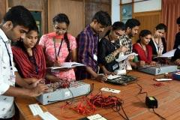

**COMPUTER ORGANIZATION LAB**

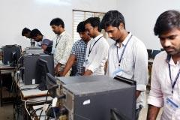

**DATA COMMUNICATION & NETWORKS LAB**

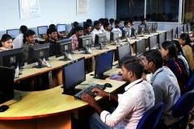

**JAVA & .NET & WEB TECHNOLOGIES LAB**

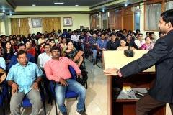

**SEMINAR HALL**

**Sub-Heading :** [**Department Committees**](https://gvpcdpgc.edu.in/mca/mca_dept_committe.php)

##### List of Departmantal Committees

**The purpose of the committee is to advise on how departmental leadership can be supported and enhanced in their administrative and faculty governance responsibilities. The committees work on all aspects of academic operations for the smooth functioning of the department.**

## 1. Department Academic Committee (DAC)

Objectives: The Department Academic Committee will review the following Academic activities of the Department

* Academic Calender
* Time Table
* Professional Body Membership and Activities
* Examinations
* Result analysis
* Guest lectures/workshops

Members:

* Dr.I.S.Pallavi (Chair)
* Dr. D. Chandravathi (Cordinator)
* Mr. P. Venkata Rao (Member)
* Mr. B. Divakar (Member)
* Mrs. P. Ratna Pavani (Member)

## 2. Department Class Committee(DCC)

Objectives:

* To review the syllabus completion status
* Attendance
* Arrange PTM
* Counselling

Members:

* Dr.I.S.Pallavi (Chair)
* Dr. D. Chandravathi (Cordinator)
* Mr. P. Venkata Rao (Member)
* Mrs. P. Ratna Pavani (Member)
* Mr. B. Divakar (Member)

## 3. Department Project Review Committee (DPRC)

Objectives:

* To monitor the quality of projects
* Project Review Dates
* Project Guidelines
* Project Assessment
* Project Completion status and Documentation

Members:

* Dr.I.S.Pallavi (Chair)
* Dr. D. Chandravathi (Cordinator)
* Mr. P. Venkata Rao (Member)
* Mrs. P. Ratna Pavani (Member)
* Mr. B. Divakar (Member)

## 3. Department Placement Committee (DPC)

Objectives:

DPC envisages an ideal interface between industry requirements and student aspirations, in that the right person for the right job is ensured. Making sure the industry benefits from the students, in terms of taking up roles and responsibilities and contributing to the growth of the Department and organization. Other responsibilities of DPC including

* To ensure 100% placements to eligible students
* Maintain the good liaison with the recruiters
* To ensure Internships to all the students
* To develop strong analytical and competitive skills by arranging various training programs
* Get in touch with corporate, start-ups for different sectors and tap in opportunities
* Conduct Mock Placement Drives
* Creating awareness among students towards higher studies
* Regular Visits to Companies

Members:

* Dr. D. Chandravathi (Chair)
* Mr. B. Divakar (M.C.A. & M.Sc(CS) Cordinator)
* Mr. Ch. S.S. Rajesh Patnaik (B.C.A. -Cordinator)

**Sub-Heading :** [**Placements**](https://gvpcdpgc.edu.in/mca/mca_placement.php)

##### Placements

* **Placements-2021-2023** [**Click Here**](https://gvpcdpgc.edu.in/mca/mca_data/MCA%202021-23%20Relived%20Batch%20Placement%20Data%20FLEX.pdf)
* **Placements-2020-2022** [**Click Here**](https://gvpcdpgc.edu.in/mca/mca_data/MCA%2020-2022%20Relived%20Batch%20Placement%20Data.pdf)
* **Placements-2018-2021** [**Click Here**](https://gvpcdpgc.edu.in/mca/mca_data/MCAselectedstudentsdata.pdf)
* **Placements-2016-2019** [**Click Here**](https://gvpcdpgc.edu.in/mca/mca_data/2016-2019-Placements.pdf)
* **Placements-2015-2018** [**Click Here**](https://gvpcdpgc.edu.in/mca/mca_data/2015-2018-Placements.pdf)
* **Placements-2014-2017** [**Click Here**](https://gvpcdpgc.edu.in/mca/mca_data/2014-2017-Placements.pdf)
* **Placements-2013-2016** [**Click Here**](https://gvpcdpgc.edu.in/mca/mca_data/2013-2016-Placements.pdf)
* **Placements-2012-2015** [**Click Here**](https://gvpcdpgc.edu.in/mca/mca_data/2012-2015-Placements.pdf)
* **Placements-2011-2014** [**Click Here**](https://gvpcdpgc.edu.in/mca/mca_data/2011-2014-Placements.pdf)
* **Placements-2010-2013** [**Click Here**](https://gvpcdpgc.edu.in/mca/mca_data/2010-2013-Placements.pdf)
* **Placements-2009-2012** [**Click Here**](https://gvpcdpgc.edu.in/mca/mca_data/2009-2012-Placements.pdf)
* **Placements-2008-2011** [**Click Here**](https://gvpcdpgc.edu.in/mca/mca_data/2008-2011-Placements.pdf)
* **Placements-2007-2010** [**Click Here**](https://gvpcdpgc.edu.in/mca/mca_data/2007-2010-Placements.pdf)
* **Placements-2006-2009** [**Click Here**](https://gvpcdpgc.edu.in/mca/mca_data/2006-2009-Placements.pdf)
* **Placements-2005-2008** [**Click Here**](https://gvpcdpgc.edu.in/mca/mca_data/2005-2008-Placements.pdf)
* **Placements-2004-2007** [**Click Here**](https://gvpcdpgc.edu.in/mca/mca_data/2004-2007-Placements.pdf)
* **Placements-2003-2006** [**Click Here**](https://gvpcdpgc.edu.in/mca/mca_data/2003-2006-Placements.pdf)
* **Placements-2002-2005** [**Click Here**](https://gvpcdpgc.edu.in/mca/mca_data/2002-2005-Placements.pdf)
* **Placements-2001-2004** [**Click Here**](https://gvpcdpgc.edu.in/mca/mca_data/2001-2004-Placements.pdf)
* **Placements-2000-2003** [**Click Here**](https://gvpcdpgc.edu.in/mca/mca_data/2000-2003-Placements.pdf)
* **Placements-1999-2002** [**Click Here**](https://gvpcdpgc.edu.in/mca/mca_data/1999-2002-Placements.pdf)
* **Placements-1998-2001** [**Click Here**](https://gvpcdpgc.edu.in/mca/mca_data/1998-2001-Placements.pdf)

**Sub-Heading :** [**Research & Innovations**](https://gvpcdpgc.edu.in/mca/mca_research.php)

##### Research

* **Academic Curricular Activities** [**Click Here**](https://gvpcdpgc.edu.in/mca/mca_data/MCA-Curricular-Activities.pdf)

**Sub-Heading :** [**Activities**](https://gvpcdpgc.edu.in/mca/mca_facultyactivities.php)

**Faculty Activities**

* **2020-2021** [**Click Here**](https://gvpcdpgc.edu.in/mca/mca_data/Faculty_Activity%202021.pdf)

**Student Activities**

* **Events/Presentations** [**Click Here**](https://gvpcdpgc.edu.in/mca/mca_data/The-students-of-MCA-and-MSc.pdf)

[**DEPARTMENT OF M.Sc ORGANIC CHEMISTRY**](https://gvpcdpgc.edu.in/mscorganicchemistry/aboutorganicchemistry.php)

Sub-Heading : [**About Department**](https://gvpcdpgc.edu.in/mba/aboutmba.php)

**About Department**

**The Department of Organic Chemistry started in 2009 offers 2-year M.Sc. Chemistry (Organic chemistry specialization) with an intake of 36 students. Admission into these courses is based on Rank in Andhra University Common Entrance Test, AUCET.**

**Professors L.S.A. Dikshitulu and P.V. Subba Rao, renowned teachers and researchers of the Department of Chemistry, Andhra University, Prof. P. Rajaganapathi, Retired Professor, APES and Dr. M. Bapuji, Retd. Senior Scientist, CSIR-Institute of Minerals and Materials Technology (CSIR-IMMT), Bhubaneswar Prof. A. Nageswara Rao, Retired Professor, Department of Physical & Nuclear Chemistry, Former Director, School of Chemistry, Andhra University, as founder Professors established the Department and they are adored by all for the rich traditions and laboratory practices currently in vogue. Prof. (Mrs.) P. Umadevi, Retd. Professor of Organic Chemistry, GITAM (Deemed to be University), NET/SET qualified Assistant Professors, S.S.R.S.S.N. Murty, Dr. A. Karteek Rao, Dr V. Govinda, Dr. K. V. Padmavathi, Mrs. Ch. VRT Hema are currently working in the Department. The department focuses both on teaching and research in different areas of chemistry (Synthetic organic chemistry, natural products chemistry, Drug discovery, computational Chemistry, and study of reactions of metal complexes). The department is equipped with state of the art research and library facilities. The department encourages students to develop and enhance their scientific passion and publish their results. The department also conducts national seminars, workshops, and guest lecturers to give a focus on the emerging fields of research to our students.**

**The laboratories are well equipped with fume hood and efficient exhaust systems. The best practice, the department can boast of, is collection of the water collected in AC units. Humidity in the air is condensed in AC Units resulting in this water. This water with near zero conductivity is equivalent to distilled water and is used directly in the laboratories. Sometimes this is also passed through Ion-Exchanger and used. Each laboratory has a distilled water storage facility of 1200 litres. Final year students are given good training in thin layer and column chromatographic techniques which will be incredibly useful both for lucrative placements and research.**

Sub-Heading : [**Vision & Mission \ PEOs \ PSOs \ POs**](https://gvpcdpgc.edu.in/mscorganicchemistry/organic-chemistry_vision.php)

**Vision**

**“To create and deliver high standard quality education and research in the field of chemistry to foster a scientific temper.”**

**Mission**

**To serve the nation by educating the students by advancing scientific knowledge and by catalyzing economic growth.**

**Program Outcomes (POs)**

* **PO 1: Demonstrate, solve and understand major concepts in all disciplines of chemistry**
* **PO 2: Acquire critical thinking and the scientific knowledge to design, carry out, record and analyze the results of chemical reactions.**
* **PO 3: Create awareness of the impact of chemistry on the environment, society and development outside the scientific community**
* **PO 4: Find out the green route for chemical reaction for sustainable development.**
* **PO 5: Inculcate scientific temperament in the students and outside community.**
* **PO 6: Expose to the different processes used in industries and their applications**

Sub-Heading : [**HOD's Message**](https://gvpcdpgc.edu.in/mscorganicchemistry/organic-chemistry_hod.php)

#### HOD's Message

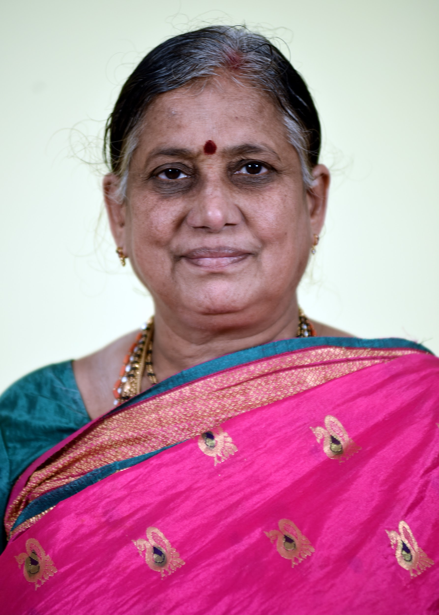

**Our department is doing extremely well with regards to the infrastructure and teaching methods. The teaching staff of my department comprises a group of highly qualified people with Ph.D., NET and APSET degrees encouraging in research and teaching. The department has a track record of and highest Placements in pharma sector like Dr Reddys, GVK Bio, Neuland, Laurus, Jublient etc..**

**We have a vary favourable faculty- to – student ratio with encourages close contact between students and their faculty mentors. This allows the faculty to give personalized attention to the academic progress of students. The department has good laboratory facility and infrastructure to develop research aptitude in the minds of students. Our courses are designed to meet the industrial as well as scientific knowledge in chemistry. and introduce them to various experimental skills. Besides the department has been constantly revising the contents of the theory and practical syllabi.**

**Prof. P. Uma Devi**

**Professor & H.O.D,**

**M.Sc. M.Phil Ph.D**

**Ph No: 9703469922**

**Sub-Heading :** [**Faculty**](https://gvpcdpgc.edu.in/mca/mca_faculty_list.php)

##### List of Faculty Members

|  | **Name-Designation-Qualification** | **Area-of-Specialization** | **E-mail** | **Date of Joining** | **Nature-of-Association** |
| --- | --- | --- | --- | --- | --- |
|  | **Prof. (Mrs.) P. Uma Devi**  **Professor & HOD** | **M.Sc., M.Phil, Ph.D**  **Organic Synthesis, Natural Products and Biopolymers** | **umadevichemistry@gmail.com**  [**Profile**](https://gvpcdpgc.edu.in/mscorganicchemistry/msc_oc_data/P.UMA%20DEVI%20resume.pdf) | **18-06-2018** | **Regular** |
|  | **Mr. S.S.R.S. S.N. Murty** | **M.Sc**  **Inorganic Chemistry General Chemistry** | **ssrssnmurty@gvpcdpgc.edu.in**  [**Profile**](https://gvpcdpgc.edu.in/mscorganicchemistry/msc_oc_data/MURTY.pdf) | **22-07-2016** | **Regular** |
|  | **Dr.Karteek Rao Amperayani** | **M.Sc., Ph.D**  **Organic Synthesis, Computational Chemistry** | **akarteekakrao@gvpcdpgc.edu.in**  [**Profile**](https://gvpcdpgc.edu.in/mscorganicchemistry/msc_oc_data/KARTEEK_resume.pdf) | **05-07-2019** | **Regular** |
|  | **Dr. Varadhi Govinda** | **M.Sc., Ph.D**  **Physical Chemistry** | **govinda@gvpcdpgc.edu.in**  [**Profile**](https://gvpcdpgc.edu.in/mscorganicchemistry/msc_oc_data/Dr%20Govinda_CV.pdf) | **25-02-2021** | **Regular** |
|  | **Dr. K. V. Padmavathi** | **M.Sc., Ph.D**  **Organic Chemistry** | **kvpadmavathi@gvpcdpgc.edu.in**  [**Profile**](https://gvpcdpgc.edu.in/mscorganicchemistry/msc_oc_data/Dr%20Padmavathi_CV.pdf) | **04-08-2011** | **Regular** |
|  | **Mrs. Ch. VRT Hema** | **M.Sc.**  **Organic Chemistry** | **hema.cvrt@gvpcdpgc.edu.in**  [**Profile**](https://gvpcdpgc.edu.in/mscorganicchemistry/msc_oc_data/cv_hema.pdf) | **19-04-2023** | **Regular** |

**Sub-Heading :** [**Syllabus**](https://gvpcdpgc.edu.in/mca/mca_syllabus.php)

##### Syllabus

* **I-Semester** [**Click Here**](https://gvpcdpgc.edu.in/mscorganicchemistry/msc_oc_data/I%20Semester%2020-21.pdf)
* **II Semester** [**Click Here**](https://gvpcdpgc.edu.in/mscorganicchemistry/msc_oc_data/II%20%20Semester%2020-21.pdf)
* **III Semester** [**Click Here**](https://gvpcdpgc.edu.in/mscorganicchemistry/msc_oc_data/III%20Semester%2020-21.pdf)
* **IV Semester** [**Click Here**](https://gvpcdpgc.edu.in/mscorganicchemistry/msc_oc_data/IV%20Semester%2020-21.pdf)

**Sub-Heading :** [**Academic Calender**](https://gvpcdpgc.edu.in/mca/mca_academic_cal.php)

##### Academic Calendar

##### TimeTables

* **Time Table-2020-21** [**Click Here**](https://gvpcdpgc.edu.in/mscorganicchemistry/msc_oc_data/2020-21%20timetable.pdf)
* **Time Table-2019-20** [**Click Here**](https://gvpcdpgc.edu.in/mscorganicchemistry/msc_oc_data/2019-20%20timetable.pdf)
* **Time Table-2018-19** [**Click Here**](https://gvpcdpgc.edu.in/mscorganicchemistry/msc_oc_data/2018-19%20timetable.pdf)
* **Time Table-2017-18** [**Click Here**](https://gvpcdpgc.edu.in/mscorganicchemistry/msc_oc_data/2017-18%20timetable.pdf)

**Sub-Heading :** [**Infrastructure**](https://gvpcdpgc.edu.in/mca/mca_labs.php)

##### Facilities

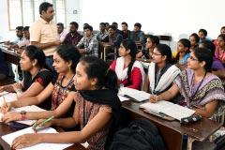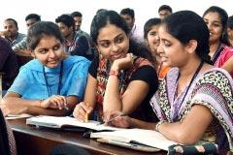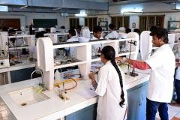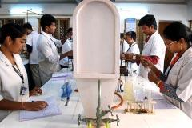

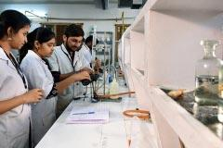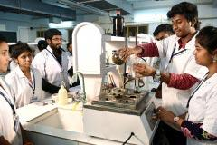

**Sub-Heading :** [**Department Committees**](https://gvpcdpgc.edu.in/mca/mca_dept_committe.php)

##### List of Departmantal Committees

**The purpose of the committee is to advise on how departmental leadership can be supported and enhanced in their administrative and faculty governance responsibilities. The committees work on all aspects of academic operations for the smooth functioning of the department.**

## 1. Department Academic Committee (DAC)

Objectives: The Department Academic Committee will review the following Academic activities of the Department

* Student admission
* Academic Calender
* Time Table
* Examinations
* Result analysis
* Guest lectures/workshops
* Meetings

Members:

* Mr. S.S.R.S.S.N. Murty (Chair)
* Prof. P Uma Devi (Coordinator)
* Dr. A Karteek Rao (member)
* Dr. V Govinda (member)

## 2. Department Class Committee(DCC)

Objectives:

* To frame syllabus
* Student progress
* Attendance
* Alumni
* Counselling
* Slow learners
* Remedial classes

Members:

* Mr. S.S.R.S.S.N. Murty (Chair)
* Dr. V Govinda (Coordinator)
* Dr. A Karteek Rao (member)
* Prof. P Uma Devi (member)

## 3. Department Placement Committee (DPC)

**Objectives:**

* **Maintain relation with pharma companies**
* **Maintain healthy relation with HR of pharma companies**
* **Industrial visits**
* **To conduct placement drives**

**Members:**

* **Mr. S.S.R.S.S.N. Murty (Chair)**
* **Dr. A Karteek Rao (Coordinator)**
* **Prof. P Uma Devi (member)**
* **Dr. V Govinda (member)**

**Sub-Heading :** [**Placements**](https://gvpcdpgc.edu.in/mca/mca_placement.php)

##### Placements

* Placements-2021-2022 [Click Here](https://gvpcdpgc.edu.in/mscorganicchemistry/msc_oc_data/Placement_data_2021-22.pdf)
* Placements-2017-2021 [Click Here](https://gvpcdpgc.edu.in/mscorganicchemistry/msc_oc_data/placements.pdf)

**Sub-Heading :** [**Research & Innovations**](https://gvpcdpgc.edu.in/mca/mca_research.php)

##### Research Areas

* Developing green methodologies for organic transformations,
* Synthesis of biological active natural product analogues
* Synthesis of novel heterocyclic compounds
* Catalyst
* Computational Chemistry
* Drug Discovery using in silico methods
* Kinetic and mechanistic studies of substitution reactions Iron(II)-α,α-diimine mixed ligand complexes
* Solution chemistry and application of ionic liquids

Recent Publications- [Click Here](https://gvpcdpgc.edu.in/mscorganicchemistry/msc_oc_data/Publications.pdf)

**Sub-Heading :** [**Activities**](https://gvpcdpgc.edu.in/mca/mca_facultyactivities.php)

##### Faculty Activities

List of Seminars Attended 2020-21 [Click Here](https://gvpcdpgc.edu.in/mscorganicchemistry/organic-chemistry_facultyactivities.php)

List of FDP/Workshop Attended 2019-20 [Click Here](https://gvpcdpgc.edu.in/mscorganicchemistry/msc_oc_data/2019-20%20seminars.pdf)

List of FDP/Workshop Attended 2018-19 [Click Here](https://gvpcdpgc.edu.in/mscorganicchemistry/msc_oc_data/2018-19%20seminars.pdf)

List of FDP/Workshop Attended 2017-18 [Click Here](https://gvpcdpgc.edu.in/mscorganicchemistry/msc_oc_data/2017-2018%20seminars.pdf)

##### Student Activities

* Students Seminars Attended [Click Here](https://gvpcdpgc.edu.in/mscorganicchemistry/msc_oc_data/seminars%20by%20students.pdf)

[**MHRM**](https://gvpcdpgc.edu.in/mhrm/aboutmhrm.php)

Sub-Heading : [**About Department**](https://gvpcdpgc.edu.in/mba/aboutmba.php)

About Department

ORIGIN AND GROWTH

The Human Resource Management Department was established in the year 2002 with an intention to promote management education in this region. The Master of Human Resource Management programme is intended to develop managerial skills in different functional areas of management with practical focus on Human Resource Management. The Department has been very fortunate in having the expertise of senior academicians and intellectuals who have been instrumental in shaping the institution to its present status with their vision and teaching. The department is currently having two senior faculty members led by Sri.B.Sivaprasad (submitted his Ph.D work in the area of HRD) and duly supported by a senior most faculty Dr.A.V.Jogarao. The faculty members are multi skilled with academic and industrial experience and having a keen interest towards the research besides the teaching.

.

ACADEMIC PROGRAMME

The course curriculum consists of 24 papers spread across 4 semesters and the field work programme is an integral part of the course curriculum. Besides this, to evaluate the students’ performance, two mid-term examinations in each subject will be held during the semester (Mid-Exam-I Descriptive; Mid-Exam II is online objective test) and internal viva-voce examination will be conducted in each semester after completion of semester end examination. The intake of students has been increased from 30 to 40 w.e.f 2007-08 academic year. Permanent affiliation has been granted by Andhra University in the academic year 2007-08. MHRM Programme entered the autonomous stream in 2009-10.

ADMISSION PROCEDURE:

Through APPGCET, College Code: 112 Subject Code Number-44

Sub-Heading : [**Vision & Mission \ PEOs \ PSOs \ POs**](https://gvpcdpgc.edu.in/mscorganicchemistry/organic-chemistry_vision.php)

Vision

Empowering the community of HR Excellence through education and training for enhanced organizational performance.

Mission

The department of Human Resources will design, develop and deliver efficient and contemporary human resource programs intended to reach out the vision through collaborative efforts of individual and institution and thereby gaining recognition, respect and reputation of stakeholders.

Core Values

* Honesty and Discipline first.
* Respect and Virtues.
* Model Leadership.
* Develop trust.
* Encourage team Work.
* Promote Educational Quality.
* Training of students by customization.

Program Specific Outcomes (PSOs)

* PSO1: Students would be able to identify, define and apply the principles of HRM effectively at work place and more importantly, translate them into reality.
* PSO2: Students would be able to gauge human capital needs in the context of dynamic organisational environment.
* PSO3: Students would be able to develop appropriate HR strategies to aid in HR planning and decision making processes of an organisation with an ultimate goal of augmenting productivity.
* PSO4: Able to nurture a yearning for learning HR competencies for organisational growth and brand image.
* PSO5: Would be able to evaluate human capital management practices in the global context.

Sub-Heading : [**HOD's Message**](https://gvpcdpgc.edu.in/mscorganicchemistry/organic-chemistry_hod.php)

#### HOD's Message

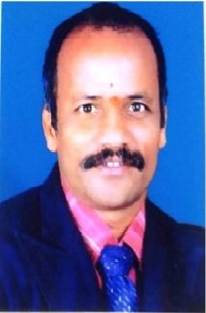

In the context of intensified competition in the corporate and fast changing economic scenario world over the Human Resource Management has assumed greater significance. In spite of economic growth, the common man appears to be more insecure and hence he is in search of quick wealth and fast living. This compelled him to lose focus on Ethics, Values and Human culture. It is time that, HRM practitioners and experts shall have to play new and innovative roles besides strengthening the HRM Processes in the organization. To ensure this phenomenon one need to know and understand the practices and systems of Human Resource Management in organizational environment. To make this possible, a Programme by name M.H.R.M (Master’s in Human Resource Management) has been designed to develop the know-how and skills in different functional areas of management with specific practical focus on Human Resource Management.

Dr. A.V.Joga Rao.

Ph.D

Professor & H.O.D

**Sub-Heading :** [**Faculty**](https://gvpcdpgc.edu.in/mca/mca_faculty_list.php)

##### List of Faculty Members

|  | **Name-Designation-Qualification** | **Area-of-Specialization** | **E-mail** | **Date of Joining** | **Nature-of-Association** |
| --- | --- | --- | --- | --- | --- |
|  | [Dr.A.V.Joga Rao](https://gvpcdpgc.edu.in/mhrm/mhrm_data/RESUME%20-Jogarao%20Attota.pdf)  Associate Professor, HOD &  Director Incharge - OPG Courses  Ph.D. | HR | drvjrattota@gvpcdpgc.edu.in  [Profile](https://gvpcdpgc.edu.in/mhrm/mhrm_data/RESUME%20-Jogarao%20Attota.pdf) | 08-08-1990 | Regular |
|  | [Dr. B.Siva Prasad](https://gvpcdpgc.edu.in/mhrm/mhrm_data/RESUME-Sivaprasad.pdf)  Associate Professor  Ph.D. | HR | Dr. B.Siva-Prasad@gvpcdpgc.edu.in  [Profile](https://gvpcdpgc.edu.in/mhrm/mhrm_data/RESUME-Sivaprasad.pdf) | 01-08-2002 | Regular |

Some of the Subjects will be dealt by inter departmental faculty members

**Sub-Heading :** [**Syllabus**](https://gvpcdpgc.edu.in/mca/mca_syllabus.php)

##### B.Tech Syllabus

* MHRM Syllabus [Click Here](https://gvpcdpgc.edu.in/mhrm/mhrm_data/Syllabus.pdf)

**Sub-Heading :** [**Academic Calender**](https://gvpcdpgc.edu.in/mca/mca_academic_cal.php)  
Academic Calendar

* Academic Calendar -2020-21[Click Here](https://gvpcdpgc.edu.in/mhrm/mhrm_data/2020-21.pdf)
* Academic Calendar -2019-20 [Click Here](https://gvpcdpgc.edu.in/mhrm/mhrm_data/2019-20.%20%20%20%20pdf)
* Academic Calendar for Academic Batch 2016-17,2017-18,2018 -19[Click Here](https://gvpcdpgc.edu.in/mhrm/mhrm_academic_cal.php#)

##### TimeTables

* Time Table-2020-21-Even-Sem [Click Here](https://gvpcdpgc.edu.in/mhrm/mhrm_academic_cal.php#)
* Time Table-2020-21-Odd-Sem [Click Here](https://gvpcdpgc.edu.in/mhrm/mhrm_academic_cal.php#)
* Time Table-2019-20-Even-Sem [Click Here](https://gvpcdpgc.edu.in/mhrm/mhrm_academic_cal.php#)
* Time Table-2019-20-Odd-Sem [Click Here](https://gvpcdpgc.edu.in/mhrm/mhrm_academic_cal.php#)

**Sub-Heading :** [**Infrastructure**](https://gvpcdpgc.edu.in/mca/mca_labs.php)

##### Facilities

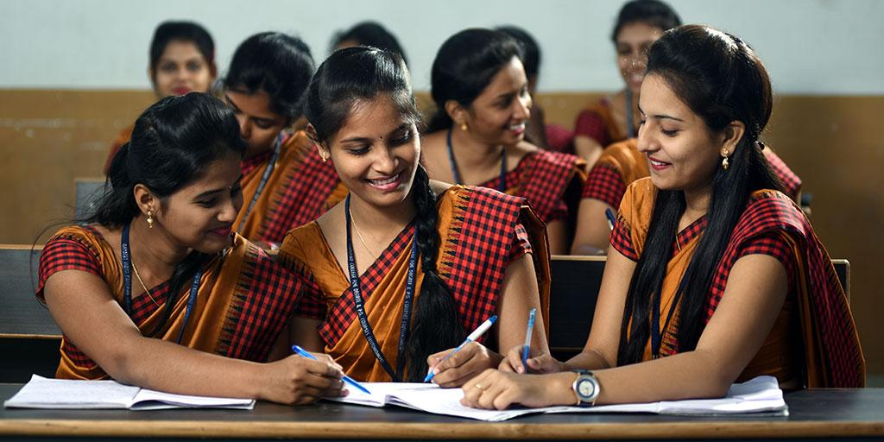  
  
A. Infrastructure

| **S.No** | **No. of Titles** | **No. of Volumes** | **Journals** |
| --- | --- | --- | --- |
| 1 | 135 | 732 | 12 |

B. Equipment

* The Department is facilitated with ICT enabled LABS
* Seminar Hall Commonly Shared
* English Lab Commonly Shared
* Computer Lab Commonly Shared

Value Addition:

Industrial Visits:  
As Field work is an integral component of course curriculum, in each semester students will be provided with an opportunity to interact with reputed industries and govt agencies to get practical exposure.

Personality Development Activities:  
The Department has been organizing Personality Development sessions on every Friday to give the additional inputs to the students and to make them to suit the present organisational needs. The PD Session is consisting of Case studies, Group Discussions, Presentations, Role Play, Business Games, HR Quiz etc., and emphasis is made on success stories of great entrepreneurs which motivate the student fraternity.

**Sub-Heading :** [**Department Committees**](https://gvpcdpgc.edu.in/mca/mca_dept_committe.php)

##### List of Departmantal Committees

The purpose of the committee is to advise on how departmental leadership can be supported and enhanced in their administrative and faculty governance responsibilities. The committees work on all aspects of academic operations for the smooth functioning of the department.

## 1. Department Academic Committee (DAC)

Objectives: The Department Academic Committee will review the following Academic activities of the Department

* Academic Calender
* Time Table
* Professional Body Membership and Activities
* Examinations
* Result analysis
* Guest lectures/workshops

Members:

* Dr.A.V.Joga Rao (Chair)
* Dr. B.Siva Prasad(Cordinator)

## 2. Department Class Committee(DCC)

Objectives:

* To review the syllabus completion status
* Attendance
* Arrange PTM
* Counselling

Members:

* Dr.A.V.Joga Rao (Chair)
* Dr. B.Siva Prasad(Cordinator)

## 3. Department Project Review Committee (DPRC)

Objectives:

* To monitor the quality of projects
* Project Review Dates
* Project Guidelines
* Project Assessment
* Project Completion status and Documentation

Members:

* Dr.A.V.Joga Rao (Chair)
* Dr. B.Siva Prasad(Cordinator)

**Sub-Heading :** [**Placements**](https://gvpcdpgc.edu.in/mca/mca_placement.php)

##### Placements

**Consistently 75-80% students of MHRM are being placed in various organizations of repute every year.**

* **Placements-2016 - 2020** [**Click Here**](https://gvpcdpgc.edu.in/mhrm/mhrm_data/Placements.pdf)

**Sub-Heading :** [**Research & Innovations**](https://gvpcdpgc.edu.in/mca/mca_research.php)

##### Research

* **Both the faculty members have published articles in National and International journals.Faculty Publications of Academic Year 2020-21** [**Click Here**](https://gvpcdpgc.edu.in/mhrm/mhrm_data/MHRM-RESEARCH%20PUBLICATIONS%20for%20web.pdf)

**Sub-Heading :** [**Activities**](https://gvpcdpgc.edu.in/mca/mca_facultyactivities.php)

**Faculty Activities**

**Student Activities**

**List of FDP/Workshop Attended 2019-20** [**Click Here**](https://gvpcdpgc.edu.in/mhrm/mhrm_data/ACITIVITIES.pdf)

**Student Participation In Co-Curricular Activities 2018-19**

* **The students of (2018-20) batch of MHRM have actively participated in one day Network HR Meet organized by HR club in the venue of Dwaraka Nagar campus of Gayatri Vidya Parishad.**
* **The students of (2016-18) & (2017-19) batches of M.H.R.M actively participated in “HR Excellence through personality development” organized by Dept of H.R.M, Andhra University on 31st March 2018.**

**Student Participation In Co-Curricular Activities 2017-18**

* **The students of (2016-18) & (2017-19) M.H.R.M actively participated in “HR Excellence through personality development” organized by Dept of H.R.M, Andhra University on 31st March 2018.**
* **The students of (2016-18) & (2017-19) M.H.R.M volunteered for the National Conference on “Empowering HR through technology-The way forward”, organized by ISTD –Visakha chapter on 08th December 2017.**
* **The students of (2016-18) & (2017-19) M.H.R.M have actively participated in 2day workshop on “Emerging issues in Industrial Relations” organized by the School of Management Studies, Gayatri Vidya Parishad on 10th & 11th October 2017.**
* **The students of (2016-18) & (2017-19) M.H.R.M has attended a quiz competition organized by National Institute of Personnel Management (NIPM) in association with Gitam University on 16th September 2017.**
* **The students of (2016-18) & (2017-19) M.H.R.M actively participated in “Human Resource Management in changing environment-Currently trends and future challenges” organized by Dept of HRM, Andhra University on 28th July 2017.**

**Student Participation In Co-Curricular Activities 2016-17**

* **Students of (2014-16) and (2015-17) batch have actively participated in “VADANYA”-Helping hands initiative organized by the students of School of Management Studies-G.V.P for school children of differently able (visually and physically challenged).**
* **Students of (2015-17) Participated actively in the survey organised by Visakhapatnam Port Trust on “Qualification and Employability’ in August 2016.**

**Extra Curricular Activities**

* **Students actively participate in the Blood Donation camps every year. Active involvement of all the students in CLEAN & GREEN, NSS activities and other such social activities.**

[**Department of MBA - Business Analytics**](https://gvpcdpgc.edu.in/mba-ba/aboutmbaba.php)

Sub-Heading : [**About Department**](https://gvpcdpgc.edu.in/mba/aboutmba.php)

About Department

The MBA in Business Analytics program is a symphony of data and strategy, orchestrating a new generation of leaders who turn information into innovation and insight into impact. In a world driven by data, where every click, transaction, and interaction generate a wealth of information, the ability to decode and harness this data is no longer a luxury—it's a necessity.

The MBA Business Analytics program was started by Gayatri Vidya Parishad College for Degree & P.G. Courses(A) in the year 2022. The objective of this program is to create good leaders who create an impact in the world with logic and values. It's a program where the art of leadership meets the science of data. Here, students are not just trained to understand business concepts; they are equipped to transform those concepts using analytical tools and techniques.

An MBA in Business Analytics here is not just about acquiring technical skills; it's about fostering a mindset of curiosity, critical thinking, and continuous learning. The journey extends beyond the classroom, with opportunities for networking, mentorship, and exposure to the latest industry trends.

The department has Entrepreneurship Development Cell (EDC), and an Industry Institute Partnership Cell (IIPC) funded by AICTE. There is constant encouragement to the faculty and students to participate in National and International Seminars, workshops and various academic development programs. The Training and Placement Cell (TPC) coordinates training and placement activities of the students. The Department has excellent academic infrastructure like smart classrooms, digital library, computer centre, media centre, seminar halls, linguistic lab, etc. Experts from Industry and Parent University are invited to deliver lectures on different courses to share their hands on experience to the students

The department is located in the 8.7-acre lush green Rushikonda campus with well- ventilated spacious class rooms, well equipped laboratories, library, play fields, canteen, vehicle parking , gym, staff rooms, waiting halls, auditorium, seminar halls, etc.

This program empowers students to become the architects of this data-driven future and is a journey of transformation, where every data point becomes a stepping stone towards innovation and success.

Sub-Heading : [**Vision & Mission \ PEOs \ PSOs \ POs**](https://gvpcdpgc.edu.in/mscorganicchemistry/organic-chemistry_vision.php)

Vision

“Provide value based management education to nurture global business leaders.”

Mission

Transform into a premier management institution in pursuit of global knowledge and pragmatic orientation for grooming leadership, entrepreneurial talent and corporate acumen to nurture socially responsible business leaders.

Program Outcomes (POs)

* PO 1: Apply knowledge of management theories and practices to solve business problems
* PO 2: Foster analytical and critical thinking abilities for data based decision making.
* PO 3: Ability to develop value based leadership ability.
* PO 4: Ability to understand analyse and communicate global, economic, legal and ethical aspects of business.
* PO 5: Ability to lead themselves and others in the achievement of organizational goals, contributing effectively to a team environment.
* PO 6: Ability to continuously learn and adapt to the dynamics of business and society.
* PO 7: Acquire entrepreneurial skills to establish and manage enterprises.

Program Educational Objectives( PEOs)

* The Educational objectives of the two years MBA program of this institution arePEO 1:To impart a general level of competence in management and to orient the students to acquire creative, innovative and entrepreneurial potential.
* PEO 2:To equip the students with requisite knowledge, skills, right attitude and orientation towards Continuous Learning and to develop efficient managers.
* PEO 3:To prepare them to adapt to a rapidly changing environment by applying their conceptual knowledge and become socially responsible and value driven citizens committed to sustainable development.
* PEO 4:Students of this program will be equipped with quantitative and qualitative skills to identify, analyze, design and create business opportunities in a globally dynamic environment.

Sub-Heading : [**HOD's Message**](https://gvpcdpgc.edu.in/mscorganicchemistry/organic-chemistry_hod.php) ( 404 page not found )

**Sub-Heading :** [**Faculty**](https://gvpcdpgc.edu.in/mca/mca_faculty_list.php)

##### List of Faculty Members

|  | **Name-Designation-Qualification** | **Area-of-Specialization** | **E-mail** | **Date of Joining** | **Nature-of-Association** |
| --- | --- | --- | --- | --- | --- |
|  | Prof. K.V.V. Murali Someswara Rao  MBA, M.Phil, Ph.D, APSET  Professor & H.O.D | Systems and Marketing | murali.koyyani@gvpcdpgc.edu.in  [Profile](https://gvpcdpgc.edu.in/mba-ba/mbaba_faculty_list.php#) | 02-08-2004 | Regular |
|  | Dr. Gedela Surya Prakasa Rao  M. A (Quantitative Economics), Ph.D, PGDBF  Associate Professor | Econometrics | surya212@gvpcdpgc.edu.in  [Profile](https://gvpcdpgc.edu.in/mba-ba/mbaba_faculty_list.php#) | 22-07-2002 | Regular |
|  | Dr. Suneetha Rapaka  B.Tech( CSIT), MBA, Ph.D , UGC NET, AP SET  Assistant Professor | Systems and HR | suneetharapaka@gvpcdpgc.edu.in  [Profile](https://gvpcdpgc.edu.in/mba-ba/mbaba_faculty_list.php#) | 19-07-2019 | Regular |
|  | Dr.P. JayaSaradaDevi  M.Sc ( Computers ), M.Tech ( Computers), MBA, Ph.D, APSET  Assistant Professor | HR and Marketing | saradadevi@gvpcdpgc.edu.in  [Profile](https://gvpcdpgc.edu.in/mba-ba/mbaba_faculty_list.php#) | 09-08-2021 | Regular |

**Sub-Heading :** **Placements**

#### Recruiters

* **  
    
  Recruiters** [**Click Here**](https://gvpcdpgc.edu.in/mba-ba/mba_data/MBA-Placement-Recruiters-Logos.pdf)
* **Recruiters 2023** [**Click Here**](https://gvpcdpgc.edu.in/mba-ba/mba_data/OUR%20RECRUITERS%202023.pdf)

##### Placements Data

* **  
    
  MBA 2021-2023 Batch Placement Data** [**Click Here**](https://gvpcdpgc.edu.in/mba-ba/mba_data/MBA_Student_Placement_Data_2021-23_Batch.pdf)
* **MBA 2020-2022 Batch Placement Data** [**Click Here**](https://gvpcdpgc.edu.in/mba-ba/mba_data/MBA_Student_Placement_Data_2020-22_Batch.pdf)
* **MBA 2019-2021 Batch Placement Data** [**Click Here**](https://gvpcdpgc.edu.in/mba-ba/mba_data/MBA_Student_Placement_Data_2019-21_Batch.pdf)
* **MBA 2018-2020 Batch Placement Data** [**Click Here**](https://gvpcdpgc.edu.in/mba-ba/mba_data/MBA_Student_Placement_Data_2018-20_Batch.pdf)
* **MBA 2017-2019 Batch Placement Data** [**Click Here**](https://gvpcdpgc.edu.in/mba-ba/mba_data/MBA-2017-2019-Batch-Placement-Data.pdf)
* **MBA 2016-2018 Batch Placement Data** [**Click Here**](https://gvpcdpgc.edu.in/mba-ba/mba_data/MBA-2016-2018-Batch-Placement-Data.pdf)
* **MBA 2015-2017 Batch Placement Data** [**Click Here**](https://gvpcdpgc.edu.in/mba-ba/mba_data/MBA-2015-2017-Batch-Placement-Data.pdf)
* **MBA 2014-2016 Batch Placement Data** [**Click Here**](https://gvpcdpgc.edu.in/mba-ba/mba_data/MBA-2014-2016-Batch-Placement-Data.pdf)

##### Placements Brochure

* **MBA Placement Brochure** [**Click Here**](https://gvpcdpgc.edu.in/mba-ba/mba_data/MBA-Placement-Brochure.pdf)

##### List of MBA Students

* **List of MBA Students 2018-2020 BATCH**[**Click Here**](https://gvpcdpgc.edu.in/mba-ba/mba_data/List-of-MBA-Students-2018-2020-BATCH.pdf)
* **List of MBA Students 2019-2021 BATCH**[**Click Here**](https://gvpcdpgc.edu.in/mba-ba/mba_data/List-of-MBA-Students-2019-2021-BATCH.pdf)
* **List of MBA Students 2020-2022 BATCH**[**Click Here**](https://gvpcdpgc.edu.in/mba-ba/mba_data/List_of_MBA_Students_2020-2022_BATCH.pdf)
* **List of MBA Students 2021-2023 BATCH**[**Click Here**](https://gvpcdpgc.edu.in/mba-ba/mba_data/List_of_MBA_Students_2021-2023_BATCH.pdf)
* **List of MBA Students 2022-2024 BATCH**[**Click Here**](https://gvpcdpgc.edu.in/mba-ba/mba_data/List_of_MBA_Students_2022-2024_BATCH.pdf)

[**Department of Master of Computer Science**](https://gvpcdpgc.edu.in/msc/aboutmsc.php)

Sub-Heading : [**About Department**](https://gvpcdpgc.edu.in/mba/aboutmba.php)

**About Department**

**Department of computer science is offering the fallowing programs:**

**Master of Science in Computer Sciences (M. Sc (CS))  
Bachelor of Computer Applications (BCA)**

**The department of Computer Applications was started in the year 1993. The first batch passed out in 1996. So far 23 batches of students have graduated from our MCA program as of 2018. The MCA program attracts some of the best students from the MCA Integrated Common Entrance Test (ICET) rankings. The intake of MSc(CS) Program is 40.**

**Bachelor in Computer Application (BCA) is an undergraduate degree course in computer applications. The BCA Program in Gayatri Vidya Parishad College for PG Courses is reintroduced in the academic year 2017-18 based on the demand of the course with an intake 60. BCA course is tailored for those who want to excel in the field of computers in graduate level. Courses covered in BCA student are at part with Engineering syllabus.**

Sub-Heading : [**Vision & Mission \ PEOs \ PSOs \ POs**](https://gvpcdpgc.edu.in/mscorganicchemistry/organic-chemistry_vision.php)

**Vision**

**Creating Human Excellence For A Better Society.**

**Mission**

**Unfold Into A World-Class Organization With Strong Academic And Research Base, Producing Responsible Citizens To Cater To The Changing Needs Of The Society.**

**Program Outcomes (POs)**

* **PO1:: Apply Knowledge of Computing fundamentals and domain logic in Problem solving..**
* **PO2: Ability to identify computing problems and formulate a strategy in solving domain specific problems**
* **PO3: Ability to acquire, adapt and relate the application of modern tools in computing activities**
* **PO4: Ability to engage in continuous learning to transform into a computing Professional**
* **PO5: To Understand and commit to the Societal and Professional ethics relevant to professional Computing Practice.**
* **PO6: Ability to function effectively as an individual, Member or Leader in diverse teams.**
* **PO7: Ability to apply Innovation to cater to the development of individual or and society**

**Program Specific Outcomes (PSOs)**

* **PSO1: Enhance the skill set to communicate effectively in professional and diverse groups.**
* **PSO2: Enrich their computer savvy and possess strong foundation of their professional empathetic**
* **PSO3: Inculcate Employability and Entrepreneur skills among students and train them in developing customized solutions for Enterprises.**

Sub-Heading : **Faculty**

##### List of Faculty Members

|  | **Name-Designation-Qualification** | **Area-of-Specialization** | **Phone Number** | **Email** |
| --- | --- | --- | --- | --- |
|  | **Dr I .S. Pallavi**  **Professor &**  **Head of the Department** | **Cryptography and Network Security,Cyber Security,DBMS,OS** | **9666105272** | **ipallavi@gvpcdpgc.edu.in** |
|  | **P Venkata Rao**  **Associate Professor** | **Network Security,AI,Data Mining,BigData** | **9491901487** | **venkataraopolaki@gvpcdpgc.edu.in** |
|  | **P Ratna Pavani**  **Assistant Professor** | **Network Security,AI,Multimedia,OS** | **9666777528** | **ratnapavanip@gvpcdpgc.edu.in** |
|  | **B.Divakar**  **Assistant Professor** | **Internet of Things,Programming Languages,Cloud Computing** | **9553062462** | **divakar.bangaru@gvpcdpgc.edu.in** |
|  | **U Sahiti**  **Assistant Professor** | **AI-ML,Computer Networks** | **9849339874** | **sahitiu@gvpcdpgc.edu.in** |
|  | **CH S S Rajesh Patnaik**  **Assistant Professor** | **Internet of Things,Programming Languages,Computer Networks and Network Security** | **9533998596** | **santu.patnaik@gvpcdpgc.edu.in** |
|  | **A V Prabhakar**  **Assistant Professor** | **Programming Languages,Computer Networks** | **9502354729** | **av.prabhakar@gvpcdpgc.edu.in** |

**Sub-Heading :** [**Syllabus**](https://gvpcdpgc.edu.in/mca/mca_syllabus.php)

##### MSc Computer science Syllabus

* **MSc-Syllabus 2023-24** [**Click Here**](https://gvpcdpgc.edu.in/syllabus/msc/Final-Proposed%20Syllabus%20for%20M.Sc(CS)-2022-24%20batch%20(1).pdf)
* **MSc-Syllabus 2022-23** [**Click Here**](https://gvpcdpgc.edu.in/syllabus/msc/Final-Proposed%20Syllabus%20for%20M.Sc(CS)-2022-24%20batch%20(1).pdf)
* **MSc-Syllabus 2021-22** [**Click Here**](https://gvpcdpgc.edu.in/syllabus/msc/M.Sc(CS)%20Syllabi%202020-21.pdf)
* **MSc-Syllabus 2020-21** [**Click Here**](https://gvpcdpgc.edu.in/syllabus/msc/M.Sc(CS)%20Syllabi%202020-21.pdf)
* **MSc-Syllabus 2019-20** [**Click Here**](https://gvpcdpgc.edu.in/syllabus/msc/MSc-Syllabus%202016-17.pdf)
* **MSc-Syllabus 2018-19** [**Click Here**](https://gvpcdpgc.edu.in/syllabus/mca/MCA-Syllabus2016-17.pdf)
* **MSc-Syllabus 2017-18** [**Click Here**](https://gvpcdpgc.edu.in/syllabus/msc/MSc-Syllabus%202016-17.pdf)
* **MSc-Syllabus 2016-17** [**Click Here**](https://gvpcdpgc.edu.in/syllabus/msc/MSc-Syllabus%202016-17.pdf)

**Sub-Heading :** [**Academic Calender**](https://gvpcdpgc.edu.in/mca/mca_academic_cal.php)  
Academic Calendar

* Academic Calendar -2020-21[Click Here](https://gvpcdpgc.edu.in/msc/msc_academic_cal.php#)
* Academic Calendar -2019-20 [Click Here](https://gvpcdpgc.edu.in/msc/msc_academic_cal.php#)
* Academic Calendar for Academic Batch 2016-17,2017-18,2018 -19[Click Here](https://gvpcdpgc.edu.in/msc/msc_academic_cal.php#)

**Sub-Heading :** [**Department Committees**](https://gvpcdpgc.edu.in/mca/mca_dept_committe.php)

##### List of Departmantal Committees

The purpose of the committee is to advise on how departmental leadership can be supported and enhanced in their administrative and faculty governance responsibilities. The committees work on all aspects of academic operations for the smooth functioning of the department.

## 1. Department Academic Committee (DAC)

Objectives: The Department Academic Committee will review the following Academic activities of the Department

* Academic Calender
* Time Table
* Professional Body Membership and Activities
* Examinations
* Result analysis
* Guest lectures/workshops

Members:

* Dr.I.S.Pallavi (Chair)
* Dr. D. Chandravathi (Cordinator)
* Mr. P. Venkata Rao (Member)
* Mr. B. Divakar (Member)
* Mrs. P. Ratna Pavani (Member)

## 

## 

## 2. Department Class Committee(DCC)

Objectives:

* To review the syllabus completion status
* Attendance
* Arrange PTM
* Counselling

Members:

* Dr.I.S.Pallavi (Chair)
* Dr. D. Chandravathi (Cordinator)
* Mr. P. Venkata Rao (Member)
* Mrs. P. Ratna Pavani (Member)
* Mr. B. Divakar (Member)

## 3. Department Project Review Committee (DPRC)

Objectives:

* To monitor the quality of projects
* Project Review Dates
* Project Guidelines
* Project Assessment
* Project Completion status and Documentation

Members:

* Dr.I.S.Pallavi (Chair)
* Dr. D. Chandravathi (Cordinator)
* Mr. P. Venkata Rao (Member)
* Mrs. P. Ratna Pavani (Member)
* Mr. B. Divakar (Member)

## 4. Department Placements Committee (DPC)

Objectives:

DPC envisages an ideal interface between industry requirements and student aspirations, in that the right person for the right job is ensured. Making sure the industry benefits from the students, in terms of taking up roles and responsibilities and contributing to the growth of the Department and organization. Other responsibilities of DPC including

* To ensure 100% placements to eligible students
* Maintain the good liaison with the recruiters
* To ensure Internships to all the students
* To develop strong analytical and competitive skills by arranging various training programs
* Get in touch with corporate, start-ups for different sectors and tap in opportunities
* Conduct Mock Placement Drives
* Creating awareness among students towards higher studies
* Regular Visits to Companies

Members:

* Dr. D. Chandravathi (Chair)
* Mr. B. Divakar (M.C.A. & M.Sc(CS) Cordinator)
* Mr. Ch. S.S. Rajesh Patnaik (B.C.A. -Cordinator)

**Sub-Heading :** [**Placements**](https://gvpcdpgc.edu.in/mca/mca_placement.php)

##### Placements

* **Placements-1998-2001** [**Click Here**](https://www.gvpcdpgc.edu.in/wp-content/uploads/2018/12/1998-2001-Placements.pdf)
* **Placements-1999-2002** [**Click Here**](https://www.gvpcdpgc.edu.in/wp-content/uploads/2018/12/1999-2002-Placements.pdf)
* **Placements-2000-2003** [**Click Here**](https://www.gvpcdpgc.edu.in/wp-content/uploads/2018/12/2000-2003-Placements.pdf)
* **Placements-2001-2004** [**Click Here**](https://www.gvpcdpgc.edu.in/wp-content/uploads/2018/12/2001-2004-Placements.pdf)
* **Placements-2002-2005** [**Click Here**](https://www.gvpcdpgc.edu.in/wp-content/uploads/2018/12/2002-2005-Placements.pdf)
* **Placements-2003-2006** [**Click Here**](https://www.gvpcdpgc.edu.in/wp-content/uploads/2018/12/2003-2006-Placements.pdf)
* **Placements-2004-2007** [**Click Here**](https://www.gvpcdpgc.edu.in/wp-content/uploads/2018/12/2004-2007-Placements.pdf)
* **Placements-2005-2008** [**Click Here**](https://www.gvpcdpgc.edu.in/wp-content/uploads/2018/12/2005-2008-Placements.pdf)
* **Placements-2006-2009** [**Click Here**](https://www.gvpcdpgc.edu.in/wp-content/uploads/2018/12/2006-2009-Placements.pdf)
* **Placements-2007-2010** [**Click Here**](https://www.gvpcdpgc.edu.in/wp-content/uploads/2018/12/2007-2010-Placements.pdf)
* **Placements-2008-2011** [**Click Here**](https://www.gvpcdpgc.edu.in/wp-content/uploads/2018/12/2008-2011-Placements.pdf)
* **Placements-2009-2012** [**Click Here**](https://www.gvpcdpgc.edu.in/wp-content/uploads/2018/12/2009-2012-Placements.pdf)
* **Placements-2010-2013** [**Click Here**](https://www.gvpcdpgc.edu.in/wp-content/uploads/2018/12/2010-2013-Placements.pdf)
* **Placements-2011-2014** [**Click Here**](https://www.gvpcdpgc.edu.in/wp-content/uploads/2018/12/2011-2014-Placements.pdf)
* **Placements-2012-2015** [**Click Here**](https://www.gvpcdpgc.edu.in/wp-content/uploads/2018/12/2012-2015-Placements.pdf)
* **Placements-2013-2016** [**Click Here**](https://www.gvpcdpgc.edu.in/wp-content/uploads/2018/12/2013-2016-Placements.pdf)
* **Placements-2014-2017** [**Click Here**](https://www.gvpcdpgc.edu.in/wp-content/uploads/2018/12/2014-2017-Placements.pdf)
* **Placements-2015-2018** [**Click Here**](https://www.gvpcdpgc.edu.in/wp-content/uploads/2018/12/2015-2018-Placements.pdf)
* **Placements-2017-2019** [**Click Here**](https://www.gvpcdpgc.edu.in/wp-content/uploads/2018/12/2016-2019-Placements.pdf)
* **Placements-2019-2021** [**Click Here**](https://gvpcdpgc.edu.in/msc/msc_data/M.Sc(cs)%20(2021)%20selected%20students%20data%20UP%20TO%20NOV%202021.pdf)
* **Placements-2020-2022** [**Click Here**](https://gvpcdpgc.edu.in/msc/msc_data/M.Sc(CS)%202020%20-21%20Batch%20Placement.pdf)
* **Placements-2021-2023** [**Click Here**](https://gvpcdpgc.edu.in/msc/msc_data/M.Sc(CS)%202021%20-23%20Batch%20Placement%20FLEX.pdf)

**Sub-Heading :** [**Research & Innovations**](https://gvpcdpgc.edu.in/mca/mca_research.php)

##### Research

* **Academic Curricular Activities** [**Click Here**](https://gvpcdpgc.edu.in/msc/mca_data/MCA-Curricular-Activities.pdf)

**Sub-Heading :** [**Activities**](https://gvpcdpgc.edu.in/mca/mca_facultyactivities.php)

**Faculty Activities**

**Student Activities**

* **Events/Presentations** [**Click Here**](https://gvpcdpgc.edu.in/msc/mca_data/The-students-of-MCA-and-MSc.pdf)

[Admissions](https://gvpcdpgc.edu.in/admissions.php):

# UG Programmes

| S.No | Name of the Course | Intake |
| --- | --- | --- |
| 1 | B.Com. Honors (General) | 60 |
| 2 | BBA Honors | 180 |
| 3 | BBA Honors (Digital Marketing) | 50 |
| 4 | B.Com. Honors (Computer Applications) | 60 |
| 5 | B.Sc. Honors (Computer Science) | 390 |
| 6 | B.Sc. Honors (Biochemistry) | 30 |
| 7 | B.Sc. Honors (Microbiology) | 30 |
| 8 | B.Sc. Honors (Electronics) | 30 |
| 9 | B.Sc. Honors (Chemistry) | 30 |
| 10 | B.Sc. Honors (Physics) | 30 |
| 11 | B.Sc. Honors (Mathematics) | 30 |
| 12 | B.Sc. Honors (Statistics) | 30 |
| 13 | BCA Honors | 60 |
| 14 | B.Sc. Honors (Data Science) | 60 |

# PG Programmes

| S.No | Name of the Course | Intake |
| --- | --- | --- |
| 1 | Master of Business Administration (MBA) | 180 |
| 2 | Master of Business Administration (MBA) - Business Analytics | 60 |
| 3 | Master of Computer Applications (MCA) | 60 |
| 4 | Master of Human Resourse Management (MHRM) | 40 |
| 5 | M.Sc. Computer Science | 40 |
| 6 | M.Sc. Organic Chemistry | 30 |
| 7 | M.Com. | 40 |

# Engineering Programmes

| S.No | Name of the Course | Intake |
| --- | --- | --- |
| 1 | B.Tech. Civil Engineering | 60 |
| 2 | B.Tech. Computer Science and Engineering | 180 |
| 3 | B.Tech. Computer Science and Engineering (Artificial Intelligence and Machine Learning) | 60 |
| 4 | B.Tech. Electronics & Communication Engineering | 120 |
| 5 | B.Tech. Mechanical Engineering | 60 |
| 6 | M.Tech. Structural Engineering | 12 |
| 7 | M.Tech. Computer Science and Technology | 12 |

[**Placements**](https://gvpcdpgc.edu.in/placement/train_placementhome.php):

Training & Placements

Training and Placement (T&P) cell is an integral part of all the institutions. Gayatri Vidya Parishad has been strengthened over the years and achieved many milestones in its journey towards Quality and quantity of students who are placed from the various institutions of Gayatri Vidya Parishad.

Our aim:

The aim of the T & P cell is to mould all the students of the institution to meet the industry expectations and place them into top companies in the industry.To achieve these objectives the cell organizes and coordinates Campus Recruitment Training (CRT) programs with a commitment of placing every students in a reputed company.These programmes help the students acquire required technical skills, develop personality and focus on holistic development. They are designed to give the society, better citizens as per our mission statement.

Our Strengths:

Our students who have excelled themselves in the academics also displayed ethical and moral values picked up during their tenure in the college, thus making themselves self learning and self evolving into good Samaritans. The success stories of their contributions to the organizations who picked them up from the campus, have new and better companies to the campus and enhanced their trust and belief in our institutions.

Our Training:

A thorough and complete awareness is given to the students on various career programmes and certifications as per the current demands. Accordingly, appropriate resource persons are identified and training sessions are planned in such a way that their curriculum is not disturbed.

Placements for Engineering Streams

| Dean Carrier guidance, Training & Placements: | Prof. D. Giridhar |
| --- | --- |
| Email id : | deanplacements@gvpcdpgc.edu.in |
| Landline No : | 0891-2953719 |
| Ext. No : | 303 |
| Fax : | 0891-2953076 |

| Training and Placement Officer for Engineering stream : | Dr. D Chandravathi |
| --- | --- |
| Email id : | tnpent@gvpcdpgc.edu.in |
| Mobile No : | 9951862491 |

Placements for Degree Streams

| T & P Incharge for Degree Stream : | Dr. Santhosh Kumar |
| --- | --- |
| Email id : | tnp@gvpcdpgc.edu.in |
| Contact : | 7729914999 |

Sub-Heading:[**Training & Placements**](https://gvpcdpgc.edu.in/placement/train_placement.php)

**Sub-sub heading:**[**Engineering & Technology**](https://gvpcdpgc.edu.in/engg.php)

**(loop to engineering)**

**Sub-sub heading:**[**Undergraduate**](https://gvpcdpgc.edu.in/placement/trian_placementug.php)

**Undergraduate**

**Placement Officers Message** [**Click Here**](https://gvpcdpgc.edu.in/placement/UG-Placement-Officers-Message.pdf)**Placement Packages** [**Click Here**](https://gvpcdpgc.edu.in/placement/UG-PLACEMENT-PACKAGES-OF-THE-STUDENTS.pdf)**List of Placements** [**Click Here**](https://gvpcdpgc.edu.in/placement/UG-Placement-report-b.sc-bcom-bbm.pdf)

**Sub-sub heading:**[**Post Graduate**](https://gvpcdpgc.edu.in/placement/train_placement_pg.php)

**Post Graduate**

**MHRM Placements** [**Click Here**](https://gvpcdpgc.edu.in/placement/Placements_mhrm.pdf)**Msc Organic Chemistry** [**Click Here**](https://gvpcdpgc.edu.in/placement/placements_organic.pdf)

Sub-Heading:[Placement Team](https://gvpcdpgc.edu.in/placement/placement_team.php)

##### Training & Placement Officer

| **Photo** | **Name-Designation-Qualification** | **Department** | **Phone-no** | **Extention** | **E-mail** |
| --- | --- | --- | --- | --- | --- |
|  | Prof. D. Giridhar  Dean Career guidance, Training & Placement  M.Tech | Placements | 0891-2737719 | 303 | deanplacements@gvpcdpgc.edu.in |

| **Photo** | **Name-Designation-Qualification** | **Department** | **Phone-no** | **Extention** | **E-mail** |
| --- | --- | --- | --- | --- | --- |
|  | Dr. D Chandravathi  Training and Placement Officer for Engineering stream  M.Tech, Ph.D | Computer Science and Engineering | 9951862491 | 380 | tnpent@gvpcdpgc.edu.in |
|  | Dr. D Santosh Kumar Dhavala  Training and Placement Officer for UG Courses  Ph.D | Department of Physics | 7729914999 |  | tnp@gvpcdpgc.edu.in |

##### Placement Team

| **Photo** | **Name-Designation-Qualification** | **Department** | **Phone-no** | **Extention** | **E-mail** |
| --- | --- | --- | --- | --- | --- |
| For Engineering & Technology Program | | | | | |
|  | Mr. P Lakshman Rao  Assistant Professor,  B.E, M.Tech | Department of Civil Engineering | 0891-2737719 | 372 | plakshmanrao@gvpcdpgc.edu.in |
|  | Mr. M Anil  Assistant Professor,  M.Tech. | Department of Computer Science and Engineering | 0891-2737719 | 377 | anilmeka@gvpcdpgc.edu.in |
|  | Mr. V. Ram Nishanth  Assistant Professor,  B.Tech M.Tech | Electronics & Communication Engineering | 0891-2737719 | 382 | ramnishanthvanka@gvpcdpgc.edu.in |
|  | Smt. P.Kiranmayi  Assistant Professor  B.E, M.Tech | Mechanical Engineering | 0891-2737719 |  | pkiranmayi@gvpcdpgc.edu.in |
| For MBA Program | | | | | |
|  | Mr. B. Mahendra Reddy  Training and Placement Officer  B.Tech, MBA, APSET, UGCNET | Master of Business Administration |  |  | tpomba@gvpcdpgc.edu.in |
| For MCA Program | | | | | |
|  | G Venkateswar Rao  Assistant Professor | Master of Computer Applications | 9908033604 |  | venkateswararaog@gvpcdpgc.edu.in |

Sub-Heading:[Placement Activities](https://gvpcdpgc.edu.in/placement/placement_activities.php)

##### Placememt Activities

* PLACEMENT DETAILS OF 2022[Click Here](https://gvpcdpgc.edu.in/placement/GVPCDPGC%20Total%20Placements.pdf)
* BRANCH WISE PLACEMENTS DETAILS [Click Here](https://gvpcdpgc.edu.in/placement/BRANCH-WISE-PLACEMENTS-DETAILS.pdf)
* OFFERED PACKAGES SUMMARY & PLACEMENTS SUMMARY [Click Here](https://gvpcdpgc.edu.in/placement/OFFERED-PACKAGES-SUMMARYPLACEMENTS-SUMMARY..pdf)
* Overview of 2019-20 placements. [Click Here](https://gvpcdpgc.edu.in/placement/Overview-of-2019-20-placements..pdf)
* Placement Selected Students 2016-2020 Batch. [Click Here](https://gvpcdpgc.edu.in/placement/Students-Placed.pdf)
* List of Companies Visited for Campus Drives-Engineering & Technology Program [Click Here](https://gvpcdpgc.edu.in/placement/Companies-Visited.pdf)
* Engineering & Technology Program Placement Report for the Academic Year 2018-19 [Click Here](https://gvpcdpgc.edu.in/placement/Placement-Report-2018-19.pdf)
* Placement activities (UG) [Click Here](https://gvpcdpgc.edu.in/placement/Companies-Visited.pdf)
* Placement activities (UG) [Click Here](https://gvpcdpgc.edu.in/placement/UG-Placement-report-b.sc-bcom-bbm-1.pdf)
* Placements ( Msc Organic Chemistry) [Click Here](https://gvpcdpgc.edu.in/placement/Placement-data-Msc-Organic-Chemistry.pdf)
* Summary of Placement for the last four years 2018, 2017, 2016 and 2015. [Click Here](https://gvpcdpgc.edu.in/placement/summary-of-placement-for-the-last-four-years-2018-2017-2016-2015.jpg)
* Summary of Placement for the last three years 2017, 2016 and 2015. [Click Here](https://gvpcdpgc.edu.in/placement/summary-of-placement-for-the-last-three-years-2017-2016-2015.jpg)
* Placement Selected Students 2013-2017 Batch. [Click Here](https://gvpcdpgc.edu.in/placement/placement-selected-students-2013-2017-batch.jpg)
* Placement Selected Students 2013-2017 Batch as on April, 2017. [Click Here](https://gvpcdpgc.edu.in/placement/placement_activities.php#)
* Placement Selected Students 2013-2017 Batch as on Sept. 2016. [Click Here](https://gvpcdpgc.edu.in/placement/placement-selected-students-2013-2017-batch-as-on-sept-2016.pdf)
* Placement Selected Students 2012-2016 Batch (Second Batch) [Click Here](https://gvpcdpgc.edu.in/placement/Placement-Selected-Students-2012-2016-Batch.jpg)
* Placement Selected Students 2011-2015 Batch (First Batch) [Click Here](https://gvpcdpgc.edu.in/placement/Placement-Selected-Students-2011-2015-Batch.jpg)
* Students Selected in Campus Drives as on March, 2016. [Click Here](https://gvpcdpgc.edu.in/placement/ALL-Selects-website-March-2016.pdf)
* Students Selected in Campus Drives as on February, 2016. [Click Here](https://gvpcdpgc.edu.in/placement/All-Selects-till-Feb-2016.pdf)
* Students Selected in Campus Drives as on 07-11-2015. [Click Here](https://gvpcdpgc.edu.in/placement/ALL-Selects-website-2015.pdf)
* Students Selected in POLARIS,HEXAGON, TECH MAHINDRA Campus Drive. [Click Here](https://gvpcdpgc.edu.in/placement/POLARIS-HEXOGON-TECH-MAHINDRA-website-2015.pdf)
* Students Selected in WIPRO Campus Drive. [Click Here](https://gvpcdpgc.edu.in/placement/WIPRO-website-2015.pdf)
* Students Selected in TCS Campus Drive. [Click Here](https://gvpcdpgc.edu.in/placement/TCS-website-2015.pdf)
* Placement article in Andhra Jyothi Paper. [Click Here](https://gvpcdpgc.edu.in/placement/placement-article-andhrajyothi-05-01-2015.jpg)
* Students Selected in Campus Drive as on 05.01.2015. [Click Here](https://gvpcdpgc.edu.in/placement/All-selects-GVPTC-2014-15-as-on-05.01.2015.pdf)
* Placement Press note in EENADU paper [Click Here](https://gvpcdpgc.edu.in/placement/Placement-press-Eenadu-4-Jan-2015.pdf)
* Placement Press note in Andhra Jyothi paper [Click Here](https://gvpcdpgc.edu.in/placement/Andhra-jyothi-GVPTC-Placements.pdf)
* Students Selected in WIPRO Campus Drive. [Click Here](https://gvpcdpgc.edu.in/placement/WIPRO-Final-selects-GVP-Vizag.pdf)
* Students Selected in Campus Drives. [Click Here](https://gvpcdpgc.edu.in/placement/Students-Selected-in-Campus-Drives.pdf)
* Placement Activities Calendar for Final Year Students 2014-2015. [Click Here](https://gvpcdpgc.edu.in/placement/Calender-for-Final-Year-Students-2014-2015.pdf)
* Latest Technologies, Current Trends & Innovations in the IT Industry by Sri Hari Kishan Burle, Vice President, Enterprise Architecture, Business Application Services, WIPRO. [Click Here](https://gvpcdpgc.edu.in/placement/Latest-Technologies-Current-Trends-Innovations-in-the-IT-Industry.pdf)

## 

## 

## 

## 

## 

[Research](https://gvpcdpgc.edu.in/research_scholars.html):

## 

## **Department wise Details of Ph.D. Students**

Department of Management

Prof.S.Rajani

| **Sl.No.** | **Scholar Name** | **Year of Registration** | **Status** |
| --- | --- | --- | --- |
| 1. | Mr. G. Madhusudana Rao |  | Pursuing |
| 2. | Ms. Nandula Neeraja |  | Pursuing |
| 3. | Ms. Dwibhashyam Uma Sundari |  | Pursuing |
| 4. | Mr. Tenneti Sai Prasad |  | Pursuing |
| 5. | Mr. K. Bhaskara Rao |  | Pursuing |
| 6. | Ms. T. Suguna Finance |  | Pursuing |
| 7. | Ms. P. Gnaneswari |  | Pursuing |
| 8. | Munagabalasa. Raja Mohan |  | Pursuing |
| 9. | Tedlapu. Narayana Rao |  | Pursuing |
| 10. | Govinda Rao Taddi |  | Pursuing |

Dr.K.S.Bose

| **Sl.No.** | **Scholar Name** | **Year of Registration** | **Status** |
| --- | --- | --- | --- |
| 1. | Pukkla. Manoj Kumar |  | Pursuing |
| 2. | Divya jaya Lakshmi |  | Pursuing |
| 3. | Kandi Vidya Sagar |  | Pursuing |
| 4. | Shobha Rani Pila |  | Pursuing |
| 5. | Rama kalyani Chaganti |  | Pursuing |
| 6. | Venigandla Naresh |  | Pursuing |
| 7. | Nenue Durga Devi |  | Pursuing |

Dr. K.V.V.Murali Someswara Rao

| **Sl.No.** | **Scholar Name** | **Year of Registration** | **Status** |
| --- | --- | --- | --- |
| 1. | Ms.P.Uma Kumari | 2019-20 | Pursuing |
| 2. | Ms.Madhulatha Devineeda | 2020-21 | Pursuing |
| 3. | Ms.Devi Pathivada | 2020-21 | Pursuing |
| 4. | Mr.Nadupuri Dinesh | 2020-21 | Pursuing |
| 5. | Ravi Kumar Karnayina |  | Pursuing |
| 6. | Aliya Begum | 2020-21 | Pursuing |

Dr. N.Vijaya Jyothi

| **Sl.No.** | **Scholar Name** | **Year of Registration** | **Status** |
| --- | --- | --- | --- |
| 1. | Mr.Bellapu.Venkata Subbaiah | 2019-20 | Pursuing |
| 2. | Subha Galavilli |  | Pursuing |
| 3. | Yalla Dinesh Kumar |  | Pursuing |
| 4. | Gollu Dinesh Kumar |  | Pursuing |
| 5. | Rama Krishnaia A |  | Pursuing |

Dr.P.V.Mohini

| **Sl.No.** | **Scholar Name** | **Year of Registration** | **Status** |
| --- | --- | --- | --- |
| 1. | Ms.Sanapala Kanchana | 2020-21 | Pursuing |
| 2. | Mr.Shaik Khwajabi | 2020-21 | Pursuing |
| 3. | Ms.Buddharaju Venkata Samyukta | 2020-21 | Pursuing |
| 4. | Mr.Jatla Ganesh | 2020-21 | Pursuing |
| 5. | Siva naga Lakshmi Alluri |  | Pursuing |
| 6. | Yesuraju Neelapala | 2020-21 | Pursuing |
| 7. | Naraharisetti Pavani | 2020-21 | Pursuing |
| 8. | Masabathula Naresh | 2020-21 | Pursuing |

Dr A.Sairoop

| **Sl.No.** | **Scholar Name** | **Year of Registration** | **Status** |
| --- | --- | --- | --- |
| 1. | Mr.Y Pardhasaradhi | 2020-21 | Pursuing |
| 2. | Ms.N Kiran Kumari | 2020-21 | Pursuing |
| 3. | Sivakalyanakumar setty | 2020-21 | Pursuing |
| 4. | Potta Vijay Kumar | 2020-21 | Pursuing |
| 5. | Yamijala Suryanarayana Murty | 2020-21 | Pursuing |

Dr.D.S.B.PALLAVI

| **Sl.No.** | **Scholar Name** | **Year of Registration** | **Status** |
| --- | --- | --- | --- |
| 1. | Ms.S.Swathi | 2020-21 | Pursuing |
| 2. | Mr.Md.Saleem | 2020-21 | Pursuing |
| 3. | Suneetha Koosetty |  | Pursuing |
| 4. | Pedisetti Lakshmi |  | Pursuing |
| 5. | N. Sri Lakshmi Chappidi |  | Pursuing |

Dr.K.V.Nagaraj

| **Sl.No.** | **Scholar Name** | **Year of Registration** | **Status** |
| --- | --- | --- | --- |
| 1. | Mr.Bassa Veerabhadra Rao | 2020-21 | Pursuing |
| 2. | Mr.Suresh Kumar Chaganti | 2020-21 | Pursuing |
| 3. | Bela Swamy Mindanu |  | Pursuing |
| 4. | Mamidi Rupasundara Rao | 2020-21 | Pursuing |
| 5. | Gorla Sivaramakrishna |  | Pursuing |
| 6. | Sivanagaraju Akki |  | Pursuing |

Dr.M.S.R.SESHAGIRI

Department of CSE

Prof.I.S.Pallavi

| **Sl.No.** | **Scholar Name** | **Date of Registration** | **Status** |
| --- | --- | --- | --- |
| 1. | Sri Bala Malladi | 13-08-2020 | Ongoing |
| 2. | Amavarthi Kaviti | 10-08-2020 | Ongoing |

Dr.N.V.Ramana Murty

| **Sl.No.** | **Scholar Name** | **Date of Registration** | **Status** |
| --- | --- | --- | --- |
| 1. | Indurthi Ravindra Kumar | 10-07-2020 | Ongoing |
| 2. | Songa Pratap |  | Ongoing |

Dr.G.R.S.Murty

| **Sl.No.** | **Scholar Name** | **Date of Registration** | **Status** |
| --- | --- | --- | --- |
| 1. | Y Siva |  | Ongoing |
| 2. | Anil Kumar Reddy Tetali |  | Ongoing |

Dr.D.Chandravathi

| **Sl.No.** | **Scholar Name** | **Date of Registration** | **Status** |
| --- | --- | --- | --- |
| 1. | G. Suresh Kumar |  | Ongoing |
| 2. | Krishna Jyothi |  | Ongoing |

Dr.Bh.Padma

| **Sl.No.** | **Scholar Name** | **Date of Registration** | **Status** |
| --- | --- | --- | --- |
| 1. | D. Deepthi |  | Ongoing |

Department of ECE

Dr.S.Krishna Veni

| **Sl.No.** | **Scholar Name** | **Date of Registration** | **Status** |
| --- | --- | --- | --- |
| 1. | Srinivasa Gupta Noolu | 15-07-2020 | Ongoing |
| 2. | Venkatesh Seerapu | 17-07-2020 | Ongoing |
| 3. | Narasimha Reddy Bathala | 16-07-2020 | Ongoing |
| 4. | Thatithuri krishnaveni | 11-08-2020 | Ongoing |
| 5. | Syambabu Darsi | 09-07-2020 | Ongoing |
| 6. | Chavvakula Janaki Devi | 16-07-2020 | Ongoing |
| 7. | Idrish Shaik | 09-07-2020 | Ongoing |

Dr.P.A. Nageswara Rao

| **Sl.No.** | **Scholar Name** | **Date of Registration** | **Status** |
| --- | --- | --- | --- |
| 1. | Satya Sridevi B | 16-07-2020 | Ongoing |
| 2. | Rajesh katragadda | 30-08-2020 | Ongoing |
| 3. | Bosebabu Parisa | 11-07-2020 | Ongoing |
| 4. | Parepalli Kusumavani | 08-08-2020 | Ongoing |

Dr. Adinarayana

Department of Civil Engineering

Dr.D.Manasa

| **Sl.No.** | **Scholar Name** | **Date of Registration** | **Status** |
| --- | --- | --- | --- |
| 1. | Nagamohan Jonnalagadda B | 12-08-2020 | Ongoing |
| 2. | Yernaguala Rajesh | 12-08-2020 | Ongoing |
| 3. | Kolluri Dharani | 01-09-2020 | Ongoing |
| 4. | Palla V R Sravya | 15-07-2020 | Ongoing |
| 5. | Kunta Gayatri kiran | 12-07-2020 | Ongoing |

Dr.P. Jyotsna Devi

| **Sl.No.** | **Scholar Name** | **Date of Registration** | **Status** |
| --- | --- | --- | --- |
| 1. | Wunudurty Sai Deepak | 10-08-2020 | Ongoing |
| 2. | Shaik Musthafa | 15-07-2020 | Ongoing |
| 3. | Ponnana RamPrasad | 16-07-2020 | Ongoing |
| 4. | Amulya Attluri | 11-08-2020 | Ongoing |
| 5. | Anumolu Krishna Priya | 09-07-2020 | Ongoing |
| 6. | Payasam Chatradar Prasad |  | Ongoing |

Department of Mechanical Engineering

Prof.K.G.Durga Prasad

| **Sl.No.** | **Scholar Name** | **Date of Registration** | **Status** |
| --- | --- | --- | --- |
| 1. | P .Uma Mahesh | 12-08-2020 | Ongoing |
| 2. | Kandukuri Arun | 30-08-2020 | Ongoing |
| 3. | CH. Maheswara Rao | 09-07-2020 | Ongoing |
| 4. | Guttula Anusha | 15-07-2020 | Ongoing |

Prof.P.V. Vinay

| **Sl.No.** | **Scholar Name** | **Date of Registration** | **Status** |
| --- | --- | --- | --- |
| 1. | Pradeep Kumar Mavvuduru | 14-07-2020 | Ongoing |
| 2. | Maradana Siva | 16-07-2020 | Ongoing |
| 3. | Dumpala Bhanuchandra Rao | 16-07-2020 | Ongoing |
| 4. | Balijireddy Venu | 13-08-2020 | Ongoing |
| 5. | Anil Kumar Boodu | 15-07-2020 | Ongoing |

Other Departments

Dr.K.V.S.Sarma

| **Sl.No.** | **Scholar Name** | **Date of Registration** | **Status** |
| --- | --- | --- | --- |
| 1. | Siriki Giri Babu | 12-07-2020 | Ongoing |
| 2. | Chilui Satyanarayana |  | Ongoing |

Dr.S.Rajesh

| **Sl.No.** | **Scholar Name** | **Date of Registration** | **Status** |
| --- | --- | --- | --- |
| 1. | Sheik ValiKhan | 09-07-2020 | Ongoing |
| 2. | Varanasi Santosh Kumar | 18-07-2020 | Ongoing |

Dr.D.Santosh Kumar Dr.B.Mary Florence

| **Sl.No.** | **Scholar Name** | **Date of Registration** | **Status** |
| --- | --- | --- | --- |
| 1. | Mr. N. Pavan Kumar |  | Ongoing |
| 2. | Mr.M. Pamula Rao | 18-07-2020 | Ongoing |

Dr.S.Ashok Kumar

| **Sl.No.** | **Scholar Name** | **Date of Registration** | **Status** |
| --- | --- | --- | --- |
| 1. | Triveni Domada | 17-07-2020 | Ongoing |
| 2. | Gudela Ashok | 10-07-2020 | Ongoing |
| 3. | Balaramu Nasa | 16-07-2020 | Ongoing |
| 4. | Mr. Akkena Anil Kumar |  | Ongoing |

Dr.P.D.Lavanya Dr.Hepzibah Rani Singh Dr.G.Sravan Kumar Dr.G.Lakshmi Narayana Dr. A. Sayibala Dr.V. Govind Dr. A. Kartheek Rao Dr. G. Vijaya Lakshmi Dr.K. Anitha

[Examination](https://gvpcdpgc.edu.in/examcell/examcircular.php):

Student Certificate Verification

* [STUDENT CERTIFICATE VERIFICATION UG & PG COURSES](https://gvpcdpgc.directverify.in/student/index.html#)

Circular

* [UG SEM-II(S) IV(S) VI (R,S) RV circular May-2024](https://gvpcdpgc.edu.in/examcell/UG_SEM-II(S)IV(S)VI(R,S)RV_circular-May-2024.pdf)
* [UG SEM-IV Regular exams Time Table July-2024](https://gvpcdpgc.edu.in/examcell/UG%20SEM-IV%20Regular%20exams%20Time%20Table%20July-2024.pdf)
* [UG SEM-II supply (22ab) exams Time Table July-2024](https://gvpcdpgc.edu.in/examcell/UG%20SEM-II%20supply%20(22ab)%20exams%20Time%20Table%20July-2024.pdf)
* [UG SEM-II Regular exams Time Table July-2024](https://gvpcdpgc.edu.in/examcell/UG%20SEM-II%20Regular%20exams%20Time%20Table%20July-2024.pdf)
* [MBA - BA Sem 4 Time Table Aug 2024](https://gvpcdpgc.edu.in/examcell/MBA%20-%20BA%20Sem%204%20Time%20Table%20Aug%202024.pdf)
* [MBA & MBA-BA Sem 2 Time Table July 2024](https://gvpcdpgc.edu.in/examcell/MBA%20&%20MBA-BA%20Sem%202%20Time%20Table%20Jyly%202024.pdf)
* [MBA Sem 4 Time Table July 2024](https://gvpcdpgc.edu.in/examcell/MBA%20Sem%204%20Time%20Table%20Jyly%202024.pdf)
* [OPG Sem 4 Time Table July 2024](https://gvpcdpgc.edu.in/examcell/OPG%20Sem%204%20Time%20Table%20July%202024.pdf)
* [PG Sem 2 Time Table July 2024](https://gvpcdpgc.edu.in/examcell/PG%20Sem%202%20Time%20Table%20July%202024.pdf)
* [B.Tech I Year I Semester Supplementary Time Table Jul-2024](https://gvpcdpgc.edu.in/examcell/B.Tech%20I%20Year%20I%20Semester%20Supplementary%20Time%20Table%20Jul-2024.pdf)
* [B.Tech I Year II Semester Regular and Supplementary Time Table Jul-2024](https://gvpcdpgc.edu.in/examcell/B.Tech%20I%20Year%20II%20Semester%20Regular%20and%20Supplementary%20Time%20Table%20Jul-2024.pdf)
* [M.Tech I Year II Semester Regular and Supplementary Time Table Jul-2024](https://gvpcdpgc.edu.in/examcell/M.Tech%20I%20Year%20II%20Semester%20Regular%20and%20Supplementary%20Time%20Table%20Jul-2024.pdf)
* [B.Tech II Year III Semester Supplementary Time Table July-2024](https://gvpcdpgc.edu.in/examcell/B.Tech%20II%20Year%20III%20Semester%20Supplementary%20Time%20Table%20July-2024.pdf)
* [B.Tech II Year IV Semester Regular and Supplementary Time Table Jul-2024](https://gvpcdpgc.edu.in/examcell/B.Tech%20II%20Year%20IV%20Semester%20Regular%20and%20Supplementary%20Time%20Table%20Jul-2024.pdf)
* [M.Tech I Sem Revaluation Circular Feb-24](https://gvpcdpgc.edu.in/examcell/M.Tech%20I%20Sem%20Revaluation%20Circular%20Feb-24.pdf)
* [PG Sem 4 Exam Feee Circular July 2024](https://gvpcdpgc.edu.in/examcell/PG%20Sem%204%20Exam%20Feee%20Circular%20July%202024.pdf)
* [PG Sem 2 Exam Fee Circular July 2024](https://gvpcdpgc.edu.in/examcell/PG%20Sem%202%20Exam%20Fee%20Circular%20July%202024.pdf)
* [UG SEM-IV Regular exam fee circular Jul-2024](https://gvpcdpgc.edu.in/examcell/UG%20SEM-IV%20Regular%20exam%20fee%20circular%20Jul-2024.pdf)
* [UG SEM-II Reg & supply (22ab) exam fee circular Jul-2024](https://gvpcdpgc.edu.in/examcell/UG%20SEM-II%20Reg%20&%20supply%20(22ab)%20exam%20fee%20circular%20Jul-2024.pdf)
* [B.Tech Advanced Supplementary Examination Time Table Jun-2024](https://gvpcdpgc.edu.in/examcell/B.Tech%20Advanced%20Supplementary%20Exam%20Fee%20Circular%20June-2024.pdf)
* [M.Tech II Year IV Semester Regular Exam Fee Circular July-2024](https://gvpcdpgc.edu.in/examcell/M.Tech%20II%20Year%20IV%20Semester%20Regular%20Exam%20Fee%20Circular%20July-2024.pdf)
* [B.Tech Advanced Supplementary Exam Fee Circular June-2024](https://gvpcdpgc.edu.in/examcell/B.Tech%20Advanced%20Supplementary%20Exam%20Fee%20Circular%20June-2024.pdf)
* [B.Tech II Year IV Sem Regular and Supplementary Exam Fee Circular July-2024](https://gvpcdpgc.edu.in/examcell/B.Tech%20II%20Year%20IV%20Sem%20Regular%20and%20Supplementary%20Exam%20Fee%20Circular%20July-2024.pdf)
* [B.Tech I Year I Sem Supplementary Exam Fee Circular July-2024](https://gvpcdpgc.edu.in/examcell/B.Tech%20I%20Year%20I%20Sem%20Supplementary%20Exam%20Fee%20Circular%20July-2024.pdf)
* [B.Tech I Year II Sem Regular and Supplementary Exam Fee Circular July-2024](https://gvpcdpgc.edu.in/examcell/B.Tech%20I%20Year%20II%20Sem%20Regular%20and%20Supplementary%20Exam%20Fee%20Circular%20July-2024.pdf)
* [B.Tech II Year III Sem Supplementary Exam Fee Circular July-2024](https://gvpcdpgc.edu.in/examcell/B.Tech%20II%20Year%20III%20Sem%20Supplementary%20Exam%20Fee%20Circular%20July-2024.pdf)
* [B.Tech II Year IV Sem Honors and Minors Regular and Supplementary Exam Fee Circular July-2024](https://gvpcdpgc.edu.in/examcell/B.Tech%20II%20Year%20IV%20Sem%20Honors%20and%20Minors%20Regular%20and%20Supplementary%20Exam%20Fee%20Circular%20July-2024.pdf)
* [M.Tech I Year II Sem Regular and Supplementary Exam Fee Circular July-2024](https://gvpcdpgc.edu.in/examcell/M.Tech%20I%20Year%20II%20Sem%20Regular%20and%20Supplementary%20Exam%20Fee%20Circular%20July-2024.pdf)
* [PG SEM-I MBA MBA-BA MSc-OC Revaluation Circular Feb-24](https://gvpcdpgc.edu.in/examcell/PG%20SEM_I%20MBA%20MBA-BA%20MSc-OC%20Revaluation%20Circular%20Feb-24.pdf)
* [UG SEM-I Regular exam RV Circular 2024](https://gvpcdpgc.edu.in/examcell/UG%20SEM-I%20Regular%20exam%20RV%20Circular%202024.pdf)
* [B.Tech VI Sem Revaluation Circular Apr-2024](https://gvpcdpgc.edu.in/examcell/B.Tech%20VI%20Sem%20Revaluation%20Circular%20Apr-2024.pdf)
* [MBA-BA, MHRM & MSc oc Revalutaion Circular Feb 2024](https://gvpcdpgc.edu.in/examcell/MBA-BA,%20MHRM%20&%20MSc%20oc%20Revalutaion%20Circular%20Feb%202024.pdf)
* [MCA & MSc Computers Science Revaluation Circular Feb 2024](https://gvpcdpgc.edu.in/examcell/MCA%20&%20MSc%20Computers%20Science%20Revaluation%20Circular%20Feb%202024.pdf)
* [Postponement of UG supply ( II , IV sem) (6th & 7th MAY) circular](https://gvpcdpgc.edu.in/examcell/Postponement%20of%20UG%20supply%20(%20II,%20I've%20sem)%20(6th%20&%207th%20MAY)%20circular.pdf)
* [UG B.Voc Sem-VI Regular exam Time Table May-2024](https://gvpcdpgc.edu.in/examcell/UG%20B.Voc%20Sem-VI%20Regular%20exam%20Time%20Table%20May-2024.pdf)
* [UG SEM-II 18,19 ab Supply Time Table May-2024](https://gvpcdpgc.edu.in/examcell/UG%20SEM-II%2018,19%20ab%20Supply%20Time%20Table%20May-2024.pdf)
* [UG SEM-II 20, 21 ab Supply time table May-2024](https://gvpcdpgc.edu.in/examcell/UG%20SEM-II%2020,%2021%20ab%20Supply%20time%20table%20May-2024.pdf)
* [UG SEM-IV 18,19 ab Supply Time Table May-2024](https://gvpcdpgc.edu.in/examcell/UG%20SEM-IV%2018,19%20ab%20Supply%20Time%20Table%20May-2024.pdf)
* [UG SEM-IV 20, 21 ab Supply time table May-2024](https://gvpcdpgc.edu.in/examcell/UG%20SEM-IV%2020,%2021%20ab%20Supply%20time%20table%20May-2024.pdf)
* [UG SEM-VI Supply Time Table May-2024](https://gvpcdpgc.edu.in/examcell/UG%20SEM-VI%20Supply%20Time%20Table%20May-2024.pdf)
* [UG SEM III (RS) II (S) Revaluation Circular Jan-2024](https://gvpcdpgc.edu.in/examcell/UG%20SEM%20III%20(RS)%20II%20(S)%20Revaluation%20Circular%20Jan-2024.pdf)
* [PG Special Drive Exam Time Table Apr 2024](https://gvpcdpgc.edu.in/examcell/PG%20Special%20Drive%20Exam%20Time%20Table%20Apr%202024.pdf)
* [B.Tech I,II and III Semesters Revaluation Circular Feb-2024](https://gvpcdpgc.edu.in/examcell/B.Tech%20I,II%20and%20III%20Semesters%20Revaluation%20Circular%20Feb-2024.pdf)
* [UG Special Drive Examinations Time Table April-2024](https://gvpcdpgc.edu.in/examcell/UG%20Special%20Drive%20Examinations%20Time%20Table%20April%20-2024.pdf)
* [UG SEM-VI regular Exam Fee Circular-2024](https://gvpcdpgc.edu.in/examcell/UG%20SEM-VI%20regular%20&%20Supply%20Exam%20Fee%20Circular-2024.pdf)
* [UG SEM- II, IV & VI Supply Exam Fee Circular 2024](https://gvpcdpgc.edu.in/examcell/UG%20SEM-%20II,%20IV%20Supply%20Exam%20Fee%20Circular%202024%20.pdf)
* [B.Tech VI Sem Regular and Supplementary Time Table Apr-2024](https://gvpcdpgc.edu.in/examcell/B.Tech_VI_Sem_Regular%20and_Supplementary_Time_Table_Apr-2024.pdf)
* [MBA Sem-III Time Table April 2024](https://gvpcdpgc.edu.in/examcell/MBA_Sem-III_Time_Table_April_2024.pdf)
* [III Year B.Tech VI Sem Honors and Minors Exam Fee Circular Apr-2024](https://gvpcdpgc.edu.in/examcell/III%20Year%20B.Tech%20VI%20Sem%20Honors%20and%20Minors%20Exam%20Fee%20Circular%20Apr-2024.pdf)
* [IV Year B.Tech VIII Sem Regular & Supplementary Exam Fee Circular Apr-2024](https://gvpcdpgc.edu.in/examcell/IV%20Year%20B.Tech%20VIII%20Sem%20Regular%20&%20Supplementary%20Exam%20Fee%20Circular%20Apr-2024.pdf)
* [III Year B.Tech VI Sem Regular & Supplementary Exam Fee Circular Apr-2024](https://gvpcdpgc.edu.in/examcell/III%20Year%20B.Tech%20VI%20Sem%20Regular%20&%20Supplementary%20Exam%20Fee%20Circular%20Apr-2024.pdf)
* [Graduation Ceremony-2024 Circular](https://gvpcdpgc.edu.in/examcell/Graduation%20Ceremony-2024%20Circular.pdf)
* [B.Tech V Sem and VII Sem Revaluation Circular Nov-2023](https://gvpcdpgc.edu.in/examcell/B.Tech_V_Sem_and_VII_Sem_Revaluation_Circular_Nov-2023.pdf)
* [M.Tech I Semester Time Table Feb-2024](https://gvpcdpgc.edu.in/examcell/M.Tech_I_Semester_Time_Table_Feb-2024.pdf)
* [UG & PG Special Drive Examination Circular 2024](https://gvpcdpgc.edu.in/examcell/UG&PG_Special_Drive_Examination_Circular_2024.pdf)
* [PG Sem-I Time Table Feb 2024](https://gvpcdpgc.edu.in/examcell/PG_Sem-I_Time_Table_Feb_2024.pdf)
* [MBA-BA Sem-III time table Feb 2024](https://gvpcdpgc.edu.in/examcell/MBA-BA_Sem-III_time_table_Feb_2024.pdf)
* [I Year B.Tech II Semester Supplementary Exam Time Table Feb-2024](https://gvpcdpgc.edu.in/examcell/I_Year_B.Tech_II_Semester_Supplementary_Exam_Time_Table_Feb-2024.pdf)
* [I Year B.Tech I Semester Regular and Supplementary Exam Time Table Feb-2024](https://gvpcdpgc.edu.in/examcell/I_Year_B.Tech_I_Semester_Regular_and_Supplementary_Exam_Time_Table_Feb-2024.pdf)
* [UG V Sem Revaluation Circular Nov-2023](https://gvpcdpgc.edu.in/examcell/UG_V_Sem_Revaluation_Circular_Nov-2023.pdf)
* [M.Tech I Yr I Sem Time Table Feb-2024](https://gvpcdpgc.edu.in/examcell/M.Tech_I_Yr_I_Sem_Time_Table_Feb-2024.pdf)
* [M.Tech I Yr I Sem Exam Fee Circular Feb-2024](https://gvpcdpgc.edu.in/examcell/M.Tech%20I%20Yr%20I%20Sem%20Exam%20Fee%20Circular%20Feb-2024.pdf)
* [Revised UG SEM-III Supply Exam Time Table January-2024](https://gvpcdpgc.edu.in/examcell/Revised_UG_SEM-III_Supply_Exam_Time_Table%20_January-2024.pdf.pdf)
* [MBA BA Sem I Supplementary Exam time table Feb 2024](https://gvpcdpgc.edu.in/examcell/MBA%20BA%20Sem%20I%20Supplementary%20Exam%20time%20table%20Feb%202024.pdf)
* [PG Sem III (Except MBA) Exam Time Table Feb 2024](https://gvpcdpgc.edu.in/examcell/PG%20Sem%20III%20(Except%20MBA)%20Exam%20Time%20Table%20Feb%202024.pdf)
* [PG Sem-III (except MBA) Exam Fee Circular February 2024](https://gvpcdpgc.edu.in/examcell/PG_Sem-III_(except%20MBA)_Exam_Fee_Circular_February_2024.pdf)
* [PG Sem-I Exam Fee Circular February 2024](https://gvpcdpgc.edu.in/examcell/PG_Sem-I_Exam_Fee_Circular_February_2024.pdf)
* [II Year B.Tech I Semester Regular and Supplementary Exam Time Table Feb-2024](https://gvpcdpgc.edu.in/examcell/II_Year_B.Tech_I_Semester_Regular_and_Supplementary_Exam_Time_Table_Feb-2024.pdf)
* [II Year M.Tech I Semester Time Table Feb-2024](https://gvpcdpgc.edu.in/examcell/II_Year_M.Tech_I_Semester_Time_Table_Feb-2024.pdf)
* [PG Sem-II RV Circular September 2023](https://gvpcdpgc.edu.in/examcell/PG_Sem-II_RV_Circular_September_2023.pdf)
* [I Yr B.Tech I Sem Reg & supply Exam Fee Circular FEB-2024](https://gvpcdpgc.edu.in/examcell/I_Yr_B.Tech_I_Sem_Reg&supply_Exam_Fee_Circular_FEB-2024.pdf)
* [I Yr B.Tech II Sem supply R-22 Exam Fee Circular FEB-2024](https://gvpcdpgc.edu.in/examcell/I_Yr_B.Tech_II_Sem_supply_R-22_Exam_Fee_Circular_FEB-2024.pdf)
* [II Yr B.Tech I Sem Reg & Supply Exam Fee Circular FEB-2024](https://gvpcdpgc.edu.in/examcell/II_Yr_B.Tech_I_Sem_Reg&Supply_Exam_Fee_Circular_FEB-2024.pdf)
* [UG SEM-III Regular Exam Time Table January-2024](https://gvpcdpgc.edu.in/examcell/UG_SEM-III_Regular_Exam_Time_Table_January-2024.pdf.pdf)
* [UG SEM-I Supply Exam Time Table January-2024](https://gvpcdpgc.edu.in/examcell/UG_SEM-I_Supply_Exam_Time_Table_January-2024.pdf)
* [UG SEM-I Regular Exam Time Table January-2024](https://gvpcdpgc.edu.in/examcell/UG_SEM-I_Regular_Exam_Time_Table_January-2024.pdf)
* [UG SEM-I, III Exam Fee Circular Jan-2024](https://gvpcdpgc.edu.in/examcell/UG%20SEM-I%20,%20III%20Exam%20Fee%20Circular%20Jan-2024.pdf)
* [PG Instant Exam Time Table Nov 2023](https://gvpcdpgc.edu.in/examcell/PG_Instant_Exam_Time_Table_Nov_2023.pdf)
* [PG Instant Exam Circular 2021-23 batch November 2023](https://gvpcdpgc.edu.in/examcell/PG_Instant_Exam_Circular_2021-23_batch_November_2023.pdf)
* [I yr B.Tech SEM-I & II Rv Circular Sep-2023](https://gvpcdpgc.edu.in/examcell/I%20yr%20B.Tech%20SEM-I%20&%20II%20Rv%20Circular%20Sep-2023.pdf)
* [III Yr B.Tech I Sem Examinations Time Table Nov-2023](https://gvpcdpgc.edu.in/examcell/III_Yr_B.Tech_I_Sem_Examinations_Time_Table_Nov-2023.pdf)
* [IV Yr B.Tech I Sem Examinations Time Table Nov-2023](https://gvpcdpgc.edu.in/examcell/IV_Yr_B.Tech_I_Sem_Examinations_Time_Table_Nov-2023.pdf)
* [UG SEM-V B.Sc B.Com BBA BCA B.Voc Examinations Time Table Nov-2023](https://gvpcdpgc.edu.in/examcell/UG_SEM-V_B.Sc_B.Com_BBA_BCA_B.Voc_Examinations_Time_Table_Nov-2023.pdf)
* [UG SEM-II Revaluation Circular Aug-2023](https://gvpcdpgc.edu.in/examcell/UG%20SEM-II%20Revaluation%20Circular%20Aug-2023.pdf)
* [UG Special Exam Time Table Oct-2023](https://gvpcdpgc.edu.in/examcell/UG%20Special%20Exam%20Time%20Table%20Oct-2023.pdf)
* [II MBA IV Semester Revalution Circular July 2023](https://gvpcdpgc.edu.in/examcell/II_MBA_IV_Semester_Revalution_Circular_July_2023.pdf)
* [UG Sepcial Examination Circular OCT-2023](https://gvpcdpgc.edu.in/examcell/UG%20Sepcial%20Examination%20Circular%20OCT-2023.pdf)
* [MBA II Semester Exam rescheduled circular sept 2023](https://gvpcdpgc.edu.in/examcell/MBA%20II%20Semester%20Exam%20rescheduled%20circular%20sept%202023.pdf)
* [MBA II Semester Revised Time Table September 2023](https://gvpcdpgc.edu.in/examcell/MBA%20II%20Semester%20Revised%20Time%20Table%20September%202023.pdf)
* [MHRM AND MSC OC Revaluation circular June 2023](https://gvpcdpgc.edu.in/examcell/MHRM%20AND%20MSC%20OC%20Revaluation%20circular%20June%202023.pdf)
* [UG Instant Exam Time Table 2023](https://gvpcdpgc.edu.in/examcell/UG_Instant_Exam_Time_Table_2023.pdf)
* [UG Instant Circular 2023](https://gvpcdpgc.edu.in/examcell/UG_Instant_Circular_2023.pdf)
* [I yr B.Tech II Semester Exam (Reg & Supply) Time Table Sep-23](https://gvpcdpgc.edu.in/examcell/I_yr_B.Tech_II_Semester_Exam_(Reg_&_Supply)_Time_Table_Sep-23.pdf)
* [I yr B.Tech I Semester Exam (Supply) Time Table Sep-23](https://gvpcdpgc.edu.in/examcell/I_yr_B.Tech_I_Semester_Exam_(Supply)_Time_Table_Sep-23.pdf)
* [I yr M.Tech II Semester Exam Time Table Sep-23](https://gvpcdpgc.edu.in/examcell/I_yr_M.Tech_II_Semester_Exam_Time_Table_Sep-23.pdf)
* [PG Sem II Exam fee circular September-2023](https://gvpcdpgc.edu.in/examcell/PG_Sem_II_Exam_fee_circular_September-2023.pdf)
* [PG Sem-II Time Table Sep-2023](https://gvpcdpgc.edu.in/examcell/PG_Sem-II_Time_Table_Sep-2023.pdf)
* [I YR B.Tech II Sem Fee Circular SEP-23](https://gvpcdpgc.edu.in/examcell/1._I_YR_B.Tech_II_Sem_Fee_Circular_SEP-23.pdf)
* [I yr B.Tech (22AB) I Sem Fee Circular SEP-23](https://gvpcdpgc.edu.in/examcell/2._I_yr_B.Tech_(22AB)_I_Sem_Fee_Circular_SEP-23.pdf)
* [UG SEM-II (R) Exam Time Table Aug-2023](https://gvpcdpgc.edu.in/examcell/3._UG_SEM-II_(R)_Exam_Time_Table_Aug-2023.pdf)
* [II yr B.Tech Semester II RV Circular Jun-23](https://gvpcdpgc.edu.in/examcell/II_yr_B.Tech_Semester_II_RV_Circular_Jun-23.pdf)
* [I PG I Semester Revaluation Circular Apr 2023](https://gvpcdpgc.edu.in/examcell/I_PG_I_Semester_Revaluation_Circular_Apr_2023.pdf)
* [UG SEM II(S) IV(RS) VI(S) RV CIRCULAR](https://gvpcdpgc.edu.in/examcell/UG_SEM_II(S)_IV(RS)_VI(S)_RV_CIRCULAR.pdf)
* [BTech advance supply time table 2023](https://gvpcdpgc.edu.in/examcell/BTech_advance_supply_time_table_2023.pdf)
* [II MBA Semester III Revaluation Circular 2023](https://gvpcdpgc.edu.in/examcell/II_MBA_Semester_III_Revaluation_Circular_2023.pdf)
* [II MBA SEM 4 TIME TABLE JULY 2023](https://gvpcdpgc.edu.in/examcell/II_MBA_SEM_4_TIME_TABLE_JULY_2023.pdf)
* [B.Tech Instant Exam Time Table](https://gvpcdpgc.edu.in/examcell/B.Tech_Instant_Exam_Time_Table.pdf)
* [II yr B.Tech II SEM Time Table June-2023](https://gvpcdpgc.edu.in/examcell/II%20yr%20B.Tech%20II%20SEM%20Time%20Table%20June-2023.pdf)
* [PG sem 4 Time Table June 2023 except MBA](https://gvpcdpgc.edu.in/examcell/PG%20sem%204%20Time%20Table%20June%202023%20except%20MBA.pdf)
* [III yr B.Tech Semester II RV Circular, April-2023](https://gvpcdpgc.edu.in/examcell/III_yr_B.Tech_Semester_II_RV_Circular,_April-2023.pdf)
* [I yr B.Tech Semester I RV Circular, April-2023](https://gvpcdpgc.edu.in/examcell/I_yr_B.Tech_Semester_I_RV_Circular,_April-2023.pdf)
* [UG SEM-I RV Circular](https://gvpcdpgc.edu.in/examcell/UG_SEM-I_RV_Circular.pdf)
* [B.Tech R-19 Instant Exam Notification](https://gvpcdpgc.edu.in/examcell/B.Tech_R-19_Instant_Exam_Notification.pdf)
* [PG Sem 3 Revaluation Circular Jan 2023](https://gvpcdpgc.edu.in/examcell/PG_Sem_3_Revaluation_Circular_Jan_2023.pdf)
* [SEM-IV (R S) 20,21 AB TIME TABLE MAY-2023](https://gvpcdpgc.edu.in/examcell/1._SEM-IV_(R_S)_20,21_AB_TIME_TABLE_MAY-2023.pdf)
* [SEM-IV SUPPLY 2016 to 2019 AB TIME TABLE MAY-2023](https://gvpcdpgc.edu.in/examcell/2._SEM-IV_SUPPLY_2016_to_2019_AB_TIME_TABLE_MAY-2023.pdf)
* [SEM-VI B.Voc REGULAR TIME TABLE MAY-2023](https://gvpcdpgc.edu.in/examcell/3._SEM-VI_B.Voc_REGULAR_TIME_TABLE_MAY-2023.pdf)
* [SEM-VI SUPPLY 2016 to 2019 AB TIME TABLE MAY-2023](https://gvpcdpgc.edu.in/examcell/4._SEM-VI_SUPPLY_2016_to_2019_AB_TIME_TABLE_MAY-2023.pdf)
* [SEM-II 20,21 AB SUPPLY TIME TABLE MAY-2023](https://gvpcdpgc.edu.in/examcell/5._SEM-II_20,21_AB_SUPPLY_TIME_TABLE_MAY-2023.pdf)
* [SEM-II SUPPLY 2016 to 2019 AB TIME TABLE MAY-2023](https://gvpcdpgc.edu.in/examcell/6._SEM-II_SUPPLY_2016_to_2019_AB_TIME_TABLE_MAY-2023.pdf)
* [UG II,IV and VI Exam Fee Circular May-23](https://gvpcdpgc.edu.in/examcell/7._UG_II,IV_and_VI_Exam_Fee_Circular_May-23.pdf)
* [UG SEM-III V JAN-2023 REVALUATION CIRCULAR](https://gvpcdpgc.edu.in/examcell/UG_SEM-III_V_JAN-2023_REVALUATION_CIRCULAR.pdf)
* [III B.Tech SEM-II Exam Time Table Apr-2023](https://gvpcdpgc.edu.in/examcell/III_B.Tech_SEM-II_Exam_Time_Table_Apr-2023.pdf)
* [M.Tech SEM-I Exam Time Table](https://gvpcdpgc.edu.in/examcell/M.Tech_SEM%20-I_Exam_Time_Table.pdf)
* [I Yr B.Tech Sem-I Exam Time Table Apr-2023](https://gvpcdpgc.edu.in/examcell/I_Yr_B.Tech%20_Sem-I_Exam_Time_Table_Apr-2023.pdf)
* [PG Sem I Time Table April 2023](https://gvpcdpgc.edu.in/examcell/PG_Sem_I_Time_Table_April_2023.pdf)
* [MBA SEM-III Exam Time Table March-2023](https://gvpcdpgc.edu.in/examcell/MBA_SEM-III_Exam_Time_Table_March-2023.pdf)
* [MBA SEM-III Exam Fee Circular March 2023](https://gvpcdpgc.edu.in/examcell/MBA_SEM-III_Exam_Fee_Circular_March_2023.pdf)
* [UG SEM-I Exam Time Table March-2023](https://gvpcdpgc.edu.in/examcell/UG_SEM-I_Exam_Time_Table_March-2023.pdf)
* [UG SEM-I EXAM FEE CIRCULAR MAR-2023](https://gvpcdpgc.edu.in/examcell/UG_SEM-II_EXAM_FEE_CIRCULAR_MAR-2023.pdf)
* [M.Tech Sem-III Exam Time Table](https://gvpcdpgc.edu.in/examcell/M.Tech_Sem-III_Exam_Time_Table.pdf)
* [M.Tech Sem-III Fee Circular](https://gvpcdpgc.edu.in/examcell/M.Tech_Sem-III_Fee_Circular.pdf)
* [III B.Tech Sem-I RV Circular December-2022](https://gvpcdpgc.edu.in/examcell/III_B.Tech_Sem-I_RV_Circular_December-2022.pdf)
* [PG INSTANT EXAM TIME TABLE JAN 2023](https://gvpcdpgc.edu.in/examcell/PG_INSTANT_EXAM_TIME_TABLE%20_JAN_2023.pdf)
* [PG Instant exam circular 2022](https://gvpcdpgc.edu.in/examcell/PG_Instant_exam_circular_2022.pdf)
* [PG sem 2 revaluation circular sep 2022](https://gvpcdpgc.edu.in/examcell/PG_sem_2_revaluation_circular_sep_2022.pdf)
* [PG Instant exam circular 2022](https://gvpcdpgc.edu.in/examcell/PG_Instant_exam_circular_2022.pdf)
* [IV B.Tech Sem-I October-2022-RV Circular](https://gvpcdpgc.edu.in/examcell/IV_B.Tech_Sem-I_October-2022-RV_Circular.pdf)
* [PG SEM 3 Time Table JAN 2023](https://gvpcdpgc.edu.in/examcell/PG_SEM_3_Time_Table_JAN_2023.pdf)
* [II yr B.Tech SEM-I Exam Fee Circular JAN-2023](https://gvpcdpgc.edu.in/examcell/II_yr_B.Tech_SEM-I_Exam_Fee_Circular_JAN-2023.pdf)
* [II yr B.Tech SEM-I Exam Time Table Regular & Supply JAN-2023](https://gvpcdpgc.edu.in/examcell/II_yr_B.Tech_SEM-I_Exam_Time_Table_Regular_&_Supply_JAN-2023.pdf)
* [PG Exam fee circular Jan 2023](https://gvpcdpgc.edu.in/examcell/PG_Exam_fee_circular_Jan%202023.pdf)
* [Revised UG SEM-V Supply B.Sc B.Com BBA BCA Time Table Jan-2023](https://gvpcdpgc.edu.in/examcell/Revised_UG_SEM-V_Supply_B.Sc_B.Com_BBA_BCA_Time_Table_Jan-2022.pdf)
* [Revised UG SEM-III Supply B.Sc B.Com BBA BCA Time Table Jan-2023](https://gvpcdpgc.edu.in/examcell/Revised_UG_SEM-III_Supply_B.Sc_B.Com_BBA_BCA_Time_Table_Jan-2022.pdf)
* [UG SEM-V BBA BCA Time Table Jan-2023](https://gvpcdpgc.edu.in/examcell/UG_SEM-V_BBA_BCA_Time_Table_Jan-2022.pdf)
* [UG SEM-V B.Sc B.Voc Exam Time Table Jan-2023](https://gvpcdpgc.edu.in/examcell/UG_SEM-V_B.Sc_B.Voc_Exam_Time_Table_Jan-2022.pdf)
* [UG SEM-V B.Com Time Table Jan-2023](https://gvpcdpgc.edu.in/examcell/UG_SEM-V_B.Com_Time_Table_Jan-2022.pdf)
* [UG SEM-III B.Com Time Table Jan-2023](https://gvpcdpgc.edu.in/examcell/UG_SEM-III_B.Com_Time_Table_Jan-2022.pdf)
* [UG SEM-III BBA BCA Time Table Jan-2023](https://gvpcdpgc.edu.in/examcell/UG_SEM-III_BBA_BCA_Time_Table_Jan-2022.pdf)
* [UG SEM-III B.Sc B.Voc Time Table Jan-2023](https://gvpcdpgc.edu.in/examcell/UG_SEM-III_B.Sc_B.Voc_Time_Table_Jan-2022.pdf)
* [UG SEM-III V exam fee circular](https://gvpcdpgc.edu.in/examcell/UG_SEM-III_V_exam_fee_circular.pdf)
* [UG SEM-II IV RV Circular](https://gvpcdpgc.edu.in/examcell/UG%20SEM-II%20IV%20RV%20Circular.pdf)
* [III Yr B.Tech I Sem Time-Table Dec-2022](https://gvpcdpgc.edu.in/examcell/III%20Yr%20B.Tech%20I%20Sem%20Time-Table%20Dec-2022.pdf)
* [I yr B.Tech II Sem RV Circular Sep-2022](https://gvpcdpgc.edu.in/examcell/1%20I%20yr%20B.Tech%20II%20Sem%20RV%20Circular%20Sep-2022.pdf)
* [III yr B.Tech I Sem Fee notofication Dec-2022](https://gvpcdpgc.edu.in/examcell/2%20III%20yr%20B.Tech%20I%20Sem%20Fee%20notofication%20Dec-2022.pdf)
* [III B.Tech I Sem Honor Minor Notification](https://gvpcdpgc.edu.in/examcell/3%20III%20B.Tech%20I%20Sem%20Honor%20Minor%20Notification.pdf)
* [PG SEM IV REVALUATION CIRCULAR AUG 2022](https://gvpcdpgc.edu.in/examcell/4%20PG%20SEM%20IV%20REVALUATION%20CIRCULAR%20AUG%202022.pdf)
* [Notice](https://gvpcdpgc.edu.in/examcell/Notice.pdf)
* [IV yr B.Tech I Semester Time Table, October-2022](https://gvpcdpgc.edu.in/examcell/IV%20yr%20B.Tech%20I%20Semester%20Time%20Table,%20October-2022.pdf)
* [II yr B.Tech II SEM RV Circular](https://gvpcdpgc.edu.in/examcell/II%20yr%20B.Tech%20II%20SEM%20RV%20Circular.pdf)

Contact Us

* Office : 0891-2955084
* E-mails : examcell_gvp@yahoo.com, examcell_gvppg@yahoo.com

Please enter your Registration number :

Sub-Heading:[UG Examination](https://gvpcdpgc.edu.in/examcell/examcellug.php)

##### Members Of Examination Cell

|  | **Name & Qualification** | **Designation** | **E-mail** |
| --- | --- | --- | --- |
|  | Dr. K. V. V. Murali Someswara Rao  MBA, M.Phil, Ph.D | Controller of Examinations | coe@gvpcdpgc.edu.in |
|  | Sri K.Nataraju  M.Sc.(Elec.), M.Tech | Assistant Controller of Examinations(UG) | knataraju@gvpcdpgc.edu.in |

Sub-Heading:[PG Examination](https://gvpcdpgc.edu.in/examcell/examcellpg.php)

##### Members Of Examination Cell

|  | **Name & Qualification** | **Designation** | **E-mail** |
| --- | --- | --- | --- |
|  | Dr. K. V. V. Murali Someswara Rao  MBA, M.Phil, Ph.D | Controller of Examinations | coe@gvpcdpgc.edu.in |
|  | Dr. G. Surya Prakasa Rao  M.A(Q.E), Ph. D, PGDBF | Assistant Controller of Examinations(PG) | surya212@gvpcdpgc.edu.in |

Sub-Heading:[E & T Examination](https://gvpcdpgc.edu.in/examcell/examengg.php)

##### Members Of Examination Cell

|  | **Name & Qualification** | **Designation** | **E-mail** |
| --- | --- | --- | --- |
|  | Dr. K. V. V. Murali Someswara Rao  MBA, M.Phil, Ph.D | Controller of Examinations | coe@gvpcdpgc.edu.in |
|  | Dr. S. Rajesh  M.Sc, Ph.D | Assistant Controller of Examinations(E&T) | srajeshmaths@gvpcdpgc.edu.in |

Sub-Heading:[Results](https://gvpcdpgc.edu.in/examcell/examresults.php)

##### Results

* [UG SEM-II supply Results -May-2024](https://gvpcdpgc.edu.in/examcell/UG_SEM-II_supply_Results-May-2024.pdf)
* [UG SEM-IV supply Results May-2024](https://gvpcdpgc.edu.in/examcell/UG_SEM-IVsupply_Results-May-2024.pdf)
* [UG SEM-VI Reg & supply Results May-2024](https://gvpcdpgc.edu.in/examcell/UG_SEM-VIReg&supplyResults-May-2024.pdf)
* [M.Tech II Year IV Semester Regular Results Jun-24](https://gvpcdpgc.edu.in/examcell/M.Tech%20II%20Year%20IV%20Semester%20Regular%20%20Results%20Jun-24.pdf)
* [UG SEM-I (S) III (R,S) Revaluation Result Jan-2024](https://gvpcdpgc.edu.in/examcell/UG%20SEM-I%20(S)%20III%20(R,S)%20Revaluation%20Result%20Jan-2024.pdf)
* [PG Sem I & III Revaluation Results Feb 2024](https://gvpcdpgc.edu.in/examcell/PG%20Sem%20I%20&%20III%20Revaluation%20Results%20Feb%202024.pdf)
* [B.Tech Advanced Supplementary Results June-2024](https://gvpcdpgc.edu.in/examcell/B.Tech%20Advanced%20Supplementary%20Results%20June-2024.pdf)
* [M.Tech I Sem Revaluation Result Feb-2024](https://gvpcdpgc.edu.in/examcell/M.Tech%20I%20Sem%20Revaluation%20Result%20Feb-2024.pdf)
* [B.Tech VI Semester Revaluation Results APR-2024](https://gvpcdpgc.edu.in/examcell/B.Tech%20VI%20Semester%20Revaluation%20Results%20APR-2024.pdf)
* [PG SEM-I MBA MBA-BA MSc-OC Result Feb-24](https://gvpcdpgc.edu.in/examcell/PG%20SEM-I%20MBA%20MBA-BA%20MSc-OC%20Result%20Feb-24.pdf)
* [UG SEM-I Regular Examination Result 2024](https://gvpcdpgc.edu.in/examcell/UG%20SEM-I%20Regular%20Examination%20Result%202024.pdf)
* [B.Tech VI Sem Honors and Minors Results Apr-2024](https://gvpcdpgc.edu.in/examcell/B.Tech%20VI%20Sem%20Honors%20and%20Minors%20Results%20Apr-2024.pdf)
* [B.Tech VI Sem Regular and Supplementary Results Apr-2024](https://gvpcdpgc.edu.in/examcell/B.Tech%20VI%20Sem%20Regular%20and%20Supplementary%20Results%20Apr-2024.pdf)
* [B.Tech VIII Sem Regular Results Apr-2024](https://gvpcdpgc.edu.in/examcell/B.Tech%20VIII%20Sem%20Regular%20Results%20Apr-2024.pdf)
* [M.Sc. OC Sem III Results feb 2024](https://gvpcdpgc.edu.in/examcell/M.Sc.%20OC%20Sem%20III%20Results%20feb%202024.pdf)
* [MBA-BA Sem III Results Feb 2024](https://gvpcdpgc.edu.in/examcell/MBA-BA%20Sem%20III%20Results%20Feb%202024.pdf)
* [MHRM Sem I Results Feb 2024](https://gvpcdpgc.edu.in/examcell/MHRM%20Sem%20I%20Results%20Feb%202024.pdf)
* [MHRM Sem III Results Feb 2024](https://gvpcdpgc.edu.in/examcell/MHRM%20Sem%20III%20Results%20Feb%202024.pdf)
* [B.Tech I,II and III Semesters Revaluation Results FEB 2024](https://gvpcdpgc.edu.in/examcell/B.Tech%20I,%20II%20and%20III%20Semesters%20Revaluation%20Results%20Feb-2024.pdf)
* [MCA I Sem Results Feb 2024](https://gvpcdpgc.edu.in/examcell/MCA%20I%20Sem%20Results%20Feb%202024.pdf)
* [MCA III Sem Results Feb 2024](https://gvpcdpgc.edu.in/examcell/MCA%20III%20Sem%20Results%20Feb%202024.pdf)
* [MSc Computer Science I Sem Results Feb 2024](https://gvpcdpgc.edu.in/examcell/MSc%20Computer%20Science%20I%20Sem%20Results%20Feb%202024.pdf)
* [MSc Computer Science III Sem Results Feb 2024](https://gvpcdpgc.edu.in/examcell/MSc%20Computer%20Science%20III%20Sem%20Results%20Feb%202024.pdf)
* [UG SEM-I (S) Jan-2024 Results](https://gvpcdpgc.edu.in/examcell/UG%20SEM-I%20(S)%20Jan-2024%20Results.pdf)
* [UG SEM-III (R S) Jan-2024 Results](https://gvpcdpgc.edu.in/examcell/UG%20SEM-III%20(R%20S)%20Jan-2024%20Results.pdf)
* [II Year M.Tech III Semester Regular Results Feb-2024](https://gvpcdpgc.edu.in/examcell/II%20Year%20M.Tech%20III%20Semester%20Regular%20Results%20Feb-2024.pdf)
* [I Year M.Tech I Semester Regular Results Feb-2024](https://gvpcdpgc.edu.in/examcell/I%20Year%20M.Tech%20I%20Semester%20Regular%20Results%20Feb-2024.pdf)
* [I Year B.Tech I Semester Regular and Supplementary Results Feb-2024](https://gvpcdpgc.edu.in/examcell/I%20Year%20B.Tech%20I%20Semester%20Regular%20and%20Supplementary%20Results%20Feb-2024.pdf)
* [I Year B.Tech II Semester Supplementary Results Feb-2024.pdf](https://gvpcdpgc.edu.in/examcell/I%20Year%20B.Tech%20II%20Semester%20Supplementary%20Results%20Feb-2024.pdf)
* [II Year B.Tech III Semester Regular and Supplementary Results Feb-2024](https://gvpcdpgc.edu.in/examcell/II%20Year%20B.Tech%20III%20Semester%20Regular%20and%20Supplementary%20Results%20Feb-2024.pdf)
* [UG SEM-V RV Result Nov-2023](https://gvpcdpgc.edu.in/examcell/UG%20SEM-V%20RV%20Result%20Nov-2023.pdf)
* [B.Tech V Sem and VII Sem Revaluation Results Nov-2023](https://gvpcdpgc.edu.in/examcell/B.Tech%20V%20Sem%20and%20VII%20Sem%20Revaluation%20Results%20Nov-2023.pdf)
* [B.Tech IV Year I Sem Honors and Minors Results Nov-2023](https://gvpcdpgc.edu.in/examcell/B.Tech_IV_Year_I_Sem_Honors_and_Minors_Results_Nov-2023.pdf)
* [B.Tech III Year I Sem Honors and Minors Results Nov-2023](https://gvpcdpgc.edu.in/examcell/B.Tech_III_Year_I_Sem_Honors_and_Minors_Results_Nov-2023.pdf)
* [PG Sem-II Revaluation Results Sept-2023](https://gvpcdpgc.edu.in/examcell/PG_Sem-II_Revaluation_Results_Sept-2023.pdf)
* [B.Tech III Year V Semester Regular and Supplementary Results Nov-2023](https://gvpcdpgc.edu.in/examcell/B.Tech_III_Year_V_Semester_Regular_and_Supplementary_Results_Nov-2023.pdf)
* [B.Tech IV Year VII Semester Regular and Supplementary Results Nov-2023](https://gvpcdpgc.edu.in/examcell/B.Tech_IV_Year_VII_Semester_Regular_and_Supplementary_Results_Nov-2023.pdf)
* [UG V Sem Regular and Supplementary Results Nov-2023](https://gvpcdpgc.edu.in/examcell/UG_V_Sem_Regular_and_Supplementary_Results_Nov-2023.pdf)
* [I Year B.Tech I and II Semesters Revaluation Results Sep-2023](https://gvpcdpgc.edu.in/examcell/I_Year_B.Tech_I_and_II_Semesters_Revaluation_Results_Sep-2023.pdf)
* [MBA Sem-II Results Septermber 2023](https://gvpcdpgc.edu.in/examcell/MBA_Sem-II_Results_Septermber_2023.pdf)
* [MBA-BA Semester-II Results September 2023](https://gvpcdpgc.edu.in/examcell/MBA-BA_Semester-II_Results_September_2023.pdf)
* [MCA Semester-II Results September 2023](https://gvpcdpgc.edu.in/examcell/MCA_Semester-II_Results_September_2023.pdf)
* [MHRM Semester-II Result September 2023](https://gvpcdpgc.edu.in/examcell/MHRM_Semester-II_Result_September_2023.pdf)
* [MSc-CS Semester-II Results September 2023](https://gvpcdpgc.edu.in/examcell/MSc-CS_Semester-II_Results_September_2023.pdf)
* [MSc-OC Semester-II September 2023](https://gvpcdpgc.edu.in/examcell/MSc-OC_Semester-II_September_2023.pdf)
* [PG Instant Exam Result Nov 2023](https://gvpcdpgc.edu.in/examcell/PG_Instant_Exam_Result_Nov_2023.pdf)
* [UG SEM-VI Special Exam Results OCT-2023](https://gvpcdpgc.edu.in/examcell/UG_SEM-VI_Special_Exam_Results_OCT-2023.pdf)
* [UG SEM-IV Special Exam Results OCT-2023](https://gvpcdpgc.edu.in/examcell/UG_SEM-IV_Special_Exam_Results_OCT-2023.pdf)
* [UG SEM-III Special Exam Results OCT-2023](https://gvpcdpgc.edu.in/examcell/UG_SEM-III_Special_Exam_Results_OCT-2023.pdf)
* [UG SEM-II Special Exam Results OCT-2023](https://gvpcdpgc.edu.in/examcell/UG_SEM-II_Special_Exam_Results_OCT-2023.pdf)
* [UG SEM-I Special Exam Results OCT-2023](https://gvpcdpgc.edu.in/examcell/UG_SEM-I_Special_Exam_Results_OCT-2023.pdf)
* [I yr B.Tech I Semester SUPPLY (2022 AB) RESULTS, SEP-2023](https://gvpcdpgc.edu.in/examcell/I%20yr%20B.Tech%20I%20Semester%20SUPPLY%20(2022%20AB)%20RESULTS,%20SEP-2023.pdf)
* [I yr B.Tech II Semester REG & SUPPLY RESULTS, SEP-2023](https://gvpcdpgc.edu.in/examcell/I%20yr%20B.Tech%20II%20Semester%20REG%20&%20SUPPLY%20RESULTS,%20SEP-2023.pdf)
* [UG SEM-V Special Exam Results Oct-2023](https://gvpcdpgc.edu.in/examcell/UG%20SEM-V%20Special%20Exam%20Results%20Oct-2023.pdf)
* [II MBA Sem 4 Revaluation Results July 2023](https://gvpcdpgc.edu.in/examcell/II_MBA_Sem4_Revaluation_Results_July_2023.pdf)
* [II M.Sc. OC Sem 4 Revaluation Results June 2023](https://gvpcdpgc.edu.in/examcell/II_M.Sc.OC_Sem4_Revaluation_Results_June_2023.pdf)
* [UG SEM-II Result Aug-2023](https://gvpcdpgc.edu.in/examcell/UG_SEM-II_Result_Aug-2023.pdf)
* [II MBA Sem IV Results July 2023](https://gvpcdpgc.edu.in/examcell/II_MBA_Sem_IV_Results_July_2023.pdf)
* [II yr B.Tech II Sem RV Result JUN-2023](https://gvpcdpgc.edu.in/examcell/II_yr_B.Tech_II_sem_RV_Result_JUN-2023.pdf)
* [UG INSTANT EXAM RESULTS SEP-2023](https://gvpcdpgc.edu.in/examcell/UG_Instant_Exam_Result.pdf)
* [MHRM SEM-IV RESULTS JUNE 2023](https://gvpcdpgc.edu.in/examcell/MHRM%20SEM-IV%20RESULTS%20JUNE%202023.pdf)
* [M.SC. OC SEM-IV RESULTS JUNE 2023](https://gvpcdpgc.edu.in/examcell/M.SC.%20OC%20SEM-IV%20RESULTS%20JUNE%202023.pdf)
* [B.Tech R-19 Sem-II Advance Supply Result Aug-23](https://gvpcdpgc.edu.in/examcell/B.Tech_R-19_Sem-II_Advance_Supply_Result_Aug-23.pdf)
* [UG SEM-II, IV, VI SUPPLY RV Result May-23](https://gvpcdpgc.edu.in/examcell/UG_SEM-II,IV,VI_SUPPLY_rv_Result_May-23.pdf)
* [PG Semester-I Revaluation Results April 2023](https://gvpcdpgc.edu.in/examcell/PG_Semester-I_Revaluation_Results_April_2023.pdf)
* [UG SEM-VI BSc BCA BVoc BCom RESULT](https://gvpcdpgc.edu.in/examcell/1._UG_SEM-VI_BSc_BCA_BVoc_BCom_RESULT.pdf)
* [UG Sem-VI (RS) BBA Result](https://gvpcdpgc.edu.in/examcell/2._UG_Sem-VI_(RS)_BBA_Result.pdf)
* [UG Sem-IV (RS) BBA Result](https://gvpcdpgc.edu.in/examcell/3._UG_Sem-IV_(RS)_BBA_Result.pdf)
* [UG Sem-II (S) BBA Result](https://gvpcdpgc.edu.in/examcell/4._UG_Sem-II_(S)_BBA_Result.pdf)
* [II yr M.Tech II Sem Result](https://gvpcdpgc.edu.in/examcell/5._II_yr_M.Tech_II_Sem_Result.pdf)
* [I yr B.Tech I Sem RV Result](https://gvpcdpgc.edu.in/examcell/6._I_yr_B.Tech_I_Sem_RV_Result.pdf)
* [II yr B.Tech Semester II Result Jun-23](https://gvpcdpgc.edu.in/examcell/II_yr_B.Tech_Semester_II_Result_Jun-23.pdf)
* [II yr B.Tech Semester II Minors Honors Result Jun-23](https://gvpcdpgc.edu.in/examcell/II_yr_B.Tech_Semester_II_Minors_Honors_Result_Jun-23.pdf)
* [MCA Sem 4 Results June 2023](https://gvpcdpgc.edu.in/examcell/MCA_Sem_4_Results_June_2023.pdf)
* [M.Sc. Cs sem 4 Results June 2023](https://gvpcdpgc.edu.in/examcell/M.Sc._Cs_sem_4_Results_June_2023.pdf)
* [MBA Sem 3 Revaluation Results March 2023](https://gvpcdpgc.edu.in/examcell/MBA_Sem_3_Revaluation_Results_March_2023.pdf)
* [I MBA Semester-I Results Apr 2023](https://gvpcdpgc.edu.in/examcell/I_MBA_Semester-I_Results_Apr%202023.pdf)
* [I MSc Organic Chemistry Sem I Results Apr 2023](https://gvpcdpgc.edu.in/examcell/I_MSc_Organic_Chemistry_Sem_I_Results_Apr_2023.pdf)
* [I MHRM Semester-I Results Apr 2023](https://gvpcdpgc.edu.in/examcell/I_MHRM_Semester-I_Results_Apr_2023.pdf)
* [I MBA-BA Sem I Results Apr 2023](https://gvpcdpgc.edu.in/examcell/I_MBA-BA_Sem_I_Results_Apr_2023.pdf)
* [M.Sc. Computer Science Sem I Results Apr 2023](https://gvpcdpgc.edu.in/examcell/M.Sc._Computer_Science_Sem_I_Results_Apr_2023.pdf)
* [MCA Sem I Results Apr 2023](https://gvpcdpgc.edu.in/examcell/MCA_Sem_I_Results_Apr_2023.pdf)
* [UG SEM-VI (SUPPLY) RESULT EXCEPT BBA MAY-2023](https://gvpcdpgc.edu.in/examcell/3.UG_SEM-VI_(SUPPLY)_RESULT_EXCEPT_BBA_MAY-2023.pdf)
* [UG SEM-II (S) RESULT EXCEPT BBA MAY-2023](https://gvpcdpgc.edu.in/examcell/2.UG_SEM-II_(S)_RESULT_EXCEPT_BBA_MAY-2023.pdf)
* [UG SEM-IV (RS) RESULT EXCEPT BBA MAY-2023](https://gvpcdpgc.edu.in/examcell/1.UG_SEM-IV_(RS)_RESULT_EXCEPT_BBA_MAY-2023.pdf)
* [UG I Semester Revaluation Results March-2023](https://gvpcdpgc.edu.in/examcell/UG_I_Semester_Revaluation_Results_March-2023.pdf)
* [II MBA Semester III Results March 2023](https://gvpcdpgc.edu.in/examcell/II_MBA_Semester_III_Results_March_2023.pdf)
* [MCA MSC-CS and MSc-OC Semester III Revaluation Result Jan 2023](https://gvpcdpgc.edu.in/examcell/MCA_MSC-CS_and_MSc-OC_Semester_III_Revaluation_Result_Jan_2023.pdf)
* [B.Tech Instant Results June 2023](https://gvpcdpgc.edu.in/examcell/B.Tech_Instant_Results_June,2023.pdf)
* [UG RV SEM-III & V B.Sc B.Com BCA BCA-DS B.Voc BBA JAN-23 RESULTS](https://gvpcdpgc.edu.in/examcell/UG_RV_SEM-III_&_V_B.Sc_B.Com_BCA_BCA-DS_B.Voc_BBA_JAN-23_RESULTS.pdf)
* [III yr B.Tech Semester II Result, April-2023](https://gvpcdpgc.edu.in/examcell/III_yr_B.Tech_Semester_II_Result,_April-2023.pdf)
* [B.Tech Semester I Result April 2023](https://gvpcdpgc.edu.in/examcell/B.Tech_Semester_I_Result,_April_2023.pdf)
* [UG SEM-I B.Sc B.Com BCA BCA-DS B.Voc BBA MAR-2023 RESULTS](https://gvpcdpgc.edu.in/examcell/UG_SEM-I_B.Sc_B.Com_BCA_BCA-DS_B.Voc_BBA_MAR-2023_RESULTS.pdf)
* [PG Sem 3 (Except MBA) Results Jan 2023](https://gvpcdpgc.edu.in/examcell/PG_Sem_3_(Except%20MBA)_Results_Jan_2023.pdf)
* [UG SEM-V B.Sc B.Com BCA B.Voc BBA JAN-2023 RESULTS](https://gvpcdpgc.edu.in/examcell/UG_SEM-V_B.Sc_B.Com_BCA_B.Voc_BBA_JAN-2023_RESULTS.pdf)
* [UG SEM-III B.Sc B.Com BCA BCA-DS B.Voc BBA JAN-2023 RESULTS](https://gvpcdpgc.edu.in/examcell/UG_SEM-III_B.Sc_B.Com_BCA_BCA-DS_B.Voc_BBA_JAN-2023_RESULTS.pdf)
* [UG B.Sc II and IV Semester Revaluation Results Sep 2022](https://gvpcdpgc.edu.in/examcell/UG_B.Sc_II_and_IV_Semester_Revaluation_Results_Sep_2022.pdf)
* [UG B.Com II and IV Semester Revaluation Results Sep 2022](https://gvpcdpgc.edu.in/examcell/UG_B.Com_II_and_IV_Semester_Revaluation_Results_Sep_2022.pdf)
* [UG BBA BCA and BCA(DS) II and IV Semester Revaluation Results Sep 2022](https://gvpcdpgc.edu.in/examcell/UG_BBA_BCA_and_BCA(DS)_II_and_IV_Semester_Revaluation_Results_Sep_2022.pdf)
* [III B.Tech Sem-I Results December-2022](https://gvpcdpgc.edu.in/examcell/III_B.Tech_Sem-I_Results_December-2022.pdf)
* [II MHRM sem 4 results Aug 2022](https://gvpcdpgc.edu.in/examcell/II%20MHRM%20sem%204%20results%20Aug%202022.pdf)
* [I MSC OC sem 2 results sep 2022](https://gvpcdpgc.edu.in/examcell/I%20MSC%20OC%20sem%202%20results%20sep%202022.pdf)
* [I MSC CS sem 2 results sep 2022](https://gvpcdpgc.edu.in/examcell/I%20MSC%20CS%20sem%202%20results%20sep%202022.pdf)
* [I MHRM sem 2 results sep 2022](https://gvpcdpgc.edu.in/examcell/I%20MHRM%20sem%202%20results%20sep%202022.pdf)
* [I MCA sem 2 results sep 2022](https://gvpcdpgc.edu.in/examcell/I%20MCA%20sem%202%20results%20sep%202022.pdf)
* [I MBA Sem 2 results sep 2022](https://gvpcdpgc.edu.in/examcell/I%20MBA%20Sem%202%20results%20sep%202022.pdf)
* [IV B.Tech Sem-I Result October-2022](https://gvpcdpgc.edu.in/examcell/IV_B.Tech_Sem-I_Result_October-2022.pdf)
* [UG SEM-IV BSc BCom BBA BCA BVoc result Sep-2022](https://gvpcdpgc.edu.in/examcell/UG%20SEM-IV%20BSc%20BCom%20BBA%20BCA%20BVoc%20result%20Sep-2022.pdf)
* [UG SEM-II BSc BCom BBA BCA BCA-DS BVoc result Sep-2022](https://gvpcdpgc.edu.in/examcell/UG%20SEM-II%20BSc%20BCom%20BBA%20BCA%20BCA-DS%20BVoc%20result%20Sep-2022.pdf)
* [II Yr B.Tech II Sem Honors Minors Result](https://gvpcdpgc.edu.in/examcell/1%20II%20Yr%20B.Tech%20II%20Sem%20Honors%20Minors%20Result.pdf)
* [I Yr B.Tech II Sem results, Sep-2022](https://gvpcdpgc.edu.in/examcell/2%20I%20Yr%20B.Tech%20II%20Sem%20results,%20Sep-2022.pdf)
* [I Yr M.Tech Sem-II result, Sep-2022](https://gvpcdpgc.edu.in/examcell/3%20I%20Yr%20M.Tech%20Sem-II%20result,%20Sep-2022.pdf)
* [II MBA IV SEM RESULTS AUGUST 2022](https://gvpcdpgc.edu.in/examcell/4%20II%20MBA%20IV%20SEM%20RESULTS%20AUGUST%202022.pdf)
* [II MSC ORGANIC CHEMISTRY IV SEM RESULTS AUGUST 2022](https://gvpcdpgc.edu.in/examcell/5%20II%20MSC%20ORGANIC%20CHEMISTRY%20IV%20SEM%20RESULTS%20AUGUST%202022.pdf)
* [II MSC COMPUTR SCIENCE IV SEMESTER RESULTS AUGUST 2022](https://gvpcdpgc.edu.in/examcell/6%20II%20MSC%20COMPUTR%20SCIENCE%20IV%20SEMESTER%20RESULTS%20AUGUST%202022.pdf)
* [II MCA IV SEM RESULTS SEPTEMBER 2022](https://gvpcdpgc.edu.in/examcell/7%20II%20MCA%20IV%20SEM%20RESULTS%20SEPTEMBER%202022.pdf)
* [PG sem I MHRM and M.Sc. OC Revaluation Results June 2022](https://gvpcdpgc.edu.in/examcell/PG%20sem%20I%20MHRM%20and%20M.Sc.%20OC%20Revaluation%20Results%20June%202022.pdf)
* [PG sem I MBA, MCA, M.Sc. CS Revaluation Results may 2022](https://gvpcdpgc.edu.in/examcell/PG%20sem%20I%20MBA,%20MCA,%20M.Sc.%20CS%20Revaluation%20Results%20may%202022.pdf)
* [I Sem MBA, MCA, M.Sc CS RV Result May 2022](https://gvpcdpgc.edu.in/examcell/I%20Sem%20MBA,%20MCA,%20M.Sc%20CS%20RV%20Result%20%20May%202022.pdf)
* [UG B.Com and B.Com(Computer) Advanced Supplementary Results Sep-2022](https://gvpcdpgc.edu.in/examcell/UG%20B.Com%20and%20B.Com(Computer)%20Advanced%20Supplementary%20Results%20Sep-2022.pdf)
* [UG BBA Advanced Supplementary Results Sep-2022](https://gvpcdpgc.edu.in/examcell/UG%20BBA%20Advanced%20Supplementary%20Results%20Sep-2022.pdf)
* [UG B.Sc and BCA Advanced Supplementary Results Sep-2022](https://gvpcdpgc.edu.in/examcell/UG%20B.Sc%20and%20BCA%20Advanced%20Supplementary%20Results%20Sep-2022.pdf)
* [PG SEMESTER 3 REVALUATION RESULTS APR 2022](https://gvpcdpgc.edu.in/examcell/PG%20SEMESTER%203%20REVALUATION%20RESULTS%20APR%202022.pdf)
* [II yr B.Tech II Semester Results](https://gvpcdpgc.edu.in/examcell/II%20yr%20B.Tech%20II%20Semester%20Results.pdf)

Sub-Heading:[Examination Rules](https://gvpcdpgc.edu.in/examcell/examrules.php)

##### Examination Rules

* Examination Rules - Degree exams [Click Here](https://gvpcdpgc.edu.in/examcell/EXAM-RULES-degreeexaminations.pdf)
* Examination Rules - P.G. Courses [Click Here](https://gvpcdpgc.edu.in/examcell/EXAM-RULES-RULES-AND-REGULATIONS-FOR-P.G.-COURSES.pdf)

Sub-Heading: [Archives](https://gvpcdpgc.edu.in/examcell/examarc.php)

##### Circulars

* [MHRM & MSC OC SEM 1 JUNE REVALUATION CIRCULAR JUNE 2022](https://gvpcdpgc.edu.in/examcell/MHRM%20&%20MSC%20OC%20SEM%201%20JUNE%20REVALUATION%20CIRCULAR%20JUNE%202022.pdf)
* [MCA & MSC CS SEM 1 REVALUATION CIRCULAR MAY 2022](https://gvpcdpgc.edu.in/examcell/MCA%20&%20MSC%20CS%20SEM%201%20REVALUATION%20CIRCULAR%20MAY%202022.pdf)
* [MBA SEM1 REVALUATION CIRCULAR MAY 2022](https://gvpcdpgc.edu.in/examcell/MBA%20SEM1%20REVALUATION%20CIRCULAR%20%20MAY%202022.pdf)
* [I Yr M.Tech II Semester Exam Time Table SEP-2022](https://gvpcdpgc.edu.in/examcell/I%20Yr%20M.Tech%20II%20Semester%20Exam%20Time%20Table%20SEP-2022.pdf)
* [PG sem 2 Exam Time Table Sep-2022](https://gvpcdpgc.edu.in/examcell/PG%20sem%202%20Exam%20Time%20Table%20Sep-2022.pdf)
* [Pg Sem 2 Exam Fee circular Sept-2022](https://gvpcdpgc.edu.in/examcell/Pg%20Sem%202%20Exam%20Fee%20circular%20Sept-2022.pdf)
* [I Yr B.Tech II Sem Exam Revised Time Table SEP-2022](https://gvpcdpgc.edu.in/examcell/1.%20I%20Yr%20B.Tech%20II%20Sem%20Exam%20Revised%20Time%20Table%20SEP-2022.pdf)
* [UG B.Sc B.Voc II Sem Exam Time Table Sep-2022](https://gvpcdpgc.edu.in/examcell/3.UG%20B.Sc%20B.Voc%20II%20Sem%20Exam%20Time%20Table%20Sep-2022.pdf)
* [UG B.Com II Sem Exam Time Table Sep-2022](https://gvpcdpgc.edu.in/examcell/4.%20UG%20B.Com%20II%20Sem%20Exam%20Time%20Table%20Sep-2022.pdf)
* [UG BBA BCA II Sem Exam Time Table Sep-2022](https://gvpcdpgc.edu.in/examcell/5.UG%20BBA%20BCA%20II%20Sem%20Exam%20Time%20Table%20Sep-2022.pdf)
* [UG B.Sc B.Voc IV Sem Exam Time Table Sep-2022](https://gvpcdpgc.edu.in/examcell/6.UG%20B.Sc%20B.Voc%20IV%20Sem%20Exam%20Time%20Table%20Sep-2022.pdf)
* [UG B.Com IV Sem Exam Time Table Sep-2022](https://gvpcdpgc.edu.in/examcell/7.%20UG%20B.Com%20IV%20Sem%20Exam%20Time%20Table%20Sep-2022.pdf)
* [UG BBA BCA IV Sem Exam Time Table Sep-2022](https://gvpcdpgc.edu.in/examcell/8.%20UG%20BBA%20BCA%20IV%20Sem%20Exam%20Time%20Table%20Sep-2022.pdf)
* [Advanced Supplementary Examination](https://gvpcdpgc.edu.in/examcell/1.UG%20Special%20Examination%20Circular.pdf)
* [UG Advanced Supplememtary Examination Time Table](https://gvpcdpgc.edu.in/examcell/2.%20UG%20Advanced%20Supplememtary%20Examination%20Time%20Table.pdf)
* [I B.Tech II Sem Examination Fee Circular](https://gvpcdpgc.edu.in/examcell/3.%20I%20B.Tech%20II%20Sem%20Examination%20Fee%20Circular.pdf)
* [UG Instant Examination Time Table 2022](https://gvpcdpgc.edu.in/examcell/UG%20Instant%20Examination%20Time%20Table%202022.pdf)
* [PPG IV SEM Exam Postponed Circular](https://gvpcdpgc.edu.in/examcell/PG%20IV%20SEM%20%20Exam%20Postponed%20Circular.pdf)
* [PG 3 SEM RV CIRCULAR 22](https://gvpcdpgc.edu.in/examcell/1.%20PG%203%20SEM%20RV%20CIRCULAR%2022.pdf)
* [III B.Tech II SEM RV Circular 2022](https://gvpcdpgc.edu.in/examcell/2.%20III%20B.Tech%20II%20SEM%20RV%20Circular%202022.pdf)
* [PG SEM-IV MHRM Time Table](https://gvpcdpgc.edu.in/examcell/3.PG%20SEM-IV%20MHRM%20Time%20Table.pdf)
* [PG SEM-IV MBA MCA MScOC Time Table](https://gvpcdpgc.edu.in/examcell/4.PG%20SEM-IV%20MBA%20MCA%20MScOC%20Time%20Table.pdf)
* [UG INSTANT EXAMINATION NOTIFICATION](https://gvpcdpgc.edu.in/examcell/1.%20UG%20INSTANT%20EXAMINATION%20NOTIFICATION.pdf)
* [PG SEM 4 EXAM FEE CIRCULAR 22](https://gvpcdpgc.edu.in/examcell/2.%20PG%20SEM%204%20EXAM%20FEE%20CIRCULAR%2022.pdf)
* [II B.Tech Honor Minor Fee Notification & Time Table](https://gvpcdpgc.edu.in/examcell/3.%20II%20B.Tech%20Honor%20Minor%20Fee%20Notification%20&%20Time%20Table.pdf)
* [II B.Tech II Sem Exam Fee Circular-jul-2022](https://gvpcdpgc.edu.in/examcell/4.%20II%20B.Tech%20II%20Sem%20Exam%20Fee%20Circular-jul-2022.pdf)
* [II B.Tech II Sem Exam Fee Circular-July 2022](https://gvpcdpgc.edu.in/examcell/5.%20II%20B.Tech%20II%20Sem%20Exam%20Fee%20Circular-July%202022.pdf)
* [Graduation Ceremony Registration circular-2022](https://gvpcdpgc.edu.in/examcell/Graduation%20Ceremony%20Registration%20circular-2022.pdf)
* [Graduation Ceremony Notification - 2022](https://gvpcdpgc.edu.in/examcell/Graduation%20Ceremony%20Notification%20-%202022.pdf)
* [UG Special Examination Updated Time Table, Jun-2022](https://gvpcdpgc.edu.in/examcell/UG%20Special%20Examination%20Updated%20Time%20Table,%20Jun-2022.pdf)
* [B.Tech SEM- I RV CIRCULAR APR-2022](https://gvpcdpgc.edu.in/examcell/1.%20B.Tech%20SEM-%20I%20RV%20CIRCULAR%20APR-2022.pdf)
* [Convocation Notification](https://gvpcdpgc.edu.in/examcell/1.Convocation%20Notification.pdf)
* [PG SEM-I MHRM, MSc OC SEM End Exam Time Table, JUN-22](https://gvpcdpgc.edu.in/examcell/3.%20PG%20SEM-I%20MHRM,%20MSc%20OC%20SEM%20End%20Exam%20Time%20Table,%20JUN-22.pdf)
* [UG SEM- I, II, IV, VI RV CIRCULAR APR-2022](https://gvpcdpgc.edu.in/examcell/2.%20UG%20SEM-%20I,%20II,%20IV,%20VI%20RV%20CIRCULAR%20APR-2022.pdf)
* [UG SEM-III RV CIRCULAR MAR-2022](https://gvpcdpgc.edu.in/examcell/1.UG%20SEM-III%20RV%20CIRCULAR%20MAR-2022.pdf)
* [B.Tech II Yr SEM-I Revaluation Circular, MAR-2022](https://gvpcdpgc.edu.in/examcell/B.Tech%20II%20Yr%20SEM-I%20Revaluation%20Circular,%20MAR-2022.pdf)
* [UG Special Examination Circular, May 2022](https://gvpcdpgc.edu.in/examcell/UG%20Special%20Examination%20Circular,%20May%202022.pdf)
* [PG SEM 1 MBA MCA MSC-CS TIME TABLE MAY 2022](https://gvpcdpgc.edu.in/examcell/PG%20SEM%201%20MBA%20MCA%20MSC-CS%20TIME%20TABLE%20MAY%202022.pdf)
* [PG SEM-I MBA MCA FEE CIRCULAR, MAY-2022](https://gvpcdpgc.edu.in/examcell/PG%20SEM-I%20MBA%20MCA%20FEE%20CIRCULAR,%20MAY-2022.pdf)
* [III Yr B.Tech SEM-II Time Table, MAY-2022](https://gvpcdpgc.edu.in/examcell/III%20Yr%20B.Tech%20SEM-II%20Time%20Table,%20MAY-2022.pdf)
* [III Yr B.Tech SEM-II FEE CIRCULAR, MAY-2022](https://gvpcdpgc.edu.in/examcell/III%20Yr%20B.Tech%20SEM-II%20FEE%20CIRCULAR,%20MAY-2022.pdf)
* [I Yr M.Tech SEM-I Time table, MAY-2022](https://gvpcdpgc.edu.in/examcell/I%20Yr%20M.Tech%20SEM-I%20Time%20table,%20MAY-2022.pdf)
* [I Yr M.Tech SEM-I FEE CIRCULAR MAY-2022](https://gvpcdpgc.edu.in/examcell/I%20Yr%20M.Tech%20SEM-I%20FEE%20CIRCULAR%20MAY-2022.pdf)
* [UG SEM II B.Sc, B.Com, BBA, BCA Exam SUPPLEMENTARY Time Table, APR-2022](https://gvpcdpgc.edu.in/examcell/UG%20SEM%20II%20B.Sc,%20B.Com,%20BBA,%20BCA%20%20Exam%20SUPPLEMENTARY%20Time%20Table,%20APR-2022.pdf)
* [UG SEM I BBA, BCA, BCA(DS) Exam Time Table, APR-2022](https://gvpcdpgc.edu.in/examcell/UG%20SEM%20I%20BBA,%20BCA,%20BCA(DS)%20Exam%20Time%20Table,%20APR-2022.pdf)
* [UG SEM I B.Com Exam Time Table, APR-2022](https://gvpcdpgc.edu.in/examcell/UG%20SEM%20I%20B.Com%20Exam%20Time%20Table,%20APR-2022.pdf)
* [UG SEM I B.Sc, B.Voc Exam Time Table, APR-2022](https://gvpcdpgc.edu.in/examcell/UG%20SEM%20I%20B.Sc,%20B.Voc%20Exam%20Time%20Table,%20APR-2022.pdf)
* [UG SEM I Exam Fee Circular, APR-2022](https://gvpcdpgc.edu.in/examcell/UG%20SEM%20I%20Exam%20Fee%20Circular,%20APR-2022.pdf)
* [PG SEM-III REGULAR AND SUPPLY EXAM TIME TABLE, APR-2022](https://gvpcdpgc.edu.in/examcell/PG%20SEM-III%20REGULAR%20AND%20%20SUPPLY%20EXAM%20TIME%20TABLE,%20APR-2022.pdf)
* [I B.Tech I Semester Time table Apr-2022](https://gvpcdpgc.edu.in/examcell/I%20B.Tech%20I%20Semester%20Time%20table%20Apr-2022.pdf)
* [I B.Tech I Semester Exam Fee Circular Apr-2022](https://gvpcdpgc.edu.in/examcell/I%20B.Tech%20I%20Semester%20Exam%20Fee%20Circular%20Apr-2022.pdf)
* [UG IV SEMESTER SUPPLY EXAM TIME TABLE APR-2022](https://gvpcdpgc.edu.in/examcell/UG%20IV%20SEMESTER%20SUPPLY%20EXAM%20TIME%20TABLE%20APR-2022.pdf)
* [UG VI B.Sc B.Com BBA BCA SEMESTER EXAM TIME TABLE APR-2022](https://gvpcdpgc.edu.in/examcell/UG%20VI%20B.Sc%20B.Com%20BBA%20BCA%20%20SEMESTER%20EXAM%20TIME%20TABLE%20APR-2022.pdf)
* [UG EVEN SEM (,2,4,6) EXAM FEE CIRCULAR REG , SUPPLY APR-2022](https://gvpcdpgc.edu.in/examcell/UG%20EVEN%20SEM%20(,2,4,6)%20EXAM%20FEE%20CIRCULAR%20REG%20,%20SUPPLY%20APR-2022.pdf)
* [UG Sem-III Examination Fee Circular March-2022](https://gvpcdpgc.edu.in/examcell/UG%20Sem-III%20Examination%20Fee%20Circular%20March-2022.pdf)
* [UG Sem-III Examination Time Table March-2022](https://gvpcdpgc.edu.in/examcell/UG%20Sem-III%20Examination%20Time%20Table%20March-2022.pdf)
* [PG Sem-III Examination Fee Circular](https://gvpcdpgc.edu.in/examcell/PG%20Sem-III%20Examination%20Fee%20Circular.pdf)
* [B.Tech II-I Semester R-20 & R-19 EXAM TIME TABLE, MAR- 2022](https://gvpcdpgc.edu.in/examcell/B.Tech%20II-I%20Semester%20R-20%20&%20R-19%20EXAM%20TIME%20TABLE,%20MAR-%202022.pdf)
* [B.Tech II-I Semester R-20 & R-19 EXAM NOTIFICATION, MAR- 2022](https://gvpcdpgc.edu.in/examcell/B.Tech%20II-I%20Semester%20R-20%20&%20R-19%20EXAM%20NOTIFICATION,%20MAR-%202022.pdf)
* [UG BBA SEM-II, V REVALUATION CIRCULAR, NOV-2021](https://gvpcdpgc.edu.in/examcell/UG%20BBA%20SEM-II,%20V%20REVALUATION%20CIRCULAR,%20NOV-2021.pdf)
* [M.Tech II-I (III) SEMESTER R-20 EXAM TIME TABLE, MAR- 2022](https://gvpcdpgc.edu.in/examcell/M.Tech%20II-I%20(III)%20SEMESTER%20R-20%20EXAM%20TIME%20TABLE,%20MAR-%202022.pdf)
* [M.Tech II-I REGULAR SEMESTER (R-20) EXAM NOTIFICATION, FEB-2022](https://gvpcdpgc.edu.in/examcell/M.Tech%20II-I%20REGULAR%20SEMESTER%20(R-20)%20EXAM%20NOTIFICATION,%20FEB-2022.pdf)
* [UG SEMESTER II, III, V REVALUATION CIRCULAR-NOV-2021](https://gvpcdpgc.edu.in/examcell/UG%20SEMESTER%20II,%20III,%20V%20REVALUATION%20CIRCULAR-NOV-2021.pdf)
* [B.Tech III-I (V) SEMESTER R-19 EXAM NOTIFICATION, JAN 2022](https://gvpcdpgc.edu.in/examcell/B.Tech%20III-I%20(V)%20SEMESTER%20FEE%20CIRCLAR.pdf)
* [B.Tech III-I (V) SEMESTER R-19 EXAMINATION TIME TABLE, JAN 2022](https://gvpcdpgc.edu.in/examcell/B.Tech%20III-I%20(V)%20SEMESTER%20TIME%20TABLE.pdf)
* [UG SEM-II B.Com TIME TABLE REGULAR](https://gvpcdpgc.edu.in/examcell/UG%20SEM-II%20B.Com%20TIME%20TABLE%20REGULAR.pdf)
* [UG SEM-II B.Sc B.Voc TIME TABLE REGULAR](https://gvpcdpgc.edu.in/examcell/UG%20SEM-II%20B.Sc%20B.Voc%20TIME%20TABLE%20REGULAR.pdf)
* [UG SEM-II BBA BCA TIME TABLE REGULAR](https://gvpcdpgc.edu.in/examcell/UG%20SEM-II%20BBA%20BCA%20TIME%20TABLE%20REGULAR.pdf)
* [UG SEM-III B.SC B.COM BBA BCA TIME TABLE SUPPLY](https://gvpcdpgc.edu.in/examcell/UG%20SEM-III%20%20B.SC%20B.COM%20BBA%20BCA%20TIME%20TABLE%20SUPPLy.pdf)
* [UG SEM-V B.SC B.COM BBA BCA REG.SUPPLY TIME TABLE](https://gvpcdpgc.edu.in/examcell/UG%20SEM-V%20B.SC%20B.COM%20BBA%20BCA%20REG.SUPPLY%20TIME%20TABLE.pdf)
* [PG SEM-II TIME TABLE REGULAR](https://gvpcdpgc.edu.in/examcell/PG%20SEM-II%20%20TIME%20TABLE%20REGULAR.pdf)
* [PG SEM-V REG, SUPPLY of MCA TIME TABLE](https://gvpcdpgc.edu.in/examcell/PG%20SEM-V%20REG,%20SUPPLY%20of%20MCA%20TIME%20TABLE.pdf)
* Last date for submission of examination application for all UG courses for odd semester-end examinations, November, 2018
* Last date for revaluation of answer scripts of 1,3,5 Semester-end Examinations

##### Results

* [MSC ORGANIC CHEMISTRY SEM 1 RESULTS JUNE 2022](https://gvpcdpgc.edu.in/examcell/MSC%20ORGANIC%20CHEMISTRY%20SEM%201%20RESULTS%20JUNE%202022.pdf)
* [MSC COMPUTER SCIENCE SEM 1 RESULTS MAY 2022](https://gvpcdpgc.edu.in/examcell/MSC%20COMPUTER%20SCIENCE%20SEM%201%20RESULTS%20MAY%202022.pdf)
* [MHRM SEM 1 RESULTS JUNE 2022](https://gvpcdpgc.edu.in/examcell/MHRM%20SEM%201%20RESULTS%20JUNE%202022.pdf)
* [MCA SEM 1 RESULTS MAY 2022](https://gvpcdpgc.edu.in/examcell/MCA%20SEM%201%20RESULTS%20MAY%202022.pdf)
* [MBA SEM 1 MAY 2022 RESULTS](https://gvpcdpgc.edu.in/examcell/MBA%20SEM%201%20MAY%202022%20RESULTS.pdf)
* [MCA SEM 6 JUNE 22 RESULTS](https://gvpcdpgc.edu.in/examcell/MCA%20SEM%206%20JUNE%2022%20RESULTS.pdf)
* [UG Instant Exam Result](https://gvpcdpgc.edu.in/examcell/9.%20UG%20Instant%20Exam%20Result.pdf)
* [PG SEM-III Results 2022](https://gvpcdpgc.edu.in/examcell/1.%20PG%20SEM-III%20Results%202022.pdf)
* [III B.Tech II SEM result 2022](https://gvpcdpgc.edu.in/examcell/2.%20III%20B.Tech%20II%20SEM%20result%202022.pdf)
* [II B.Tech I SEM RV Result](https://gvpcdpgc.edu.in/examcell/3.%20II%20B.Tech%20I%20SEM%20RV%20Result.pdf)
* [UG Special Exam Result](https://gvpcdpgc.edu.in/examcell/1.%20UG%20Special%20Exam%20Result.pdf)
* [UG B.Sc SEM 1 2 4 6 RV Result APR-2022](https://gvpcdpgc.edu.in/examcell/2.%20UG%20B.Sc%20SEM%201%202%204%206%20RV%20Result%20APR-2022.pdf)
* [UG B.Com SEM 1 2 4 6 RV Result APR-2022](https://gvpcdpgc.edu.in/examcell/3.%20UG%20B.Com%20SEM%201%202%204%206%20RV%20Result%20APR-2022.pdf)
* [UG BBA BCA SEM 1 2 4 6 RV Result APR-2022](https://gvpcdpgc.edu.in/examcell/4.%20UG%20BBA%20BCA%20SEM%201%202%204%206%20RV%20Result%20APR-2022mod.pdf)
* [B.Tech SEM- I REG & SUPPLY RESULT APR-2022](https://gvpcdpgc.edu.in/examcell/2.%20B.Tech%20SEM-%20I%20REG%20&%20SUPPLY%20RESULT%20APR-2022.pdf)
* [UG SEM- VI REG & SUPPLY RESULT APR-2022](https://gvpcdpgc.edu.in/examcell/3.UG%20SEM-%20VI%20REG%20&%20SUPPLY%20RESULT%20APR-2022.pdf)
* [UG SEM- IV SUPPLY RESULT APR-2022](https://gvpcdpgc.edu.in/examcell/4.UG%20SEM-%20IV%20SUPPLY%20RESULT%20APR-2022.pdf)
* [UG SEM- II SUPPLY RESULT APR-2022](https://gvpcdpgc.edu.in/examcell/5.UG%20SEM-%20II%20SUPPLY%20RESULT%20APR-2022.pdf)
* [UG SEM- I REG & SUPPLY RESULT APR-2022](https://gvpcdpgc.edu.in/examcell/6.UG%20SEM-%20I%20REG%20&%20SUPPLY%20RESULT%20APR-2022.pdf)
* [UG SEM- III REGULAR RESULT MAR-2022](https://gvpcdpgc.edu.in/examcell/7.UG%20SEM-%20III%20REGULAR%20RESULT%20MAR-2022.pdf)
* [B.Tech II Yr SEM-I Result, MAR-2022](https://gvpcdpgc.edu.in/examcell/B.Tech%20II%20Yr%20SEM-I%20Result,%20MAR-2022.pdf)
* [B.Tech III Yr SEM-I Revaluation Result, Jan-2022](https://gvpcdpgc.edu.in/examcell/B.Tech%20III%20Yr%20SEM-I%20Revaluation%20Result,%20Jan-2022.pdf)
* [UG SEM-II, III and V B.Sc Revaluation Result, NOV-2021](https://gvpcdpgc.edu.in/examcell/UG%20SEM-II,%20III%20and%20V%20%20B.Sc%20Revaluation%20Result,%20NOV-2021.pdf)
* [UG SEM-II, III and V B.Com Revaluation Result, NOV-2021](https://gvpcdpgc.edu.in/examcell/UG%20SEM-II,%20III%20and%20V%20%20B.Com%20Revaluation%20Result,%20NOV-2021.pdf)
* [UG SEM-II, III and V BBA BCA Revaluation Result, NOV-2021](https://gvpcdpgc.edu.in/examcell/UG%20SEM-II,%20III%20and%20V%20BBA%20BCA%20Revaluation%20Result,%20NOV-2021.pdf)
* [B.Tech 3-1 JAN-2022 RESULT](https://gvpcdpgc.edu.in/examcell/B.Tech%203-1%20JAN-2022%20%20RESULT.pdf)
* [B.Tech 3-1 JAN-2022 RV CIRCULAR](https://gvpcdpgc.edu.in/examcell/B.Tech%203-1%20JAN-2022%20RV%20CIRCULAR.pdf)
* [PG SEM-II RV RESULT,NOV-21](https://gvpcdpgc.edu.in/examcell/PG%20SEM-II%20RV%20RESULT,NOV-21.pdf)
* [UG BBA SEM-V RESULT NOV-2021](https://gvpcdpgc.edu.in/examcell/UG%20BBA%20SEM-V%20RESULT%20NOV-2021.pdf)
* [UG BBA SEM-II RESULT NOV-2021](https://gvpcdpgc.edu.in/examcell/UG%20BBA%20SEM-II%20RESULT%20NOV-2021.pdf)
* [PG MCA SEM-V RESULTS-NOV-2021](https://gvpcdpgc.edu.in/examcell/PG%20MCA%20SEM-V%20RESULTS-NOV-2021.pdf)
* [PG M.SC (ORG.) SEM-II RESULTS-NOV-2021](https://gvpcdpgc.edu.in/examcell/PG%20M.SC%20(ORG.)%20SEM-II%20RESULTS-NOV-2021.pdf)
* [PG M.SC. (CS) SEM-II RESULTS-NOV-2021](https://gvpcdpgc.edu.in/examcell/PG%20M.SC.%20(CS)%20SEM-II%20RESULTS-NOV-2021.pdf)
* [PG MBA SEM-II RESULTS-NOV-2021 <](https://gvpcdpgc.edu.in/examcell/PG%20MBA%20SEM-II%20RESULTS-NOV-2021.pdf)
* [PG MCA SEM-II RESULTS-NOV-2021](https://gvpcdpgc.edu.in/examcell/PG%20MCA%20SEM-II%20RESULTS-NOV-2021.pdf)
* [PG MHRM SEM-II RESULTS-NOV-2021](https://gvpcdpgc.edu.in/examcell/PG%20MHRM%20SEM-II%20RESULTS-NOV-2021.pdf)
* [B.Tech I YR SEM-II REVALUATION RESULT-OCT-2021](https://gvpcdpgc.edu.in/examcell/B.Tech%20I%20YR%20SEM-II%20REVALUATION%20RESULT-OCT-2021.pdf)
* [B.Sc, BCA SEM-V RESULT NOV-2021](https://gvpcdpgc.edu.in/examcell/B.Sc,%20BCA%20SEM-V%20RESULT%20NOV-2021.pdf)
* [B.Com SEM-V RESULT NOV-2021](https://gvpcdpgc.edu.in/examcell/B.Com%20SEM-V%20RESULT%20NOV-2021.pdf)
* [B.Sc, BCA SEM-III (S) RESULT NOV-2021](https://gvpcdpgc.edu.in/examcell/B.Sc,%20BCA%20SEM-III%20(S)%20RESULT%20NOV-2021.pdf)
* [B.Com SEM-III(S) RESULT NOV-2021](https://gvpcdpgc.edu.in/examcell/B.Com%20SEM-III(S)%20RESULT%20NOV-2021.pdf)
* [BBA SEM-III (S) RESULT NOV-2021](https://gvpcdpgc.edu.in/examcell/BBA%20SEM-III%20(S)%20RESULT%20NOV-2021.pdf)
* [B.Sc, BCA & B.Voc SEM-II RESULT NOV-2021](https://gvpcdpgc.edu.in/examcell/B.Sc,%20BCA%20&%20B.Voc%20SEM-II%20RESULT%20NOV-2021.pdf)
* [B.Com SEM-II RESULT NOV-2021](https://gvpcdpgc.edu.in/examcell/B.Com%20SEM-II%20RESULT%20NOV-2021.pdf)
* [B.Tech I YR SEM-I & II YR SEM-IV REVALUATION RESULT-JUL-2021](https://gvpcdpgc.edu.in/examcell/B.Tech%20I%20YR%20SEM-I%20&%20II%20YR%20SEM-IV%20REVALUATION%20RESULT-JUL-2021.pdf)
* [B.TECH II-II (IV) SEMESTER RESULTS](https://gvpcdpgc.edu.in/examcell/Engg%202019%20Batch%204th%20Sem%20Result%20List.pdf)
* [B.TECH I-II (II) SEMESTER RESULTS, OCT 2021](https://gvpcdpgc.edu.in/examcell/Engg%202020%20Batch%202nd%20Sem%20Result%20List.pdf)
* Results of 1,3,5 Semester-end UG Examinations,November,2018
* Results of 1,3,5, Semester-end PG Examinations, November,2018
* 8th Convocation -2018
* Results of 1,3,5 Semester-end UG Examinations,November,2018
* Results of 1,3,5, Semester-end PG Examinations, November,2018
* 8th Convocation -2018

##### Time Tables

* Semester-end UG examinations, November, 2018
* Semester-end PG examinations for I MBA and I MCA December,2018

Faculty: **AICTE APPROVED**

**POST GRADUATE**

Management Studies:

##### List of Faculty Members

|  | **Name-Designation-Qualification** | **Area-of-Specialization** | **E-mail** | **Date of Joining** | **Nature-of-Association** |
| --- | --- | --- | --- | --- | --- |
|  | [Prof. P. V. Sarma](https://gvpcdpgc.edu.in/gvp_faculty/mba_faculty_list.php#)  Honorary Professor  & Director  MA, MSc, Ph.D. | Quantitative Methods | vyaghreswarasarma@gvpcdpgc.edu.in  [Profile](https://gvpcdpgc.edu.in/gvp_faculty/mba_faculty_list.php#) | 03-01-2005 | Regular |
|  | [Prof. S. Rajani](https://gvpcdpgc.edu.in/gvp_faculty/mba_data/Prof.S.Rajani.pdf)  Senior Professor  MBA, Ph.D, UGCNET(JRF) | Human Resource Management | rajani95s@gvpcdpgc.edu.in  [Profile](https://gvpcdpgc.edu.in/gvp_faculty/mba_faculty_list.php#) | 05-09-2001 | Regular |
|  | [Prof. K. S. Bose](https://gvpcdpgc.edu.in/gvp_faculty/mba_data/Prof.K.S.Bose.pdf)  Professor , HOD  MBA, Ph.D, NET | Marketing Management | ksbose@gvpcdpgc.edu.in  [Profile](https://gvpcdpgc.edu.in/gvp_faculty/mba_faculty_list.php#) | 27-01-1998 | Regular |
|  | [Dr. P. V. Mohini](https://gvpcdpgc.edu.in/gvp_faculty/mba_data/Dr.P_V_Mohini.pdf)  Professor  MBA, M.Com, M.Phil, Ph.D | Finance | mohinipuni@gvpcdpgc.edu.in  [Profile](https://gvpcdpgc.edu.in/gvp_faculty/mba_faculty_list.php#) | 20-12-2000 | Regular |
|  | [Dr. K. V. V. Murali Someswara Rao](https://gvpcdpgc.edu.in/gvp_faculty/mba_data/Dr.K.V.V.MURALI_%20SOMESWARA_RAO.pdf)  Professor  MBA, M.Phil, Ph.D, APSET | Systems and Marketing | murali.koyyani@gvpcdpgc.edu.in  [Profile](https://gvpcdpgc.edu.in/gvp_faculty/mba_faculty_list.php#) | 02-08-2004 | Regular |
|  | [Dr. A. Sairoop](https://gvpcdpgc.edu.in/gvp_faculty/mba_data/Dr.A_Sairoop.pdf)  Associate Professor  BL, MBA, Ph.D | Human Resource Management | saiallena@gvpcdpgc.edu.in  [Profile](https://gvpcdpgc.edu.in/gvp_faculty/mba_faculty_list.php#) | 01-07-2007 | Regular |
|  | [Dr. N. Vijaya Jyothi](https://gvpcdpgc.edu.in/gvp_faculty/mba_data/Dr.N.Vijaya_Jyothi.pdf)  Associate Professor  MBA, Ph.D | Finance | vijayajyothi@gvpcdpgc.edu.in  [Profile](https://gvpcdpgc.edu.in/gvp_faculty/mba_faculty_list.php#) | 30-09-2013 | Regular |
|  | [Dr. A. Anand](https://gvpcdpgc.edu.in/gvp_faculty/mba_data/Dr.ANAND_AYYAGARI.pdf)  Associate Professor  M.Sc(Stat), Ph.D, UGCNET | Statistical Quality Control | anandayyagari@gvpcdpgc.edu.in  [Profile](https://gvpcdpgc.edu.in/gvp_faculty/mba_faculty_list.php#) | 28-09-1991 | Regular |
|  | Mr.P.Venkata Krishna  MBA  Director IIPC | Marketing Management | venkatakrishna@gvpcdpgc.edu.in  [Profile](https://gvpcdpgc.edu.in/gvp_faculty/mba_faculty_list.php#) | 03-04-2021 | Regular |
|  | [Dr. N. V. S. Anil Kumar](https://gvpcdpgc.edu.in/gvp_faculty/mba_data/N.V.S.ANIL_KUMAR.pdf)  Assistant Professor  MBA, Ph.D | Finance | anil@gvpcdpgc.edu.in  [Profile](https://gvpcdpgc.edu.in/gvp_faculty/mba_faculty_list.php#) | 01-08-2012 | Regular |
|  | [Dr. A. Nooka Raju](https://gvpcdpgc.edu.in/gvp_faculty/mba_data/A_Nooka_Raju.pdf)  Assistant Professor  MBA, M.Com, M.Phil, Ph.D, UGCNET | Finance | anrajuammu@gvpcdpgc.edu.in  [Profile](https://gvpcdpgc.edu.in/gvp_faculty/mba_faculty_list.php#) | 30-09-2013 | Regular |
|  | [Mr. K. Gowri Shankar](https://gvpcdpgc.edu.in/gvp_faculty/mba_data/Gowri_Shankar.pdf)  Assistant Professor  M.Com, MBA, M.Phil, APSET | Finance | gowrisankar@gvpcdpgc.edu.in  [Profile](https://gvpcdpgc.edu.in/gvp_faculty/mba_faculty_list.php#) | 01-06-2018 | Regular |
|  | [Dr. D. Saibala Pallavi](https://gvpcdpgc.edu.in/gvp_faculty/mba_data/Dr.D.S.B.PALLAVI.pdf)  Assistant Professor  MBA, M.Com, M.Phil, Ph.D | Human Resource Management | dsbpallavi@gvpcdpgc.edu.in  [Profile](https://gvpcdpgc.edu.in/gvp_faculty/mba_faculty_list.php#) | 10-09-2015 | Regular |
|  | [Dr. V. Rajesh](https://gvpcdpgc.edu.in/gvp_faculty/mba_data/Rajesh_Vemula.pdf)  Assistant Professor  M.Com, MBA, APSET, Ph.D | Marketing Management | rajeshvemula@gvpcdpgc.edu.in  [Profile](https://gvpcdpgc.edu.in/gvp_faculty/mba_faculty_list.php#) | 22-07-2015 | Regular |
|  | [Ms. K. Gouthami](https://gvpcdpgc.edu.in/gvp_faculty/mba_data/K.GOWTHAMI.pdf)  Assistant Professor  MBA, APSET | HRM | gowthamik@gvpcdpgc.edu.in  [Profile](https://gvpcdpgc.edu.in/gvp_faculty/mba_faculty_list.php#) | 18-09-2015 | Regular |
|  | [Mr. B. Mahendra Reddy](https://gvpcdpgc.edu.in/gvp_faculty/mba_data/MAHENDRA_REDDY_BOGALA.pdf)  Assistant Professor  B.Tech, MBA, APSET, UGCNET | Marketing Management | mahendra@gvpcdpgc.edu.in  [Profile](https://gvpcdpgc.edu.in/gvp_faculty/mba_faculty_list.php#) | 11-09-2017 | Regular |
|  | [Dr. K.V. Nagaraj](https://gvpcdpgc.edu.in/gvp_faculty/mba_data/Dr.K.VENKATA_NAGARAJ.pdf)  Assistant Professor  MBA, M.Com, APSET, Ph.D | Marketing Management | nagaraj@gvpcdpgc.edu.in  [Profile](https://gvpcdpgc.edu.in/gvp_faculty/mba_faculty_list.php#) | 18-06-2018 | Regular |
|  | Dr.B.Ashok  MBA, APSET, Ph.D  Assistant Professor | Finance | ashokbotta@gvpcdpgc.edu.in  [Profile](https://gvpcdpgc.edu.in/gvp_faculty/mba_faculty_list.php#) | 03-04-2021 | Regular |
|  | Dr. S. Vara Lakshmi  MBA, Ph.D  Assistant Professor | Marketing | varalakshmi@gvpcdpgc.edu.in  [Profile](https://gvpcdpgc.edu.in/gvp_faculty/mba_faculty_list.php#) | 01-05-2023 | Regular |

**POST GRADUATE**

Computer Applications

##### List of Faculty Members

|  | **Name-Designation-Qualification** | **Area-of-Specialization** | **E-mail** | **Date of Joining** | **Nature-of-Association** |
| --- | --- | --- | --- | --- | --- |
|  | [Dr I .S. Pallavi](https://.pdf/)  Professor &  Director MCA  M.Tech.,Ph.D. | Cryptography and Network Security,Cyber Security,DBMS,OS | ipallavi@gvpcdpgc.edu.in  [Profile](https://gvpcdpgc.edu.in/mca/.pdf) | 01-07-2001 | Regular |
|  | [P Venkata Rao](https://gvpcdpgc.edu.in/gvp_faculty/mca_faculty_list.php#)  Associate Professor  M.Tech.,Ph.D. | Network Security,AI,Data Mining,BigData | venkataraopolaki@gvpcdpgc.edu.in  [Profile](https://gvpcdpgc.edu.in/gvp_faculty/mca_faculty_list.php#) | 02-06-2007 | Nature-of-Association |
|  | [P Ratna Pavani](https://gvpcdpgc.edu.in/gvp_faculty/mca_faculty_list.php#)  Assistant Professor | Network Security,AI,Multimedia,OS | ratnapavanip@gvpcdpgc.edu.in  [Profile](https://gvpcdpgc.edu.in/mca/.pdf) | 18-03-2007 | Regular |
|  | [B.Divakar](https://gvpcdpgc.edu.in/gvp_faculty/mca_faculty_list.php#)  Assistant Professor | Internet of Things,Programming Languages,Cloud Computing | divakar.bangaru@gvpcdpgc.edu.in  [Profile](https://gvpcdpgc.edu.in/mca/.pdf) | 14-07-2010 | Regular |
|  | [CH S S Rajesh Patnaik](https://.pdf/)  Assistant Professor | Internet of Things,Programming Languages,Computer Networks and Network Security | santu.patnaik@gvpcdpgc.edu.in  [Profile](https://gvpcdpgc.edu.in/gvp_faculty/mca_faculty_list.php#) | 26-11-2019 | Regular |
|  | [A V PRABHAKAR](https://.pdf/)  Assistant Professor | Programming Languages,Computer Networks | av.prabhakar@gvpcdpgc.edu.in  [Profile](https://gvpcdpgc.edu.in/gvp_faculty/mca_faculty_list.php#) | 13-06-2023 | Regular |

**UNDERGRADUATE - ENGINEERING**

Civil Engineering

##### List of Faculty Members

|  | **Name-Designation-Qualification** | **Area-of-Specialization** | **E-mail** | **Date of Joining** | **Nature-of-Association** |
| --- | --- | --- | --- | --- | --- |
|  | [Dr. P. Jyotsna Devi](https://gvpcdpgc.edu.in/civil/civil_data/Jyotsna.pdf)  Professor, & H.O.D,  B.E, M. E, Ph. D | Structural Engineering | drjyotsnadevi@gvpcdpgc.edu.in  [Profile](https://gvpcdpgc.edu.in/civil/civil_data/Jyotsna.pdf) | 05-08-2016 | Regular |
|  | [Dr. D. Manasa](https://gvpcdpgc.edu.in/civil/civil_data/Dr.D.Manasa.pdf)  Professor ,  B.Tech, M. E, Ph. D | Structural Engineering | drmanasa@gvpcdpgc.edu.in  [Profile](https://gvpcdpgc.edu.in/civil/civil_data/Dr_Manasa.pdf) | 01-01-2015 | Regular |
|  | [Dr. B. Vidya](https://gvpcdpgc.edu.in/civil/civil_data/VIDYA.pdf)  Associate Professor,  B. E, M. E,.Ph. D | Structural Engineering | vidya@gvpcdpgc.edu.in  [Profile](https://gvpcdpgc.edu.in/civil/civil_data/VIDYA.pdf) | 02-02-2015 | Regular |
|  | [Smt. Vijaya L. Dittakavi](https://gvpcdpgc.edu.in/civil/civil_data/vijaya_cv.pdf)  Sr. Assistant Professor,  B.Arch, MCRP | City and Regional Planning | vijaya@gvpcdpgc.edu.in  [Profile](https://gvpcdpgc.edu.in/civil/civil_data/vijaya_cv.pdf) | 19-09-2018 | Regular |
|  | [Smt. J. Renuka](https://gvpcdpgc.edu.in/civil/civil_data/renuka_jana.pdf)  Assistant Professor,  B. Tech, M. E, MISTE | Structural Engineering | prenuka7@gvpcdpgc.edu.in  [Profile](https://gvpcdpgc.edu.in/civil/civil_data/RENUKA.pdf) | 10-07-2014 | Regular |
|  | [Mr. P. Manikanta](https://gvpcdpgc.edu.in/civil//civil_data/MANIKANTA%20RESUME.pdf)  Assistant Professor,  B.E, M.Tech | Structural Engineering | manikanta@gvpcdpgc.edu.in  [Profile](https://gvpcdpgc.edu.in/civil/civil_data/MANIKANTA%20RESUME.pdf) | 02-11-2015 | Regular |
|  | [Ms.G.Sravani](https://gvpcdpgc.edu.in/civil/civil_data/SRAVANI%20RESUME.pdf)  Assistant Professor,  B.E, M.Tech, AMIE | Soil Mechanics & Foundation Engineering | gsravani@gvpcdpgc.edu.in  [Profile](https://gvpcdpgc.edu.in/civil/civil_data/sravani.pdf) | 01-09-2015 | Regular |
|  | [Mrs.A. Satya Sunitha](https://gvpcdpgc.edu.in/civil/civil_data/A_SATYA_SUNITHA.pdf)  Assistant Professor,  B.Tech, M.E | Hydraulics, Coastal & Harbour Engineering | sunitha@gvpcdpgc.edu.in  [Profile](https://gvpcdpgc.edu.in/civil/civil_data/Sunitha.pdf) | 01-07-2017 | Regular |
|  | [Mr.Pinakana. Lakshman Rao](https://gvpcdpgc.edu.in/civil/civil_data/p_laxman.pdf)  Assistant Professor,  B.Tech, M.E | Water Resource Engineering | p_lakshmanrao@gvpcdpgc.edu.in  [Profile](https://gvpcdpgc.edu.in/civil/civil_data/p_laxman.pdf) | 21-04-2021 | Regular |
|  | [Dr.Sesha Ratnam Pasalapudi](https://gvpcdpgc.edu.in/civil/civil_data/sesha%20Resume%202024.pdf)  Assistant Professor,  B.Tech, M.E | Structural Engineering | sesharatnam@gvpcdpgc.edu.in  [Profile](https://gvpcdpgc.edu.in/civil/civil_data/sesha%20Resume%202024.pdf) | 01-07-2021 | Regular |
|  | [Mr. N. Manoj Kumar](https://gvpcdpgc.edu.in/civil/civil_data/NMKRESUME.pdf)  Assistant Professor,  B.Tech, M.Tech | Structural Engineering | manoj@gvpcdpgc.edu.in  [Profile](https://gvpcdpgc.edu.in/civil/civil_data/NMKRESUME.pdf) | 01-01-2022 | Regular |
|  | [Mrs. PASUMARTHI Pallavi](https://gvpcdpgc.edu.in/civil/civil_data/pallaviresume.pdf)  Assistant Professor,  B.Tech, M.Tech | Transportation Engineering | pallavipasumarthi@gvpcdpgc.edu.in  [Profile](https://gvpcdpgc.edu.in/civil/civil_data/pallaviresume.pdf) | 21-01-2022 | Regular |
|  | [Ms. S. Akhila](https://gvpcdpgc.edu.in/civil/civil_data/RESUME_AKHILA.pdf)  Assistant Professor,  B.Tech, M.Tech | Soil Mechanics and Foundation Engineering | akhila@gvpcdpgc.edu.in  [Profile](https://gvpcdpgc.edu.in/civil/civil_data/RESUME_AKHILA.pdf) | 15-12-2022 | Regular |

**UNDERGRADUATE - ENGINEERING**

**Computer Science and Engineering**

##### List of Faculty Members

|  | **Name-Designation-Qualification** | **Area-of-Specialization** | **E-mail** | **Date of Joining** | **Nature-of-Association** |
| --- | --- | --- | --- | --- | --- |
|  | [**Prof. D. Saritha**](https://gvpcdpgc.edu.in/cse/cse_data/saritha.pdf)  **Vice - Principal**  **B.E, M.Tech** | **Databases & Data Mining** | **sarithad@gvpcdpgc.edu.in**  [**Profile**](https://gvpcdpgc.edu.in/cse/cse_data/saritha.pdf) | **01-07-1995** | **Regular** |
|  | [**Dr. N.V. Ramana Murthy**](https://gvpcdpgc.edu.in/cse/cse_data/Dr.N.V.Ramana_Murty.pdf)  **Professor & H.O.D (CSE(AI&ML))**  **M. Tech, Ph. D** | **Artificial Intelligence & Robotics,**  **Machine Learning** | **drnvrmurty@gvpcdpgc.edu.in**  [**Profile**](https://gvpcdpgc.edu.in/cse/cse_data/Dr.N%20V%20RAMANA%20MURTY%20latest%20RESUME.pdf) | **19-06-2004** | **Regular** |
|  | **Dr.G.R.S Murthy**  **Professor & H.O.D (CSE)**  **M.Tech,Ph.D** | **Computer Vision** | **murthy.grs@gvpcdpgc.edu.in**  [**Profile**](https://gvpcdpgc.edu.in/cse/cse_data/Dr.GRS_Murthy_CV.pdf) | **27-04-2021** | **Regular** |
|  | [**Dr. Bh. Padma**](https://gvpcdpgc.edu.in/cse/cse_data/Bh_Padma.pdf)  **Associate Professor**  **M.Tech ,Ph.D** | **Cryptography and Network Security** | **padmabh@gvpcdpgc.edu.in**  [**Profile**](https://gvpcdpgc.edu.in/cse/cse_data/BhP-profile%20by%20Aug%202021.pdf) | **22-08-2005** | **Regular** |
|  | [**Dr. D Chandravathi**](https://gvpcdpgc.edu.in/gvp_faculty/cse_faculty_list.php#)  **Associate Professor**  **M.Tech,Ph.D** | **Cloud Security** | **chandravathid@gvpcdpgc.edu.in**  [**Profile**](https://gvpcdpgc.edu.in/mca/.pdf) | **30-09-2022** | **Regular** |
|  | [**Dr. K N Brahmaji Rao**](https://gvpcdpgc.edu.in/gvp_faculty/cse_faculty_list.php#)  **Associate Professor**  **M.Tech,Ph.D** | **Aritificial Intelligence** | **brahmaji77@gvpcdpgc.edu.in**  [**Profile**](https://gvpcdpgc.edu.in/mca/.pdf) | **01-07-2023** | **Regular** |
|  | [**Dr D.S.S.N.Raju**](https://gvpcdpgc.edu.in/gvp_faculty/cse_faculty_list.php#)  **Assistant Professor,**  **Ph.D** | **Wireless Sensor Networks, VLSI** | **trijeth@gvpcdpgc.edu.in**  [**Profile**](https://gvpcdpgc.edu.in/gvp_faculty/cse_faculty_list.php#) | **30-09-2022** | **Regular** |
|  | [**Sri. G. Kalyan Chakravarthi**](https://gvpcdpgc.edu.in/cse/cse_data/G_Kalyan_Chakravarthi.pdf)  **Assistant Professor,**  **B. Tech, M. Tech** | **Computer Science & Technology** | **gkalyan@gvpcdpgc.edu.in**  [**Profile**](https://gvpcdpgc.edu.in/cse/cse_data/G_Kalyan.pdf) | **25-11-2016** | **Regular** |
|  | **Sri R.Kanaka Raju**  **Assistant Professor,**  **M.Tech** | **BIG DATA** | **rkanakaraju@gvpcdpgc.edu.in**  [**Profile**](https://gvpcdpgc.edu.in/gvp_faculty/cse_faculty_list.php#) | **15-12-2022** | **Regular** |
|  | **Smt L.Pratibha**  **Assistant Professor,**  **M.C.A., M.Tech.** | **MACHINE LEARNING** | **pratibha@gvpcdpgc.edu.in**  [**Profile**](https://gvpcdpgc.edu.in/gvp_faculty/cse_faculty_list.php#) | **15-04-2023** | **Regular** |
|  | **Mr. M. Anil**  **Assistant Professor,**  **B. Tech, M. Tech** | **Computer Science and Engineering** | **anilmeka@gvpcdpgc.edu.in**  [**Profile**](https://gvpcdpgc.edu.in/cse/cse_data/anilresume.pdf) | **05-01-2022** | **Regular** |
|  | **Mr. S. Arun Kumar**  **Assistant Professor,**  **B. Tech, M. Tech** | **Computer Science and Technology** | **arunkumar@gvpcdpgc.edu.in**  [**Profile**](https://gvpcdpgc.edu.in/gvp_faculty/cse_faculty_list.php#) | **15-12-2022** | **Regular** |
|  | **Ms. D M V Priya**  **Assistant Professor,**  **B. Tech, M. Tech** | **Artificial Intelligence and Robotics** | **priya@gvpcdpgc.edu.in**  [**Profile**](https://gvpcdpgc.edu.in/cse/cse_data/priya_resume.pdf) | **05-06-2023** | **Regular** |
|  | **Mr Ch.Bhanu Kumar**  **Assistant Professor,**  **B. Tech, M. Tech** | **Computer Science and Technology** | **bhanu.chappa@gvpcdpgc.edu.in**  [**Profile**](https://gvpcdpgc.edu.in/cse/cse_data/) | **01-12-2023** | **Regular** |

**UNDERGRADUATE - ENGINEERING**

**Electronics and Communication Engineering**

##### List of Faculty Members

|  | **Name-Designation-Qualification** | **Area-of-Specialization** | **E-mail** | **Date of Joining** | **Nature-of-Association** |
| --- | --- | --- | --- | --- | --- |
|  | [Dr. S. Krishna Veni](https://gvpcdpgc.edu.in/ece/images/ece_data/veni_resume.pdf)  Professor & H.O.D,  M.Tech, Ph. D | Antenna Arrays | drkrishnaveni@gvpcdpgc.edu.in  [Profile](https://gvpcdpgc.edu.in/ece/ece_data/veni_resume.pdf) | 15-07-2016 | Regular |
|  | [Dr. P. A. Nageswara Rao](https://gvpcdpgc.edu.in/ece/ece_data/Dr.P.A_NAGESWARA_RAO.pdf)  Associate Professor,  M.E, Ph. D | Process Controlled Instrumentation,Antenna | drnageswararao@gvpcdpgc.edu.in  [Profile](https://gvpcdpgc.edu.in/ece/ece_data/Dr.P.A_NAGESWARA_RAO.pdf) | 02-05-2018 | Regular |
|  | [Dr.V.Adinarayana](https://gvpcdpgc.edu.in/ece/ece_data/DrV%20Adi%20%20resume%2024%2007%2021.pdf)  Associate Professor,  B.E, M.E, Ph.D | Wireless Communications | dradinarayana@gvpcdpgc.edu.in  [Profile](https://gvpcdpgc.edu.in/ece/ece_data/DrV%20Adi%20%20resume%2024%2007%2021.pdf) | 27-04-2021 | Regular |
|  | [Dr. Ch. Manohar Kumar](https://gvpcdpgc.edu.in/ece/ece_data/Dr.ch_manohar_kumar_Resume.pdf)  Associate Professor,  B. Tech, M. Tech, Ph.D | Radar & Microwave Engineering | manohar@gvpcdpgc.edu.in  [Profile](https://gvpcdpgc.edu.in/ece/ece_data/Dr.ch_manohar_kumar_Resume.pdf) | 07-01-2014 | Regular |
|  | [Mr. S. Venkatesh](https://gvpcdpgc.edu.in/ece/ece_data/venkatesh.pdf)  Assistant Professor,  B. Tech, M. Tech | V.L.S.I System Design | venkateshece@gvpcdpgc.edu.in  [Profile](https://gvpcdpgc.edu.in/ece/ece_data/venkatesh.pdf) | 16-06-2014 | Regular |
|  | [Mr. V. Ram Nishanth](https://gvpcdpgc.edu.in/ece/ece_data/Resume_RNV.pdf)  Assistant Professor,  B. Tech, M. Tech | Communication Systems | ramnishanthvanka@gvpcdpgc.edu.in  [Profile](https://gvpcdpgc.edu.in/ece/ece_data/Resume_RNV.pdf) | 09-06-2014 | Regular |
|  | [Mr. A. Mahesh Babu](https://gvpcdpgc.edu.in/ece/ece_data/mahesh%20resume%20new.pdf)  Assistant Professor,  B.Tech, M.Tech | Radar & Microwave Engineering | maheshbabu07402@gvpcdpgc.edu.in  [Profile](https://gvpcdpgc.edu.in/ece/ece_data/mahesh%20resume%20new.pdf) | 24-09-2015 | Regular |
|  | [Mrs.G.Sowjanya Lakshmi](https://gvpcdpgc.edu.in/ece/ece_data/G.Sowjanya_Resume.pdf)  Assistant Professor,  B.E, M.Tech | V.L.S.I System Design | G.Sowjanya@gvpcdpgc.edu.in  [Profile](https://gvpcdpgc.edu.in/ece/ece_data/G.Sowjanya_Resume.pdf) | 16-07-2021 | Regular |
|  | [Mrs.P.N.S Sailaja](https://gvpcdpgc.edu.in/ece/ece_data/sailaja%20resume%2019-12_2020.pdf)  Assistant Professor,  M.Tech | Digital Image Processing | Mrs.P.N.S Sailaja@gvpcdpgc.edu.in  [Profile](https://gvpcdpgc.edu.in/ece/ece_data/sailaja%20resume%2019-12_2020.pdf) | 13-05-2021 | Regular |
|  | [Mrs. Aruna. Adlaboina](https://gvpcdpgc.edu.in/ece/ece_data/aruna.pdf)  Assistant Professor,  B.Tech, M.Tech | Systems and Signal Processing | arunaece@gvpcdpgc.edu.in  [Profile](https://gvpcdpgc.edu.in/ece/ece_data/aruna.pdf) | 14-02-2022 | Regular |
|  | [Mrs. K. Deepthi](https://gvpcdpgc.edu.in/gvp_faculty/ece_faculty_list.php#)  Assistant Professor,  B.Tech, M.Tech | VLSI | deepthi@gvpcdpgc.edu.in  [Profile](https://gvpcdpgc.edu.in/gvp_faculty/ece_faculty_list.php#) | 23-01-2023 | Regular |
|  | [Mr. E. Raju](https://gvpcdpgc.edu.in/gvp_faculty/ece_faculty_list.php#)  Assistant Professor,  B.Tech, M.Tech | Digital Systems and Signal Processing | rajuegala@gvpcdpgc.edu.in  [Profile](https://gvpcdpgc.edu.in/gvp_faculty/ece_faculty_list.php#) | 12-06-2023 | Regular |
|  | [Mrs. M. Tharangini](https://gvpcdpgc.edu.in/gvp_faculty/ece_faculty_list.php#)  Assistant Professor,  B.Tech, M.Tech | Embedded Systems | mtharangini@gvpcdpgc.edu.in  [Profile](https://gvpcdpgc.edu.in/gvp_faculty/ece_faculty_list.php#) | 12-06-2023 | Regular |
|  | [Mrs. V. Sridevi](https://gvpcdpgc.edu.in/gvp_faculty/ece_faculty_list.php#)  Assistant Professor,  B.Tech, M.Tech | Communication Systems | sridevivelaga@gvpcdpgc.edu.in  [Profile](https://gvpcdpgc.edu.in/gvp_faculty/ece_faculty_list.php#) | 12-06-2023 | Regular |

**UNDERGRADUATE - ENGINEERING**

Mechanical Engineering

##### List of Faculty Members

|  | **Name-Designation-Qualification** | **Area-of-Specialization** | **E-mail** | **Date of Joining** | **Nature-of-Association** |
| --- | --- | --- | --- | --- | --- |
|  | [Dr. P.V. Vinay](https://gvpcdpgc.edu.in/mech/mech_data/PVV.pdf)  Professor & Dean Academic Affairs  B.Tech, M. E, Ph. D | Heat transfer in Energy Systems,  Manufacturing | vpragada@gvpcdpgc.edu.in  [Profile](https://gvpcdpgc.edu.in/mech/mech_data/PVV.pdf) | 04-08-2011 | Regular |
|  | [Dr. Ch. Himagireesh](https://gvpcdpgc.edu.in/mech/mech_data/Dr.%20Ch.%20Himagireesh.pdf)  Associate Professor & H.O.D  B.Tech, M.E, Ph.D | CAD/CAM | gireeshhima@gvpcdpgc.edu.in  [Profile](https://gvpcdpgc.edu.in/mech/mech_data/Dr.%20Ch.%20Himagireesh.pdf) | 13-06-2013 | Regular |
|  | [Sri. M.V.Prasad](https://gvpcdpgc.edu.in/mech/mech_data/M.V.%20Prasad.pdf)  Assistant Professor,  B. E, M. E | Industrial Engineering | prasad_mv@gvpcdpgc.edu.in  [Profile](https://gvpcdpgc.edu.in/mech/mech_data/M.V.%20Prasad.pdf) | 18-06-2014 | Regular |
|  | [Mr. P. Krishna Murty](https://gvpcdpgc.edu.in/mech/mech_data/.pdf)  Assistant Professor,  B.Tech, M.Tech | Machine Design | pkrishnamurthy@gvpcdpgc.edu.in  [Profile](https://gvpcdpgc.edu.in/mech/mech_data/PKM.pdf) | 02-11-2016 | Regular |
|  | [Mr. Ch.Murali](https://gvpcdpgc.edu.in/mech/mech_data/CHM.pdf)  Assistant Professor,  B.E, M.Tech | CAD/CAM | murali@gvpcdpgc.edu.in  [Profile](https://gvpcdpgc.edu.in/mech/mech_data/CHM.pdf) | 09-07-2018 | Regular |
|  | [Smt. Taj](https://gvpcdpgc.edu.in/mech/mech_data/Taj.pdf)  Assistant Professor,  B.Tech, M.Tech | CAD | taj@gvpcdpgc.edu.in  [Profile](https://gvpcdpgc.edu.in/mech/mech_data/Taj.pdf) | 11-07-2019 | Regular |
|  | [Smt. P.Kiranmayi](https://gvpcdpgc.edu.in/mech/mech_data/kiranmayi%20resume.pdf)  Assistant Professor,  B.E, M.Tech | Industrial Engineering | pkiranmayi@gvpcdpgc.edu.in  [Profile](https://gvpcdpgc.edu.in/mech/mech_data/PK.pdf) | 02-08-2019 | Regular |
|  | [Mr. K Sai Kiran Kumar](https://gvpcdpgc.edu.in/gvp_faculty/mech_faculty_list.php#)  Assistant Professor,  B.Tech, M.Tech | Design and Manufacturing | saikirankumar@gvpcdpgc.edu.in  [Profile](https://gvpcdpgc.edu.in/gvp_faculty/mech_faculty_list.php#) | 19-01-2023 | Regular |

**UNDERGRADUATE - ENGINEERING**

Basic Sciences and Humanities

### Basic Sciences and Humanities

##### List of Faculty Members

|  | **Name-Designation-Qualification** | **Area-of-Specialization** | **E-mail** | **Date of Joining** | **Nature-of-Association** |
| --- | --- | --- | --- | --- | --- |
|  | [Dr. R. Ram Babu](https://gvpcdpgc.edu.in/gvp_faculty/.pdf)  Professor  M.SC, Ph.D | Chemistry | rrambabu@gvpcdpgc.edu.in  [Profile](https://gvpcdpgc.edu.in/gvp_faculty/bsh_data/profiles/one%20page%20biodata%20Rambabu.pdf) | 29-09-2021 | Regular |
|  | [Dr.K.V.S.Sarma](https://gvpcdpgc.edu.in/gvp_faculty/bsh_data/Dr%20sarma.pdf)  Associate Professor & H.O.D  M.SC, Ph.D | Graph Theory | kvs.sarma@gvpcdpgc.edu.in  [Profile](https://gvpcdpgc.edu.in/gvp_faculty/bsh_data/Dr%20sarma.pdf) | 11-06-2015 | Regular |
|  | [Dr. B.V.S. Arun Kumar](https://gvpcdpgc.edu.in/gvp_faculty/bsh_data/profiles/Dr.%20B%20V%20S%20Arun%20Kumar.pdf)  Associate Professor  MBA, Ph.D |  | kumarasvb@gvpcdpgc.edu.in  [Profile](https://gvpcdpgc.edu.in/gvp_faculty/.pdf) | 19-04-2023 | Regular |
|  | [Dr.S.Rajesh](https://gvpcdpgc.edu.in/gvp_faculty/bsh_data/onepagerajesh.pdf)  Senior Assistant Professor  M.SC, Ph.D | Fixed Point Theory | srajeshmaths@gvpcdpgc.edu.in.edu.in  [Profile](https://gvpcdpgc.edu.in/gvp_faculty/bsh_data/.pdf) | 04-08-2011 | Regular |
|  | [Dr.G.Lakshmi Narayana](https://gvpcdpgc.edu.in/gvp_faculty/bsh_data/profiles/one%20page%20biodata%20Dr.Lakshmi%20Narayana%20G..pdf)  Senior Assistant Professor  M.SC ,Ph.D | Environmental Science | glakshminarayana@gvpcdpgc.edu.in  [Profile](https://gvpcdpgc.edu.in/gvp_faculty/.pdf) | 04-08-2011 | Regular |
|  | [Dr. D. Santhosh Kumar](https://gvpcdpgc.edu.in/gvp_faculty/bsh_data/profiles/One%20page%20biodata%20Dr.%20D.%20Santhosh%20Kumar.pdf)  Senior Assistant Professor  Ph.D | Physics | drdhavala@gvpcdpgc.edu.in  [Profile](https://gvpcdpgc.edu.in/gvp_faculty/.pdf) | 19-06-2013 | Regular |
|  | [Dr.A.Sayibala](https://gvpcdpgc.edu.in/gvp_faculty/bsh_data/profiles/.pdf)  Senior Assistant Professor  M.A., Ph.D | ELT and 21st century English Literature | sayibala@gvpcdpgc.edu.in  [Profile](https://gvpcdpgc.edu.in/gvp_faculty/.pdf) | 14-04-2023 | Regular |
|  | [Dr. D. Chaya Kumari](https://gvpcdpgc.edu.in/gvp_faculty/bsh_data/profiles/Dr.%20D.%20Chaya%20Kumari.pdf)  Senior Assistant Professor  M.Sc, Ph.D |  | chaya.divakarla@gvpcdpgc.edu.in  [Profile](https://gvpcdpgc.edu.in/gvp_faculty/.pdf) | 19-04-2023 | Regular |
|  | [Mr. B. Rama Prasad](https://gvpcdpgc.edu.in/gvp_faculty/bsh_data/profiles/Mr.%20B.%20Rama%20Prasad.pdf)  Assistant Professor,  M.Sc | Mathematics | ramaprasadu.bangaru@gvpcdpgc.edu.in  [Profile](https://gvpcdpgc.edu.in/gvp_faculty/.pdf) | 04-08-2011 | Regular |
|  | [Mr. V. Siva Krishna Neelam](https://gvpcdpgc.edu.in/gvp_faculty/bsh_data/SivaKrishna.pdf)  Assistant Professor,  M.SC, M.Phil | Physics | vsk.neelam@gvpcdpgc.edu.in  [Profile](https://gvpcdpgc.edu.in/gvp_faculty/.pdf) | 04-08-2011 | Regular |
|  | [Dr.B.Mary Florence](https://gvpcdpgc.edu.in/gvp_faculty/bsh_data/onepageflorence.pdf)  Assistant Professor,  M.A, Ph.D | English | florence@gvpcdpgc.edu.in  [Profile](https://gvpcdpgc.edu.in/gvp_faculty/.pdf) | 21-01-2015 | Regular |
|  | [Dr. K.V. Padmavathi](https://gvpcdpgc.edu.in/gvp_faculty/bsh_data/profiles/Dr.%20K.%20V.%20Padmavathi.pdf)  Assistant Professor  M.Sc Chemistry, Ph.D | Organic Chemistry | padmavathikv@gvpcdpgc.edu.in  [Profile](https://gvpcdpgc.edu.in/gvp_faculty/.pdf) | 04-08-2011 | Regular |
|  | [Mr. V.V.K.S.N. Murthy](https://gvpcdpgc.edu.in/gvp_faculty/bsh_data/profiles/Mr.%20V.%20V.%20K.%20S.%20N.%20Murthy.pdf)  Assistant Professor |  | [Profile](https://gvpcdpgc.edu.in/gvp_faculty/.pdf) | 01-09-2012 | Regular |
|  | [Cap. R. B. Ananth Rao](https://gvpcdpgc.edu.in/gvp_faculty/bsh_data/profiles/Ananth.pdf)  Assistant Professor  M.P.Ed |  | ananth@gvpcdpgc.edu.in  [Profile](https://gvpcdpgc.edu.in/gvp_faculty/.pdf) | 05-09-2011 | Regular |

Faculty:  **UNIVERSITY**

**POST GRADUATE**

Computer Sciences

##### List of Faculty Members

|  | **Name-Designation-Qualification** | **Area-of-Specialization** | **E-mail** | **Date of Joining** | **Nature-of-Association** |
| --- | --- | --- | --- | --- | --- |
|  | [Dr I .S. Pallavi](https://.pdf/)  Professor &  Director MCA  M.Tech.,Ph.D. | Cryptography and Network Security,Cyber Security,DBMS,OS | ipallavi@gvpcdpgc.edu.in  [Profile](https://gvpcdpgc.edu.in/mca/.pdf) | 01-07-2001 | Regular |
|  | [P Venkata Rao](https://gvpcdpgc.edu.in/gvp_faculty/mca_faculty_list.php#)  Associate Professor  M.Tech.,Ph.D. | Network Security,AI,Data Mining,BigData | venkataraopolaki@gvpcdpgc.edu.in  [Profile](https://gvpcdpgc.edu.in/gvp_faculty/mca_faculty_list.php#) | 02-06-2007 | Nature-of-Association |
|  | [P Ratna Pavani](https://gvpcdpgc.edu.in/gvp_faculty/mca_faculty_list.php#)  Assistant Professor | Network Security,AI,Multimedia,OS | ratnapavanip@gvpcdpgc.edu.in  [Profile](https://gvpcdpgc.edu.in/mca/.pdf) | 18-03-2007 | Regular |
|  | [B.Divakar](https://gvpcdpgc.edu.in/gvp_faculty/mca_faculty_list.php#)  Assistant Professor | Internet of Things,Programming Languages,Cloud Computing | divakar.bangaru@gvpcdpgc.edu.in  [Profile](https://gvpcdpgc.edu.in/mca/.pdf) | 14-07-2010 | Regular |
|  | [CH S S Rajesh Patnaik](https://.pdf/)  Assistant Professor | Internet of Things,Programming Languages,Computer Networks and Network Security | santu.patnaik@gvpcdpgc.edu.in  [Profile](https://gvpcdpgc.edu.in/gvp_faculty/mca_faculty_list.php#) | 26-11-2019 | Regular |
|  | [A V PRABHAKAR](https://.pdf/)  Assistant Professor | Programming Languages,Computer Networks | av.prabhakar@gvpcdpgc.edu.in  [Profile](https://gvpcdpgc.edu.in/gvp_faculty/mca_faculty_list.php#) | 13-06-2023 | Regular |

**POST GRADUATE**

Organic Chemistry

##### List of Faculty Members

|  | **Name-Designation-Qualification** | **Area-of-Specialization** | **E-mail** | **Date of Joining** | **Nature-of-Association** |
| --- | --- | --- | --- | --- | --- |
|  | M.Sc., Ph.D. | Inorganic reaction mechanism of metal complexes, Physical chemistry | anipindinr@gmail.com  [Profile](https://gvpcdpgc.edu.in/mscorganicchemistry/msc_oc_data/ANR.pdf) | 06-09-2017 | Regular |
|  | Prof. (Mrs.) P. Uma Devi | M.Sc., Ph.D  Organic Synthesis, Natural Products and Biopolymers | umadevichemistry@gmail.com  [Profile](https://gvpcdpgc.edu.in/mscorganicchemistry/msc_oc_data/P.UMA%20DEVI.pdf) | 18-06-2018 | Regular |
|  | Dr.Karteek Rao Amperayani | M.Sc., Ph.D  Organic Synthesis, Computational Chemistry | akarteekakrao@gvpcdpgc.edu.in  [Profile](https://gvpcdpgc.edu.in/mscorganicchemistry/msc_oc_data/KARTEEK.pdf) | 05-07-2019 | Regular |
|  | Dr. Varadhi Govinda | M.Sc., Ph.D  Physical Chemistry | varadhigovinda47@gmail.com  [Profile](https://gvpcdpgc.edu.in/mscorganicchemistry/msc_oc_data/Dr%20Govinda_CV.pdf) | 25-02-2021 | Regular |

**POST GRADUATE**

Human Resource Management

##### List of Faculty Members

|  | **Name-Designation-Qualification** | **Area-of-Specialization** | **E-mail** | **Date of Joining** | **Nature-of-Association** |
| --- | --- | --- | --- | --- | --- |
|  | [Dr.A.V.Joga Rao](https://gvpcdpgc.edu.in/mhrm/mhrm_data/RESUME%20-Jogarao%20Attota.pdf)  Assoc.Professor & HOD  Ph.D. | HR | drvjrattota@gvpcdpgc.edu.in  [Profile](https://gvpcdpgc.edu.in/mhrm/mhrm_data/RESUME%20-Jogarao%20Attota.pdf) | 08-08-1990 | Regular |
|  | [Dr. B.Siva-Prasad](https://gvpcdpgc.edu.in/mhrm/mhrm_data/RESUME-Sivaprasad.pdf)  Assoc.Professor  Ph.D. | HR | Dr. B.Siva-Prasad@gvpcdpgc.edu.in  [Profile](https://gvpcdpgc.edu.in/mhrm/mhrm_data/RESUME-Sivaprasad.pdf) | 00-00-2011 | Regular |

Some of the Subjects will be dealt by inter departmental faculty members

Clubs:

##### Literary Club [Click Here](https://gvpcdpgc.edu.in/Literary_Club.pdf)

##### 

##### Sports Club [Click Here](https://gvpcdpgc.edu.in/Sports_Club.pdf)

##### 

##### ACM Chapter [Click Here](https://gvpcdpgc.edu.in/ACM_CHAPTER.pdf)

##### 

##### Yuva Club [Click Here](https://gvpcdpgc.edu.in/Yuva_Club.pdf)